WEB-BASED PIGGERY MANAGEMENT SYSTEM WITH

MOBILE-BASED QR CODE SCANNER FOR RVM HOG FARM IN LAMBA, BANGA SOUTH COTABATO

A Capstone Project Proposal

Presented to the Faculty of the

Information and Communications Technology Program

STI College Koronadal

In Partial Fulfilment

of the Requirements for the Degree

Bachelor of Science in Information Technology

Royd P. Catalunes

April Jude D. Provido

Pea Marie D. Tumilap

June 2022

# APPROVAL SHEET

This capstone project proposal titled: Web-based Piggery Management System with Mobile-based QR Code Scanner for RVM Hog Farm in Lamba, Banga South Cotabato prepared and submitted by Royd P. Catalunes, April Jude D. Provido and Pea Marie D. Tumilap in partial fulfillment of the requirements for the degree of Bachelor of Science in Information Technology, has been examined and is recommended for acceptance and approval.

Regine Jesa J. Palara, MIT

Capstone Project Adviser

Accepted and approved by the Capstone Project Review Panel

in partial fulfillment of the requirements for the degree of

Bachelor of Science in Information Technology

|  |  |
| --- | --- |
| Mark C. Tres Reyes, MIT | Cliff M. Capileño, MIT |
| Panel Member | Panel Member |

Engr. Jessie M. Gayosa, MPA, MIT

Lead Panelist

Noted:

|  |  |
| --- | --- |
| Engr. Leila B. Guerrero, PhD. | Engr. Leila B. Guerrero, PhD. |
| Capstone Project Coordinator | Program Head |

June 2022

# Table of Contents

|  |  |  |
| --- | --- | --- |
|  | | Page |
| Title Page | | i |
| Approval Sheet | | ii |
| Table of Contents | | iii |
| List of Figures | | iv |
| List of Tables | | vi |
| Introduction | | 1 |
|  | Project Context | 1 |
|  | Purpose and Description of the Project | 5 |
|  | Objectives of the Study | 6 |
|  | Scope and Limitations of the Study | 8 |
| Review of Related Literature/Systems | | 11 |
|  | Review of Related Literature | 11 |
|  | Related Studies and/or Systems  Synthesis | 19  23 |
| Technical Background | | 26 |
|  | Overview of Current Technologies to be Used in the System | 26 |
|  | Calendar of Activities | 33 |
|  | Resources | 46 |
| Appendix | | 47 |
|  | Resource Persons | 47 |
|  | References | 48 |
|  | Personal Technical Vitae | 51 |
|  | |  |

List of Figures

Page

Figure 1: Class Scheduling System 19

Figure 2: Smart Student Attendance Using 20

Code Teacher Module

Figure 3: Inventory Management System 21

Creating Product Module

Figure 4: Pig Breeding Process 30

Figure 5: Pig Vaccination and Deworming Process 31

Figure 6: Veterinarian Diagnose Process 31 Figure 7: Inventory Process 32

Figure 8: Context Diagram of the Current System 33

Figure 9: Logical Data Flow Diagram of the Current System 34

(Level 1)

Figure 10: Context Diagram of the Proposed System 35

Figure 11: Physical Data Flow Diagram of the Proposed System 36

(Level 0)

Figure 12: Physical Data Flow Diagram of the Proposed System 37

(Level 1 2.0)

Figure 13: Physical Data Flow Diagram of the Proposed System 37

(Level 1 3.0)

Figure 14: Physical Data Flow Diagram of the Proposed System 38

(Level 1 4.0)

Figure 15: Physical Data Flow Diagram of the Proposed System 38

(Level 1 5.0)

Figure 16: Physical Data Flow Diagram of the Proposed System 39

(Level 1 6.0)

Figure 17: Physical Data Flow Diagram of the Proposed System 39

(Level 1 7.0)

Figure 18: Physical Data Flow Diagram of the Proposed System 40

(Level 1 8.0)

Figure 19: Physical Data Flow Diagram of the Proposed System 40

(Level 1 9.0)

Figure 20: Physical Data Flow Diagram of the Proposed System 41

(Level 1 10.0)

Figure 21: Physical Data Flow Diagram of the Proposed System 41

(Level 2)

Figure 22A-D: Login Module Interface Storyboard 44

Figure 23A: Dashboard Module Interface Storyboard 45

Figure 24A-F: Record Management for Feeding 48

Management Module Interface Storyboard

Figure 25G-J: Record Management for Vaccination 50

Management Module Interface Storyboard

**Figure 26K-N: Record Management for Deworming 52**

**Module Interface Storyboard**

**Figure 27O-P: Record Management for Medicine 53**

**Administration Module Interface Storyboard**

**Figure 28A-F: Scheduling Management Module 56**

**Interface Storyboard**

**Figure 29A-B: Pig Management Module Interface Storyboard 57**

**Figure 30A-B: Inventory Management Module 59**

**Interface Storyboard**

**Figure 31A: User Management Module Interface Storyboard 59**

**Figure 32A: Reports Module Interface Storyboard 60**

**Figure 33A: Backup & Restore Module Interface Storyboard 61**

**Figure 34A: Login Module Interface Storyboard 62**

**Figure 35A: Dashboard Module Interface Storyboard 63**

**Figure 36A-B: QR Code Scanner Module Interface Storyboard 65**

**Figure 37: Conceptual Framework 71**

**Figure 38: System Architecture of the Web-based 73**

**Piggery Management System**

**Figure 39: Use Case Diagram involving the Owner, Worker, and 74**

**Veterinarian of Piggery Management System Login Module**

**Figure 40: Activity Diagram of Web-based Piggery Management 75**

**System Login Module Use Case**

**Figure 41: Use Case Diagram involving the Worker 76**

**of Feeding Module**

**Figure 42: Activity Diagram of Add Feeding Operation Module 76**

**Use Case**

**Figure 43: Activity Diagram of Delete Feeding Operation 77**

**Module Use Case**

**Figure 44: Activity Diagram of Update Feeding Operation 77**

**Module Use Case**

**Figure 45: Use Case Diagram involving the Worker of Piggery 78**

**Management System Manage Vaccination Module**

**Figure 46: Activity Diagram of Feeding Operation Module 79**

**Use Case**

**Figure 47: Activity Diagram of Delete Feeding Operation 79**

**Module Use Case**

**Figure 48: Activity Diagram of Update Feeding Operation 80**

**Module Use Case**

**Figure 49: Use Case Diagram involving the Worker of Piggery 81**

**Management System Manage Deworming Module**

**Figure 50: Activity Diagram of Add Feeding Operation 81**

**Module Use Case**

**Figure 51: Activity Diagram of Delete Feeding Operation 82**

**Module Use Case**

List of Tables

Page

Table 1: Related Systems Summary Table 22

**Table 2: Hardware Requirements for Running 28**

**the Web Application**

**Table 3: Hardware Requirements for Installing 28**

**and Running the Mobile Application**

**Table 4: Software Requirements for web application 29**

**Table 5: Software Requirements for mobile application 29**

**Table 6: Hardware Requirement for Developing and 46**

**Testing the Web application**

**Table 7: Hardware requirement for testing mobile application 46**

# Introduction

## Project Context

The world now is changing so fast and thanks to the help of technology. Technology has now become a vital part of our life and it affects every aspect of it, including communication, transportation, health and of course in business. Because of technology, the production rate, sales, advertisement etc. have become more effective to business and have also brought an enormous impact to local farmer of livestock such as hog farm. Pig farming is a process wherein you raise and breed pigs as a livestock and they are valued as a source of meat and fat that can produce food. The increase in food consumption of people brings an enormous impact in the Piggery farm wherein the demand for livestock becomes bigger. (Netinant, P., Niratsoke, A., & Rukhiran, M., 2021), before Covid-19 started, affirms that piggery production has been one of the biggest livestock productions but when Covid-19 strikes, it starts to decline. The Internet of Things was introduced and influenced speedily in design and development, to sense, monitor, control, and manage tasks automatically. Designing and establishing a Web - based Piggery Management System with Mobile based QR Code Scanner to monitor and manage the daily tasks of a farmer. It is a system that automatically solves the problem of farmers on a traditional way of managing the piggery and the RVM hog farm also wants to have that kind of system.

Mr. Reyan Fernandez Antiquin owns RVM Hog Farm. It is located at Barangay Lamba, Banga, South Cotabato. The RVM hog farm has 40 sows, 2 boars, 213 fattening pigs, and 56 piglets. The RVM is capable of housing 75 sows and has 30 cages with a maximum capacity of 10 pigs each. They also had 2 isolation cages for the sick pigs that needed to be observed and diagnosed. The process at RVM hog farm begins the process when the sow and the boar breed. Workers will record the details of sow and boar before and after breeding. The purpose of recording the breeding date is to determine the sow’s due date and track the race of the piglets that will become the next sow of the farm. Pigs have a gestation period of 112-120 days, and farrowing occurs approximately 114 days after breeding. It is termed abortion if a pig farrows before the 109th day of pregnancy. During pregnancy, workers will feed the sow gestation feed for one hundred days before feeding a lactating feed. The veterinarian will travel to Banga from Tacurong City to check the sow, physically examine the sow, and check the pig logbook; he is also the one responsible for monitoring the health of the pigs on the farm. The veterinarian also gives the worker a schedule. This schedule includes the date of vaccination and deworming of the sow during pregnancy days. For example, during the 90 days of pregnancy, the worker gives the first dose of iron vitamin to the sow and records it in a pig logbook to avoid administering it again until the second dose during 110 days of pregnancy. When the piglets are born, they are injected with several vitamins to ensure their health. All the vitamins that are injected into the piglets are scheduled and recorded in the pig logbook. When they reach the age of one month, they are taken from their mothers to become fattening pigs on the farm. At 10 days after being separated from the sow, the pigs are being dewormed to ensure that they are healthy. This process is also recorded in the logbook. The pigs are fed until they achieve an average kilogram of 80 and are ready to be sold in the market, the selected female pigs who will become the next sow are left behind.

Pigs that are left behind will be fed and nursed by giving vitamins, vaccinations, deworming, and a variety of feeds. According to one of the workers, they record the numbers of vaccinations, deworming medicines, and feeds given to the pigs. The purpose of recording this information is for the workers and veterinarian to track the information of the pig’s vaccination and deworming to ensure that all the pigs in the batch have been given vaccination and deworming. As for the feed, they use this to track how much feed is being consumed and for the purpose of knowing on what date the pig needs to change its feed. In inventory, the worker requests items from the owner to buy hog farm stocks. The worker gives a list of items that do not include prices to the owner that need to be replenished. Thus, the owner buys these items.

The RVM Hog Farm encountered the following issues:

1. Inaccurate records of administered of vitamins and medicines. According to one of the workers, they record the number of vitamins, medicine, and a variety of feeds. However, some workers unintentionally forgot to log these details in their logbooks which resulted in confusion among some workers who also administer vitamins and medicines.
2. Misinformed the owner of the hog farm about stock requests resulting a lack of stock. The worker makes a list of items that are needed in the hog farm, but it does not include the price of the items and give it to the owner who will buy or order the items. However, the owner of RVM hog farm job requires him to go out of town. When the owner is not in the hog farm, they will not be able to buy new stocks of items. Thus, the worker is left understocked if they haven’t bought new supplies. Due to a lack of supplies, they had to postpone the operation, such as administering vaccines or medicines, or even continue the operation on another day.
3. Loss of record, RVM hog farm uses logbooks to keep their records. However, logbooks or papers can get damaged by getting wet or eaten by rodents. Thus, it threatens data integrity.
4. Unorganized recording of information. Pig information gets mixed as working with multiple pigs can mix this information and the workers will confuse which pig information is written in the logbook. Furthermore, updating this record requires the workers to rewrite it or to cross out the information in the logbook, making the logbook messy.
5. Double administration of vitamins and medicines. In line with inaccurate records and unorganized recording of information, this problem continues in giving vitamins and medicines. Due to unclear data, the workers sometimes accidentally administer two shots of vitamins or medicines. Thus, removing unnecessary items stock in inventory which leads to understocking.
6. Unplanned administration of vitamins and medicines, the workers give the pigs a medication in advance which can cause an inaccurate record of administered vitamins and medicines. If the pigs were given a medicine, they would tend to get sick. Otherwise, if the pig is given vitamins, there will be no side effects, but the vitamins will be wasted.
7. Delays in administering vitamins and medicine due to lack of stocks. The worker sometimes forgot to check the inventory and give the list of items to be bought from the hog farm. Thus, when an operation was scheduled for a specific date and the stocks were not checked, this would result in understocking and would cause the operation gets delayed as the workers need to request the owner to buy the items needed in the hog farm. The worker would borrow the items from the hog supply because the owner is not in the farm.

Based on the scenarios and issues presented above, the proponents proposed a Web-Based Piggery Management System with Mobile-Based QR Code Scanner for RVM hog that would help track pig information and health, monitor the inventory of vitamins, vaccines, feeds, and deworming medicines and to make their operations more efficient to maximize hog production. Also, it would help the data integrity of each pig’s information as it is organized and stored in a database. Other than that, the proposed system can generate an inventory report that would make the hog farm owner decide to buy new stock on time or not. Thus, helping him to budget his money. Moreover, the worker can do their feeding, vitamins, vaccine, and deworming operation without delays as the items need for the operation are checked and refilled if needed. Thus, the proponents also want to point out the importance of implementing a mobile-based QR Code scanner as this would help the worker check pig information faster with the use of the mobile phone. Moreover, the data entry, data retrieval, data consistency, and data accuracy allow the RVM Hog farm to work efficiently through its operations as the proposed system would allow data entry and the ability to monitor pig information and inventory of the hog farm.

## Purpose and Description of the Project

This project was to develop a Web-Based Piggery and Management System with Mobile Based QR Code scanner that will help RVM Hog farm in their recording of pig information, monitoring of pig health and checking the item in the inventory.

The following are the proposed functions of Web-Based Piggery Management System:

1. Manages inventory of vitamins, feeds, vaccines, and other items hog farm needs.
2. Create a schedule for the operation of the hog farm such as vaccination and deworm.
3. Records and monitors the information of each pig such as birth date, vaccine and deworming date, and food given.
4. Generate report for the following:
5. Inventory (daily, weekly, and monthly)
6. Deworming
7. Feeding
8. Vaccination
9. Expenses
10. Scans QR Code and retrieves information of each pig such as birth date, vaccine and deworming date, and food given.

The proposed project will offer benefits and significance particularly to the following:

1. **RVM hog farm owner** – He will be able to monitor the farm even if he is away. It will give him information about the exact amount of income and expenses of the farm. Not only that he can also see all the information about the pig, but he can also view the inventory of the farm when he needs it.
2. **Workers –** It will lessen their work and at the same time they can use the system to check the information of the pigs. It will also be much easier for them to trace the origin of the pig using this system.
3. **Veterinarian** – It will be beneficial to veterinarian and hog farm because the veterinarian can check every information of the system and can give advice to the owner and workers on what to do. The veterinarian can also access the system and see the information about the hog farm, check the hog farm daily using the system and save a lot of time and money.
4. **Future Researchers –** They can use this system as their guide in making the same system. It is also a tremendous help for them to understand how the system works and the benefits it will bring to the farm.

## Objectives of the Study

General Objective

The general objective of the study was to create a Web-Based Piggery Management System with Mobile Based QR Code Scanner for recording and monitoring in RVM Hog Farm Lamba, Banga, South Cotabato.

Specific Objectives

This study aims to achieve the following specific objectives:

1. To develop the following backend modules:
2. **User Management** – A module that would allow the owner to modify or create user accounts that the worker and veterinarian will be using.
3. **Cage Management** – A module that would allow the owner to manage pig cage. Also, it includes pig quarantine that will use to separate the pig once has a symptom.
4. **Pig Management** – A module for owner to view, record, and modify the information of pigs. It also includes cage and batch management of the pigs.
   1. **Pig Batch** – This module allows the owner to separate the pigs according to their batches.
5. **Inventory Management** – A module for owner that will manage the inventory of items, medicines, vaccines, and feeds.
6. To develop the following front-end modules:
7. **Dashboard** – A module for the worker that provides the overview of piggery statistics of RVM Hog Farm.
8. **Purchase Request** – A module that would allow the worker to request an item to the owner when it reach the critical level.
9. **Scheduling Management** - A module that would allow the worker to create, edit, and remove schedule for pig operation.
10. **Record Management** – A module for the worker that records hog farm operations:
    1. **Manage Feeding –** This module allows the worker to manage the feeding operation for the pigs.
    2. **Manage Vaccination –** This module allows the worker to manage the record of the pig vaccination operation.
    3. **Manage Deworming –** This module allows the worker to manage the record of pig deworming operation.
    4. **Manage Medicine administration –** This module allows the worker to manage the administration of medicine to the pigs.
    5. **Deworming Report** - This module allows the worker to print deworming operation such as number of pigs that are given deworm, deworm date, and deworm name.
11. To generate the following reports for the owner:
12. **Inventory Report** - This module allows the owner to print inventory report of the deducted and added items in inventory. The data includes the name of the item, the amount it got deducted the date and time.
13. **Deworming Report** – this module allows the owner to print deworming operation reports such as the number of pigs that are given deworm, deworm date, and deworm name.
14. **Feeding Report** – This module allows the owner to print feeding operation includes the feeds name, date and time, number of pigs that are given feeds.
15. **Vaccination Report** – This module allows the owner to print vaccination operation includes the vaccine name, age of vaccination, date of vaccination, and number of pigs given a vaccine.
16. **Expenses Report** - This module allows the owner to print the total expenses that the hog farm accumulated based on added stock in the inventory.
17. To develop a mobile application with the following modules:
    1. **Login** – This module authenticates the user and makes sure authorized person uses the android application such as the worker, owner, or veterinarian.
18. **Dashboard** – This module will display hog farm statistics in the table.
19. **QR Scan** – This module should be able to scan QR Code tag of pig, Thus, retrieving information base on the scanned tag and display it in android app.

## Scope and Limitations of the Study

This study focuses on the development of a Web-Based Piggery Management System with Mobile Based QR Code Scanner for RVM Hog Farm. It was conducted from the beginning of the second semester of the school year 2021-2022 to the first semester of 2022-2023. The target users of the system are the owner, authorized workers, and veterinarian. The proposed system used web and mobile applications to computerize and automate the recording and monitor the pigs in RVM Hog Farms. The following is the scope of the study:

1. For the web-application:
2. **Login** - This module allows the users to access the web-based application by entering a username and password into the system to keep the system safe. It uses credentials of the owner, workers, and veterinarian accounts and only authenticated users are allowed access. The modules would be accessible only to authenticated users.
3. **Dashboard** – This module provides the statistics of the hog farm such as the total number of pigs, the total number or boar, the total number of sow and inventory statistics like how many sacks of feeds, medicines, vitamins, and other farm supply left.
4. **User Management** – This module allows the administrator to modify and to create user accounts that the worker and veterinarian will be using.
5. **Pig Management** – This module allows the owner, workers, and veterinarian to manage pig information. This includes adding, modifying, and viewing pig information. Other than that Pig Management Module would be able to create a QR Code to be used as tag for pigs. Also pig management would include cage and batch management of the pigs.
6. **Inventory Management** – This module will allow owner and workers to manage inventory of their hog farm supplies including vaccine, vitamins, dewormers, feeds and other items that are used in hog farm. This module will use measurement that is used by the product (e.g., pcs, gram, or kilogram). Also, this module can add Purchase Request for the workers to create a list of requests for new items in the hog farm. When the inventory stock hit the critical level of 5 pieces of items it will send an SMS notification to the owner, reminding him about the remaining stock of the inventory.
7. **Scheduling Management** - This module will allow the owner, workers, and veterinarian to create a schedule of operations of the pig. This module would be able to send SMS Notification 5 days before the prior operation to notify the owner about the incoming operation and would be able to prepare for the operation.
8. **Record Management** - This module will allow the owner, workers, and veterinarian to record operations that are done in the pigs such us giving feeds, vaccines, deworms, and medicines. Whenever the operation is done it is automatically deducted in Inventory Module.
9. **Purchase Request** – This module will allow the workers to request an item to the owner. The items will be automatically listed when it reaches the critical level, and the user can request the listed items and also purchase request would send SMS notification to the owner for him to be aware and has no reason to forget about the items in the farm.
10. **Reports** – A module that will generate the following reports and can be printed:
11. **Inventory Report** - This module allows the administrator to print inventory reports on a daily, monthly, and yearly basis.
12. **Deworming Report** - This module allows the administrator to print deworming operation report by date.
13. **Feeding Report** – This module allows the administrator to print feeding operation report by date.
14. **Vaccination Report** - This module allows the administrator to print vaccination operation report by date.
15. **Expenses Report** - This module allows the administrator to print expenses based on added items in the inventory.
16. **Back-up and restore** – This module allows the owner to manage the data stored in the database. It allows the owner to produce backup copies of data and restore them to recover data if there is a primary data failure.
17. For the mobile application it contains the following modules:
18. **Login** – This module authenticates the user and makes sure authorized person uses the android application such as the worker, owner, or veterinarian.
19. **Dashboard** – Dashboard module will display hog farm statistics in the table.
20. **QR Scan** – This module should be able to scan QR Code tag of pig, Thus, retrieving information base on the scanned tag and display it in android app.

The following are the limitations of the study: First, the proposed system will not include budgeting as the owner does not budget their stocks and when the worker requests the item, they only list the item and do not include the budget for it. Secondly, the proposed system will have expenses but will only be used for reporting the expenses of the inventory.

# review of related literature/systems

This section presents relevant literature related to the study of the Web-based Piggery Management System and the use of Mobile Application for QR code scanning. This part explores the accounts of works that have been published by scholars and researchers, electronically which tackles payroll management, timekeeping, and web-based application that will establish the known facets of the study.

## Review of Related Literature

Pig Breed Information System

Pig Breed Information System is a system that will collect information and monitor the appearance and performance of pigs. This system will be used to help the hog farm owner to manage their business by monitoring the situation of the pigs, easy to gather data, and easy to view the overview of the operations on the farm. This system was developed to solve the problems in monitoring the health of the pigs, to have an uncomplicated situation in recording of the pigs, and to make the work of the workers convenient. For the workers to make the recording easy and to have a fast transaction during the operation in the farm (Reginio, R. & Robles, J., 2021).

On hog farm, the pig breed information works by having a database that can manage and keep track the performance and appearance of the pigs. This database enables the workers to store breed information such as recording pig situation and their health, manage, archive, and analyze the data. Workers, Owner, and Veterinarian can use mobile applications in tracking, collecting, and managing the information about the pigs for them to monitor the pigs easy (Jung, S., Lee, T., Gasic, K., Campbell, T., Yu, J., Humann, J., Ru, S., Garza, D., Hough, H., & Main, D., 2021).

Breeding is the genetic principle in agriculture because it helps farmers to improve the desirable quality of a pig. it is very essential when it comes to the animal production and for small and starting up a pig farm business because it plays an important role in the daily lives of the farmers which it helps to improve the capability of an animal to have a trait that increase the population and productions of an animals and can create a benefit to those farmers that has a business, to the customers, and especially in our surroundings. Therefore, having genetics helps improve the breeding of animals, it can produce a product and with a high standard when it comes to the pig’s meat (Hady, A. & Lammers, P., 2015).

There are methods that the farm need in processing which is the pen mating where the boar run with females, hand mating where supervised natural mating, and AI. Pen mating is commonly found in smaller operation which the best pen when it comes in breeding, next the hand mating which the female or sow is usually mated two to three times during estrus, and lastly, the third method which is the AI, it detects the heating process of the pigs which it executes twice or once per day and some AI need to be modified based on a particular farm’s availability of labor, building design, or herd genetics (Knox, R., 2021).

### Theoretical Considerations

**Theory of Database/Normalization**

Database normalization is done to reduce redundancy where it affects performance when retrieving or updating information in database. Normalization uses 3 phases where table is processed into normal form and any higher normal form cannot be processed without being processed from previous normal form (Hillyer, M., 2015). To achieve normalization, first put it in 1NF or first normal form. Next, identify the field in database where it has 2 information. To fix this it needs to separate this information into 2 rows where the piece of information will have their own respective rows. After that proceed to the second normal form or 2NF. 2NF eliminate the repeating data in column. Thus, reducing the amount of time the server request to find data with the repeating information in one column. To achieve this, identify a table first with repeating information in column. Next, create another table and add join in the repeating data into one single row then add identified like ID in the row to identify the information when inserting to another table for reference. In the previous table add column that can describe the table with ID (ex. StudentID). In third normal form or 3NF the column is separated into multiple table that groups the information base on its relativity (ex. StudentID, StudentFirstName, StudentLastName) and using a foreign key to access this information. Foreign keys are used as reference in another table which the main table (ex. StudentDetail) will contain an identification which has attribute of primary key and can be used in another table to be the reference key.

**Theory of Cloud Computing**

Cloud computing works as a decentralized storage of information where you can share this information through a network. It is also a network-based computing where the client can access it across the globe. There are two sections in how cloud computing works. First is the front end. It is where the user communicates with the server or computer. The front end also allows the user to access the data stored in cloud computing. Each cloud computing provider has a different layout for the front end of cloud computing. Secondly, we have the back end. It consists of programs that are being used to run cloud computing. This includes the operating system. Cloud computing also solve the problem on storge limitation wherein it is an unlimited online storage which can be used to store information for free (Dar, A. & Ravindran, D., 2018). Also, a network plays a big role in cloud computing as it carries data from one data center to a user's computer. Without a network, cloud computing will not work.

**Theory of QR Code**

A QR Code also known as a Quick Response Code is a graphic that can store information using black and white squares, it can also display information once it is scanned. The idea behind the QR code is to create an image that can be scanned using any device that has a QR Code reader or scanner to retrieve information stored within it. This is typically used to store long-character URLs, images, or video links. A QR code enables you to scan and copy the data it stores. Other than that, it also uses for business they put QR code in their product that allows the customer to directly scan the product to see the information and price of the product, which is beneficial to the customer, and it can save a lot of time. QR code has many uses it only depend on how you apply it (Hossain, S., Zhou, X., & Rahman, F., 2018). With a QR code, you can store information and automatically scan it to retrieve information. With the help of a library like XZing, this can be used to automatically decode QR Code and run it through the system to process and retrieve information related to it. Creating QR Codes is easy with the use of a library. An example would be QRCode.js, which is a JavaScript library that can generate QR Codes in web base format. QR Code is being decoded with the help of the square blocks that are oriented when scanned by the reader. This enables the scanner to scan it in any orientation. These blocks consist of format version, error checking version and decoding mask which is encoded in QR Code. Error checking allows the QR Code to be scanned even if 30% of it is scratched or damaged.

**Theory of Web Programming**

Web programming or web development refers to the process of developing webpages that can be deployed in the web with the help of cloud computing solutions. Web applications are growing and evolving so the number of times that the requirements on quality performance of the web application are increasing too (Odeh, A., 2019). Client coding is the UI or the web interface of the web while the server side is the data manipulation of the web page where it accesses database and server-side operations like comparison of data and delivery of data. Web programming can be used with several programming languages. However, the proponent will use PHP as choosing programming language. Hypertext Preprocessor, or PHP, is an open-source programming language that is used to create web-based applications or websites. It can be embedded into HTML. PHP uses a combination of characters (<?php?>) to go into and leave PHP mode. PHP is also known as being a server-side scripting language, where the server processes and renders data into the website instead of rendering it on the client side, which gives the code that is executed (Siame, A., & Kunda, D., 2017). Web programming works when a client and server are connected. Clients refer to web user which devices are connected to the internet via Wi-Fi or mobile networks (ethernet for desktop users). While servers are computers that serve webpages. This typically is run via cloud computer which is connected to the internet. Webpages are downloaded onto the client computer which in turn will be rendered by the web browser. Other than client and server you will need to have an internet connection which allow you to send packets of data which contains information like your IP address, TCP/IP a protocol that transmit your data into on the internet this protocol defines how data is being transmitted into the network. DNS or known to be a Domain Name System is a library or collection of addresses where each domain of website is being kept. Domain is the name of a website that you enter your web browser when you are going to the website. This matches the IP address of the server, and the domain will forward the connection to that server. And other things are website components which are composed of Code and assets like image, music, videos, and other multimedia format. By Web development it can help individuals to find their job and it leads an individual regarding to be a web developer (Wheeler, R., 2021).

**History of Development of the Piggery Production System**

The traditional system in piggery production system uses a manual process of managing the piggery. The process uses a pen and record book in recording of every information, monitoring the health of the pigs, their performance in the farm, capturing necessary events or operations on the farm, and financial records. The information that is being process is complicated and it is prone to loss of data because there are workers forgot to record some information about the pigs or even when they are in operation. That is why workers or farmers need to capture every detail when they do the operation to monitor or track the pigs if this pig is already given a vitamin, food, deworming etc. (Evin, A., Dopney, K., Cucchi, T., 2017).

Managing the pig breeding system is hard to understand and complicated because of its manual process but because of the individuals that has an innovative mind, they prefer to innovate the existing system of the breeding system which can help the farmers and workers in managing farm when it comes in breeding. They make a new, easy, and convenient system that makes the farm comfortable to use. The new system builds an Expert Management Information System that is a decision support system that helps to solve problems in farm by allowing data and model manipulation to makes the workers feel free to work. The system uses a graphical user interface (GUI) a user-friendly which workers will be comfortable to use and enables the workers to retrieve, update, and enable the system to update the user about warnings or malicious actions. The system also contains a DBMS database that contains data about the pigs such as the recording of the vitamins, deworming, birthdate, food intake and many more. An expert shell system a computer application that provide problem-solving help for specific problems that a user might need to access to solve, for example, a utility software difficulty in operation. This system helps the workers to add tables to make the report accurate (Maliappis, M., Yialouris, C., Deligeorgis, S., & Sideridis, A., 2014).

**Research Methods**

**Agile**

It is necessary to identify the research method for the proponents to know the phasing and time range of the system. It also allows them to monitor if the requirements have met the expected output. Unlike the waterfall model, the agile model enables parallel testing and development. The agile model allows the customer and developer to interact with one another. It is also a set of practices that promote continuous development and testing across a project's software development lifecycle (Janani, 2021). Before using the Agile model, the following six phases must be considered: requirements; design, development, and coding; integration and testing; implementation and deployment; and review. Each individual phase has a different process, like the requirement wherein the product owner first must have the initial documentation that has the description of the project. Next is the design, wherein the developers discuss the tools and requirements they need. The development and coding phase is the most time-consuming phase of the agile model. It is the development phase wherein the developer transforms the documentation into actual software. The integration and testing phase is where the developer tests and debugs the software to ensure that it is functioning well. The implementation and development in this phase allow the customer to use the software for demonstration. And finally, the review phase, where the owner and developer discuss and review the requirements of the software if they are achieved, at the same time they discuss new ideas for correcting the issues they encounter in the process, which can lead to another agile software development lifecycle, either with a fresh iteration or by moving on to the next stage. The agile model is likely to be used in projects where some details aren't known from the start because of its adaptability, iteration, continuous delivery, and short time periods. The agile model is flexible, wherein it is adaptable to changing development environments. However, the agile method also lacks documentation. This is due to the project's ever-changing scope in terms of requirements and problem definition.

**Waterfall**

The waterfall model is a liner-sequential process used in software development methodologies wherein it’s like a waterfall that continues to move downward through its phases. The waterfall phase must be finished before the next one can begin, and the stages do not overlap (Sharma, 2021). The waterfall model is divided into different phases, like agile, which has six phases. The waterfall also had six phases composed of requirements, system design, implementation, integration and testing, deployment of the system, and maintenance. Each of these phases has a corresponding function. The first is the requirement phase, wherein this phase focuses on the specification of the product. It also involves the purpose, function, and what is needed to be designed. The details from the first phases are used for the system design study in the second phase of system design. The implementation phase is where the development of smaller units of the system is happening. Next is the integration and testing, wherein all the units from the implementation are integrated into a system that needs constant software testing. The system deployment is completed in this phase. The system is now ready to be released into the market. And finally, the maintenance, which involves modifications of the system due to the feedback of the customer to improve the performance of the system. The waterfall model is used when the needs are well defined, obvious, and unlikely to change in the future. The waterfall model is best when it comes to a release date, wherein each step of development has a specific deadline, and the product can be guided through the various phases of the development process one by one. However, the waterfall model doesn’t interact with customers in the development phase, which sometimes leads to customer dissatisfaction. Its phases need to be completed before they can proceed to the next phase, and the waterfall model only works best for smaller projects with well-defined needs.

**Spiral**

The spiral model is a risk-driven software development process model. The spiral model is a combination of both the waterfall model and the iterative model (Martin, 2022). The spiral model is used for large projects when they want to minimize the risk. It also requires a high level of risk assessment skills. The spiral also has many loops. The spiral has four phases, such as: planning, risk analysis, engineering, and evaluation. In planning, the goal of this phase is to determine the objective and requirements. The risk analysis is where all the risk analysis is done, and the plan is being finalized. For the engineering phase, this is where the design and prototype of the system are started, which involves testing and coding. And finally, the evaluation of the software, wherein the system is evaluated by the customer. The spiral model also enables gradual releases and refinement of a product through each phase of the spiral, as well as the ability to build prototypes at each phase. The spiral model works best when it comes to risk management, wherein the spiral model continues to loop until it eliminates all the risk. However, the spiral model is not suitable for small projects because it is expensive and, at the same time, it requires a lot of time in development because of its repeated process.

## Related Studies and/or Systems

**Local**

### Class Scheduling System

### Graphical user interface, website Description automatically generatedThe Class Scheduling System was developed in the College of Computing Studies, Information and Communication Technology (CCSICT). The system plays a key role in the scheduling process of the Isabela State University-Main Campus. In developing the web application, the researcher used Sublime Text 3 and HTML 5 for the interface of the system. They used window 10 for the operating system, and XAMPP 7.1.1 and MySQL 10.1 to manage databases. They used Hypertext Preprocessor (PHP 7.1) for the language, Cascading Style Sheets (CSS3) for flexibility, and Bootstrap 4 and jQuery 3.7 for the back-end and front-end. The researchers also used Rapid Application Development (RAD) to assist them in developing the system prototype (Labuanan, F., Tapaoan, S., & Camungao, R., 2021).

Figure 1: Class Scheduling System Dashboard

Foreign

Smart Student Attendance System Using QR Code

Smart Student Attendance System Using QR Code plays a key role in recording the attendance of students wherein they need to scan the displayed QR code of their teacher. When the student is done scanning the QR code, it will automatically mark the student's attendance as present. At the same time, the system can also be used to check how many absences the student has had in one month. It can also view and edit the attendance of the student, calculate monthly attendance, and send notification to the student (Arpankumar, P., Ansel, J., Shubham, S., & Rohini, N., 2019). The researchers use web and android applications as their platform. The researchers use Java for their programming language, and they also use it to create QR code algorithms. They use PHP for the design and framework of the system, an API to generate QR codes in the system and MYSQL for their database. They use this for storing data and for database backup. In addition, this study conducted by (Arpankumar et al. 2019) suggested that the Smart Student Attendance System Using QR Code is helpful for both students and teachers. It will be easy for them to record and track their absences. Also, it will only take less than a minute for any student, as well as for the whole class, to complete their attendance, and it can save a lot of paper.

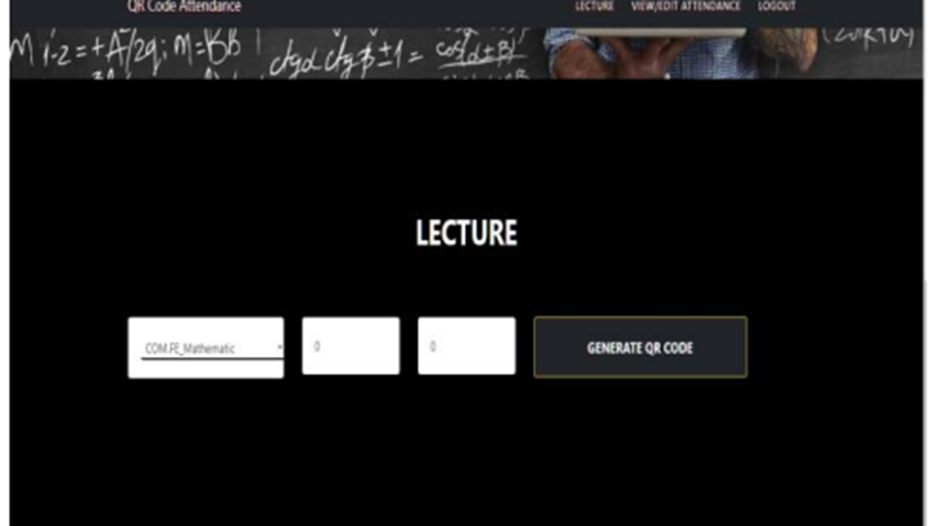

Figure 2: Smart Student Attendance System Using QR Code Teacher module

Inventory Management System

Inventory Management System was submitted at Nobel College, Pokhara University. The proposed system can be used for storing the details of the inventory, stock maintenance, updating the inventory based on the sales details, and generating sales and inventory reports daily or weekly (Maharjan, A., 2016). The Inventory Management System uses Microsoft SQL Server for the database. They also used.NET Framework 4.5 to create a platform, Microsoft Visual Studio to create console and graphical user interfaces, and Java as a programming language. The researcher uses agile methodology in developing the system, wherein by using the phase of agile, they continue to add suggestions that should make the system much better.

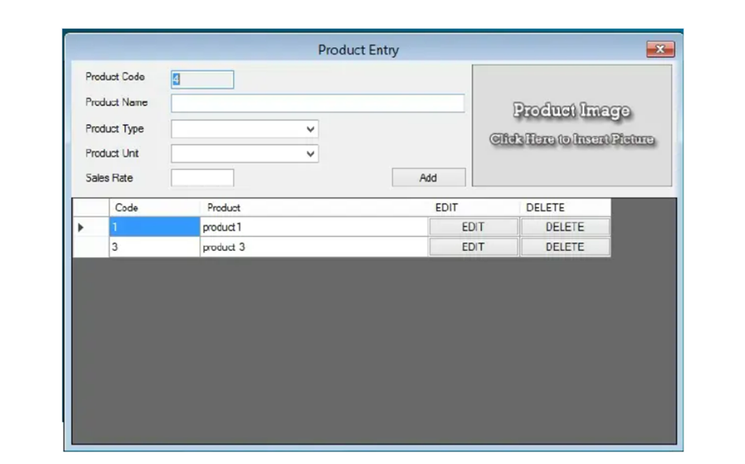

Figure 3: Inventory Management System Creating Product Module

|  |  |  |  |  |
| --- | --- | --- | --- | --- |
|  | Related Studies/Systems | |  |  |
| Components | Class Scheduling System | Smart Student Attendance System Using QR Code | | Inventory Management System |
| Development Environment | Web-based | Web-based and Android Mobile | | Web-based |
| Technology | Windows 10 | QR code | | Visual Studio |
| Programming Language | PHP | Java | | Java |
| Database | XAMPP,  MySQL | MySQL | | Microsoft SQL Server |
| Methodology | Rapid Application Development (RAD) | None | | Agile |
| Reports Generated | Schedule report | Present and Absences of the student | | Generate Sales and inventory Report |
| Security | User authentication | User authentication | | User authentication |
| System Features | It can assign schedule, view, and edit. | It can check how many absences you have. | | It is capable of providing details about stock balance and balance of transaction. |
|  | It has a search button. | It can also edit the attendance, calculate monthly absences, and send a notification to the student. | | It is capable of adding items to the inventory. |
|  | It is capable of import and export. |  | | The application also contains general organization profile. |

Table 1: Related Systems Summary Table

## Synthesis

The review of related literature and studies discussed the importance and the use of technology in the field of piggery management system. The review of related literature described and discussed the theories and technologies that could be used to develop a system that will help the hog farm to have a fast transaction in managing the piggery farm and discussing on how to eliminate the human error that the workers in the farm experienced (Reginio & Robles, 2021). Thus, discussing the process of the breed information system uses a database which the workers can store, manage, analyze, and archive data. Also, it that can help them easy to monitor and manage the performance and the health of the pig in the farm by Jung et al. (2021). The importance on how the workers control the information if they do an operation in the farm and the importance of having a healthy pig when it comes in business or enterprise, and the process on how the farmers and workers manage the animals in terms of breeding (Hady & Lammers, 2015). As Knox (2021) said, breeding has a method that the farm need. This process are the pen mating, hand mating, and an AI which can help the farm to make the process easy. This process uses a Database normalization to lessen the repetition of data in database that causes the performance in retrieving and updating the information in the database by Hiller (2015). Cloud computing is an essential technology in today's world as it allows users to access information anywhere in the world. Cloud computing uses infrastructure like data centers to run virtual servers and access data centers. These servers are built around the world, which offers fast load times depending on client internet service. As mentioned by (Dar & Ravindran, 2018), Cloud computing is cost effective as multiple users buy monthly service and they pay for the power they use which means, it is performance driven. The more the client user uses, the higher the cost, but the lower the client user uses, the lower the cost. A QR code, on the other hand, is a graphic that consists of black and white squares. As Hossain et al. (2018) mentioned, it can store long characters like URLS, images or video links. This feature is helpful with advertising and using unique identification as it could store a lot of information that can be processed by a system that integrates QR Code. Also, QR has error correction where even if 30% of the QR Code is damaged, it can still be scanned.

Furthermore, QR Code can be detected with its sides and scanned in any orientation, which is useful when used in an environment where the QR Code can be rotated. As Odeh (2019) mentioned, Web programming is essential for creating web pages. It has a lot of languages that can be used to do web programming. However, one of those languages, PHP, an open-source server-side scripting language, can be used to render web pages using server-side, which makes server-side data and code safe by (Siame & Kunda, 2017). It requires an internet connection to do so. Other than that, it requires data to pass in a network protocol called TCP/IP, which determines how the data is sent to the server. However, Wheeler (2021) said, before you can connect to a website, you must know which IP address is the server, so DNS keeps track of this IP and assigns a name to it. There are also systems that develop manually which in terms of recording the information or the data about pigs, workers are responsible in listing all the pig information such as in every operation that the farm doing, and they should capture the important events that the farm do because having a human error makes the information and report inaccurate or they can loss the record book. Also, about monitoring the health of the pigs, workers must check it regularly so that the farm owners should not worry about its pig by Evin et al. (2017). However, there is also an existing system from the past years which needs more improvement, although, it can make the work of the workers in the farm easy, but it is not totally convenient or enough to use for the current generation by Maliappis et al. (1972). The define methods can help the proponent in deciding the correct method they will used in their study. Upon the 3 methods which is the agile method which define by Janani (2021), the waterfall method which used by Sharma (2021). And spiral method of Martin (2022). These methodologies give idea to the proponent on what is the best method for their proposed system. The proponents choose agile model to develop the system because of its evolutionary wherein programmers and developers can create a system and improved it in every process. Also, because they Agile method is a step-by-step process it also can accept feedback or suggestions from clients or customers. The review of related studies showed that both local and foreign are focused on resolving the problems especially in recording of information and monitoring, which will make the recording of information and monitoring much easier. The related systems can also give idea to the proponents on what technologies will be helpful in developing a system.

The related system mentioned by Labuanan et al. (2021), the College of Computing Studies, Information and Communication Technology (CCSICT) developed a Class Scheduling System that uses HTML, XAMPP, MySQL, PHP, CSS3, Bootstrap, JQuery in developing a web application and RAD in developing a system prototype. As Arpankumar et al. (2019) said, they use mobile and QR code technology for making the recording of attendance much easier, they use MySQL for the database of the system. The system can also generate monthly reports on the absence of the students, the related system is also like the proposed system wherein the proposed system had also a mobile based QR code technology that will be used for displaying the information of the pigs. In developing the inventory system, Maharjan (2016) show that inventory purposed and capabilities which it can store items and recording items which the proponent can use as a reference in developing the inventory module of the proposed system. It also uses web-based technology that can be used by the proponent in the proposed system, the web-based technology can be accessed anywhere and anytime by the user provided they had internet connection which can give a huge advantage in the proposed system especially for the owner of the RVM hog farm that always travel. The related system also uses technologies that the proponent can also use or consider when developing the proposed system like the MySQL wherein almost all the related system uses as their database, the proposed system will also use MySQL as a database when developing a system. MySQL will play a big role in storing the data of the system which all information of the farm will be stored with. The related system shows how the technologies like CSS and PHP is used in the related system, the proponent will be using same technologies for the design and development of the proposed system. Furthermore, the proposed system is not a repetition of any system, the proposed system is designed and developed for the sake of the RVM hog farm. The proposed system is built using the following technologies: cloud computing, web programming languages like PHP and frameworks such as tailwind CSS and jQuery, android studio, XZing Library, MySQL for the database, MCamera X library, Chart.js and QRCode.js Library. That are the technologies that the proponent will be using while developing the proposed system.

## TECHNICAL BACKGROUND

## This chapter describes the technical background of the study considering the overview of the current technologies to be used in the system. This section also describes the hardware, software, peopleware, and network requirement of the proposed system.

## Overview of Current Technologies to be Used in the System

In developing the proposed system, the proponent will use certain technologies to achieve the goal the proponent needs. The proponent will use cloud computing, web programming languages like PHP and frameworks such as tailwind CSS and jQuery, android studio, XZing Library, Camera X library, Chart.js, Twilio SMS API and QRCode.js Library.

PHP or also known as Hypertext Preprocessor is a scripting language that can be used to create dynamic webpages that can be embedded with HTML pages for server-side rendering. This can be used to render and do server-side rendering and data access to database. This would provide faster development process. In UI development we will use tailwind CSS framework which would give us flexibility and productivity with our design choice. For event handling JavaScript and jQuery can be used, Other than that jQuery can be used to do Ajax Request to web server to access data that the system needs. The proposed system will be deployed online for owner, worker, and veterinarian to access it even they are not in the farm.Chart.js would be used to server as chart generator for dashboard module.

Cloud computing is a choice for hosting web servers. The proponent will use Digital Ocean VPS for this proposed system with installed software like Apache for webserver to run the web-based system and act as API end point for the mobile application to access data like their login information or pigs’ information. and MYSQL Database service which is for storing information that is needed for system like login information, pig information and inventory information.

Android application will use Java programming language with Android Studio IDE which is the current latest IDE version. This Android application can authenticate and Scan QR Code to retrieve pig information. This provides mobility so that the worker does not need to carry computer devices while doing pig information checking.

XZing QR Code Library or called Zebra Crossing is an open-source image processing library that can process 1D/2D barcode image that is implemented in JAVA and ported to other language like C# and many more. This will be used to read or scan QR Code to retrieve the unique identifier of a pig.

Camera X library is a Jetpack library that is built to help make camera app development easy. It provides easy to API that works across most of android devices which start from android 5.0 or API Level 21. This will make android camera access easy and fast for the proponent to work efficiently in the proposed system.

QRCode.js was developed by David shimjs, A JavaScript library for making QR Code using html 5 canvas and table tag in DOM. This library will be used to create QR Code with unique identifier and can be save and printed when needed. Twilio SMS API is an Application Program Interface for sending text message automatically. Twilio is a company that provide services such as SMS API, Programmable Voice call and many more. Thus, Twilio provide plans for services with monthly payment .SMS API would be used in sending SMS Notification for the scheduling management.

With the mentioned development tools and technologies, this gives proponent a power to create a web-based piggery accounting and management system with mobile based QR code scanner that can improve the management of RVM hog farm. Other than that, it provides better data retrieval, security consistency and accuracy on current situation in RVM hog farm.

**Hardware**

The minimum hardware requirements for running the web application are listed in the table below:

|  |  |
| --- | --- |
| HARDWARE | REQUIREMENTS |
| MONITOR | 19” LCD screen Resolution:1366x768 |
| PROCESSOR/CPU | 1.8GHz or faster Intel or AMD processor |
| HARD DISK SPACE | 250GB Hard Disk Drive (HDD) or 256GB Solid State Drive (SSD) |

**Table 2: Hardware Requirements for Running the Web Application**

The minimum hardware requirements for installing and running the mobile application are listed in the table below:

|  |  |
| --- | --- |
| HARDWARE | REQUIREMENTS |
| PROCESSOR | 1.3GHz Quad-Core |
| MEMORY (RAM) | 4GB RAM or higher |
| MEMORY (ROM) | 8GB ROM or higher |
| STORAGE | 32GB or better |
| DISPLAY | At least 6.5“Display or higher |

**Table 3: Hardware Requirements for Installing and Running the Mobile Application**

**Software**

The minimum software requirements for running the web application are listed in the table below:

|  |  |
| --- | --- |
| SOFTWARE | REQUIREMENTS |
| OPERATING SYSTEM (OS) | Any operation system that supports web browser |
| BROWSER | Google Chrome/Mozilla Firefox |

**Table 4: Software Requirements for web application**

The minimum software requirements for installing and running the mobile application are listed in the following tables below:

|  |  |
| --- | --- |
| SOFTWARE | REQUIREMENTS |
| OPERATING SYSTEM (OS) | Lollipop version 5.0 - 5.1.1 or higher versions |

**Table 5: Software Requirements for mobile application**

Peopleware

The following are the people involved and their responsibilities in developing the project:

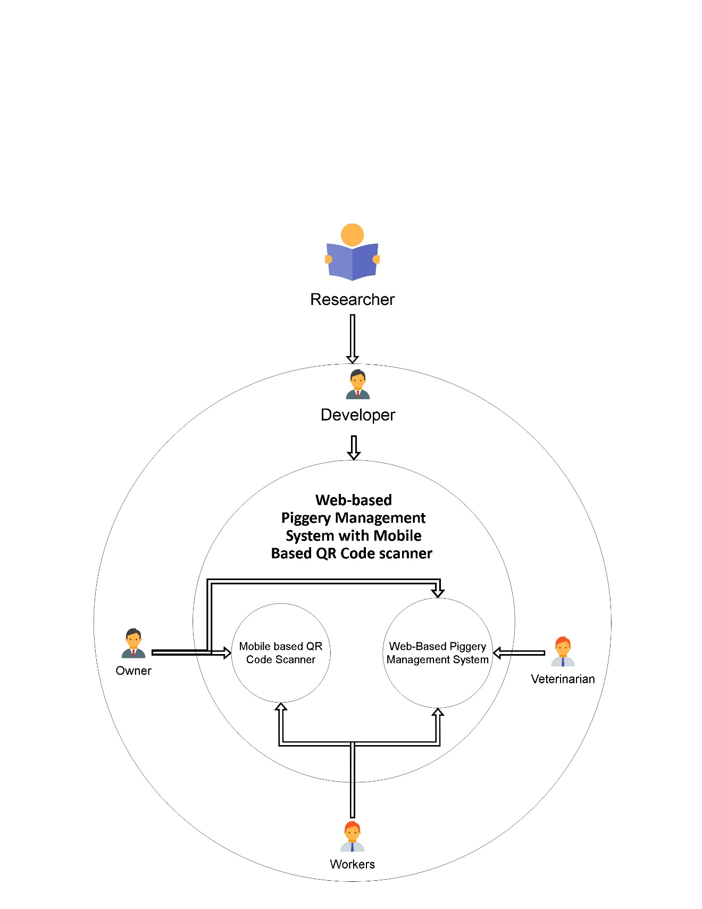

Figure #

**Researcher** - The researcher creates plans that would meet the requirements of the proposed systems. The researcher collects data from books, journals, other existing research, and other documents that can relate to the proposed system.

**Developer** – Developer’s task is to create a program that is in line to the required modules of the proposed system; and identify the possibilities of new program feature to be modified and making these modifications to in line with the proposed system. Developer will also ensure that the program is feasible and has quality assurance procedure. Developer will also be in charge on testing, deployment of tools and processes that are required to run the application.

**Owner** - Owner of RVM Hog farm has access to the mobile based QR code scanner and the web-based accounting and management system which enable him to manage the web-based system better. Other than that mobile app access gives him power to monitor each pig information if the owner is in the hog farm.

**Veterinarian** – Veterinarian needs to see information of the pig. Giving access to the web-based System allow them to view information’s that the veterinarian needs.

**Figure 24: Peopleware Diagram**

**Researcher** - The researcher creates plans that would meet the requirements of the proposed systems. The researcher collects data from books, journals, other existing research, and other documents that can relate to the proposed system.

**Developer** – Developer’s task is to create a program that is in line to the required modules of the proposed system; and identify the possibilities of new program feature to be modified and making these modifications to in line with the proposed system. Developer will also ensure that the program is feasible and has quality assurance procedure. Developer will also be in charge on testing, deployment of tools and processes that are required to run the application.

**Owner** - Owner of RVM Hog farm has access to the mobile based QR code scanner and the web-based accounting and management system which enable him to manage the web-based system better. Other than that mobile app access gives him power to monitor each pig information if the owner is in the hog farm.

**Veterinarian** – Veterinarian needs to see information of the pig. Giving access to the web-based System allow them to view information’s that the veterinarian needs.

**Worker** - Worker has access to both web based and mobile system as they need to enter data into system. Other than that, they need to view pig information and that is achievable using the android application.

**Network**

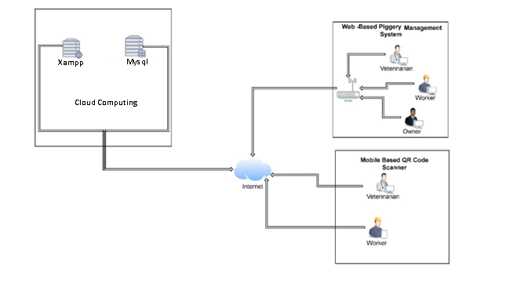

**Figure 25: Network Diagram**

The diagram above shows how the network of proposed system. Web-based system is deployed in one of digital ocean cloud computing using a VPS or called droplet. This allows owner, workers, and veterinarian to view piggery status and information anywhere and anytime. They would need to have internet connection to access the web-based system and they can be in the farm using Wi-Fi or ethernet or mobile data. The data on android application can be retrieved using the web server. In this way, everything can be easily retrieved using http request.

## Calendar of Activities

**Methodology**

The proponents will use agile model as it offers team productivity. With agile, task are divided into chunk where each chunk will have to deliver specific requirement. Agile model is a combination of iterative which means it changes can be done easily and incremental which means adding something slowly.

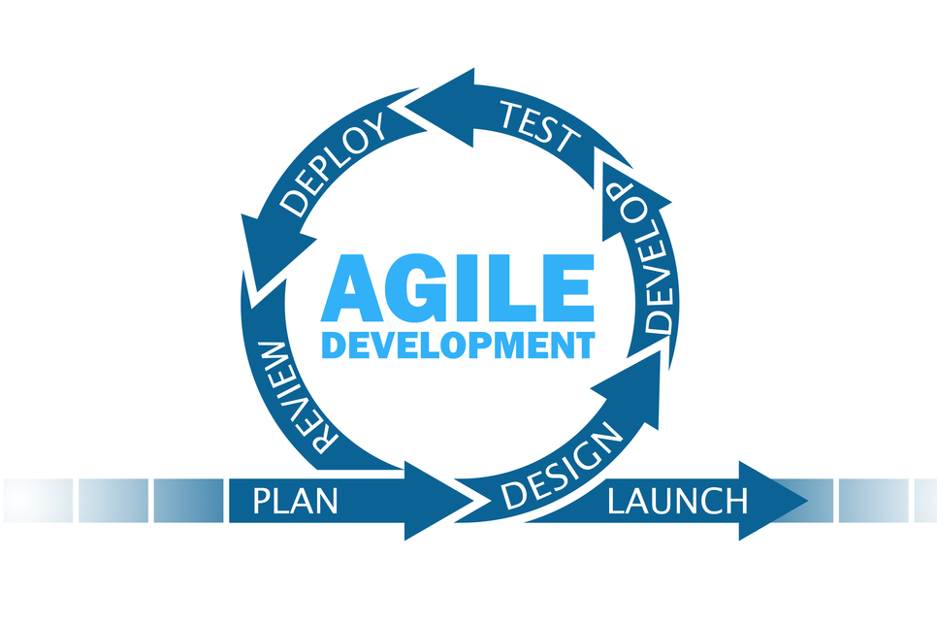

Figure 6: Agile Methodology

**Activity Name:** Project Planning and Initiation

**Objectives of the Activity:**

1. To identify the company/agency that is suitable for the proposed system.
2. To create a questionnaire that can gather data and process of the identified company/agency.
3. To create a request letter to interview the identified company/agency.

**Description:**

The proponent brainstormed an idea for a system that will be proposed to a company/agency. After deciding on the system, the proponent will find a company/agency to propose the chosen idea of the proposed system. If the proponents identified the company/agency, then they will create a letter to request permission from the manager /owner of the agency for permission to conduct an interview. Thus, if permitted then the proponent will create a questionnaire to ask for details about the problems and process of the identified company/agency. Furthermore, the proponent will gather data that can be analyzed to create the modules of the proposed system.

**Persons Involved:** Proponents, stakeholders

**Resources:** Request Letter, Questionnaire, Laptop, and Microsoft

**Timeline:** Week 3-18

**Activity Name:** Requirements Analysis

**Objectives of the Activity:**

1. To determine the current technical process of RVM Hog farm.
2. To create data flow diagram of the current system using Gane and Sarson Model.
3. To create a dataflow diagram of the proposed system using Gane and Sarson Model.
4. To determine the implementation of proposed system with the use of physical diagram.

**Description:**

The proponent would create diagram that would see if the current and proposed system will have difference. The proponent would like to see that the proposed system will have better process than the current system. The proponent would create data flow diagram that would visualize how the current process of RVM hog farm work. This would include Level 0, Logical Data Flow Diagram Level 1. Furthermore, the proponent would create data flow diagram of the proposed system that would visualize how the proposed system process would work. This includes a Level 0 Physical data flow diagram of the proposed system and Level 1 physical data flow diagram of the proposed system.

**Persons Involved:** Proponents and Developers

**Resources:** Laptop, Lucid Chart, Microsoft Word, Browser, Diagram.net, Internet Connection

**Timeline:** Week 19-20

**Activity Name:** Requirements Documentation

**Objectives of the Activity:**

1. To create functional requirements and non-functional requirement

**Description:**

The proponent would create a storyboard which would show how the User Interface of the proposed system works. Thus, creating this story board would allow the proponent to visualize and layout the look of the proposed system. Furthermore, the proponent would create functional requirements for the proposed system where it would describe how the proposed system will behave. Thus, giving the proponent plans for the proposed system when Iterations start.

**Persons Involved:** Proponents and Developers

**Resources:** Lucid Chart, Laptop, Diagram.net, Internet Connection, Browser, Microsoft Word

**Timeline:** Week 21

**Activity Name:** Design of Conceptual Framework and System Architecture

**Objectives of the Activity:**

1. To design system architecture that follows Three-Tier Architecture Model
2. To design Conceptual Framework that follow Input-Process-Output Model

**Description:**

The proponents would create System Architecture design that follows Three-Tier Architecture Model which would consist of application, presentation, and data tier. This would give the proponent an idea of how the proposed system works based on the designed System Architecture. Furthermore, the proponent would create conceptual framework that follow Input-Process-Output model to determine how the input data will be processed and outputted by the proposed system.

**Persons Involved:** Proponents and Developers

**Resources:** Laptop, Lucid Chart, Browser, Internet Connection, Diagram.net

**Timeline:** Week 22-23

**Activity Name:** Object Modeling

**Objectives of the Activity:**

1. To create an Event Decomposition, Use Case Diagram and Activity Diagram of the proposed system.

**Description:**

The proponent would create an Even Decomposition with Use Case diagram to determine which use case each event will do. Thus, the proponent would determine which stakeholders are involved in each event. Furthermore, the proponent would create activity diagram which would determine the flow of activity in the proposed system.

**Persons Involved:** Proponents, stakeholders

**Resources:** Laptop, Lucid Chart, Browser, Internet Connection, Diagram.net

**Timeline:** Week 24-25

**Activity Name:** Database Design

**Objectives of the Activity:**

1. To create Conceptual Database Model
2. To create Normalization
3. To create Logical Database Model
4. To create Physical Database Model
5. To create Data Dictionary

**Description:**

The proponent will create a Conceptual Database Model to determine how to organize the view of database and it`s relationship. This only includes entities, attributes, and the relationship of each table. Also, the proponent would create Normalization of the design Database Model thus making the database model efficient. The proponent would only use 1NF, 2NF, and 3NF in Normalization as it would be efficient enough to optimize the database model. The proponent would also create Logical Database Model which would add more detail to the Conceptual Database Model and also to create a foundation for the Physical Database Model which would offer database abstraction and would add database schema Physical Database Model would help the proponent visualize how the database structure would look like in Database Management Software (DBMS) by adding indexes, foreign keys, primary keys and other DBMS features.

**Persons Involved:** Proponents and Developers

**Resources:** Lucid Chart, Diagram.net, Microsoft World, Laptop, Internet, Browser

**Timeline:** Week 26-27

**Activity Name:** Software Development Iteration 1 – Development of <module name>

**Objectives of the Activity:**

1. To design, code and test Pig Management Module

**Description:**

The proponent would start to develop Pig Management Module. The proponent would Code the proposed module base on the scope presented. This would include a batch and cage management. Furthermore, design and event would follow the created story board and models.

**Persons Involved:** Proponents and Developers

**Resources:** XAMPP, Visual Studio Code, Laptop, Internet, Browser, LucidChart.io and Diagram.net

**Timeline:** Week 28

**Activity Name:** Software Development Iteration 2 – Development of Inventory Management

**Objectives of the Activity:**

1. To design, code and test Inventory Management

**Description:**

The proponent would start to develop Inventory Management Module. The proponent would Code the proposed module base on the scope presented. This module would follow the created story board which would help the developers to visualize how the module would look like and the series of event it would occur.

**Persons Involved:** Proponents and Developers

**Resources:** XAMPP, Visual Studio Code, Laptop, Internet, Browser, LucidChart.io and Diagram.net

**Timeline:** Week 29

**Activity Name:** Software Development Iteration 3 – Development of Scheduling Management

**Objectives of the Activity:**

1. To design, code and test Scheduling Management

**Description:**

The proponent would start to develop Scheduling Management Module. The proponent would Code the proposed module base on the scope presented. This module would follow the created story board which would help the developers to visualize how the module would look like and the series of event it would occur. Furthermore, the proponent would start to implement the SMS Notification to the module.

**Persons Involved:** Proponents and Developers

**Resources:** XAMPP, Visual Studio Code, Laptop, Internet, Browser, LucidChart.io and Diagram.net

**Timeline:** Week 30

**Activity Name:** Software Development Iteration 4– Development of Record Management

**Objectives of the Activity:**

1. To design, code and test Inventory Management

**Description:**

The proponent would start to design, code and testing Record Management Module. The proponent would Code the proposed module base on the scope presented. This module would follow the created story board which would help the developers to visualize how the module would look like and the series of event it would occur.

**Persons Involved:** Proponents and Developers

**Resources:** XAMPP, Visual Studio Code, Laptop, Internet, Browser, LucidChart.io and Diagram.net

**Timeline:** Week 31

**Activity Name:** Software Development Iteration 5– Development of Dashboard

**Objectives of the Activity:**

1. To design, code and test Dashboard

**Description:**

The proponent would start to design, code and testing Dashboard Module. The proponent would Code the proposed module base on the scope presented. This module would follow the created story board which would help the developers to visualize how the module would look like and the series of event it would occur.

**Persons Involved:** Proponents and Developers

**Resources:** XAMPP, Visual Studio Code, Laptop, Internet, Browser, LucidChart.io and Diagram.net

**Timeline:** Week 32

**Activity Name:** Software Development Iteration 6– Development of User Management

**Objectives of the Activity:**

1. To design, code and test User Management

**Description:**

The proponent would start to design, code and testing User Management Module. The proponent would Code the proposed module base on the scope presented. This module would follow the created story board which would help the developers to visualize how the module would look like and the series of event it would occur.

**Persons Involved:** Proponents and Developers

**Resources:** XAMPP, Visual Studio Code, Laptop, Internet, Browser, LucidChart.io and Diagram.net

**Timeline:** Week 33

**Activity Name:** Software Development Iteration 7– Development of Back-up and restore

**Objectives of the Activity:**

1. To design, code and test Backup and restore

**Description:**

The proponent would start to design, code and testing Back-up and Restore Module. The proponent would Code the proposed module base on the scope presented. This module would follow the created story board which would help the developers to visualize how the module would look like and the series of event it would occur.

**Persons Involved:** Proponents and Developers

**Resources:** XAMPP, Visual Studio Code, Laptop, Internet, Browser, LucidChart.io and Diagram.net

**Timeline:** Week 34

**Activity Name:** Software Development Iteration 8– Development of Reports Module

**Objectives of the Activity:**

1. To design, code and test Reports Module

**Description:**

The proponent would start to design, code and testing Reports Module. The proponent would Code the proposed module base on the scope presented. This module would follow the created story board which would help the developers to visualize how the module would look like and the series of event it would occur. This would include Inventory, Deworming, Feeding, Vaccination and Expenses report.

**Persons Involved:** Proponents and Developers

**Resources:** XAMPP, Visual Studio Code, Laptop, Internet, Browser, LucidChart.io and Diagram.net

**Timeline:** Week 34

**Activity Name:** Software Development Iteration 9– Development of QR Scan Module

**Objectives of the Activity:**

1. To design, code, and test QR Scan Module

**Description:**

The proponent would start to design, code and testing QR Scan Module. The proponent would Code the proposed module base on the scope presented. This module would follow the created story board which would help the developers to visualize how the module would look like and the series of event it would occur.

**Persons Involved:** Proponents and Developers

**Resources:** XAMPP, Android Studio, Mobile Phone, Laptop, Internet, Browser, LucidChart.io and Diagram.net

**Timeline:** Week 35

**Activity Name:** Software Development Iteration 10– Development of Dashboard Module

**Objectives of the Activity:**

1. To design, code and test Dashboard

**Description:**

The proponent would start to design, code, and testing Dashboard Module. The proponent would Code the proposed module base on the scope presented. This module would follow the created story board which would help the developers to visualize how the module would look like and the series of event it would occur.

**Persons Involved:** Proponents and Developers

**Resources:** XAMPP, Android Studio, Mobile Phone, Laptop, Internet, Browser, LucidChart.io and Diagram.net

**Timeline:** Week 35

**Activity Name:** Software Development Iteration 11– Development of Login Module for Web Application

**Objectives of the Activity:**

1. To design, code and test Login Module

**Description:**

The proponent would start to design, code and testing Login Module. The proponent would Code the proposed module base on the scope presented. This module would follow the created story board which would help the developers to visualize how the module would look like and the series of event it would occur.

**Persons Involved:** Proponents and Developers

**Resources:** XAMPP, Visual Studio Code, Laptop, Internet, Browser, LucidChart.io and Diagram.net

**Timeline:** Week 36

**Activity Name:** Software Development Iteration 11– Development of Login Module for Mobile Application

**Objectives of the Activity:**

1. To design, code and test Login Module

**Description:**

The proponent would start to design, code and testing Login Module. The proponent would Code the proposed module base on the scope presented. This module would follow the created story board which would help the developers to visualize how the module would look like and the series of event it would occur.

**Persons Involved:** Proponents and Developers

**Resources:** XAMPP, Android Studio, Laptop, Mobile Phone, Internet, Browser, LucidChart.io and Diagram.net

**Timeline:** Week 36

**Activity Name:** Alpha Testing

**Objectives of the Activity:**

1. To test the proposed System with the help of IT Professionals

**Description:**

The proponent would test the Proposed System with the help of IT Professionals and would gather feedback if the Developed System aligned with the proposed system.

**Persons Involved:** Proponents, IT Professionals, and Developers

**Resources:** XAMPP, Visual Studio Code, Laptop, Internet, Browser, LucidChart.io and Diagram.net, Android Studio, and Mobile Phone.

**Timeline:** Week 37-38

Gantt chart would visualize how the calendar of activity look like when formatted per weeks. Furthermore, Gantt chart would show clear visualization of the sequence of event will work.

**Gantt Chart of Activities**

|  |  |  |  |  |  |  |  |  |  |  |  |  |  |  |  |  |  |  |  |  |  |  |  |  |  |  |  |  |  |  |  |  |  |  |  |  |  |  |  |  |
| --- | --- | --- | --- | --- | --- | --- | --- | --- | --- | --- | --- | --- | --- | --- | --- | --- | --- | --- | --- | --- | --- | --- | --- | --- | --- | --- | --- | --- | --- | --- | --- | --- | --- | --- | --- | --- | --- | --- | --- | --- |
| MONTH | FEBRUARY | | | | MARCH | | | | APRIL | | | | MAY | | | | JUNE | | | | JULY | | | | AUGUST | | | | SEPTEMBER | | | | OCTOBER | | | | NOVEMBER | | | |
| ACTIVITY |
| Planning & Initiation |  |  |  |  |  |  |  |  |  |  |  |  |  |  |  |  |  |  |  |  |  |  |  |  |  |  |  |  |  |  |  |  |  |  |  |  |  |  |  |  |
| Requirements Analysis |  |  |  |  |  |  |  |  |  |  |  |  |  |  |  |  |  |  |  |  |  |  |  |  |  |  |  |  |  |  |  |  |  |  |  |  |  |  |  |  |
| Requirements  Documentation |  |  |  |  |  |  |  |  |  |  |  |  |  |  |  |  |  |  |  |  |  |  |  |  |  |  |  |  |  |  |  |  |  |  |  |  |  |  |  |  |
| Design of Conceptual  Framework and System  Architecture |  |  |  |  |  |  |  |  |  |  |  |  |  |  |  |  |  |  |  |  |  |  |  |  |  |  |  |  |  |  |  |  |  |  |  |  |  |  |  |  |
| Object Modeling |  |  |  |  |  |  |  |  |  |  |  |  |  |  |  |  |  |  |  |  |  |  |  |  |  |  |  |  |  |  |  |  |  |  |  |  |  |  |  |  |
| Database Design |  |  |  |  |  |  |  |  |  |  |  |  |  |  |  |  |  |  |  |  |  |  |  |  |  |  |  |  |  |  |  |  |  |  |  |  |  |  |  |  |
| System Development |  |  |  |  |  |  |  |  |  |  |  |  |  |  |  |  |  |  |  |  |  |  |  |  |  |  |  |  |  |  |  |  |  |  |  |  |  |  |  |  |
| *\*Back-end Modules*  *Development* |  |  |  |  |  |  |  |  |  |  |  |  |  |  |  |  |  |  |  |  |  |  |  |  |  |  |  |  |  |  |  |  |  |  |  |  |  |  |  |  |
| Iteration 1 – Pig Management |  |  |  |  |  |  |  |  |  |  |  |  |  |  |  |  |  |  |  |  |  |  |  |  |  |  |  |  |  |  |  |  |  |  |  |  |  |  |  |  |
| Design |  |  |  |  |  |  |  |  |  |  |  |  |  |  |  |  |  |  |  |  |  |  |  |  |  |  |  |  |  |  |  |  |  |  |  |  |  |  |  |  |
| Coding |  |  |  |  |  |  |  |  |  |  |  |  |  |  |  |  |  |  |  |  |  |  |  |  |  |  |  |  |  |  |  |  |  |  |  |  |  |  |  |  |
| Unit Testing |  |  |  |  |  |  |  |  |  |  |  |  |  |  |  |  |  |  |  |  |  |  |  |  |  |  |  |  |  |  |  |  |  |  |  |  |  |  |  |  |
| Iteration 2 – Inventory Management |  |  |  |  |  |  |  |  |  |  |  |  |  |  |  |  |  |  |  |  |  |  |  |  |  |  |  |  |  |  |  |  |  |  |  |  |  |  |  |  |
| Design |  |  |  |  |  |  |  |  |  |  |  |  |  |  |  |  |  |  |  |  |  |  |  |  |  |  |  |  |  |  |  |  |  |  |  |  |  |  |  |  |
| Coding |  |  |  |  |  |  |  |  |  |  |  |  |  |  |  |  |  |  |  |  |  |  |  |  |  |  |  |  |  |  |  |  |  |  |  |  |  |  |  |  |
| Unit Testing |  |  |  |  |  |  |  |  |  |  |  |  |  |  |  |  |  |  |  |  |  |  |  |  |  |  |  |  |  |  |  |  |  |  |  |  |  |  |  |  |
| Iteration 2 – Scheduling Management |  |  |  |  |  |  |  |  |  |  |  |  |  |  |  |  |  |  |  |  |  |  |  |  |  |  |  |  |  |  |  |  |  |  |  |  |  |  |  |  |
| Design |  |  |  |  |  |  |  |  |  |  |  |  |  |  |  |  |  |  |  |  |  |  |  |  |  |  |  |  |  |  |  |  |  |  |  |  |  |  |  |  |
| Coding |  |  |  |  |  |  |  |  |  |  |  |  |  |  |  |  |  |  |  |  |  |  |  |  |  |  |  |  |  |  |  |  |  |  |  |  |  |  |  |  |
| Unit Testing |  |  |  |  |  |  |  |  |  |  |  |  |  |  |  |  |  |  |  |  |  |  |  |  |  |  |  |  |  |  |  |  |  |  |  |  |  |  |  |  |
| MONTH | FEBRUARY | | | | MARCH | | | | APRIL | | | | MAY | | | | JUNE | | | | JULY | | | | AUGUST | | | | SEPTEMBER | | | | OCTOBER | | | | NOVEMBER | | | |
| ACTIVITY |
| Iteration 1 – Record Management |  |  |  |  |  |  |  |  |  |  |  |  |  |  |  |  |  |  |  |  |  |  |  |  |  |  |  |  |  |  |  |  |  |  |  |  |  |  |  |  |
| Design |  |  |  |  |  |  |  |  |  |  |  |  |  |  |  |  |  |  |  |  |  |  |  |  |  |  |  |  |  |  |  |  |  |  |  |  |  |  |  |  |
| Coding |  |  |  |  |  |  |  |  |  |  |  |  |  |  |  |  |  |  |  |  |  |  |  |  |  |  |  |  |  |  |  |  |  |  |  |  |  |  |  |  |
| Unit Testing |  |  |  |  |  |  |  |  |  |  |  |  |  |  |  |  |  |  |  |  |  |  |  |  |  |  |  |  |  |  |  |  |  |  |  |  |  |  |  |  |
| Iteration 1 – Dashboard |  |  |  |  |  |  |  |  |  |  |  |  |  |  |  |  |  |  |  |  |  |  |  |  |  |  |  |  |  |  |  |  |  |  |  |  |  |  |  |  |
| Design |  |  |  |  |  |  |  |  |  |  |  |  |  |  |  |  |  |  |  |  |  |  |  |  |  |  |  |  |  |  |  |  |  |  |  |  |  |  |  |  |
| Coding |  |  |  |  |  |  |  |  |  |  |  |  |  |  |  |  |  |  |  |  |  |  |  |  |  |  |  |  |  |  |  |  |  |  |  |  |  |  |  |  |
| Unit Testing |  |  |  |  |  |  |  |  |  |  |  |  |  |  |  |  |  |  |  |  |  |  |  |  |  |  |  |  |  |  |  |  |  |  |  |  |  |  |  |  |
| Iteration 1 – User Management |  |  |  |  |  |  |  |  |  |  |  |  |  |  |  |  |  |  |  |  |  |  |  |  |  |  |  |  |  |  |  |  |  |  |  |  |  |  |  |  |
| Design |  |  |  |  |  |  |  |  |  |  |  |  |  |  |  |  |  |  |  |  |  |  |  |  |  |  |  |  |  |  |  |  |  |  |  |  |  |  |  |  |
| Coding |  |  |  |  |  |  |  |  |  |  |  |  |  |  |  |  |  |  |  |  |  |  |  |  |  |  |  |  |  |  |  |  |  |  |  |  |  |  |  |  |
| Unit Testing |  |  |  |  |  |  |  |  |  |  |  |  |  |  |  |  |  |  |  |  |  |  |  |  |  |  |  |  |  |  |  |  |  |  |  |  |  |  |  |  |
| Iteration 2 – Backup and Restore |  |  |  |  |  |  |  |  |  |  |  |  |  |  |  |  |  |  |  |  |  |  |  |  |  |  |  |  |  |  |  |  |  |  |  |  |  |  |  |  |
| Design |  |  |  |  |  |  |  |  |  |  |  |  |  |  |  |  |  |  |  |  |  |  |  |  |  |  |  |  |  |  |  |  |  |  |  |  |  |  |  |  |
| Coding |  |  |  |  |  |  |  |  |  |  |  |  |  |  |  |  |  |  |  |  |  |  |  |  |  |  |  |  |  |  |  |  |  |  |  |  |  |  |  |  |
| Unit Testing |  |  |  |  |  |  |  |  |  |  |  |  |  |  |  |  |  |  |  |  |  |  |  |  |  |  |  |  |  |  |  |  |  |  |  |  |  |  |  |  |
| Iteration 2 – Reports Module |  |  |  |  |  |  |  |  |  |  |  |  |  |  |  |  |  |  |  |  |  |  |  |  |  |  |  |  |  |  |  |  |  |  |  |  |  |  |  |  |
| Design |  |  |  |  |  |  |  |  |  |  |  |  |  |  |  |  |  |  |  |  |  |  |  |  |  |  |  |  |  |  |  |  |  |  |  |  |  |  |  |  |
| Coding |  |  |  |  |  |  |  |  |  |  |  |  |  |  |  |  |  |  |  |  |  |  |  |  |  |  |  |  |  |  |  |  |  |  |  |  |  |  |  |  |
| Unit Testing |  |  |  |  |  |  |  |  |  |  |  |  |  |  |  |  |  |  |  |  |  |  |  |  |  |  |  |  |  |  |  |  |  |  |  |  |  |  |  |  |

|  |  |  |  |  |  |  |  |  |  |  |  |  |  |  |  |  |  |  |  |  |  |  |  |  |  |  |  |  |  |  |  |  |  |  |  |  |  |  |  |  |
| --- | --- | --- | --- | --- | --- | --- | --- | --- | --- | --- | --- | --- | --- | --- | --- | --- | --- | --- | --- | --- | --- | --- | --- | --- | --- | --- | --- | --- | --- | --- | --- | --- | --- | --- | --- | --- | --- | --- | --- | --- |
| MONTH | FEBRUARY | | | | MARCH | | | | APRIL | | | | MAY | | | | JUNE | | | | JULY | | | | AUGUST | | | | SEPTEMBER | | | | OCTOBER | | | | NOVEMBER | | | |
| ACTIVITY |
| Iteration 7 – QR Scan |  |  |  |  |  |  |  |  |  |  |  |  |  |  |  |  |  |  |  |  |  |  |  |  |  |  |  |  |  |  |  |  |  |  |  |  |  |  |  |  |
| Design |  |  |  |  |  |  |  |  |  |  |  |  |  |  |  |  |  |  |  |  |  |  |  |  |  |  |  |  |  |  |  |  |  |  |  |  |  |  |  |  |
| Coding |  |  |  |  |  |  |  |  |  |  |  |  |  |  |  |  |  |  |  |  |  |  |  |  |  |  |  |  |  |  |  |  |  |  |  |  |  |  |  |  |
| Unit Testing |  |  |  |  |  |  |  |  |  |  |  |  |  |  |  |  |  |  |  |  |  |  |  |  |  |  |  |  |  |  |  |  |  |  |  |  |  |  |  |  |
| Iteration 7 - Dashboard |  |  |  |  |  |  |  |  |  |  |  |  |  |  |  |  |  |  |  |  |  |  |  |  |  |  |  |  |  |  |  |  |  |  |  |  |  |  |  |  |
| Design |  |  |  |  |  |  |  |  |  |  |  |  |  |  |  |  |  |  |  |  |  |  |  |  |  |  |  |  |  |  |  |  |  |  |  |  |  |  |  |  |
| Coding |  |  |  |  |  |  |  |  |  |  |  |  |  |  |  |  |  |  |  |  |  |  |  |  |  |  |  |  |  |  |  |  |  |  |  |  |  |  |  |  |
| Unit Testing |  |  |  |  |  |  |  |  |  |  |  |  |  |  |  |  |  |  |  |  |  |  |  |  |  |  |  |  |  |  |  |  |  |  |  |  |  |  |  |  |
| Iteration 7 – Web-Based Login Module |  |  |  |  |  |  |  |  |  |  |  |  |  |  |  |  |  |  |  |  |  |  |  |  |  |  |  |  |  |  |  |  |  |  |  |  |  |  |  |  |
| Design |  |  |  |  |  |  |  |  |  |  |  |  |  |  |  |  |  |  |  |  |  |  |  |  |  |  |  |  |  |  |  |  |  |  |  |  |  |  |  |  |
| Coding |  |  |  |  |  |  |  |  |  |  |  |  |  |  |  |  |  |  |  |  |  |  |  |  |  |  |  |  |  |  |  |  |  |  |  |  |  |  |  |  |
| Unit Testing |  |  |  |  |  |  |  |  |  |  |  |  |  |  |  |  |  |  |  |  |  |  |  |  |  |  |  |  |  |  |  |  |  |  |  |  |  |  |  |  |
| Iteration 7 – Mobile-Based Login Module |  |  |  |  |  |  |  |  |  |  |  |  |  |  |  |  |  |  |  |  |  |  |  |  |  |  |  |  |  |  |  |  |  |  |  |  |  |  |  |  |
| Design |  |  |  |  |  |  |  |  |  |  |  |  |  |  |  |  |  |  |  |  |  |  |  |  |  |  |  |  |  |  |  |  |  |  |  |  |  |  |  |  |
| Coding |  |  |  |  |  |  |  |  |  |  |  |  |  |  |  |  |  |  |  |  |  |  |  |  |  |  |  |  |  |  |  |  |  |  |  |  |  |  |  |  |
| Unit Testing |  |  |  |  |  |  |  |  |  |  |  |  |  |  |  |  |  |  |  |  |  |  |  |  |  |  |  |  |  |  |  |  |  |  |  |  |  |  |  |  |
| Alpha-Testing |  |  |  |  |  |  |  |  |  |  |  |  |  |  |  |  |  |  |  |  |  |  |  |  |  |  |  |  |  |  |  |  |  |  |  |  |  |  |  |  |

## Resources

**Hardware**

The minimum hardware requirement for developing and testing the web and mobile application are listed in the table below.

|  |  |
| --- | --- |
| HARDWARE | REQUIREMENTS |
| MONITOR | 19” LCD screen Resolution:1366x768 |
| PROCESSOR/CPU | 1.8GHz or faster Intel or AMD processor |
| HARD DISK SPACE | 250GB Hard Disk Drive (HDD) or 256GB Solid State Drive (SSD) |

**Table 6: Hardware Requirement for Developing and Testing the Web application**

The minimum requirement for testing the mobile application is listed in the table below.

|  |  |
| --- | --- |
| HARDWARE | REQUIREMENTS |
| PROCESSOR | 1.3GHz Quad-Core |
| MEMORY (RAM) | 4GB RAM or higher |
| MEMORY (ROM) | 8GB ROM or higher |
| STORAGE | 32GB or better |
| DISPLAY | At least 6.5“Display or higher |

**Table 7: Hardware requirement for testing mobile application**

**METHODOLOGY, RESULTS, AND DISCUSSIONS**

Requirement Analysis

In developing the Web-Based Piggery Management System with Mobile Based QR Code Scanner for RVM Hog Farm in Lamba, Banga South Cotabato, the proponents used the agile model as a method of developing the proposed system. This method allows the developer and customer to interact with one another, it will also prioritize the customer satisfaction by providing a fully functional software product. The Requirement analysis is the process wherein it is use for determining the expectations of user for the system software. During this phase, all the requirements that are gather and analyze are used to solve the problem and eventually be applied in the development of the proposed system. The functional and system requirements of the proposed system are all collected, as well as the user and operational requirements. Additionally, this also define the current technical situation of the models, context diagram, logical data flow diagram and the functional and non-functional requirements of the current system of the RVM hog farm.

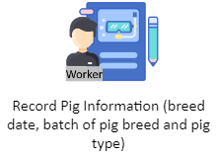**Current Technical Situation**

Figure 4: Pig Breeding Process

The worker records the pig information such as date of breed, batch of pig breed and the type of pig in the logbook.

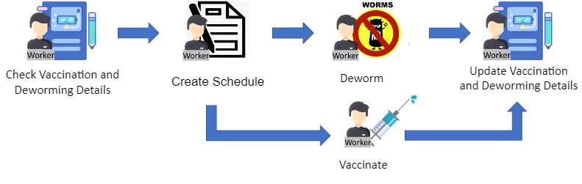

Figure 5: Pig Vaccination and Deworming Process

The worker first checks the vaccinate and deworm status of the pigs. Once the worker done checking, they now create a schedule to be follow by vaccinate and deworm of the pig. Then they conduct a vaccination and deworming for the pigs. Once the work done, they update the vaccination and deworming status of the pigs.

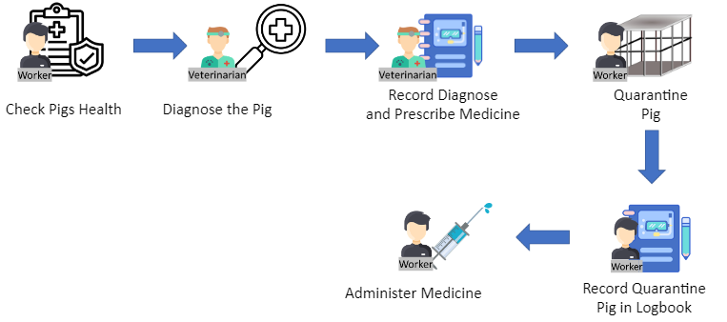

Figure 6: Veterinarian Diagnose Process

The worker checks the pig’s health. When the checking done, the veterinarian diagnoses the pig, then record the diagnose result along with the prescribed medicine in the logbook. The worker quarantines the pig and record the number of quarantine pigs in the logbook and administer medicine to the pig.

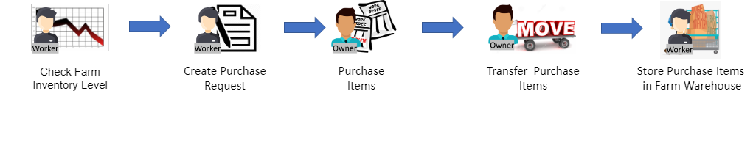

Figure 7: Inventory Process

The worker checks the farm inventory level in the warehouse. After he determine the items, he will create a purchase request and send it to the owner. The owner buys those items, transfer the items to the store worker, and them in the farm warehouse.

Data Flow Diagram of the Current System (Gane and Sarson Model)

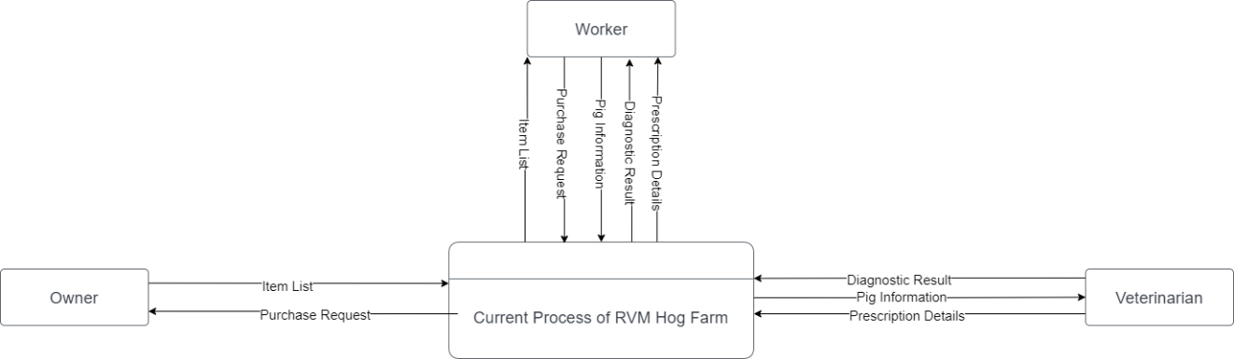

Figure 8: Context Diagram of the Current System

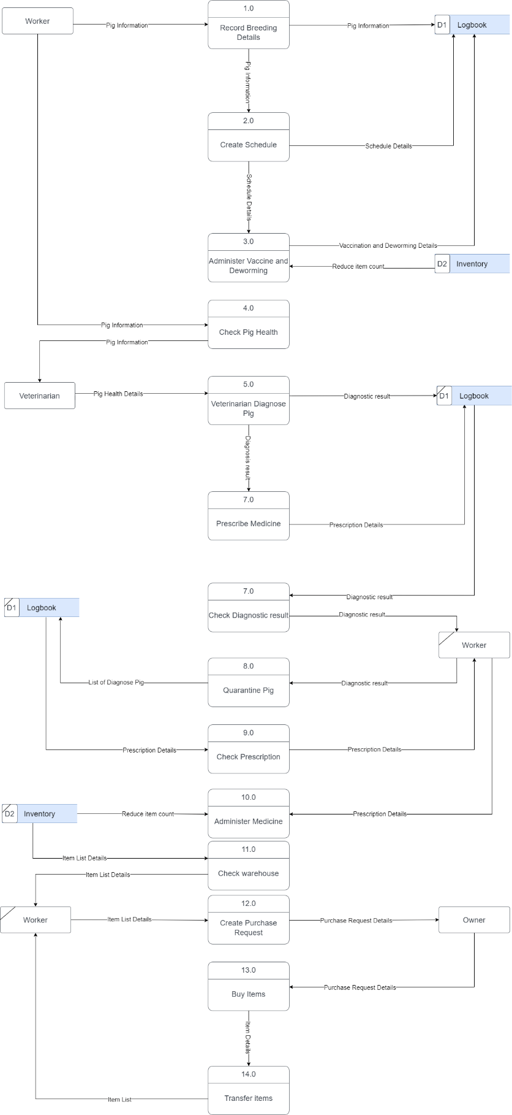

Figure 9: Logical Data Flow Diagram of the Current System (Level 1)

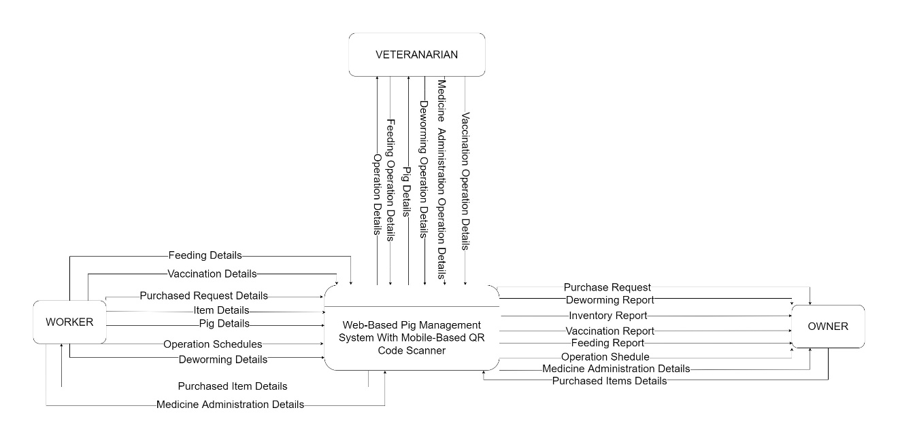

Figure 10: Context Diagram of the Proposed System

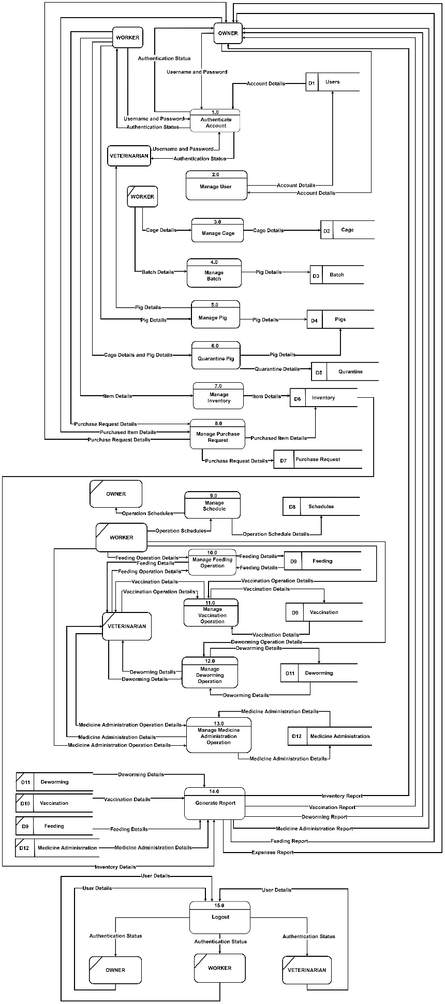

Figure 11: Physical Data Flow Diagram of the Proposed System (Level 0)

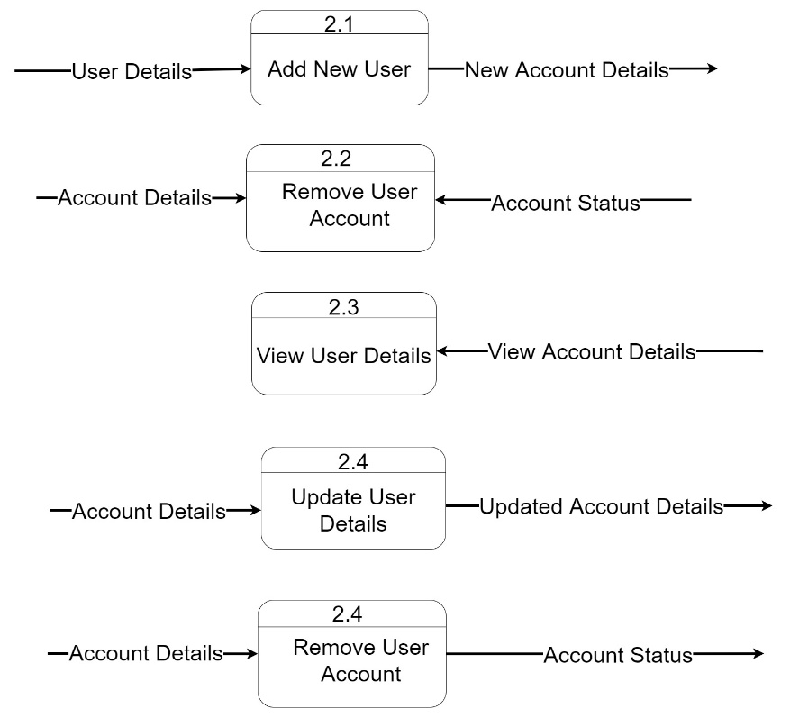

Figure 12: Physical Data Flow Diagram of the Proposed System (Level 1 2.0)

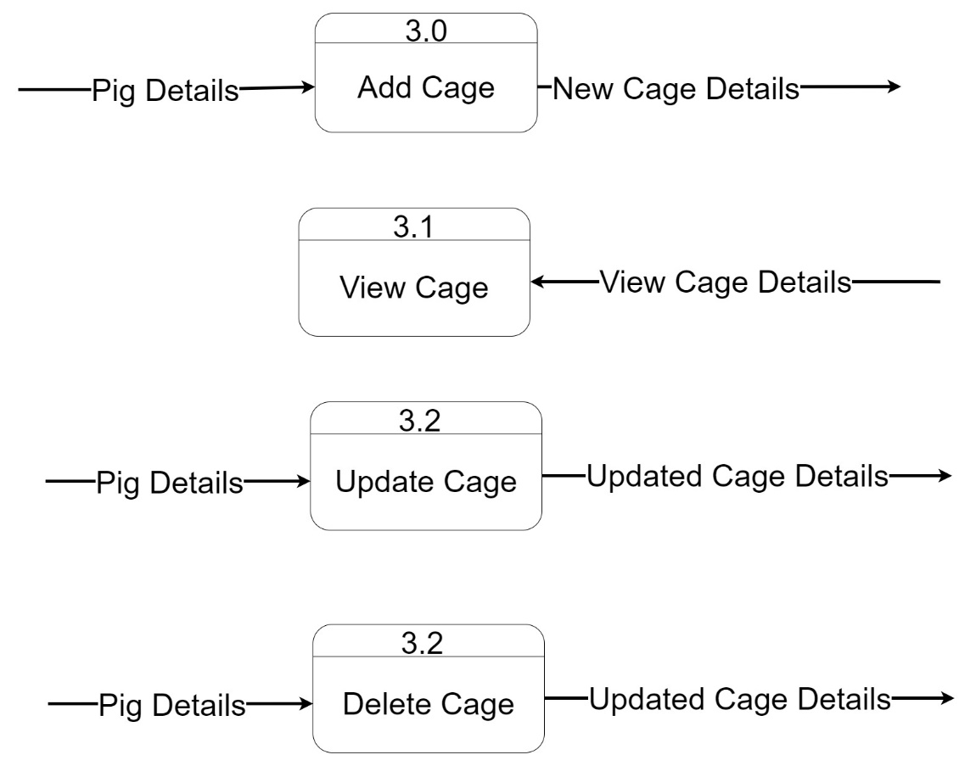

Figure 13: Physical Data Flow Diagram of the Proposed System (Level 1 3.0)

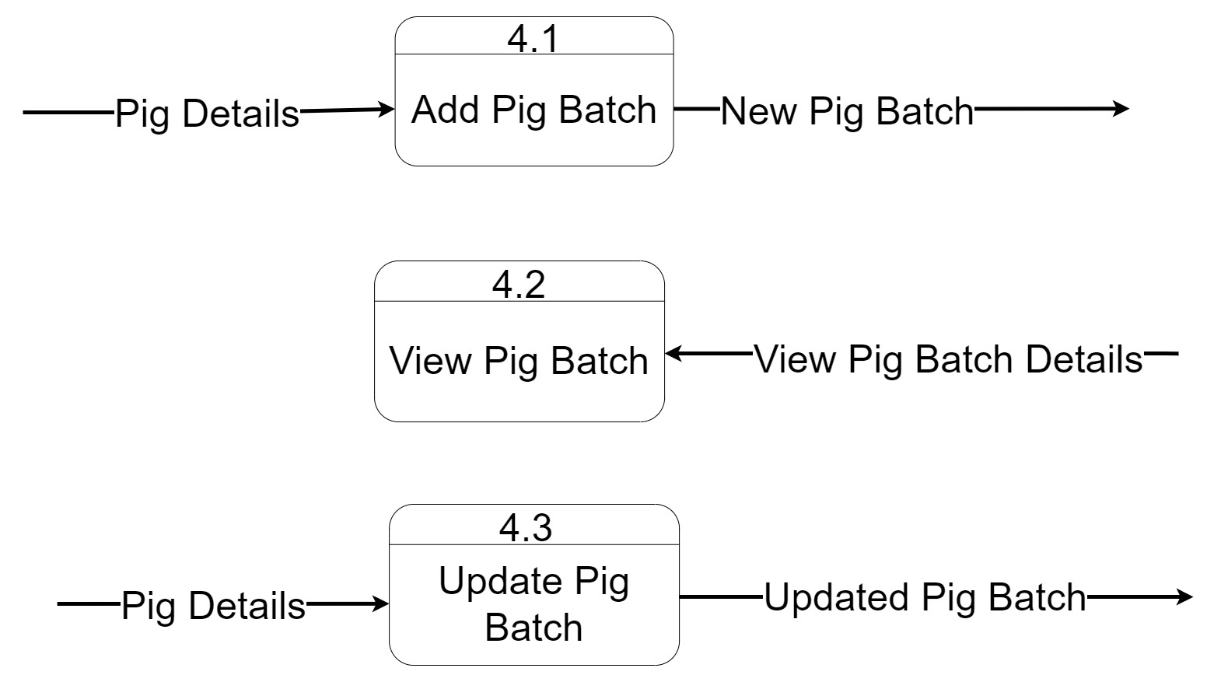

Figure 14: Physical Data Flow Diagram of the Proposed System (Level 1 4.0)

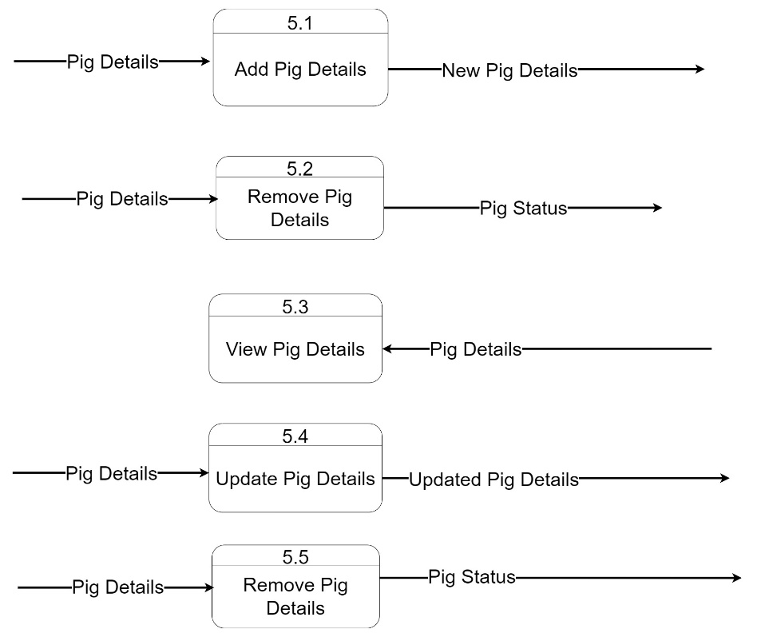

Figure 15: Physical Data Flow Diagram of the Proposed System (Level 1 5.0)

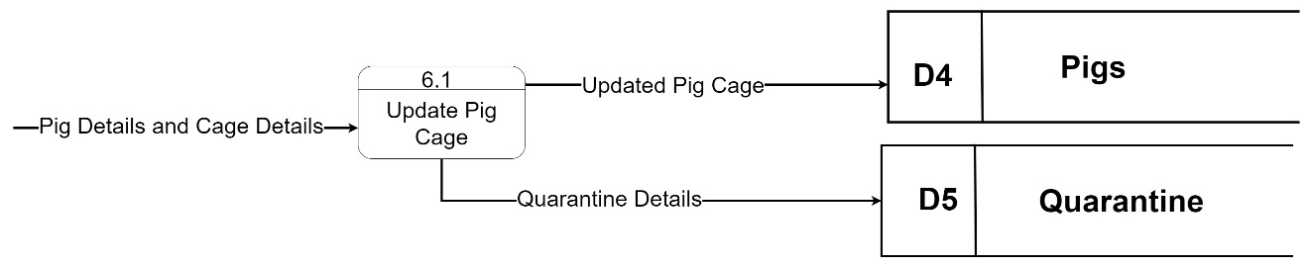

Figure 16: Physical Data Flow Diagram of the Proposed System (Level 1 6.0)

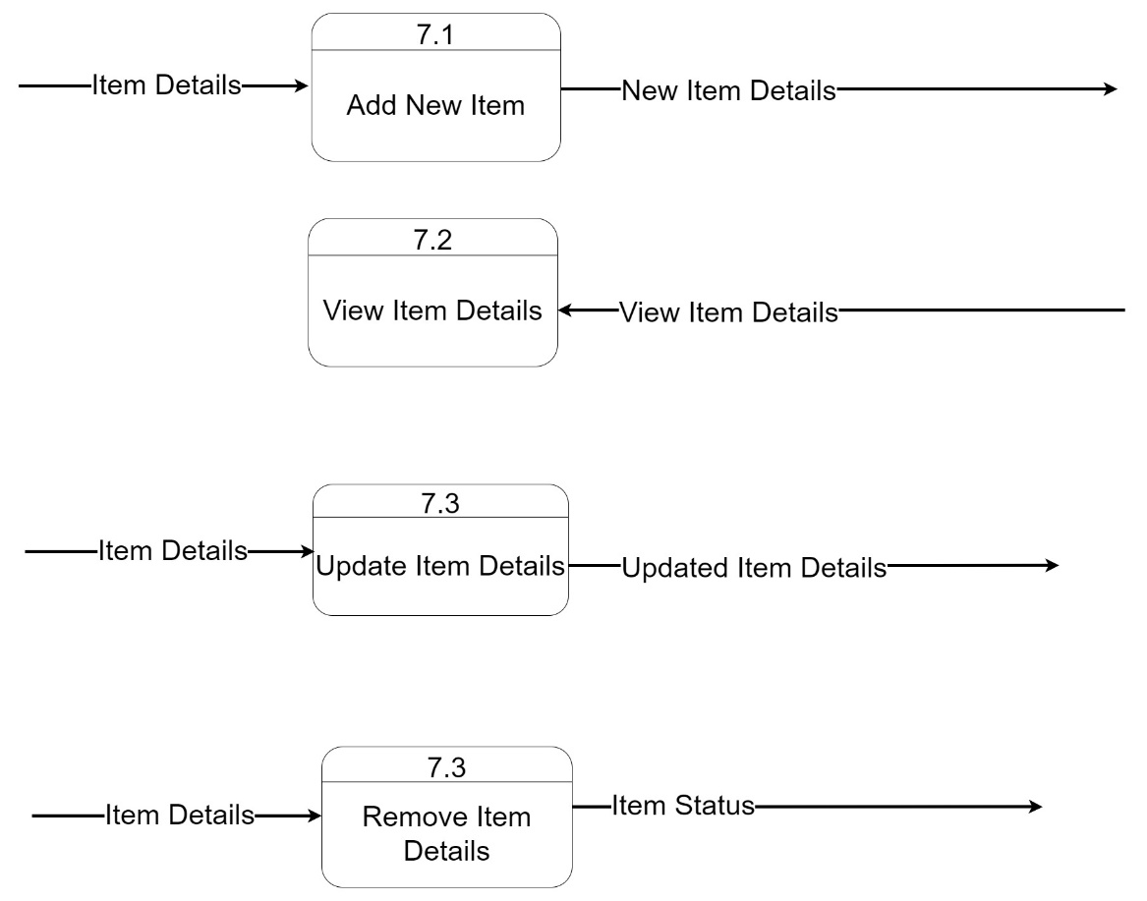

Figure 17: Physical Data Flow Diagram of the Proposed System (Level 1 7.0)

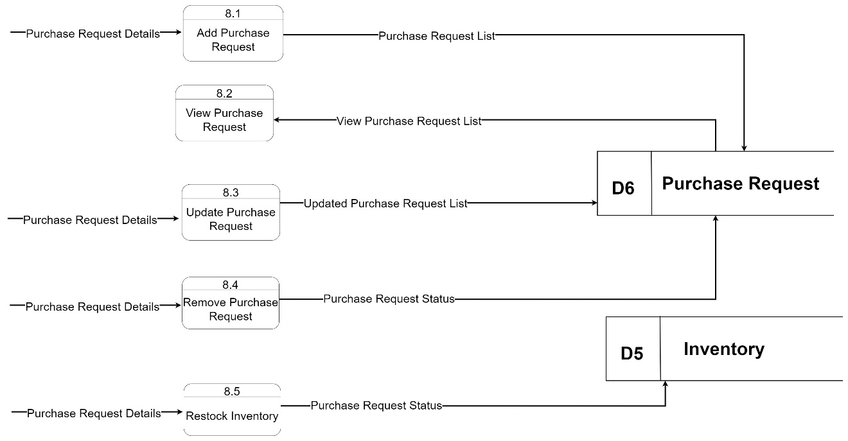

Figure 18: Physical Data Flow Diagram of the Proposed System (Level 1 8.0)

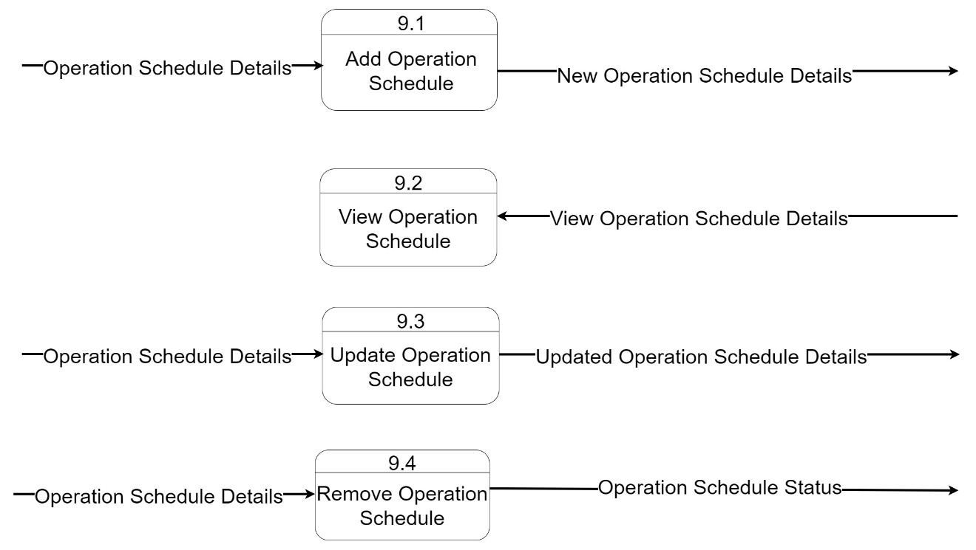

Figure 19: Physical Data Flow Diagram of the Proposed System (Level 1 9.0)

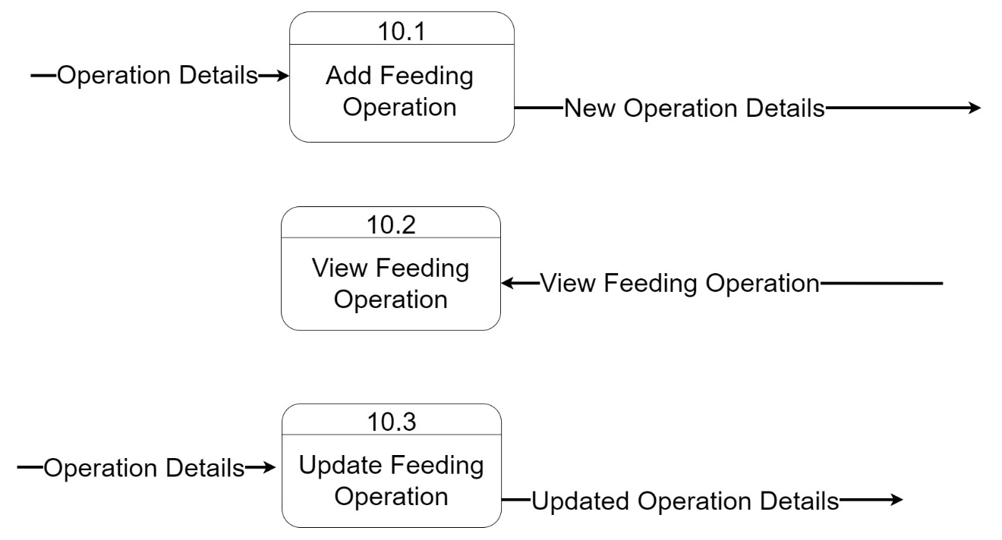

Figure 20: Physical Data Flow Diagram of the Proposed System (Level 1 10.0)

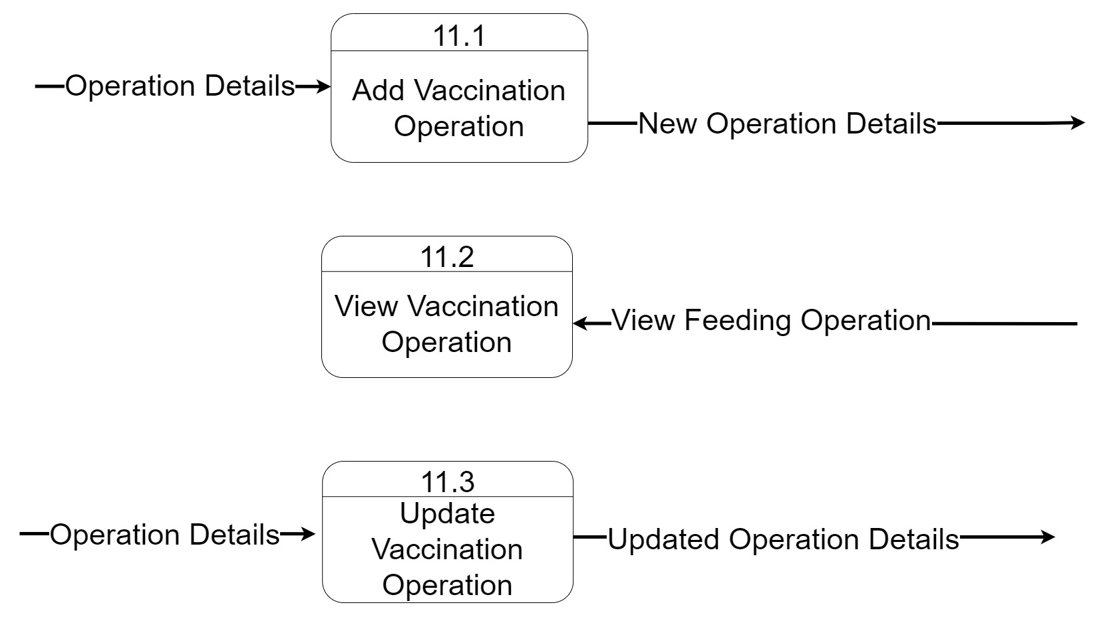

Figure 21: Physical Data Flow Diagram of the Proposed System (Level 1 11.0)

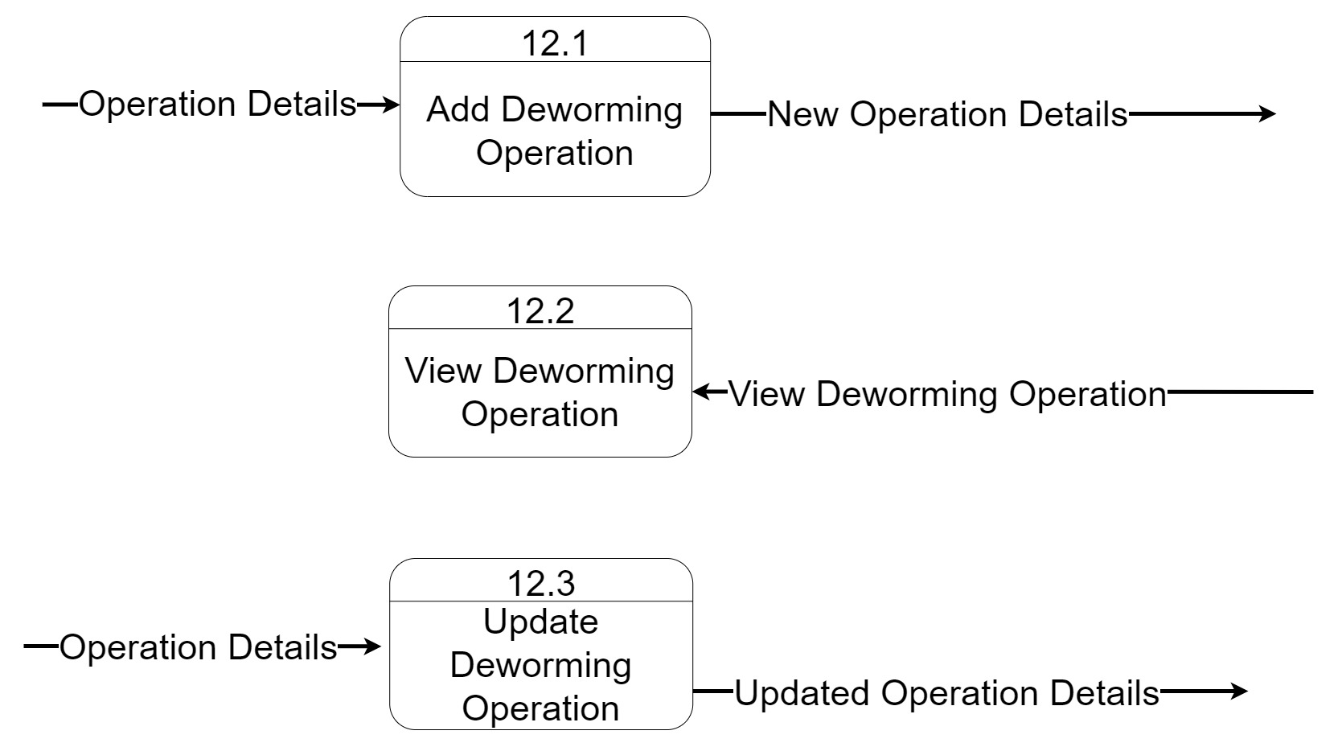

Figure 22: Physical Data Flow Diagram of the Proposed System (Level 1 12.0)

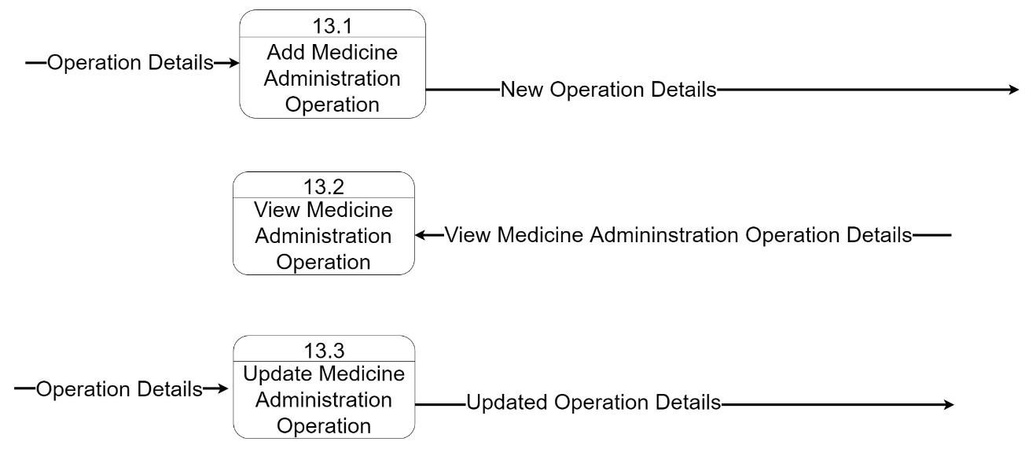

Figure 23: Physical Data Flow Diagram of the Proposed System (Level 1 13.0)

Requirement Documentation

Requirement Documentation is the procedure for writing a software requirement of the project. Software Requirement is how the system is deliberate to function. The Requirement Documentation serves as guide in developing a project and outlining the features that will be included. This places the functional and non-functional requirements of the proposed Web-based Piggery Management System with Mobile-based QR Code Scanner in Lamba, Banga South Cotabato.

The Functional requirements are the basic functions of the system which have primarily what the system must or must not do and how the system responds to inputs. The functional requirements of Web-based Piggery Management System with Mobile-based QR Code Scanner in Lamba, Banga South Cotabato are shown through system storyboard models.

The illustration below shows the functional requirements for the Web-based Piggery Management System with Mobile-based QR Code Scanner in Lamba, Banga South Cotabato web application.

The illustration below are the functional requirements of the proposed system web application.

Login

The Login module allows the user to log in to the web-based system by inputting a username and password. It uses the credentials of the owner, workers, and veterinarian accounts to allow only authenticated user to access the system.

REQ01: The user shall be able to login to the website using his/her login credentials.

A

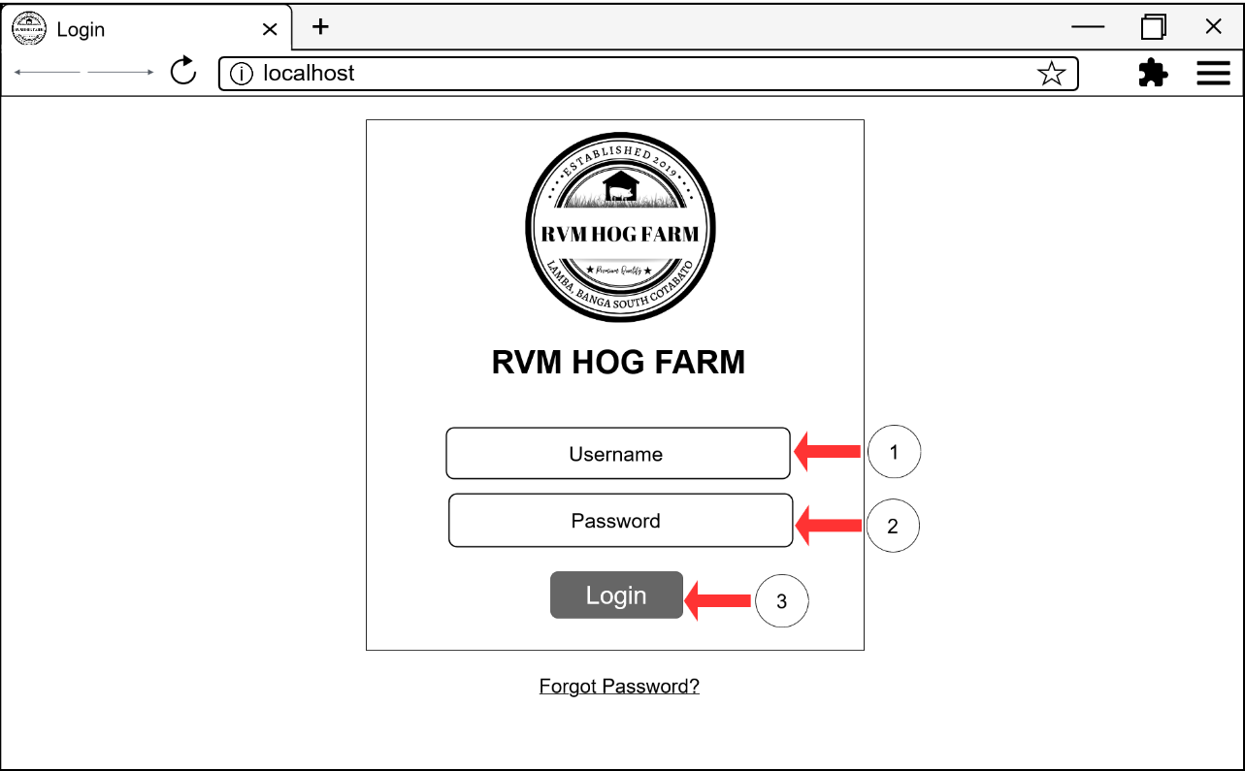

B

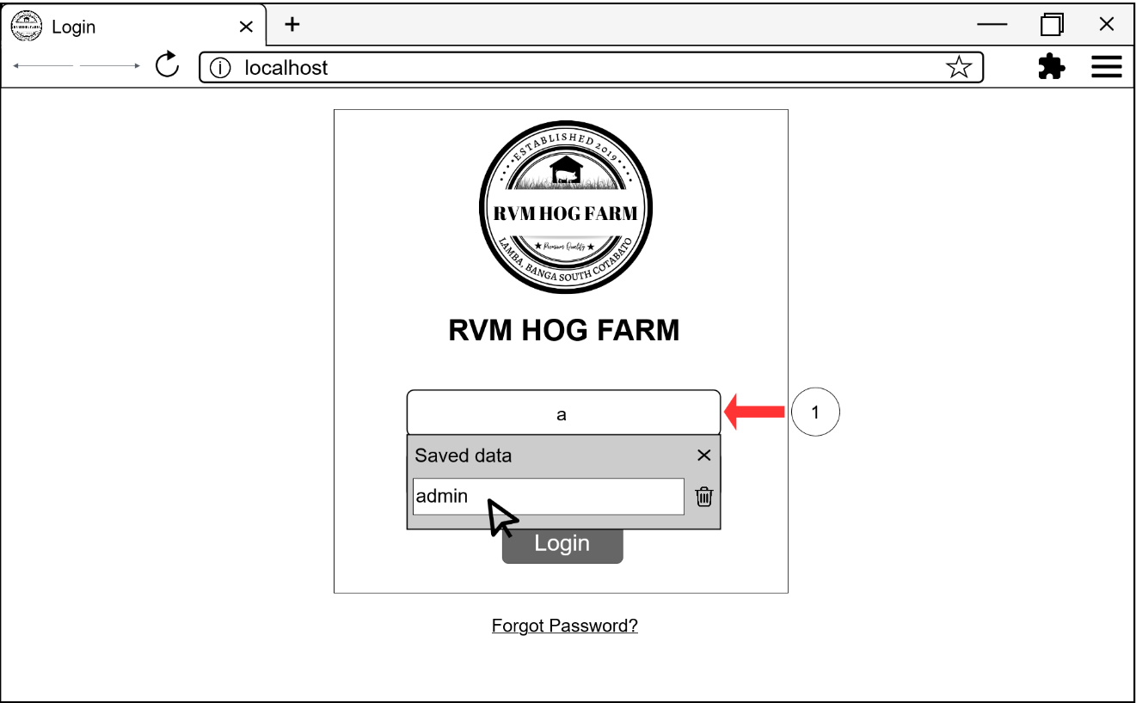

C

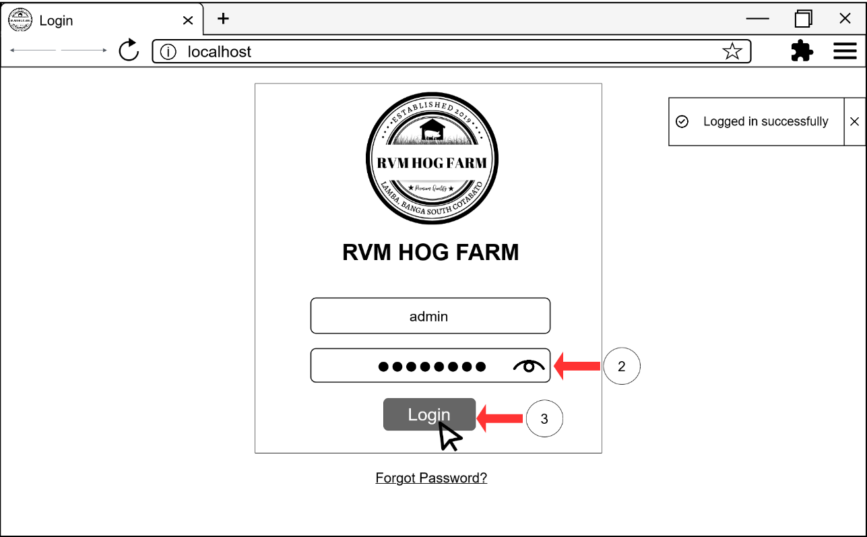

D

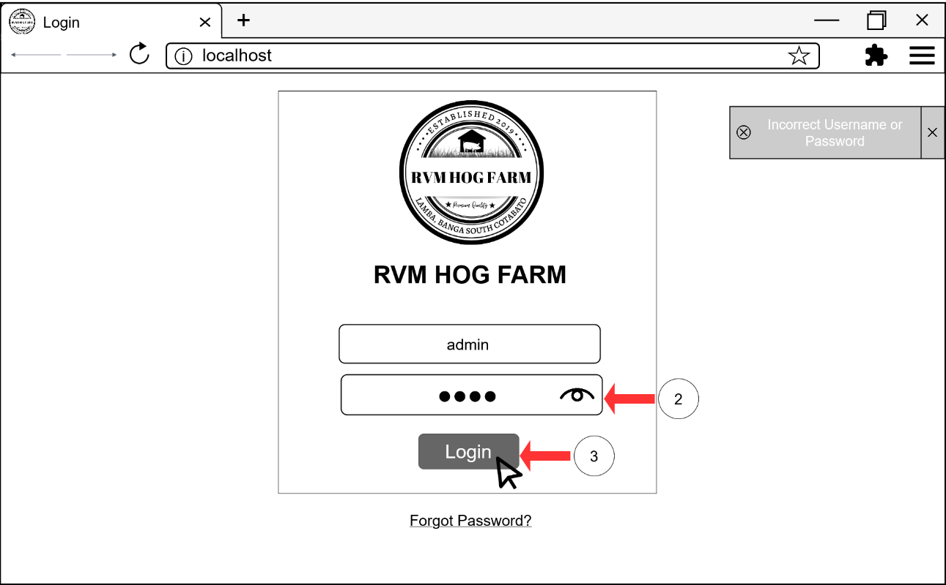

Figure 22A – D: Login Module Interface Storyboard

Dashboard

The Dashboard module provides an overview of the piggery statistics of the hog farm. This module also allows users to filter the total numbers of pigs in the farm.

REQ02: The users shall be able to view the overview of the piggery statistics of the farm.

A

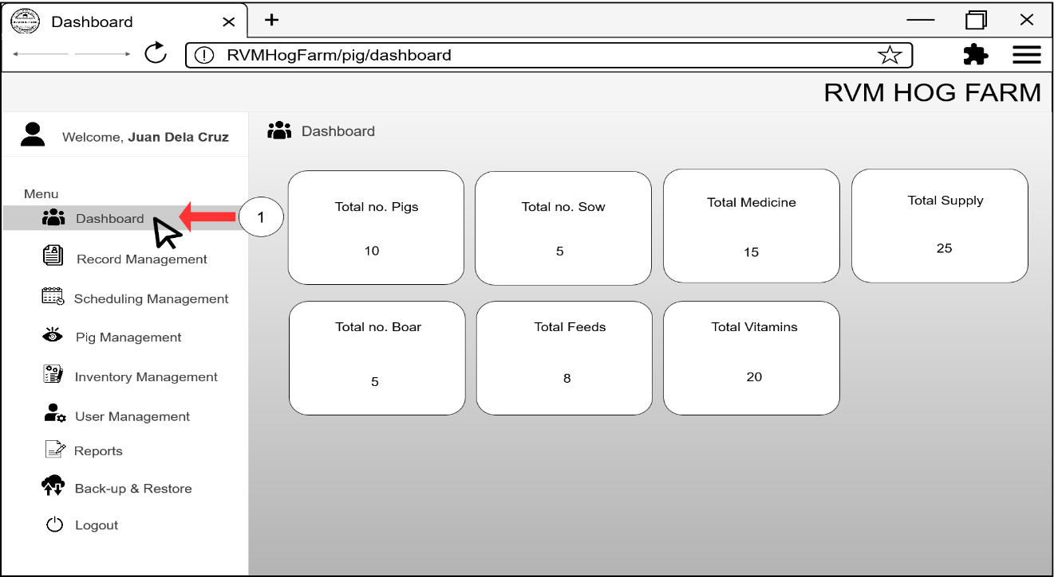

Figure 23A: Dashboard Module Interface Storyboard

Record Management

This Record Management module allows the owner, workers, and veterinarian to record the operation that are done in the farm. This module will also use to add stocks in inventory and will automatically reduce when it entered in Inventory module.

REQ03: The user shall be able to record the operations done in the farm.

REQ04: The user shall be able to add stocks in inventory.

REQ05: The user shall be able to reduce stocks in inventory when it already used.

A

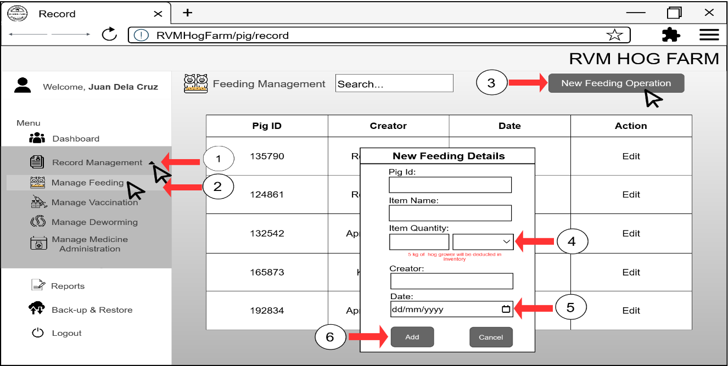

B

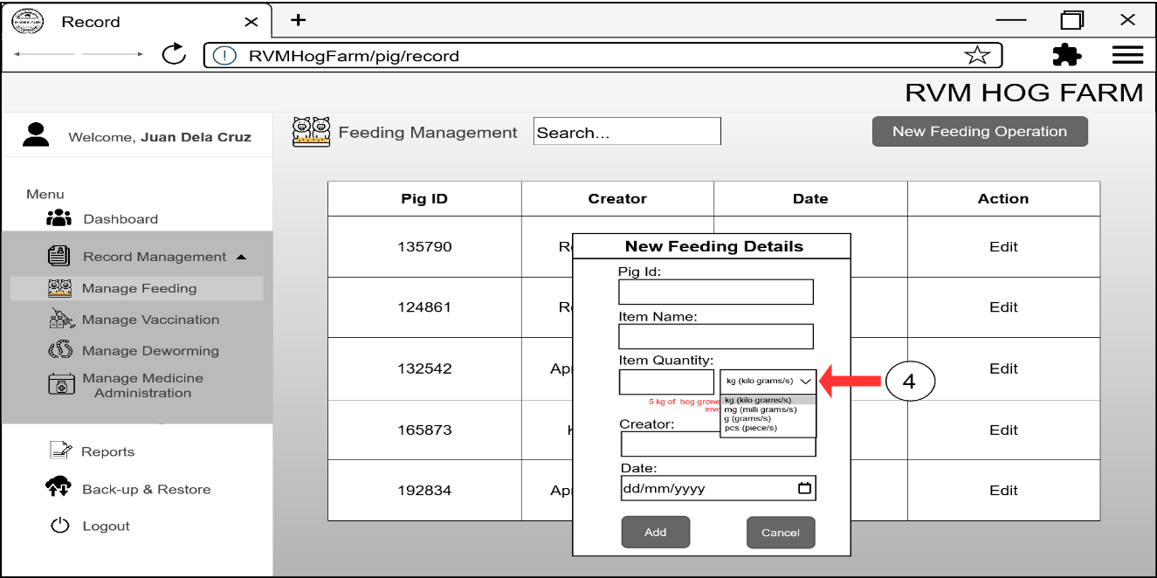

C

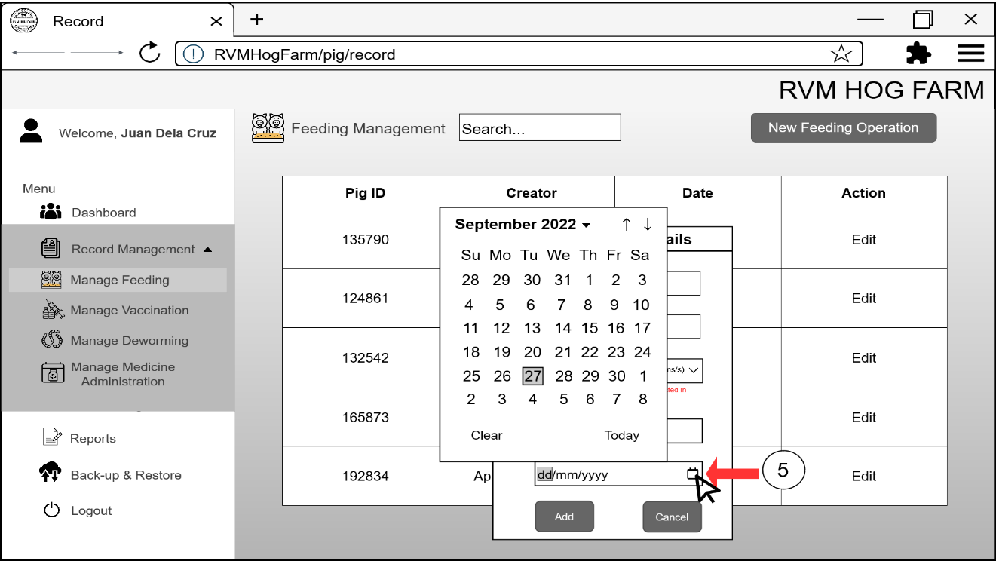

D

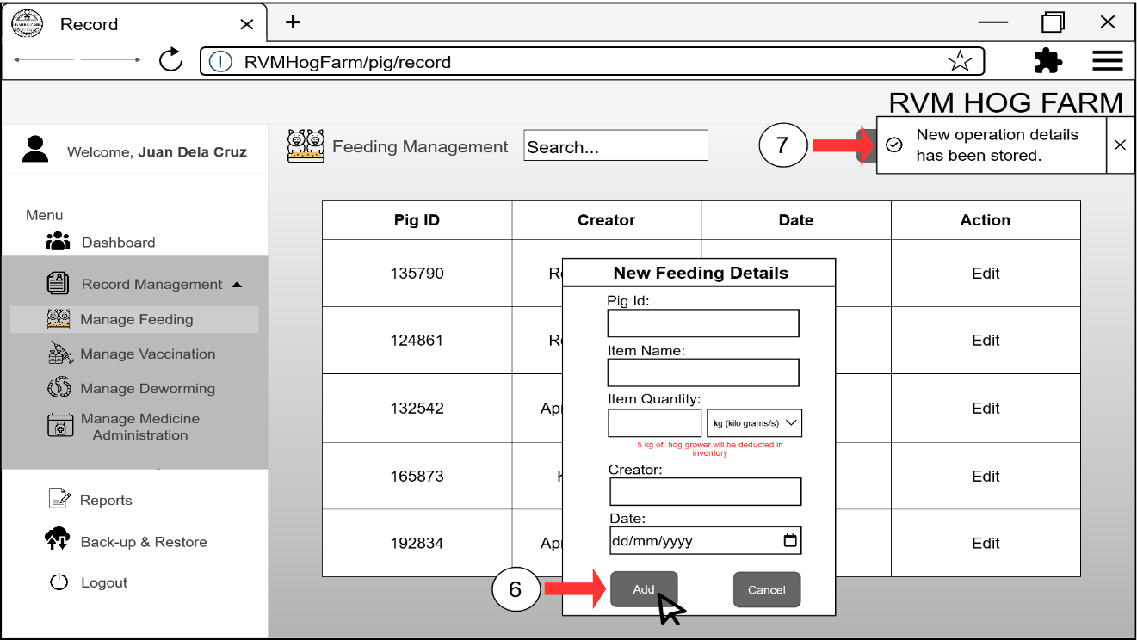

E

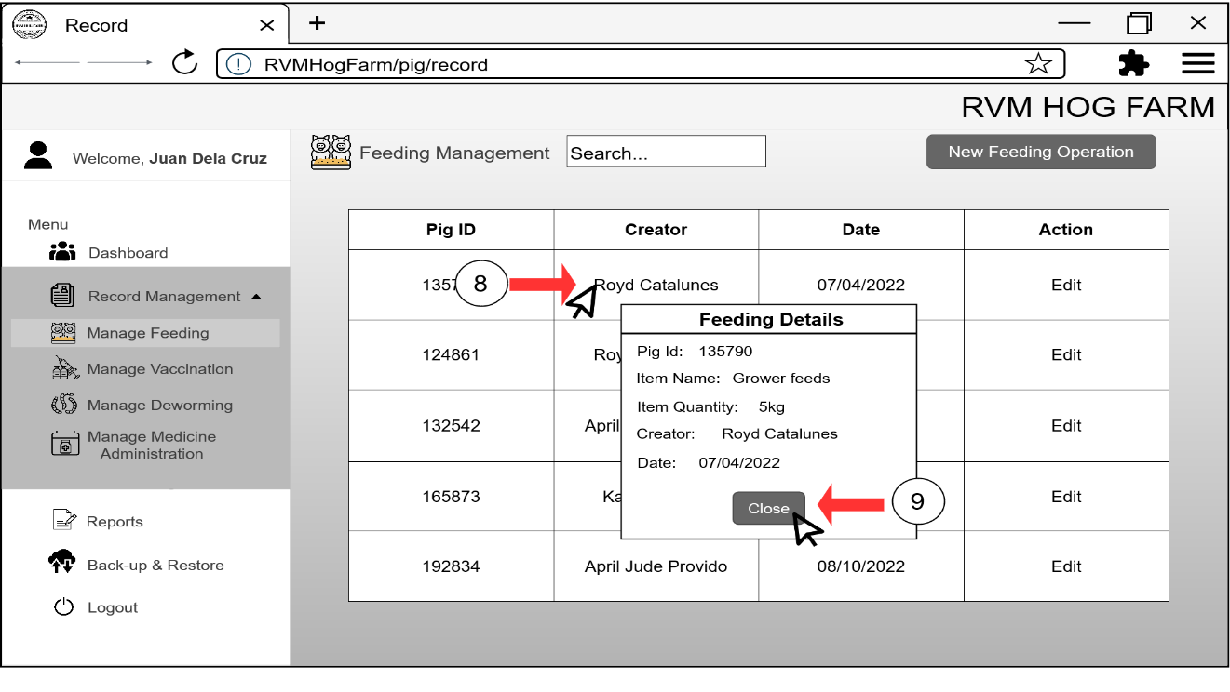

F

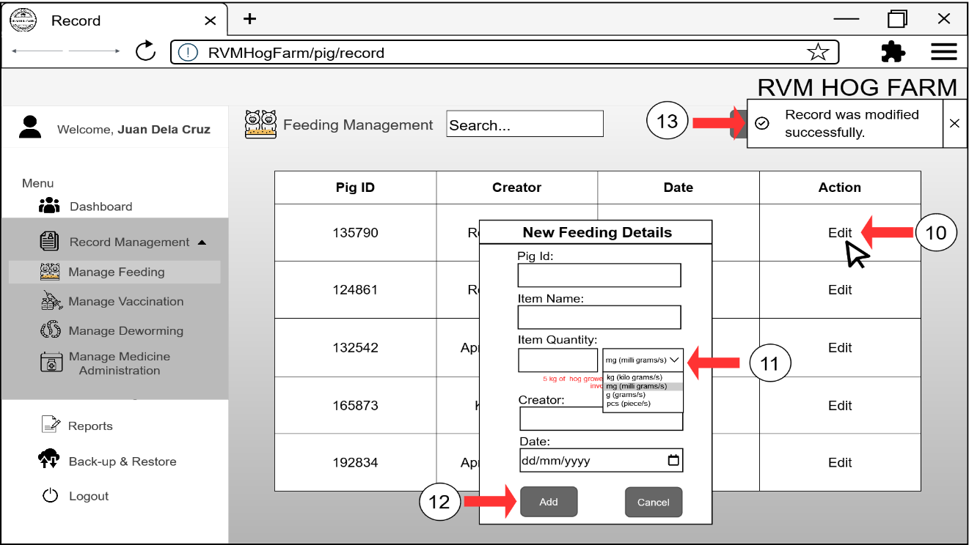

Figure 24A – F: Record Management for Feeding Management Module Interface Storyboard



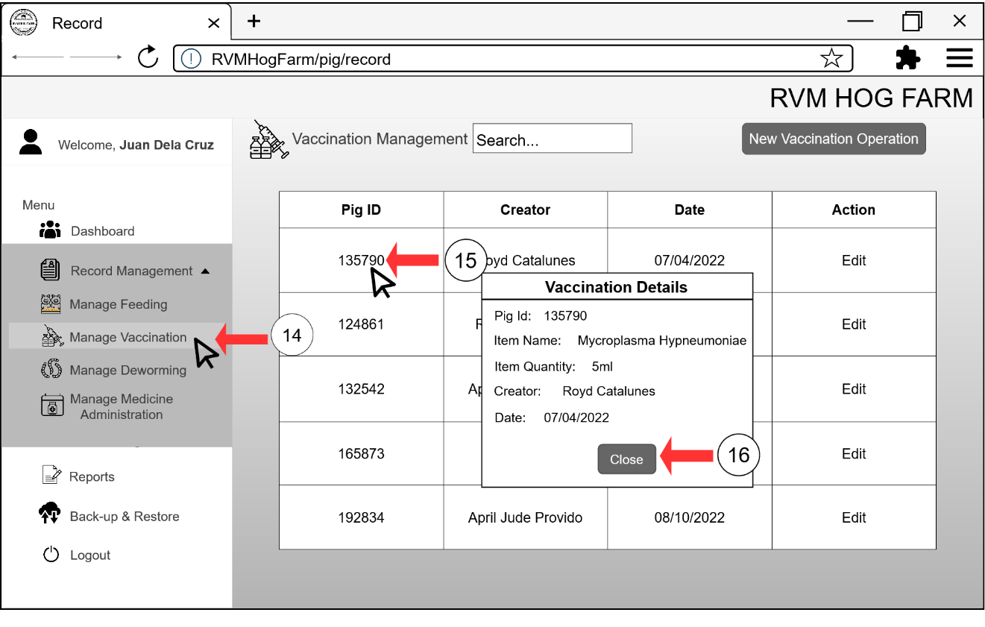



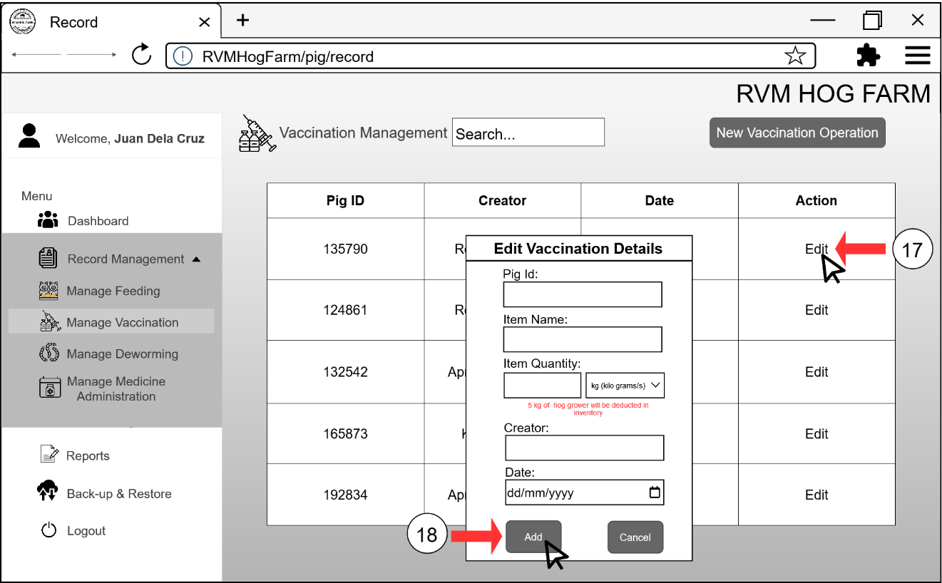



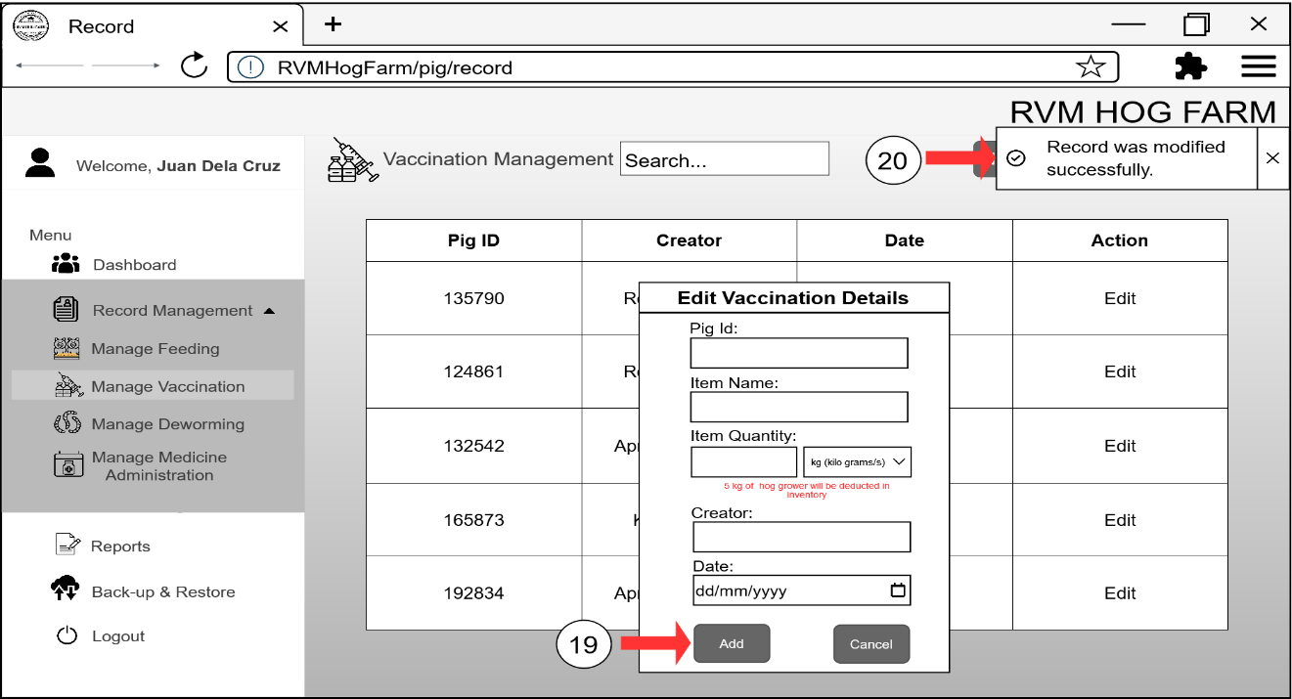



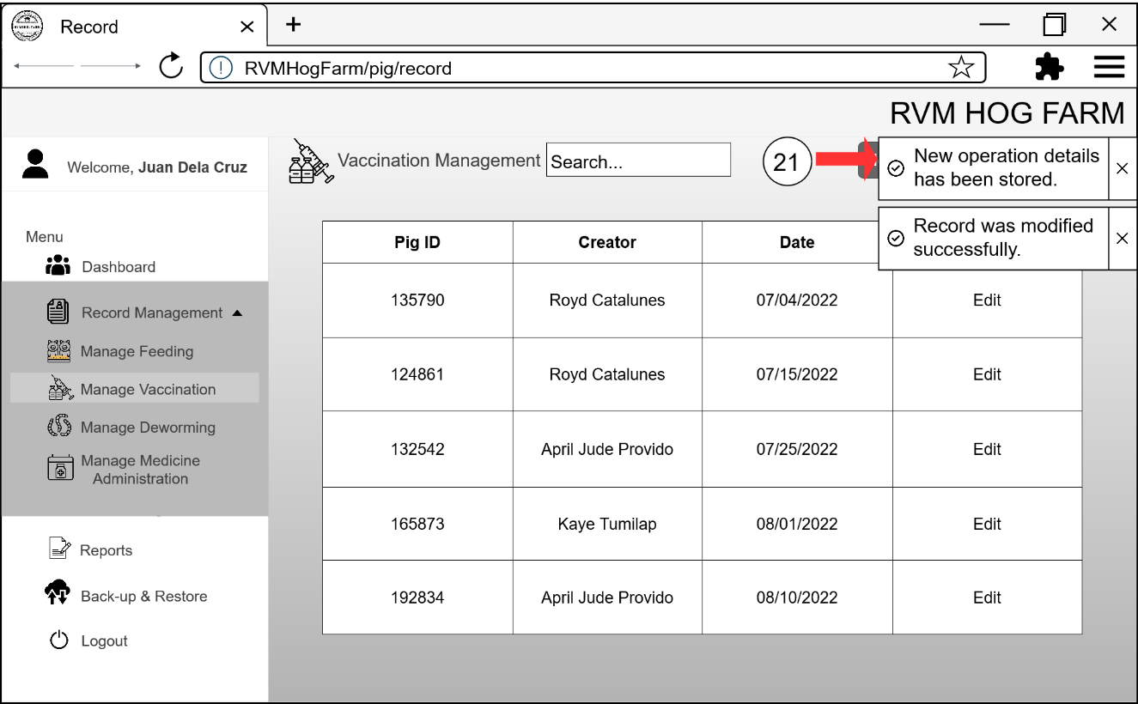

Figure 25G – J: Record Management for Vaccination Management Module Interface Storyboard

K

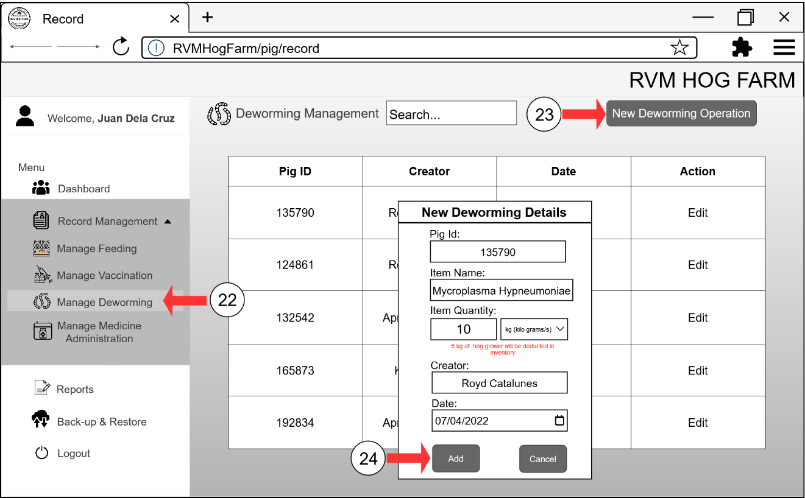

L

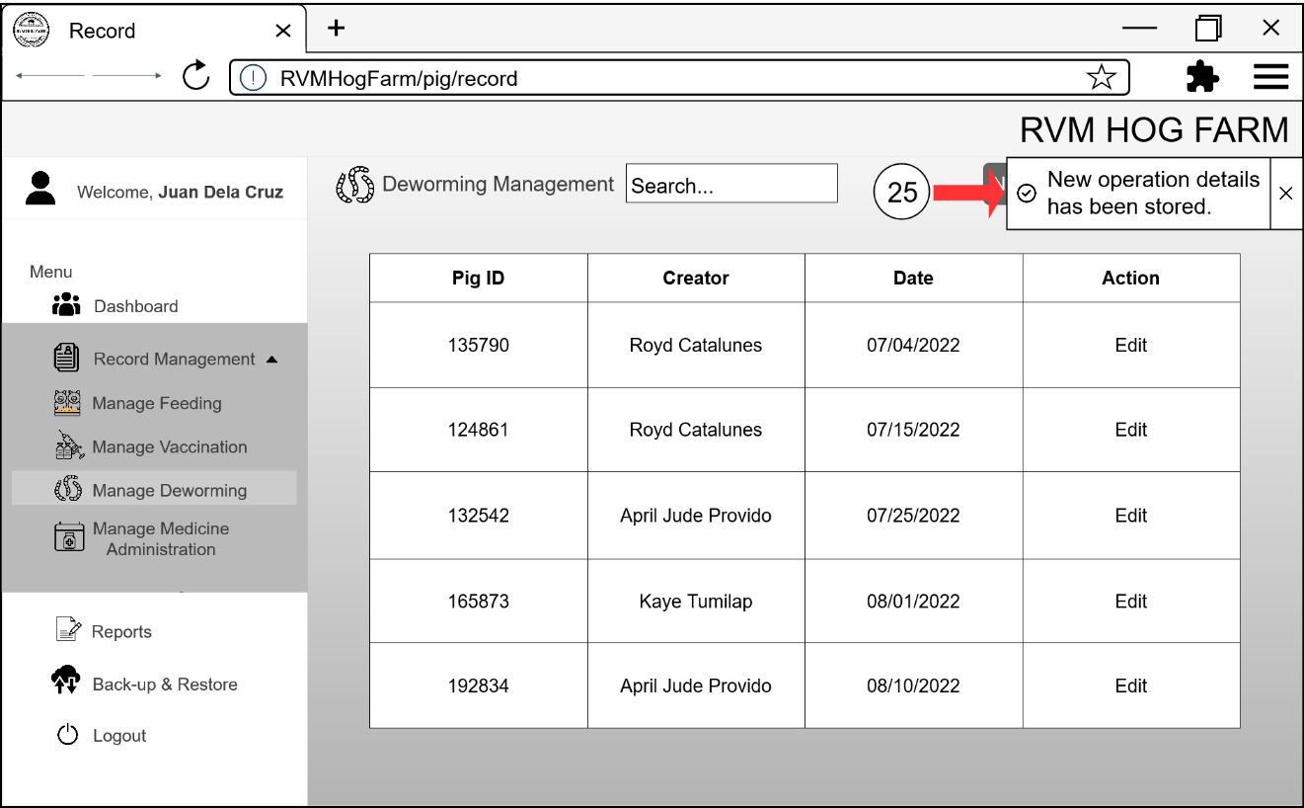

M

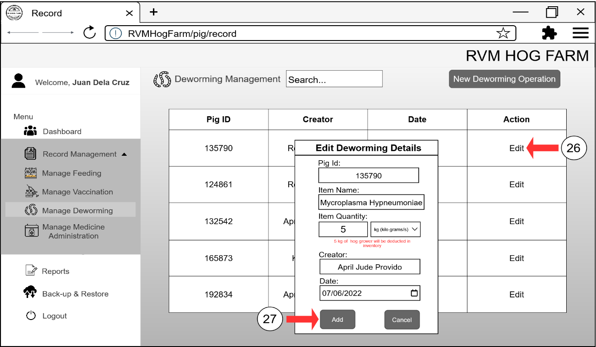

N

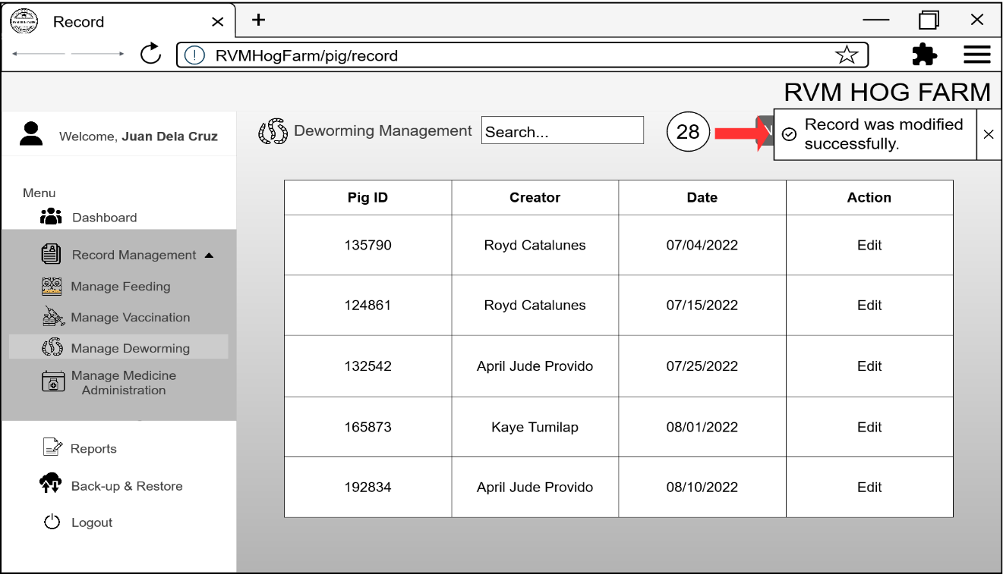

Figure 26K – N: Record Management for Deworming Management Module Interface Storyboard

O

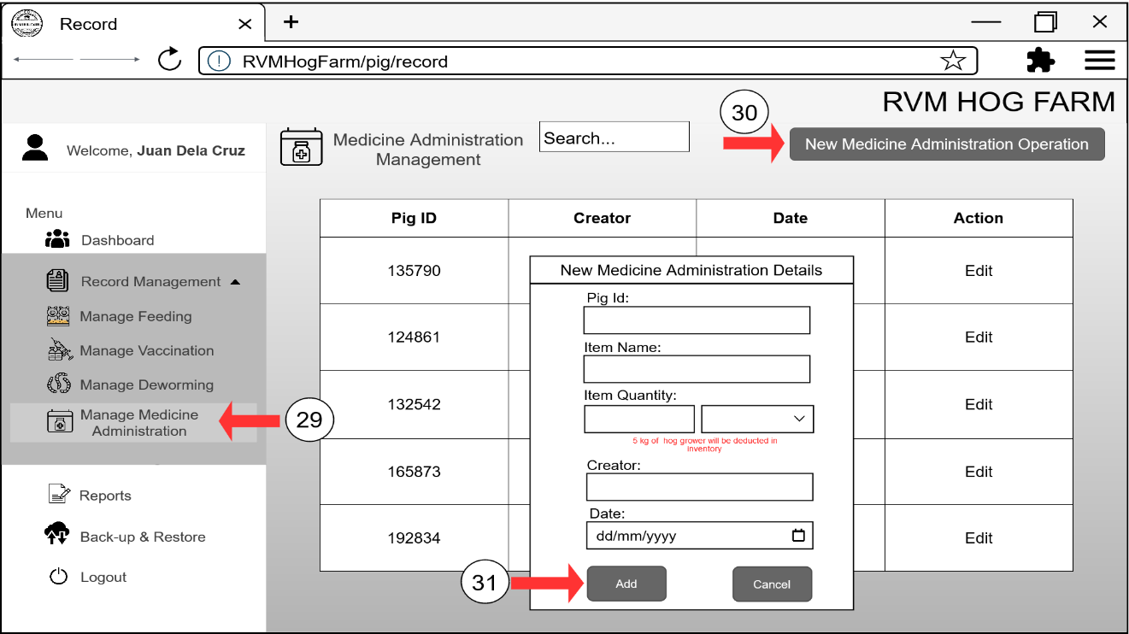

P

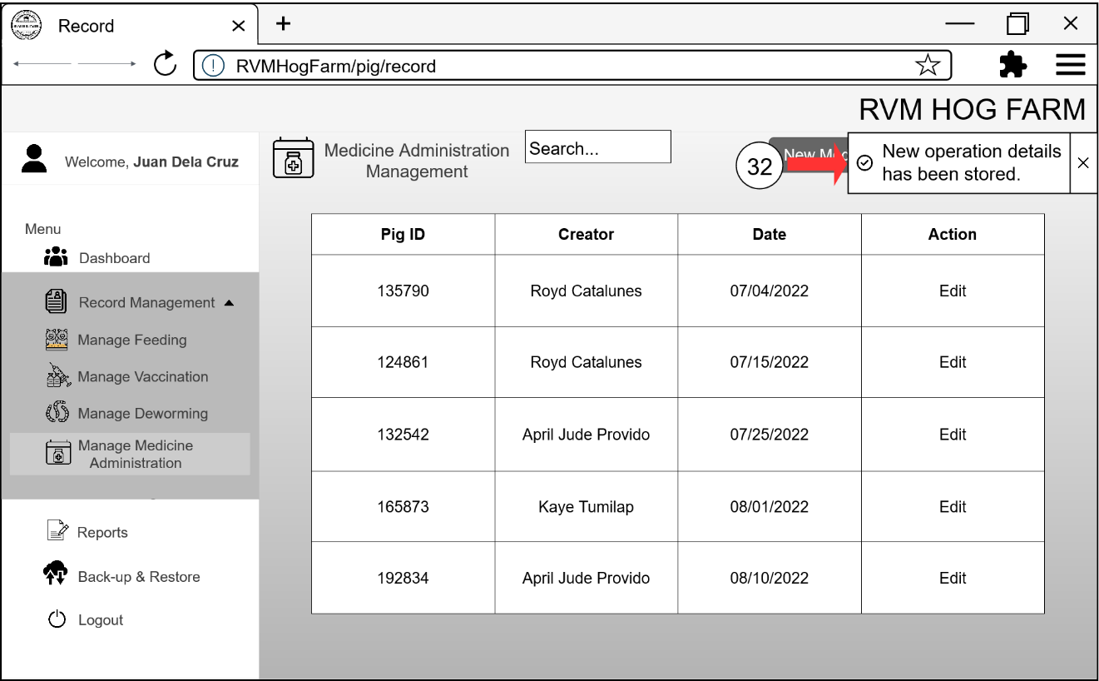

Figure 27O – P: Record Management for Medicine Administration Module Interface Storyboard

Scheduling Management

This Scheduling management allows the users to create a schedule for the operation of the pigs. This module also allows to send SMS Notifications before the operation to notify the owner about the upcoming operation.

REQ06: The user shall be able to create a schedule for the operation.

REQ07: The user shall be able to send SMS Notification to notify the owner about the upcoming operation.

A

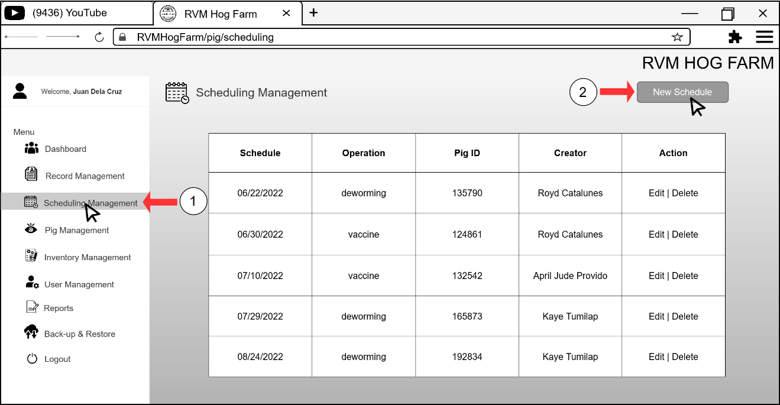

B

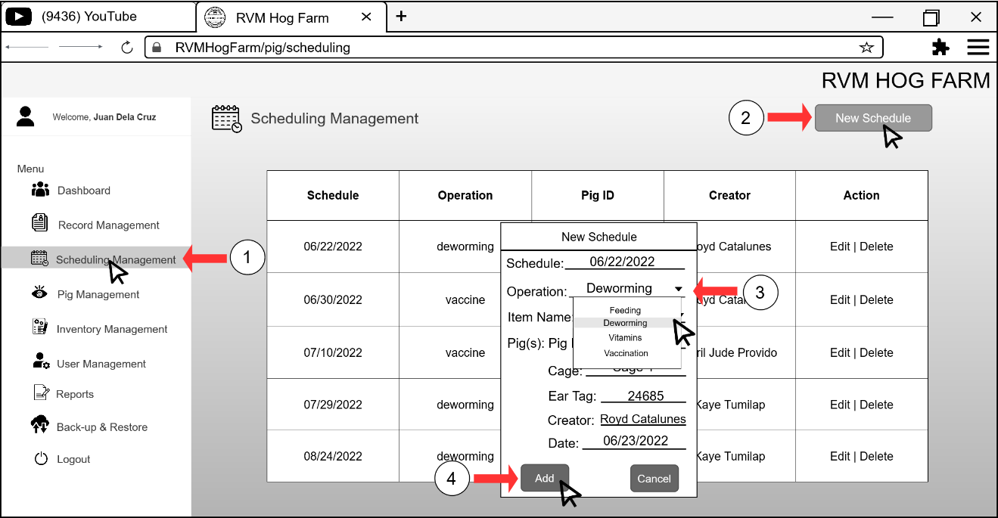

C

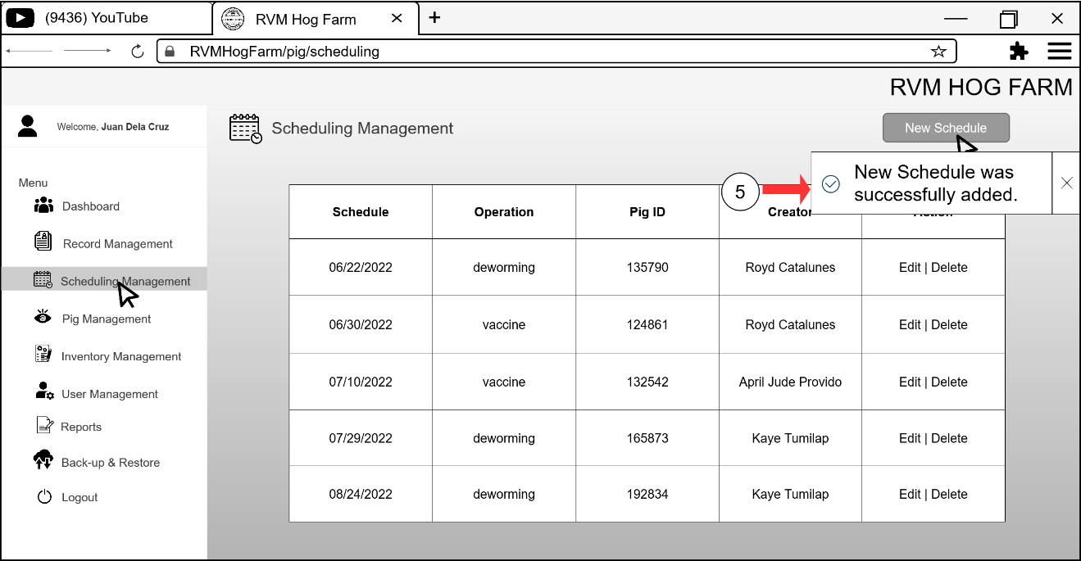

D

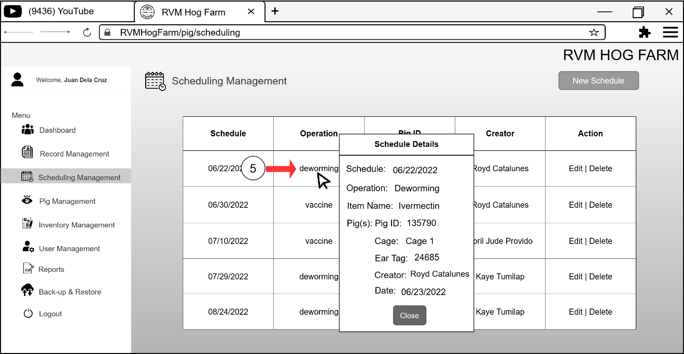

E

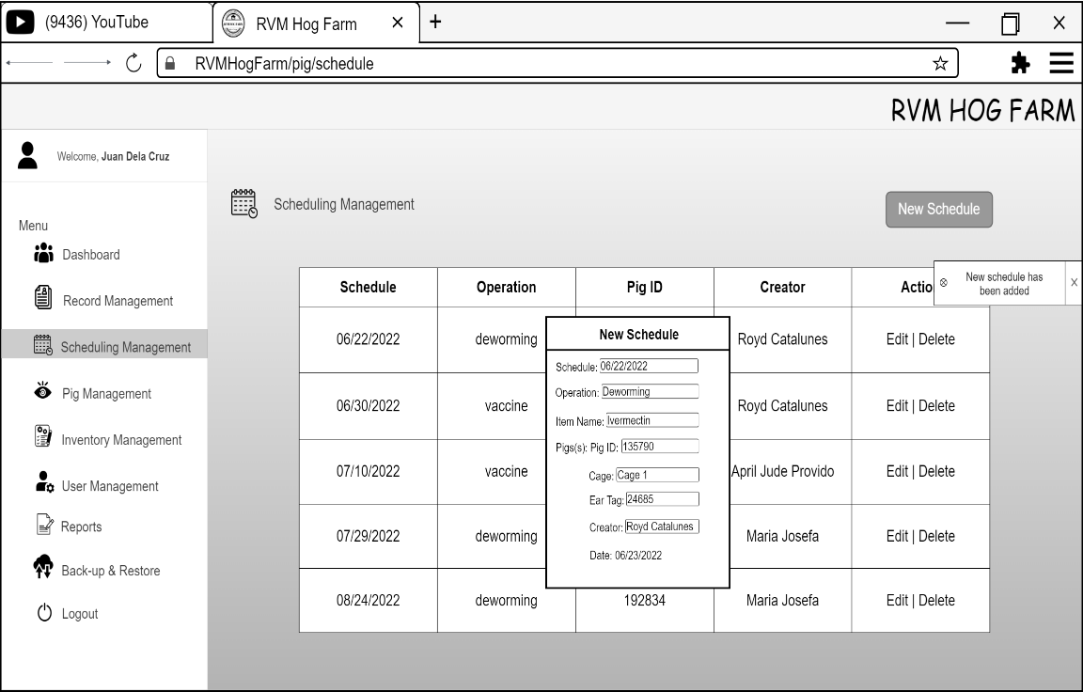



F

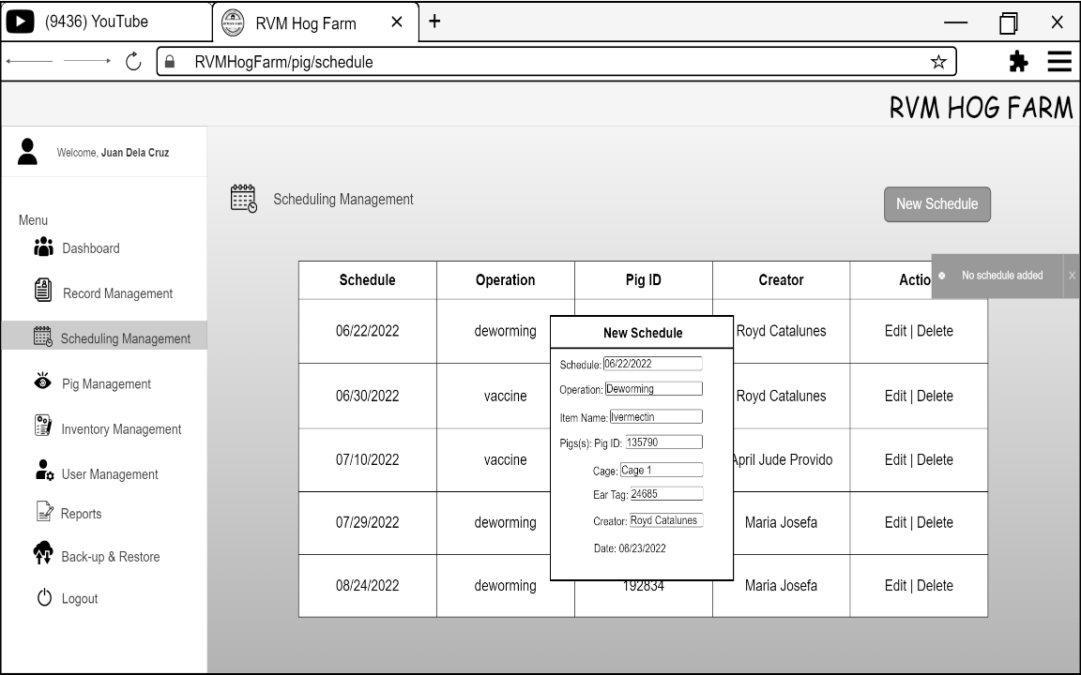

Figure 28A – F: Scheduling Management Module Interface Storyboard

Pig Management

This Pig management module allows the users to manage pig information through adding, modify, and viewing the information. This module will also create a QR code used as tags for pigs, a cage and batch management.

REQ08: The user shall be able to add pig information.

REQ09: The user shall be able to modify pig information.

REQ10: The user shall be able to view pig information.

REQ11: The user shall be able to create a QR code as which contains pig ID.

A

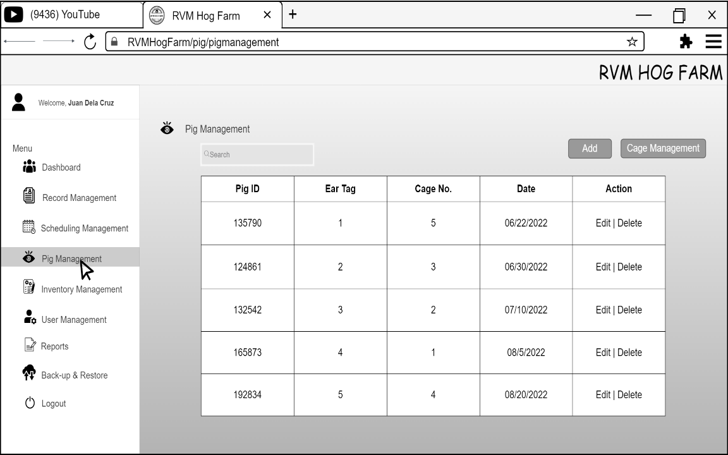



B

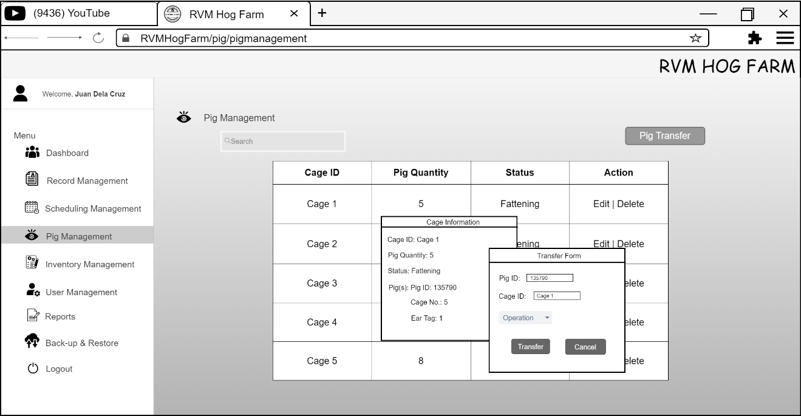

Figure 29A – B: Pig Management Module Interface Storyboard

Inventory Management

2

This Inventory management module allows the workers and owner to manage inventory farm supplies and other items used in hog farm. This module will also use measurement used by the product and can add purchase request to create a list for new items. Also, can send SMS Notification as a reminder to the owner about the remaining stocks.

REQ12: The user shall be able to add Purchase Request.

REQ13: The user shall be able to send SMS Notification to the owner as a reminder.

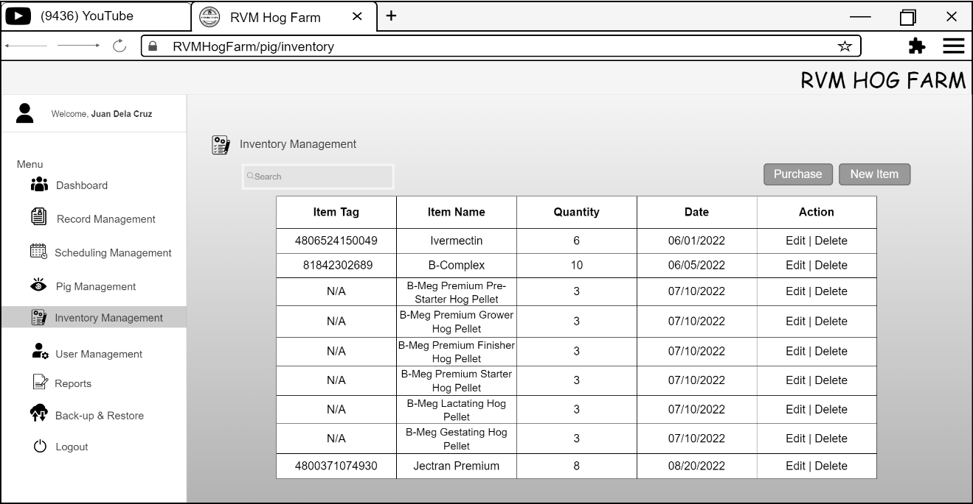

`

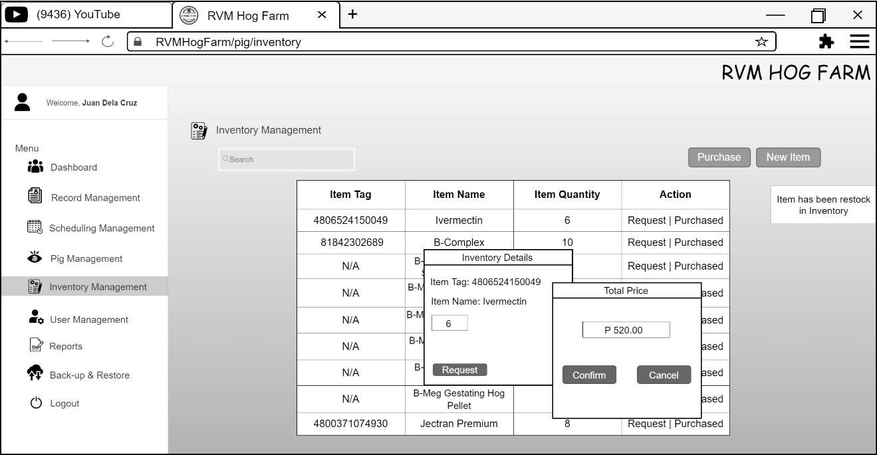

v





Figure 30A – B: Inventory Management Module Interface Storyboard

User Management

This User management module allows the administrator to modify and create user accounts that the workers and veterinarian will be using.

REQ14: The user shall be able to modify its password.

REQ15: The user shall be able to create user accounts.

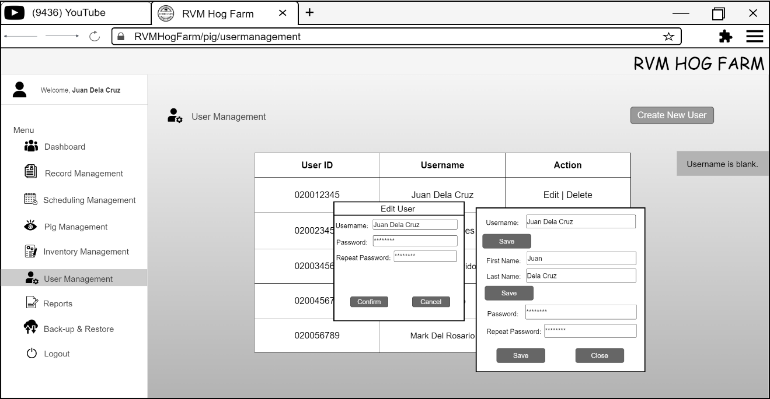











Figure 31A: User Management Module Interface Storyboard

Reports

This Reports module will be generating inventory, deworming, feeding, vaccination, and expenses reports and can be printed.

REQ16: The user shall be able to generate a report.

REQ17: The user shall be able to print a report.

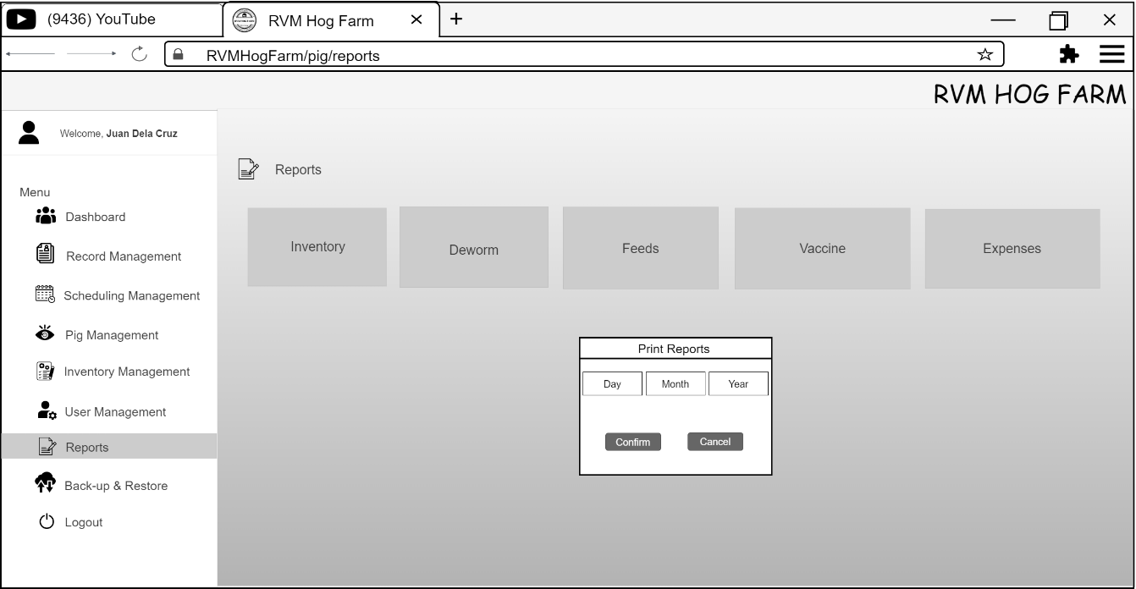







Figure 32A: Reports Module Interface Storyboard

Back-up & Restore

This Back-up and Restore module allow the administrator to manage the data stored in the database. This module will also enable the administrator to produce a backup copy and restore data if there is a primary data failure.

REQ18: The user shall be able to manage the database

REQ19: The user shall be able to produce backup copy and restore data if there is a primary data failure.

* 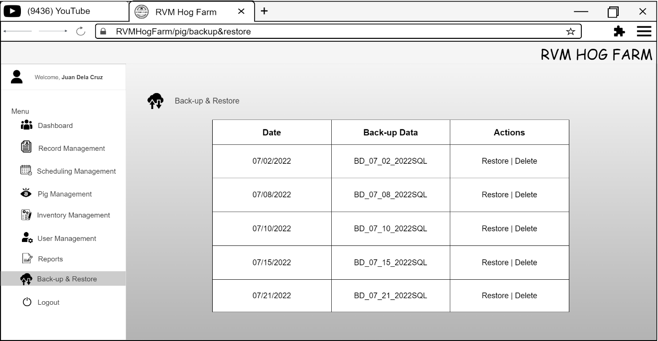



Figure 33A: Backup & Restore Module Interface Storyboard

The illustration below are the functional requirements of the proposed system mobile application.

Login

This Login module allows the user to authenticate and make sure that the authorized persons use the android application.

REQ20: The user shall be able to authenticate its account.

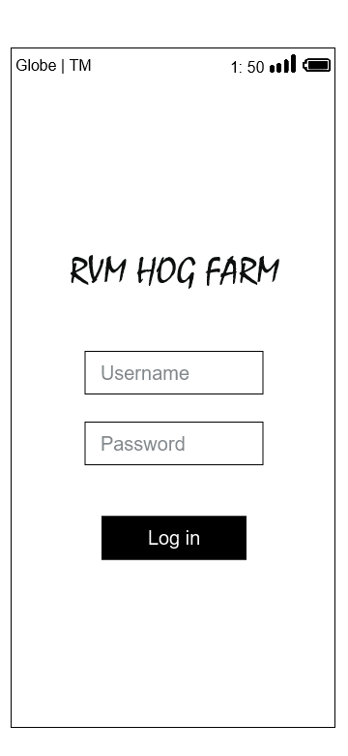



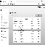



Figure 34A: Login Module Interface Storyboard

Dashboard

The Dashboard module provides an overview of the table of the hog farm statistics. This module will allow the user to view the total number of pigs, piglets and can scan using the QR code.

REQ21: The user shall be able to view the statistics in the table.

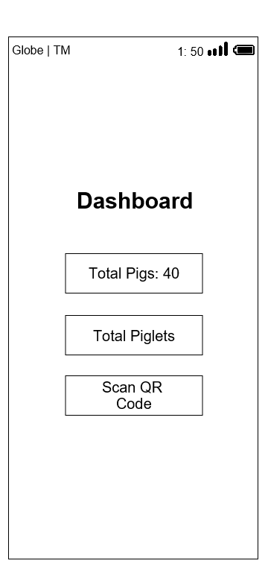







Figure 35A: Dashboard Module Interface Storyboard

QR Scan

The QR Scan module allows the user to scan the QR code tag of a pig. This module can retrieve information and display it in android application.

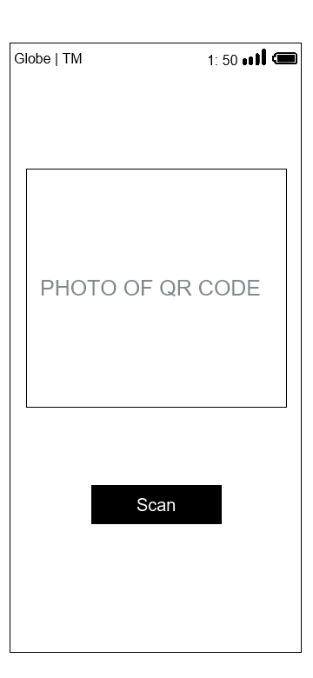REQ22: The user shall be able to scan QR code that can retrieve information

REQ23: The user shall be able to display information of the pigs.



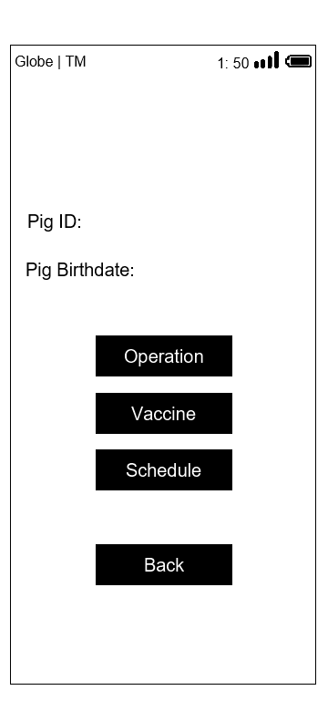







Figure 36A – B: QR Code Scanner Module Interface Storyboard

**Non-Functional Requirements**

The non-functional requirements are requirement that include the categories that are used to examine the operation of the system. It describes the measurement of the time spent in processing the web and mobile pages, its dependability in storing and retrieving data of the web application. Here are the non-functional requirements of Web-based Piggery Management System with Mobile-based QR Code Scanner for RVM Hog Farm in Lamba, Banga South Cotabato. Which includes the operational, performance, security, functionality, usability, reliability, efficiency, maintenance, and portability requirements.

**Web Application:**

**Operational Requirements**

REQ01: The web application will operate on all platforms with web browsers. Google Chrome and Mozilla Firefox are recommended browsers.

REQ02: The web application will operate to use printer for printing reports.

**Performance Requirements**

REQ03: The web application shall retrieve data in 3 to 8 seconds with stable internet connection of 100mbps.

REQ04: The web application shall upload 5000 data of pigs, sow, and boar within 5 minutes with stable internet connection of 100mbps.

**Security Requirements**

REQ05: Owner, workers, and veterinarian shall be able to use modules in the mobile application to scan and search pig information.

REQ06: The web application shall be able to provide user authentication and unauthorized users shall not be able to access the system so that the integrity and security of each user and the data must be maintained.

**Usability Requirements**

REQ07: The interface of website application is easy to use, rather than intimidating and demanding.

REQ08: The web application interface shall be a user friendly.

**Reliability Requirements**

REQ09: The web application shall be able to validate user input.

REQ10: The web application shall be able to recover all the data in the system.

**Efficiency Requirements**

REQ11: Website application modules shall be able to load in 5 seconds or less with stable internet connection of 100mbps.

REQ12: Back-up & restore data on the web application shall be able to load in 5 second or less with stable internet connection of 100mbps.

**Maintainability Requirements**

REQ13: The system database shall be able to back-up & restore data.

**Portability Requirements**

REQ14: The web application shall be able to be accessible to any operating system with latest browser. Google Chrome and Mozilla Firefox are recommended browsers.

**Mobile Application:**

**Operational Requirements**

REQ01: The mobile application shall be able to operate on all android devices with lollipop version 5.0-5.1.1 or higher versions

**Performance Requirements**

REQ02: The mobile application shall be able to retrieve data in 3 to 8 seconds with stable internet connections of 100mbps.

**Security Requirements**

REQ03: Owner, workers, and veterinarian shall be able to use modules in the mobile application to scan and search pig information.

REQ04: The mobile application shall be able to provide data security and unauthorized users shall not be able to access the system so that the integrity and security of each user and the data must be maintained.

**Usability Requirements**

REQ05: The interface of website and mobile application appears easy to use, rather than intimidating and demanding.

REQ06: The mobile application interface shall be a user friendly.

**Reliability Requirements**

REQ07: The mobile application shall be able to validate user input.

REQ08: The mobile application scanner shall be able to scan QR code.

**Efficiency Requirements**

REQ09: Mobile application modules shall be able to load in 5 seconds or less with stable internet connection of 100mbps.

REQ10: Retrieving data on the mobile application shall be able to load in 5 seconds or less with stable internet connection of 100mbps.

**Maintainability Requirements**

REQ11: The maintenance time of mobile application shall not take up to 24 hours every month.

**Portability Requirements**

REQ12: The mobile application shall be able to be accessible to any android devices with lollipop version 5.0-5.1.1 or higher versions.

Design of Software, Systems, Product, and/or Process

This chapter describes the conceptual framework in developing the Web-based Piggery Management System with Mobile-based QR Code Scanner for RVM Hog Farm in Lamba, Banga South Cotabato. This chapter presented in the review related literature and methodology that are used to design the conceptual framework of this current study. The proponents used the Input-Process-Output Model (IPO Model) Conceptual Framework, and the Three-Tier Model Systems Architecture to develop the proposed system.

Conceptual Framework

The figure below presents the conceptual framework of the Web-based Piggery Management System with Mobile-based QR Code Scanner for RVM Hog Farm in Lamba, Banga South Cotabato. It illustrates based on Input-Process-Output Model or IPO Model.

Input

Below is the input phase or the system requirements that consists of the following:

* **User Requirements** – the Web-based Piggery Management System allows the owner, workers, and veterinarian to create user account in managing the farm.
* **Back-end Requirements** – in developing the Web-based Piggery Management System with Mobile-based QR Code Scanner for web application, PHP or the Hypertext Preprocessor to create a dynamic webpage. The tailwind CSS framework is used in UI development that would give a flexibility and productivity when it comes to the design. For the mobile application, Java programming language with Android Studio IDE which is the current latest IDE version is used in developing the system. Also, XZing QR Code Library or called Zebra Crossing used to read or scan QR Code and Camera X library make camera app development easy.
* **Database Requirements** – the Digital Ocean VPS with installed software like Apache to run the web-based system and act as API end point for the mobile application to access data and MySQL Database service to store data that are needed for the system.
* **Front-end Requirements** – the Web-based Piggery Management System with Mobile-based QR Code Scanner uses QRCode.js to create QR Code with unique identifier and can be save and printed when needed and the Twilio SMS API an Application Program Interface use to send text message automatically.
* **Hardware Requirements** – the Web-based Piggery Management System with Mobile-based QR Code Scanner uses monitor, processor/CPU faster Intel or AMD processor, and hard disk space with HDD or SSD for web application. For mobile application, memory (RAM) with 4GB RAM or higher, (ROM) 8GB ROM or higher, storage and display.
* **Software Requirements** - the Web-based Piggery Management System with Mobile-based QR Code Scanner uses Operating System (OS) any OS that supports web browser and a browser include Google Chrome and Mozilla Firefox for web applications. For mobile application, it uses Operating System (OS) Lollipop version 5.0 - 5.1.1 or higher versions.

**Process**

The process uses the Agile Software Development Life Cycle which consists of the following phases in developing a system:

* **Planning** – the proponents introduced the proposed system.
* **Requirement Analysis** – the proponents analyzed the user’s input and output procedure and flow of the data of the proposed system.
* **Documentation** – the proponents analyzed the proposed system processes and problem experience and create a technical document for the proposed system.
* **Design** – the developers analyzed the functional and non-functional requirement of the proposed system and the design for the web and mobile interface.
* **Coding** – the developers begin to develop the web and mobile application.
* **Unit Testing** – the developers tested the modules of the proposed system, debugs the software, and ensures the functions of the system.
* **Alpha Testing** – the developers finalize the development of the system web and mobile application, test the system, implement, and deploy the system.

**Output**

In conclusion, the final output of the system or the system implementation of this study is the Web-based Piggery Management System with Mobile-based QR Code Scanner for RVM Hog Farm in Lamba, Banga South Cotabato will change the paper and pen process of recording and monitoring of the RVM Hog Farm.

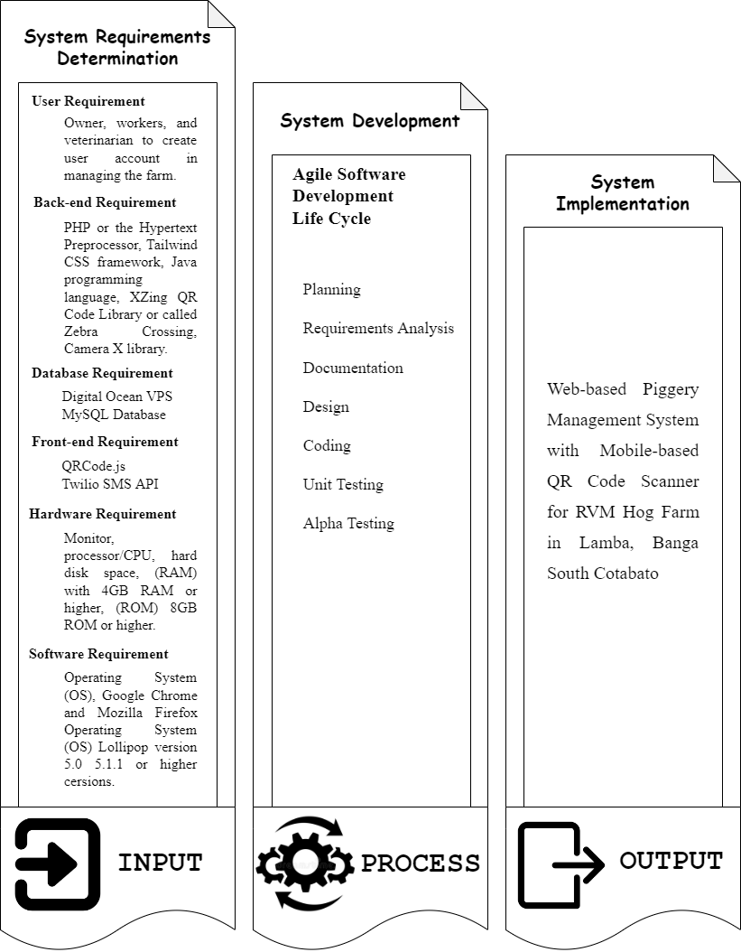

Figure 37: Conceptual Framework

System Architecture

The illustration below shows system architecture of the Web-based Piggery Management System with Mobile-based QR Code Scanner for RVM Hog Farm in Lamba, Banga South Cotabato. Based on the Three-Tier Architecture model it consists of presentation tier, web tier and database tier. The Web-based Piggery Management System with Mobile-based QR Code Scanner for RVM Hog Farm in Lamba, Banga South Cotabato is composed of two user types: web user and the android user.

Presentation Tier

The web user screen is composed of the following interfaces:

* Login
* Dashboard
* User Management
* Pig Management
* Inventory Management
* Scheduling Management
* Record Management
* Reports
* Backup & Restore

The android user screen is composed of the following interfaces:

* Login
* Dashboard
* QR Scan

Application Tier

The web user screen is composed of the following data:

* Users – manages the authentication and authorization of the users from login interface system. It manages the CRUD operation for the web user account.
* User Management – manages the CRUD operation for creating user accounts.
* Pig Management – manages the CRUD operation in managing the pig information.
* Inventory Management – manages the CRUD operation in managing the inventory of the hog farm supplies.
* Scheduling Management – manages the CRUD operation for creating a schedule of operation of the pig.
* Record Management – manages the CRUD operation for the records of giving a vaccine, deworm, feeds, medicine, and the stock records in inventory.
* Reports – generates a report regarding to the operation that has done in the farm.
* Back-up & restore – manages the CRUD operation in retrieving and delete data.

Database Tier

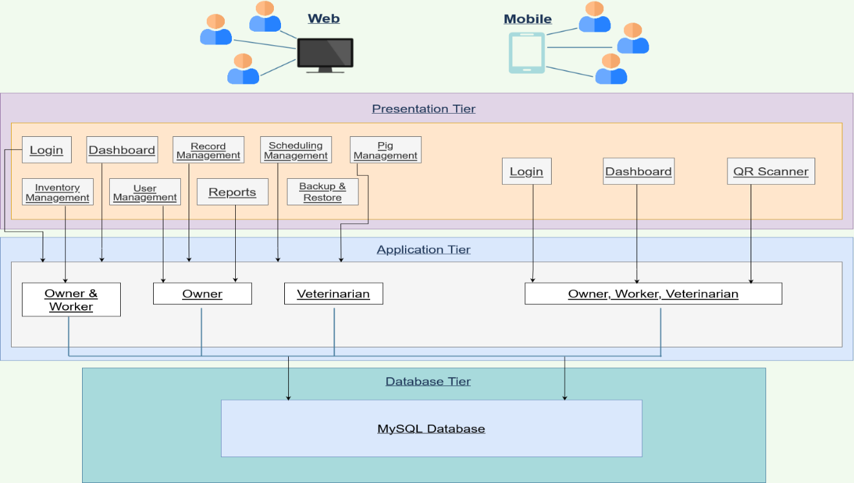

Figure 38: System Architecture of the Web-Based Piggery Management System

Object Modeling

This section places the use case model and activity diagrams for every interaction of the owner, worker, and veterinarian to the Web-based Piggery Management System with Mobil-based QR Code Scanner for RVM Hog Farm in Lamba, Banga South Cotabato.

The following illustration presents the Web-based Piggery Management System with Mobil-based QR Code Scanner for RVM Hog Farm in Lamba, Banga South Cotabato use case model and activity diagrams for each web application modules.

Login Module

|  |  |  |
| --- | --- | --- |
| Use Case | Description | User/Actor (Roles) |
| Username | The user enters the registered username. | Owner, Worker, and Veterinarian |
| Password | The user enters the registered password. | Owner, Worker, and Veterinarian |

Table 6: Event Decomposition of the Piggery Management System Login Module

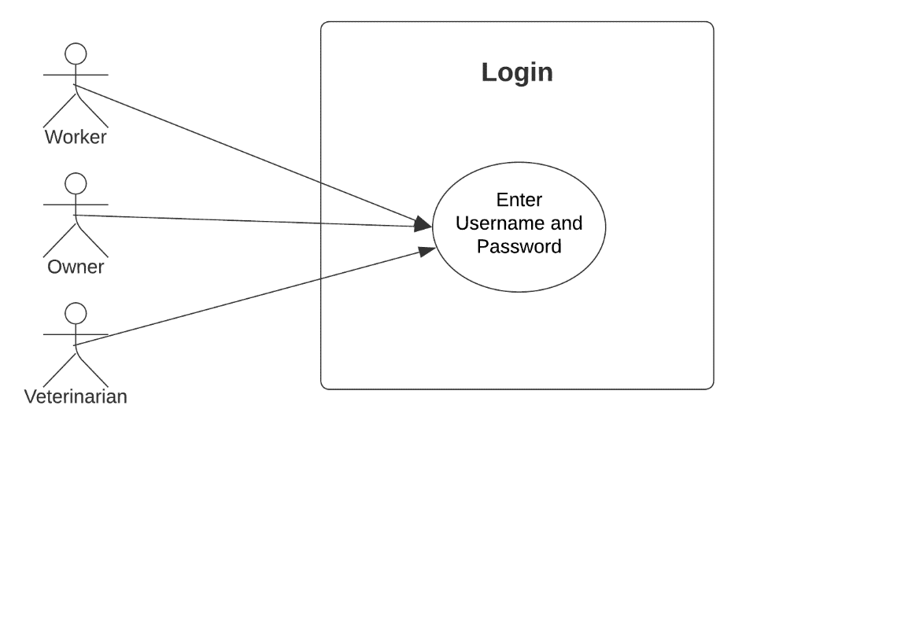

Figure 39: Use Case Diagram involving the Owner, Worker, and Veterinarian of Piggery Management System Login Module

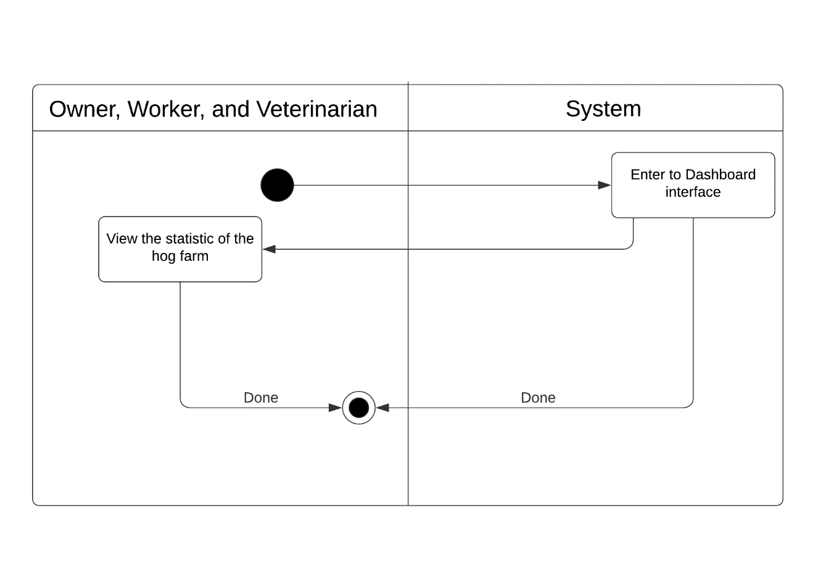

Figure 40: Activity Diagram of Web-based Piggery Management System Login Module Use Case

Dashboard Module

|  |  |  |
| --- | --- | --- |
| Use Case | Description | User/Actor (Roles) |
| Enter and view dashboard interface | The user enters the dashboard after logging in to the system and views the dashboard interface. | Owner, Worker, and Veterinarian |

Table 6: Event Decomposition of the Piggery Management System Dashboard Module

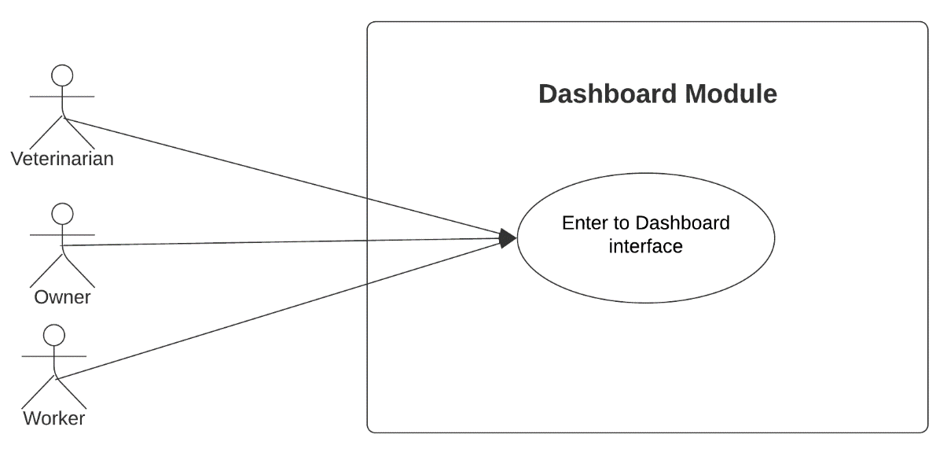

Figure 41: Use Case Diagram involving the Owner, Worker, and Veterinarian of Piggery Management System Dashboard Module

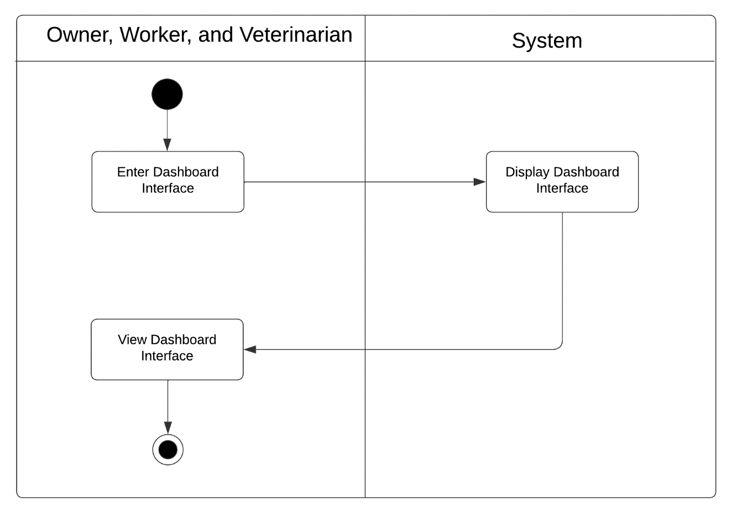

Figure 42: Activity Diagram of Web-based Piggery Management System Dashboard Module Use Case

Manage Feeding Module

|  |  |  |
| --- | --- | --- |
| Use Case | Description | User/Actor (Roles) |
| Add feeding information | The user selects the new operation button to add new feeding information. | Owner, Workers, Veterinarian |
| Search feeding information | The user selects search button to search feeding information. | Owner, Workers, Veterinarian |
| Update feeding information | The user selects the update button to update the feeding operation that are already exist. | Owner, Workers, Veterinarian |
| View feeding information | The user selects the view feeding operation details to view the feeding operations. | Owner, Workers, Veterinarian |

Table 7: Event Decomposition of the Piggery Management System Manage Feeding Module

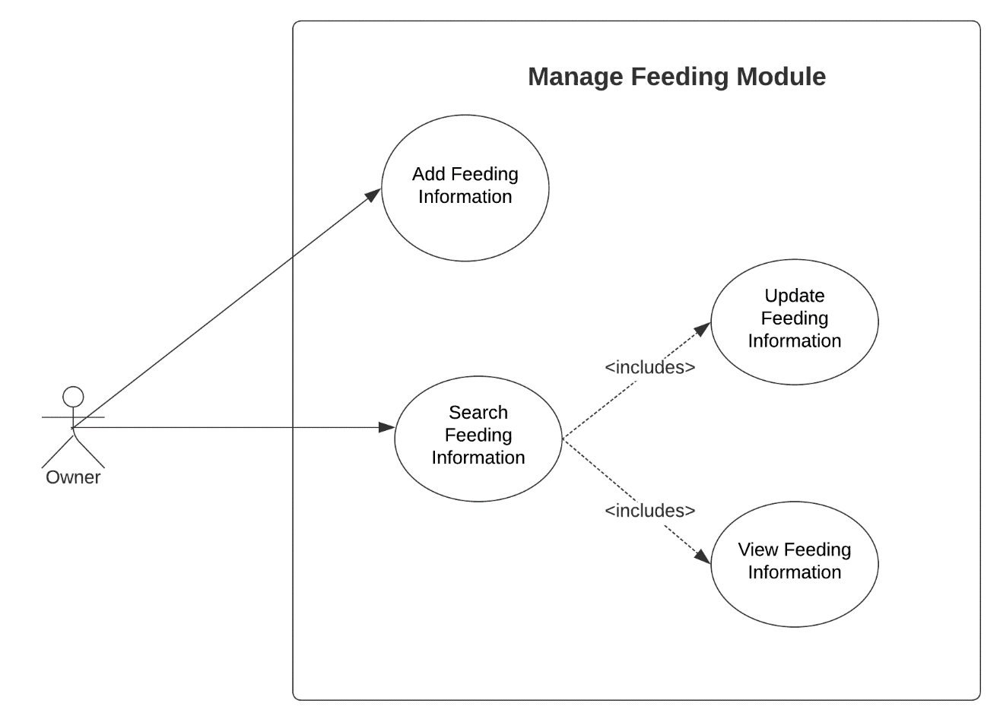

Figure 43: Use Case Diagram involving the Owner of Piggery Management System Manage Feeding Module

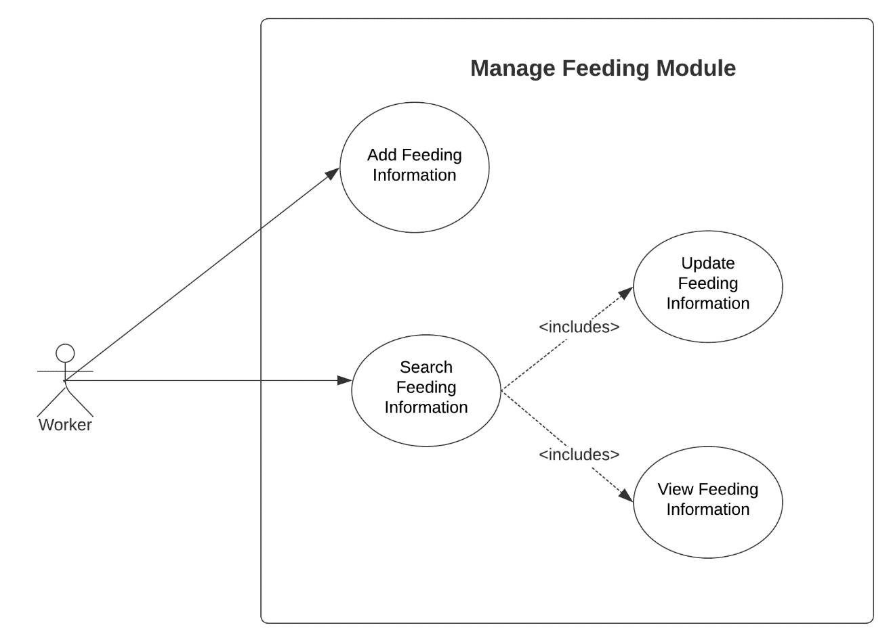

Figure 44: Use Case Diagram involving the Worker of Piggery Management System Manage Feeding Module

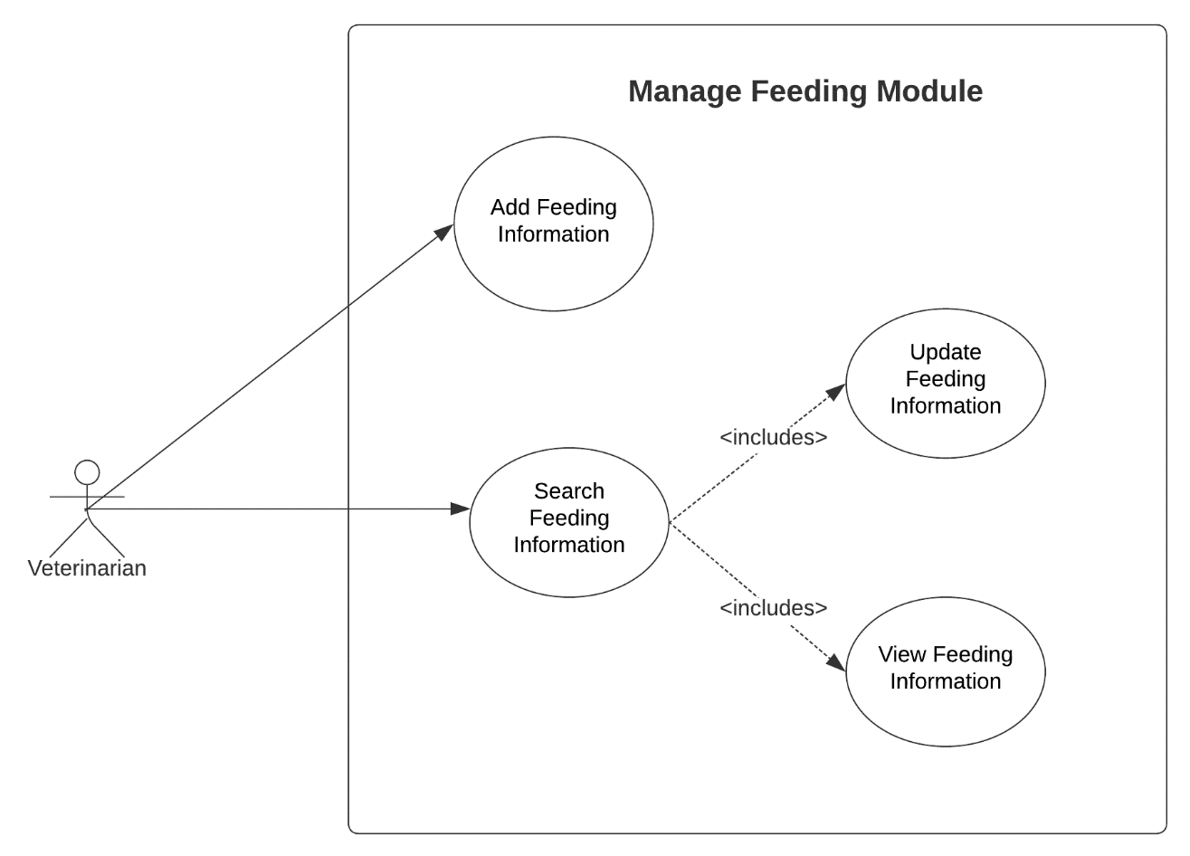

Figure 45: Use Case Diagram involving the Veterinarian of Piggery Management System Manage Feeding Module

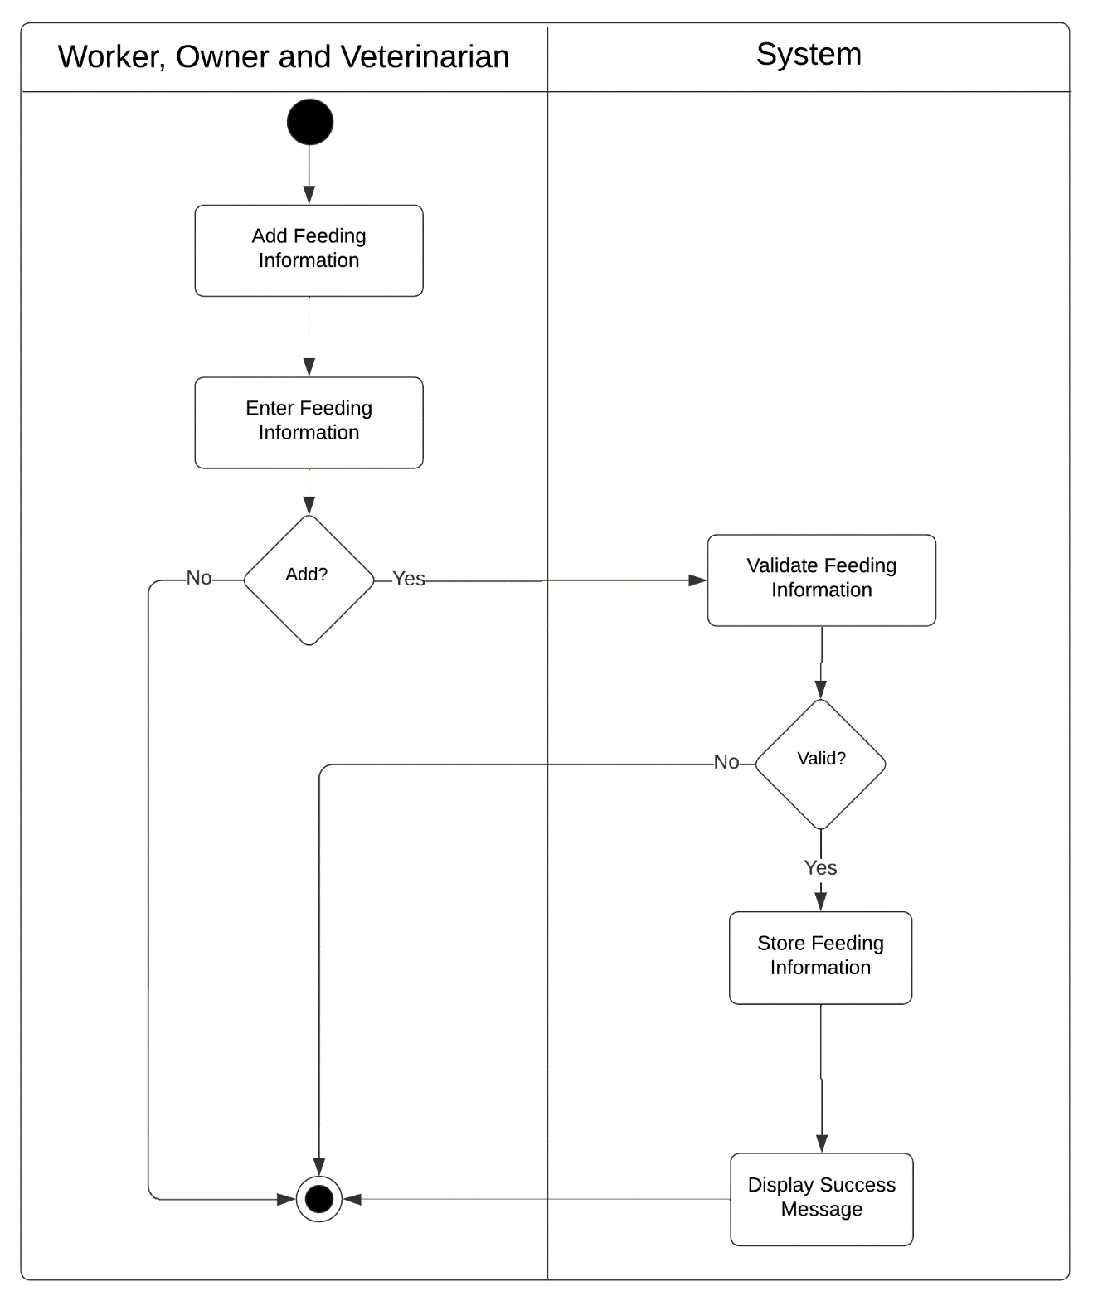

Figure 46: Activity Diagram of Web-based Piggery Management System Add Feeding Information Module Use Case

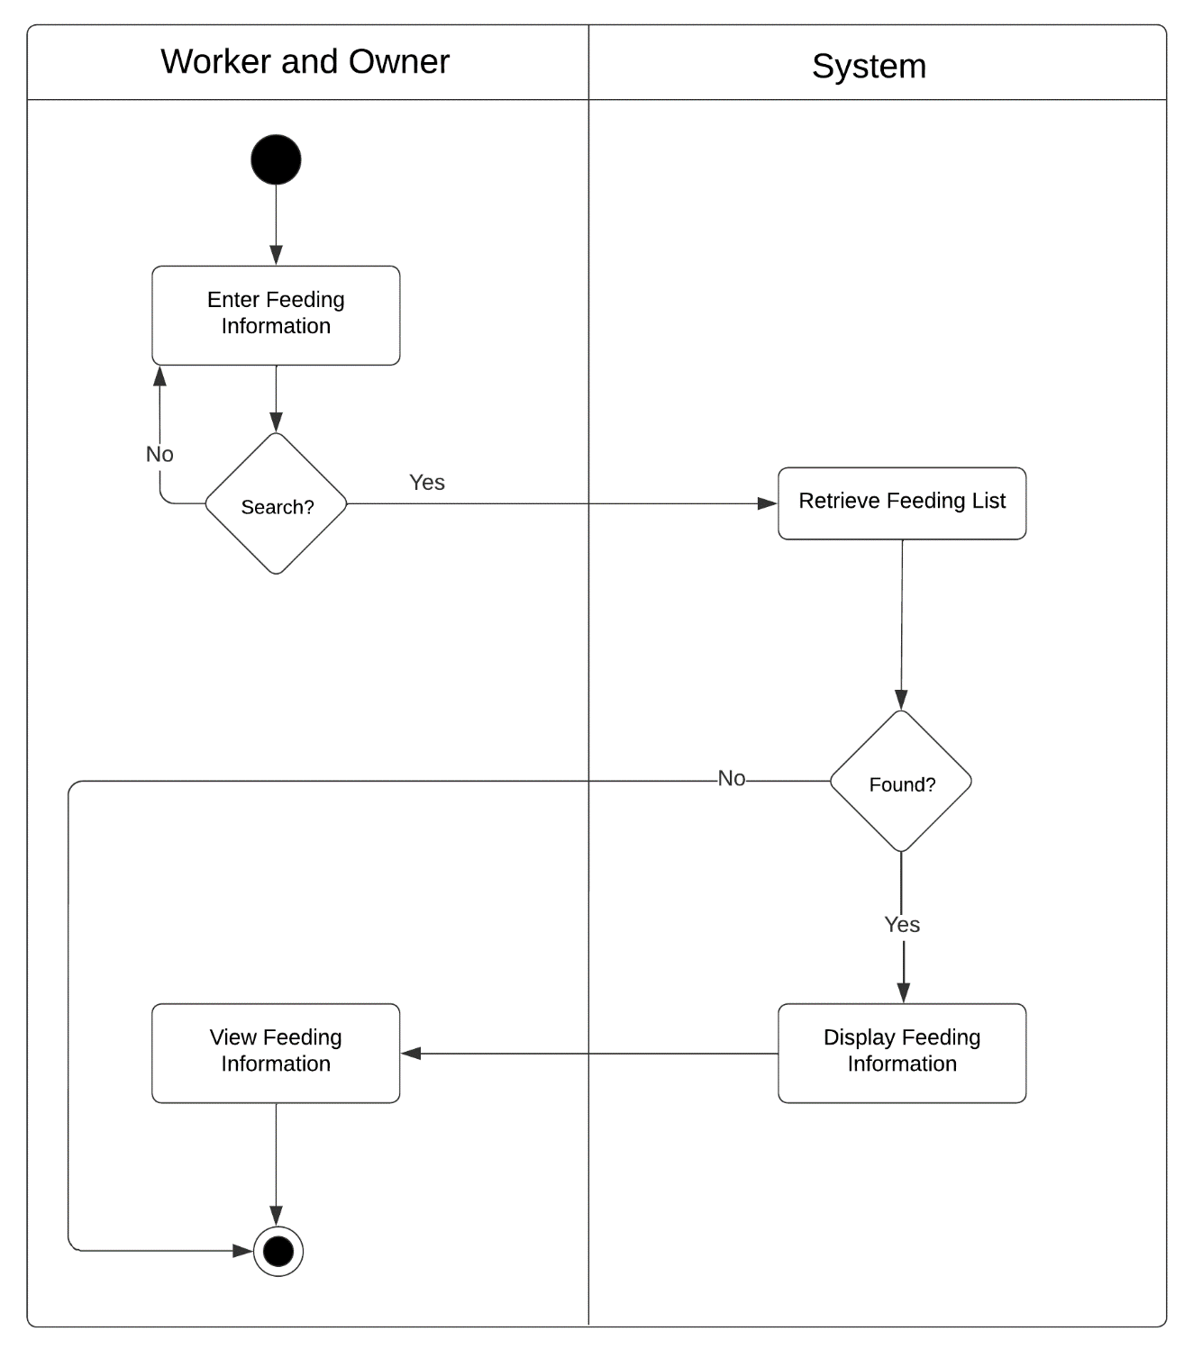

Figure 47: Activity Diagram of Web-based Piggery Management System Search Feeding Information Module Use Case

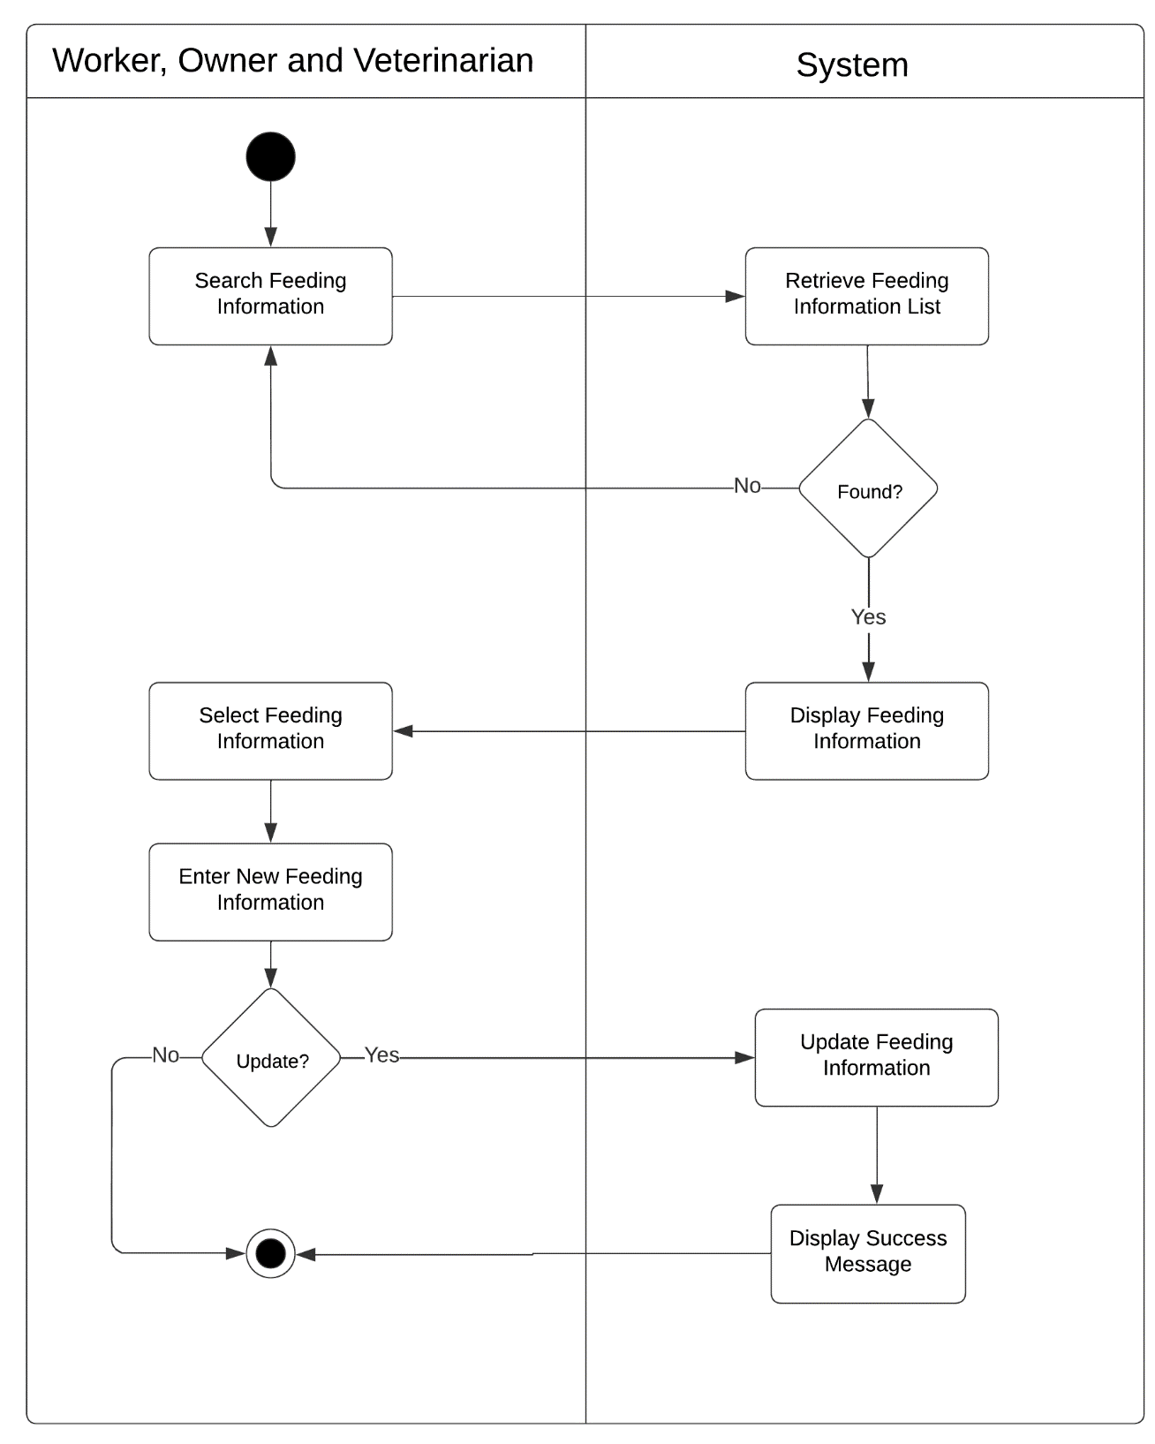

Figure 48: Activity Diagram of Web-based Piggery Management System Update Feeding Information Module Use Case

Manage Vaccination Module

|  |  |  |
| --- | --- | --- |
| Use Case | Description | User/Actor (Roles) |
| Add vaccination information | The user selects the new vaccination button to add new operation. | Owner, Workers, Veterinarian |
| Search vaccination information | The user selects the search button to search vaccination operation. | Owner, Workers, Veterinarian |
| Update vaccination information | The user selects the update vaccination operation button to update the operation that are already exist. | Owner, Workers, Veterinarian |
| View vaccination information | The user selects the view vaccination operation details to view vaccination details. | Owner, Workers, Veterinarian |

Manage Vaccination Module

Table 8: Event Decomposition of the Piggery Management System Manage Vaccination Module

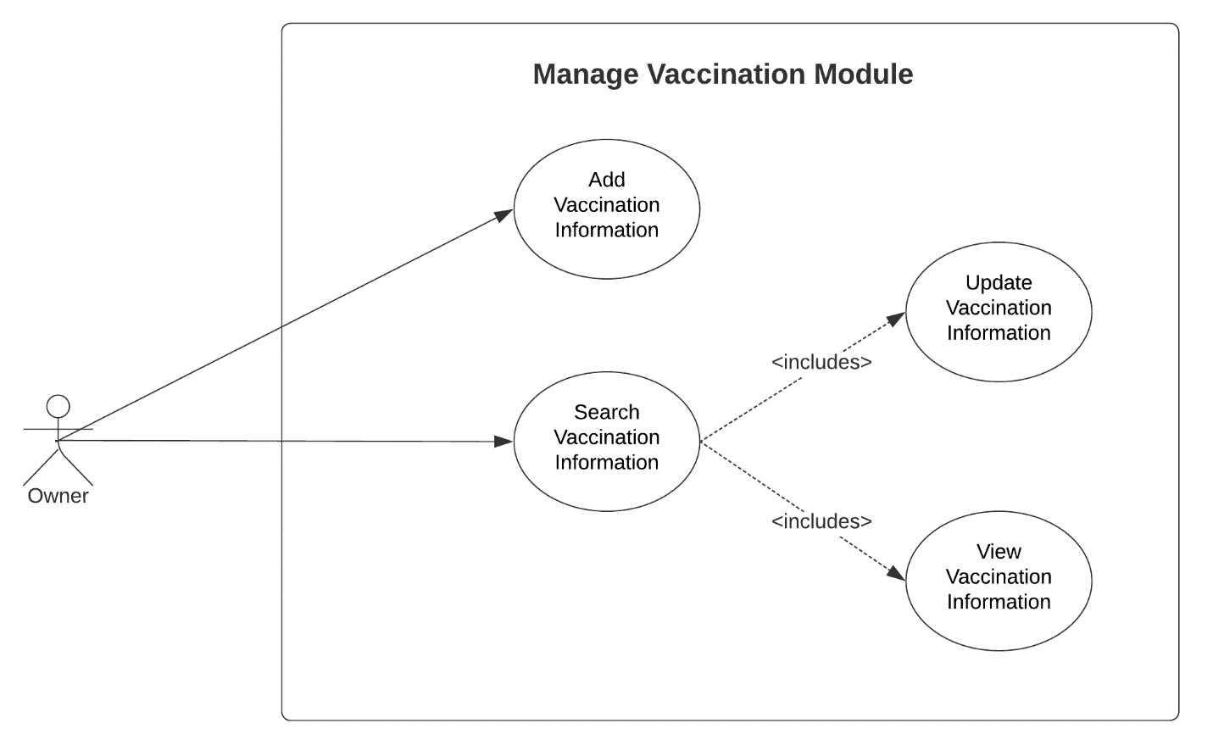

Figure 49: Use Case Diagram involving the Owner of Piggery Management System Manage Vaccination Module

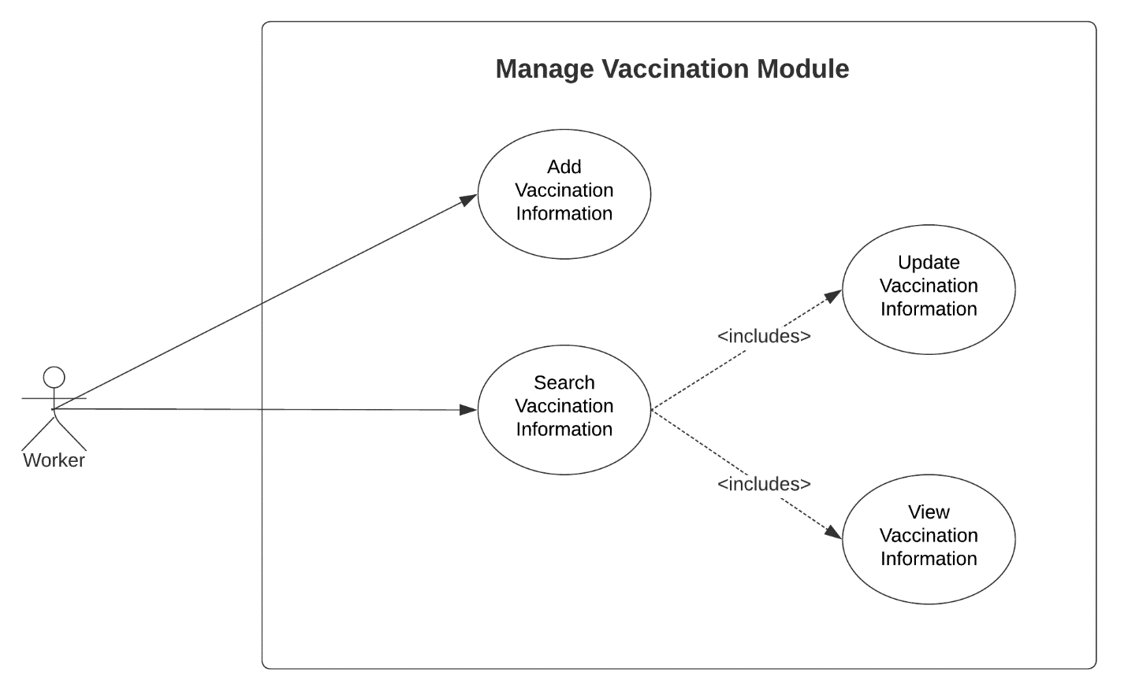

Figure 50: Use Case Diagram involving the Worker of Piggery Management System Manage Vaccination Module

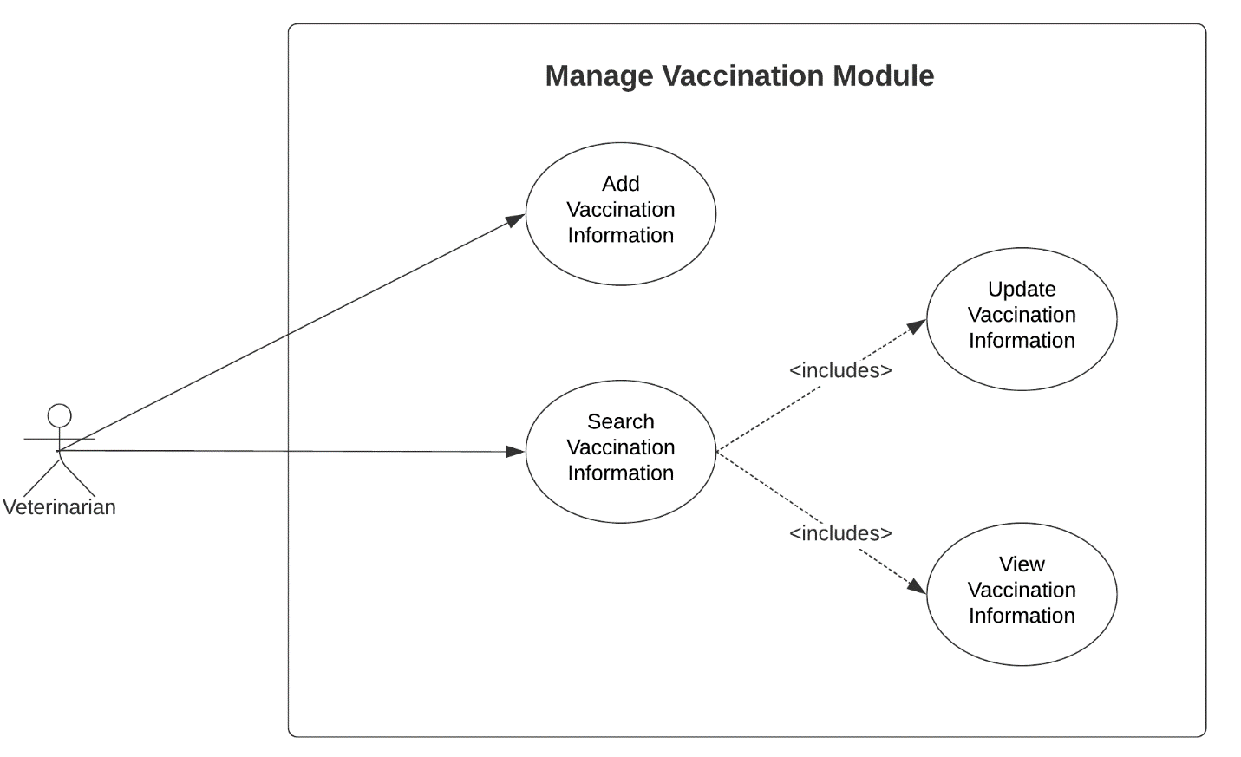

Figure 51: Use Case Diagram involving the Veterinarian of Piggery Management System Manage Vaccination Module

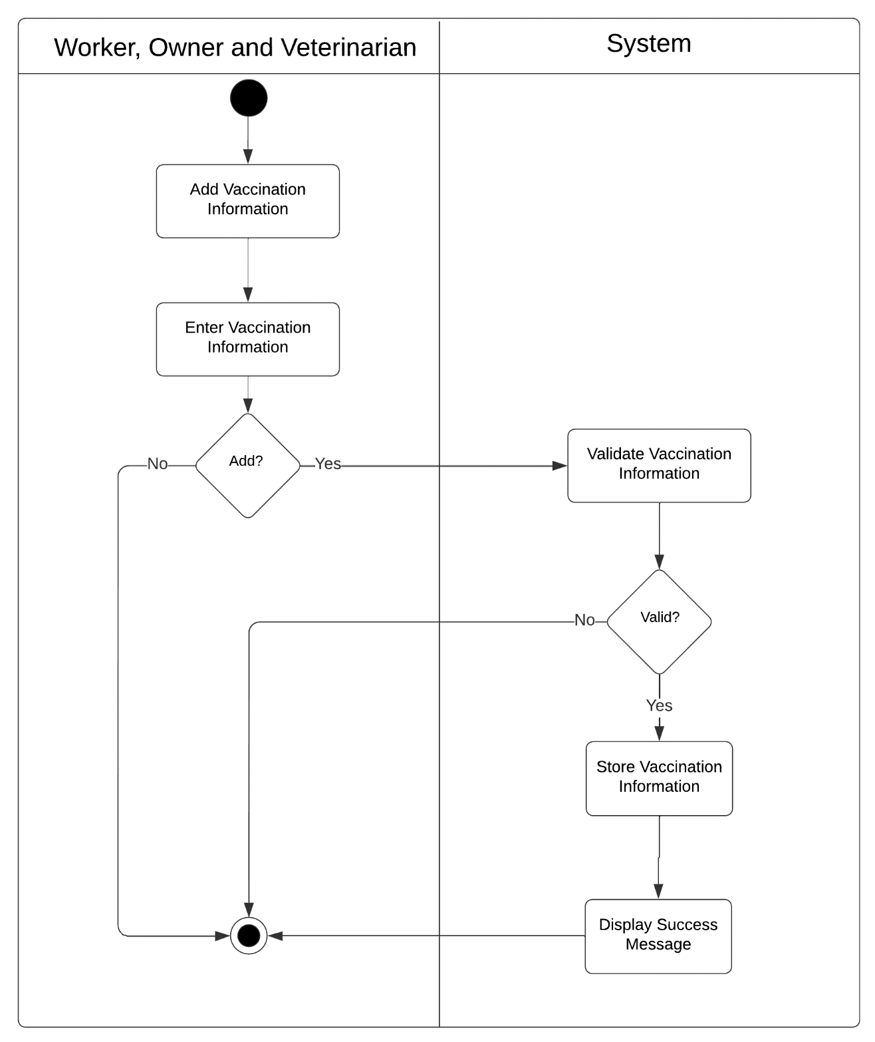

Figure 52: Activity Diagram of Web-based Piggery Management System Add Vaccination Information Module Use Case

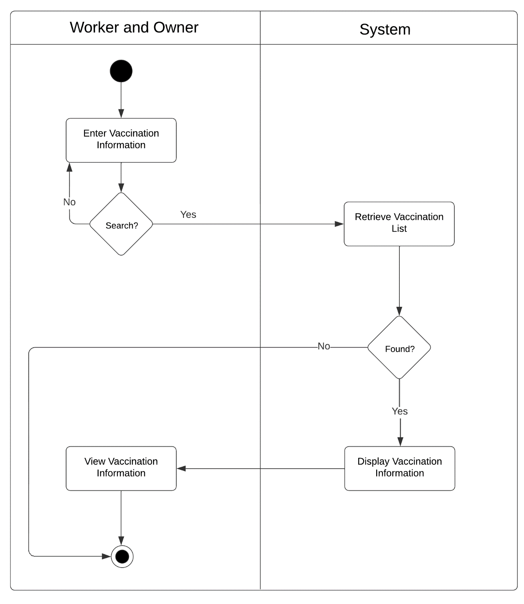

Figure 53: Activity Diagram of Web-based Piggery Management System Search Vaccination Information Module Use Case

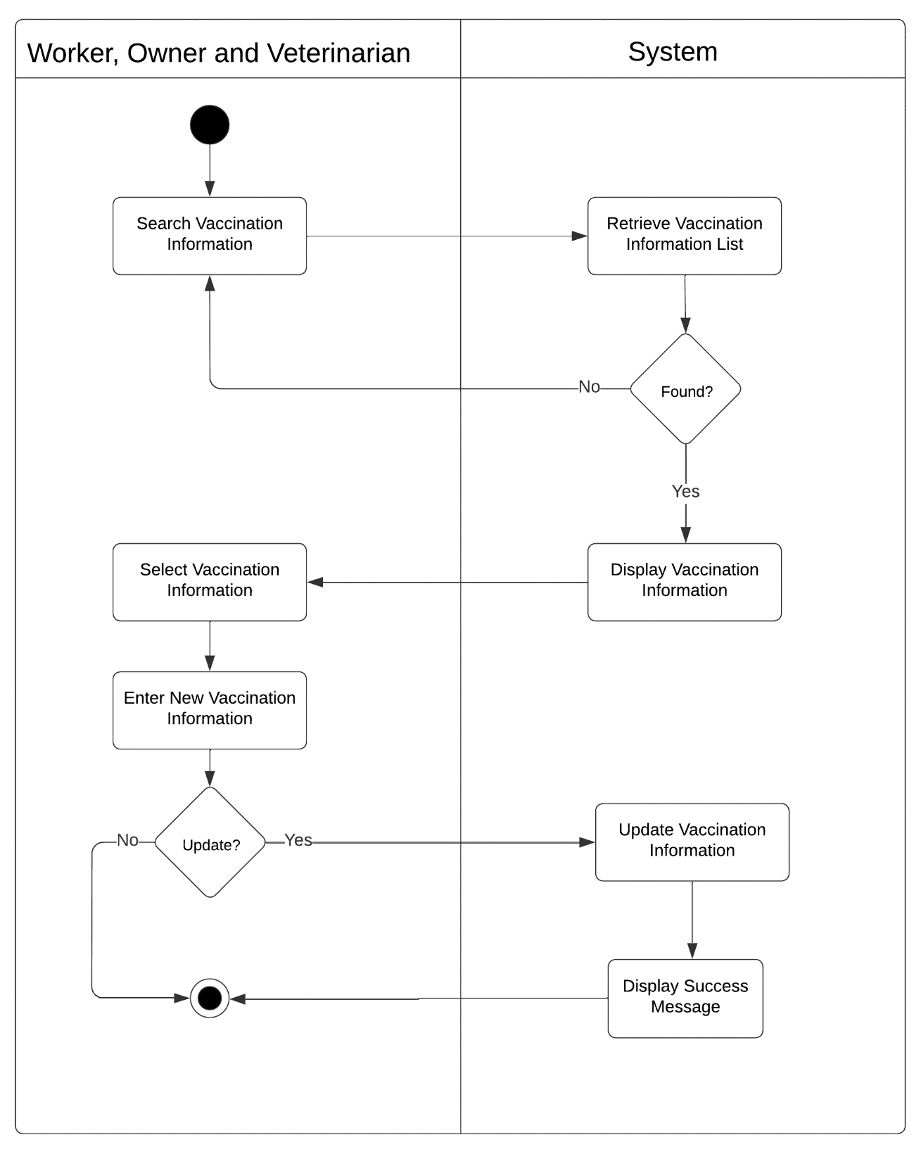

Figure 54: Activity Diagram of Web-based Piggery Management System Update Vaccination Information Module Use Case

Manage Deworming Module

|  |  |  |
| --- | --- | --- |
| Use Case | Description | User/Actor (Roles) |
| Add deworming information | The user selects the new deworming button to add new deworming operation. | Owner, Workers, Veterinarian |
| Search deworming information | The user selects search field to search deworming information. | Owner, Workers, Veterinarian |
| Update deworming information | The user selects the update deworming operation to update the operation that are already exist. | Owner, Workers, Veterinarian |
| View deworming information | The user selects the view deworming operation to view the deworming details. | Owner, Workers, Veterinarian |

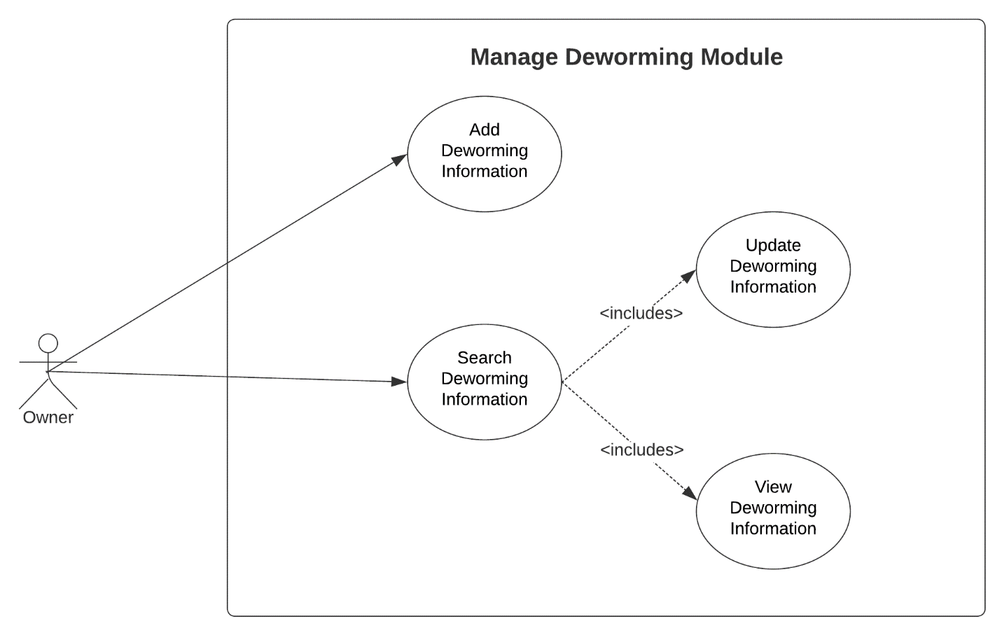Table 9: Event Decomposition of the Piggery Management System Manage Deworming Module

Figure 55: Use Case Diagram involving the Owner of Piggery Management System Manage Deworming Module

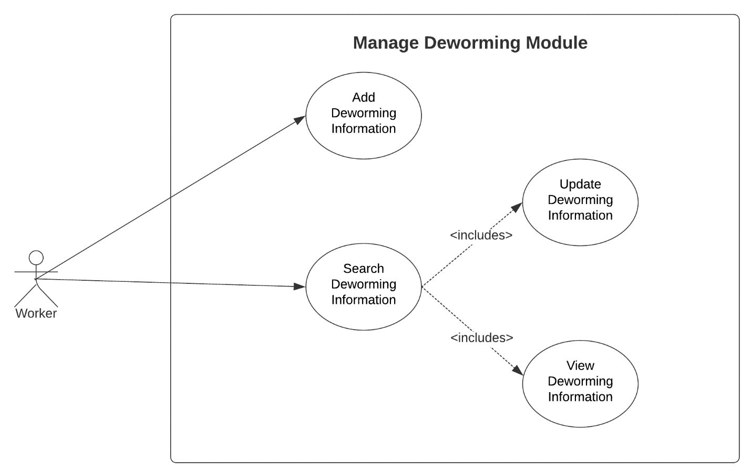

Figure 56: Use Case Diagram involving the Worker of Piggery Management System Manage Deworming Module

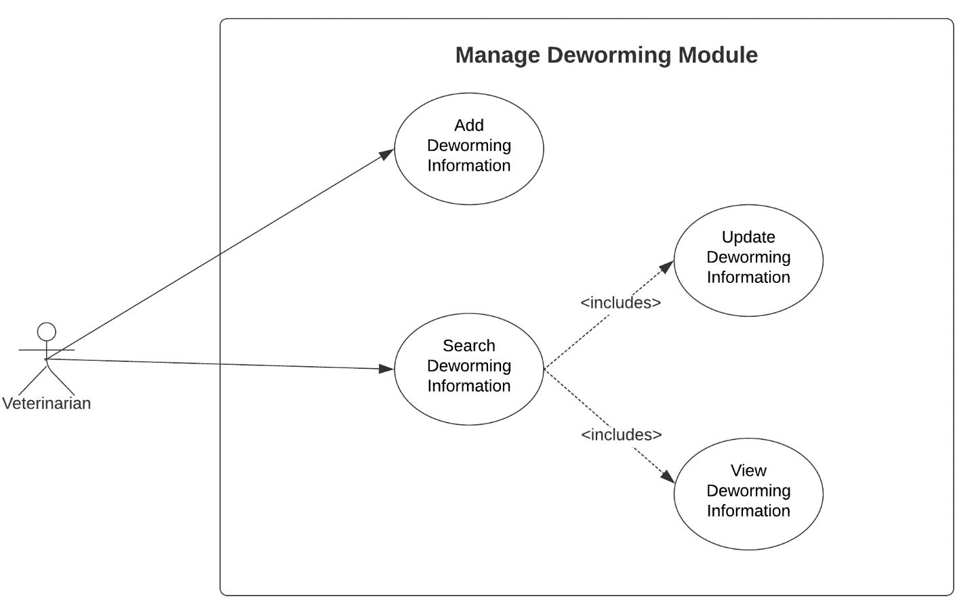

Figure 57: Use Case Diagram involving the Veterinarian of Piggery Management System Manage Deworming Module

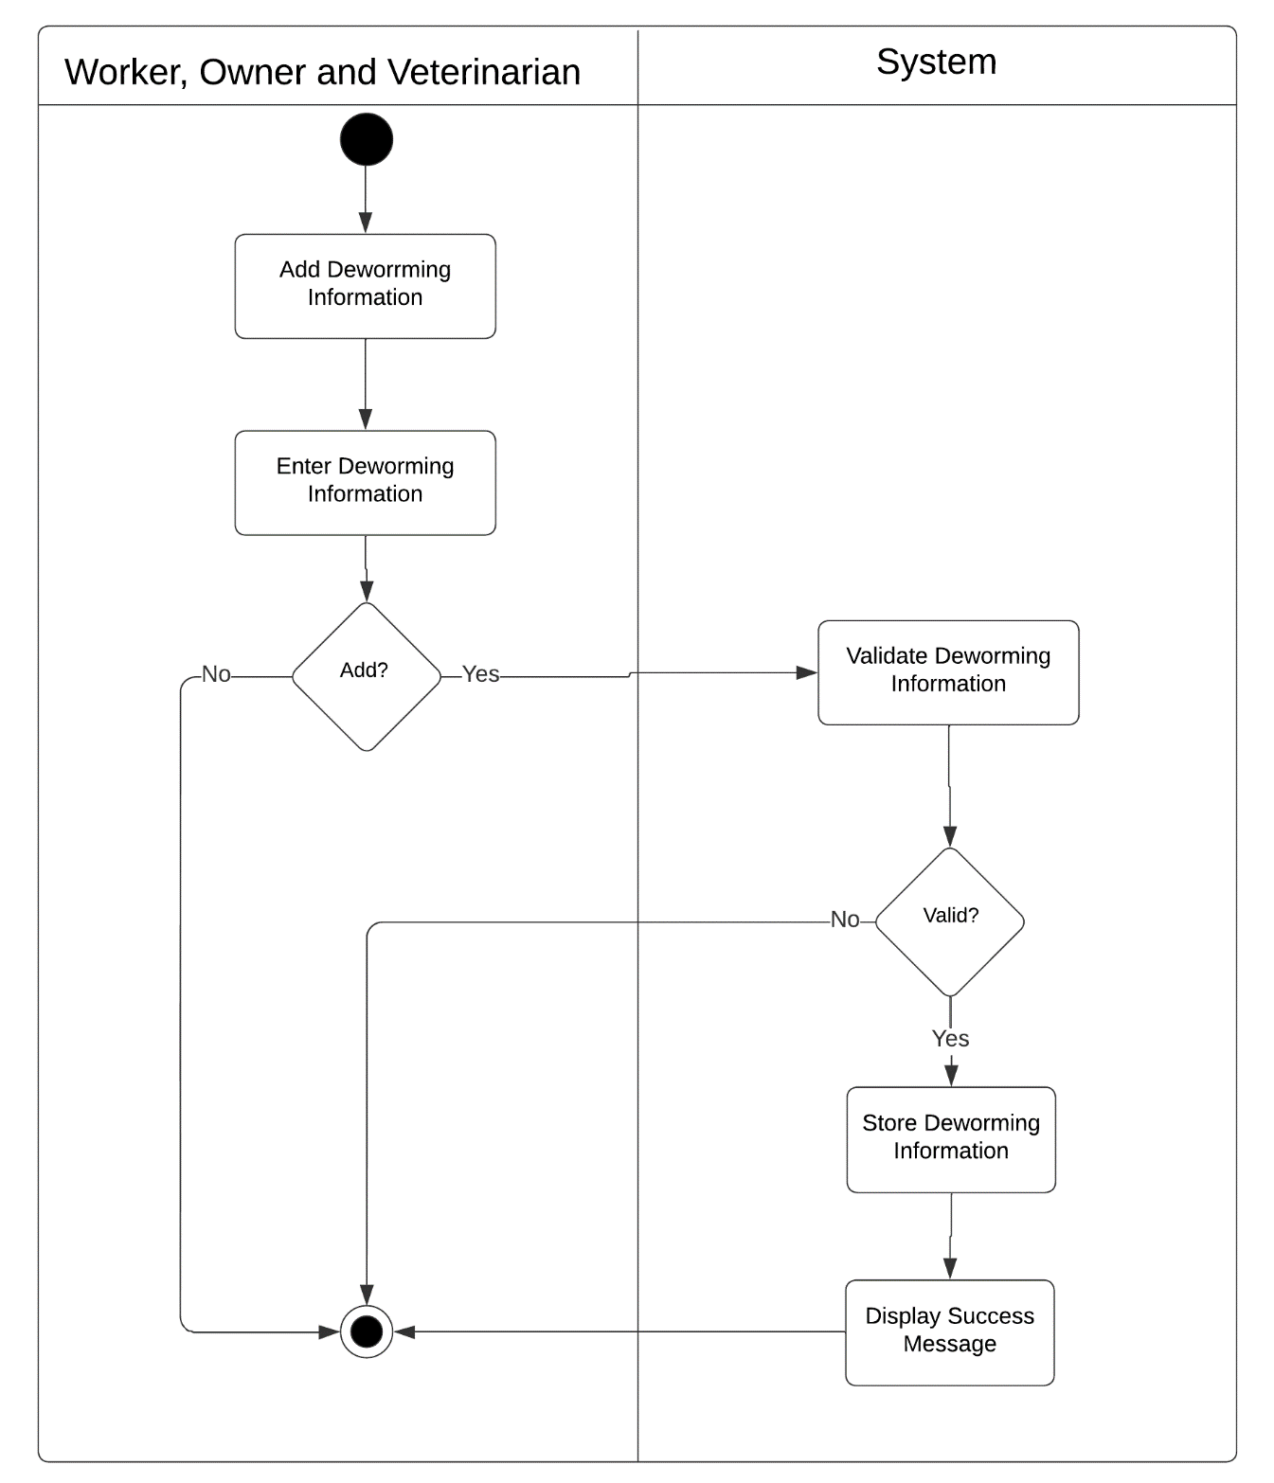

Figure 58: Activity Diagram of Web-based Piggery Management System Add Deworming Information Module Use Case

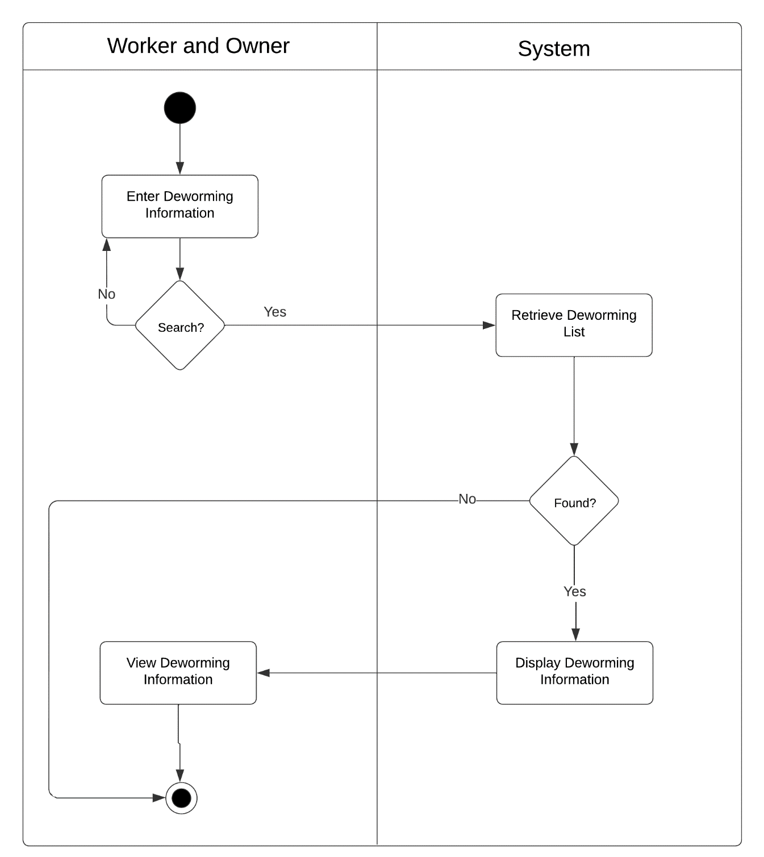

Figure 59: Activity Diagram of Web-based Piggery Management System Search Deworming Information Module Use Case

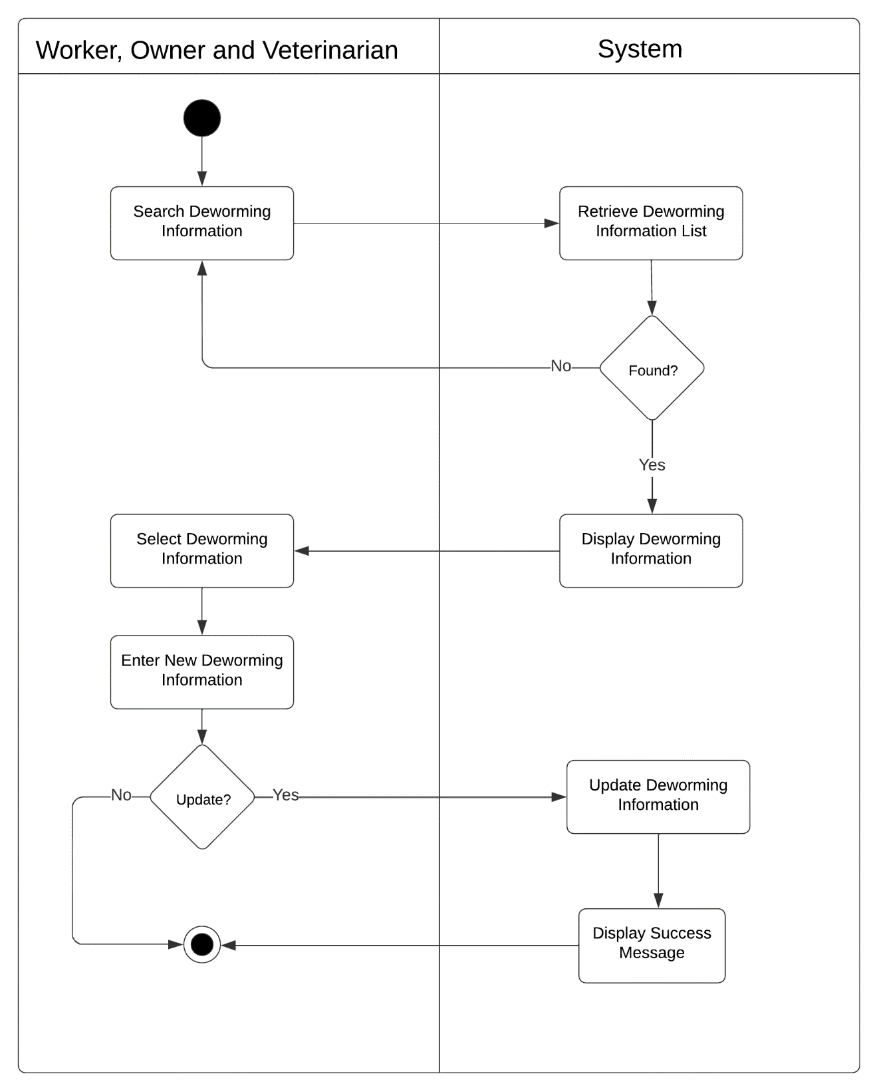

Figure 60: Activity Diagram of Web-based Piggery Management System Update Deworming Information Module Use Case

Manage Medicine Administration Module

|  |  |  |
| --- | --- | --- |
| Use Case | Description | User/Actor (Roles) |
| Add medicine administration information | The user selects the new medicine administration operation button to add new operation. | Owner, Workers, Veterinarian |
| Update medicine administration information | The user selects the update button to update the operation that are already exist. | Owner, Workers, Veterinarian |
| View medicine administration information | The user selects view button to view the medicine administration details | Owner, Workers, Veterinarian |

Table 10: Event Decomposition of the Piggery Management System Manage Medicine Administration Module

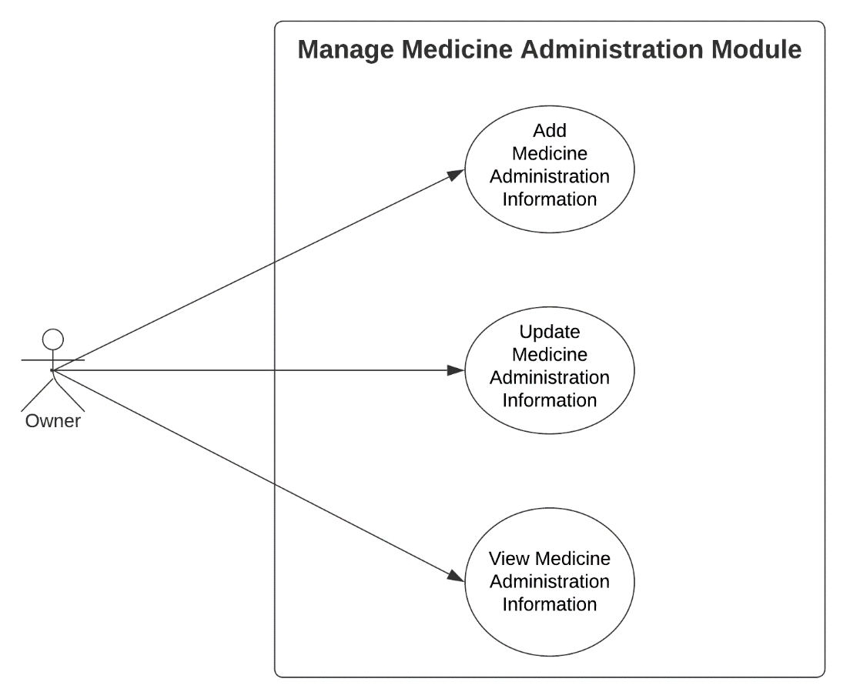

Figure 61: Use Case Diagram involving the Owner of Piggery Management System Manage Medicine Administration Module

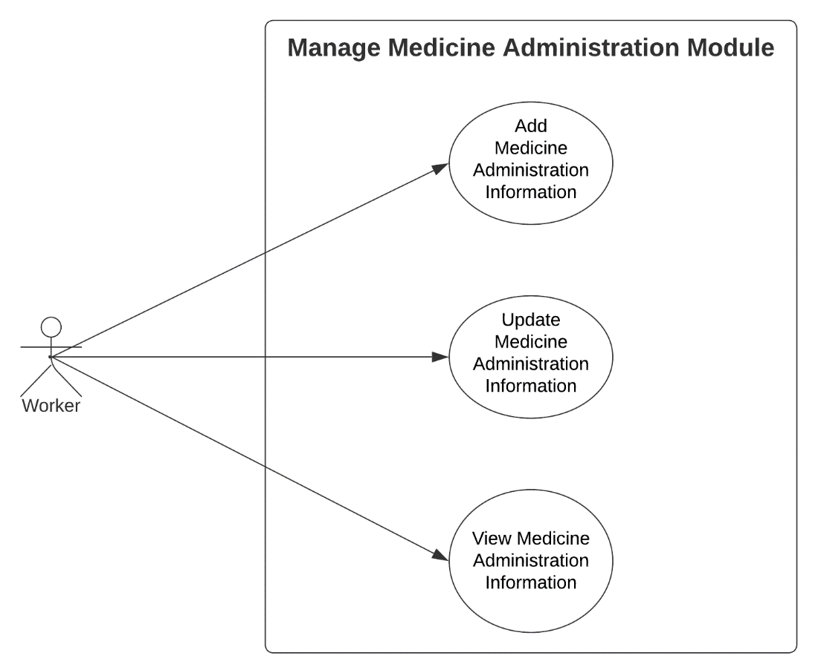

Figure 62: Use Case Diagram involving the Worker of Piggery Management System Manage Medicine Administration Module

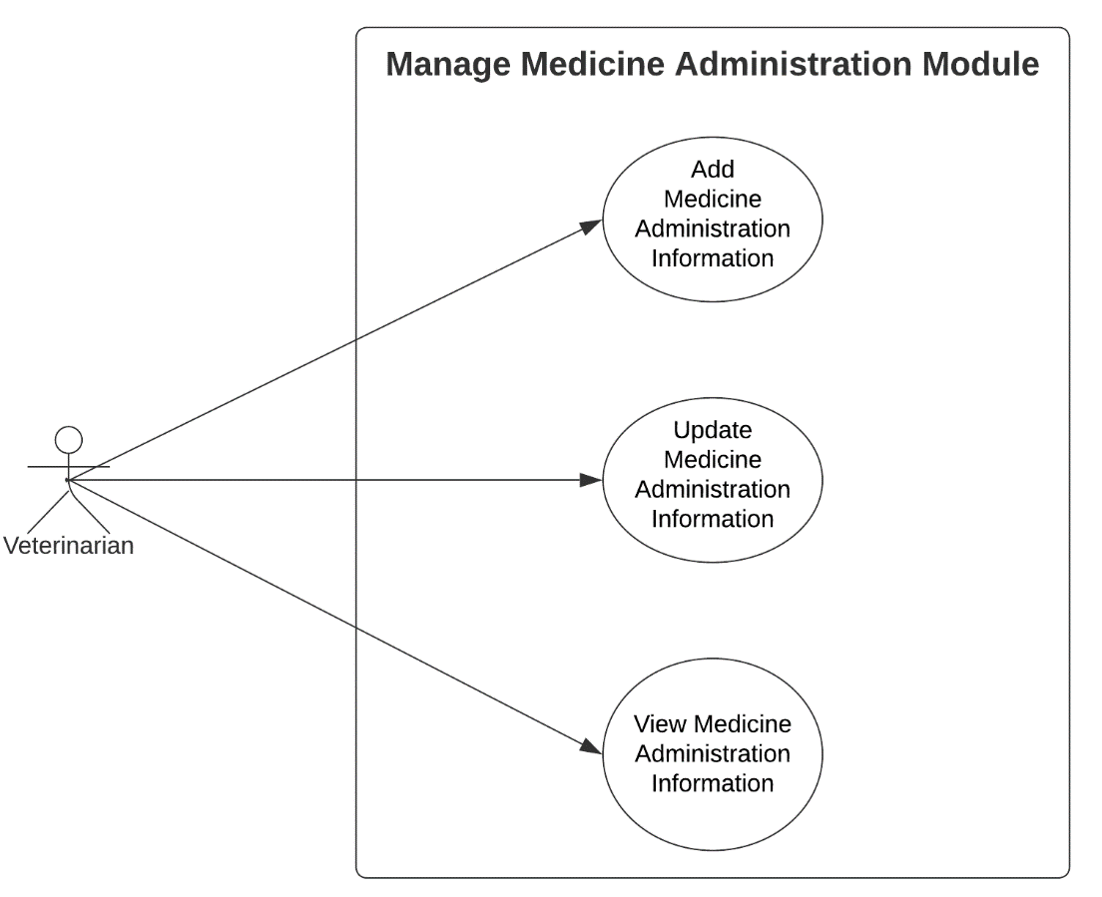

Figure 63: Use Case Diagram involving the Veterinarian of Piggery Management System Manage Medicine Administration Module

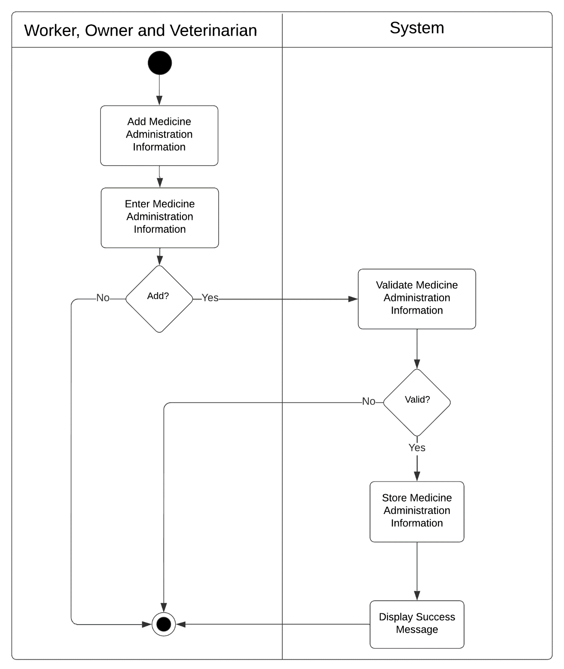

Figure 64: Activity Diagram of Web-based Piggery Management System Add Medicine Administration Information Module Use Case

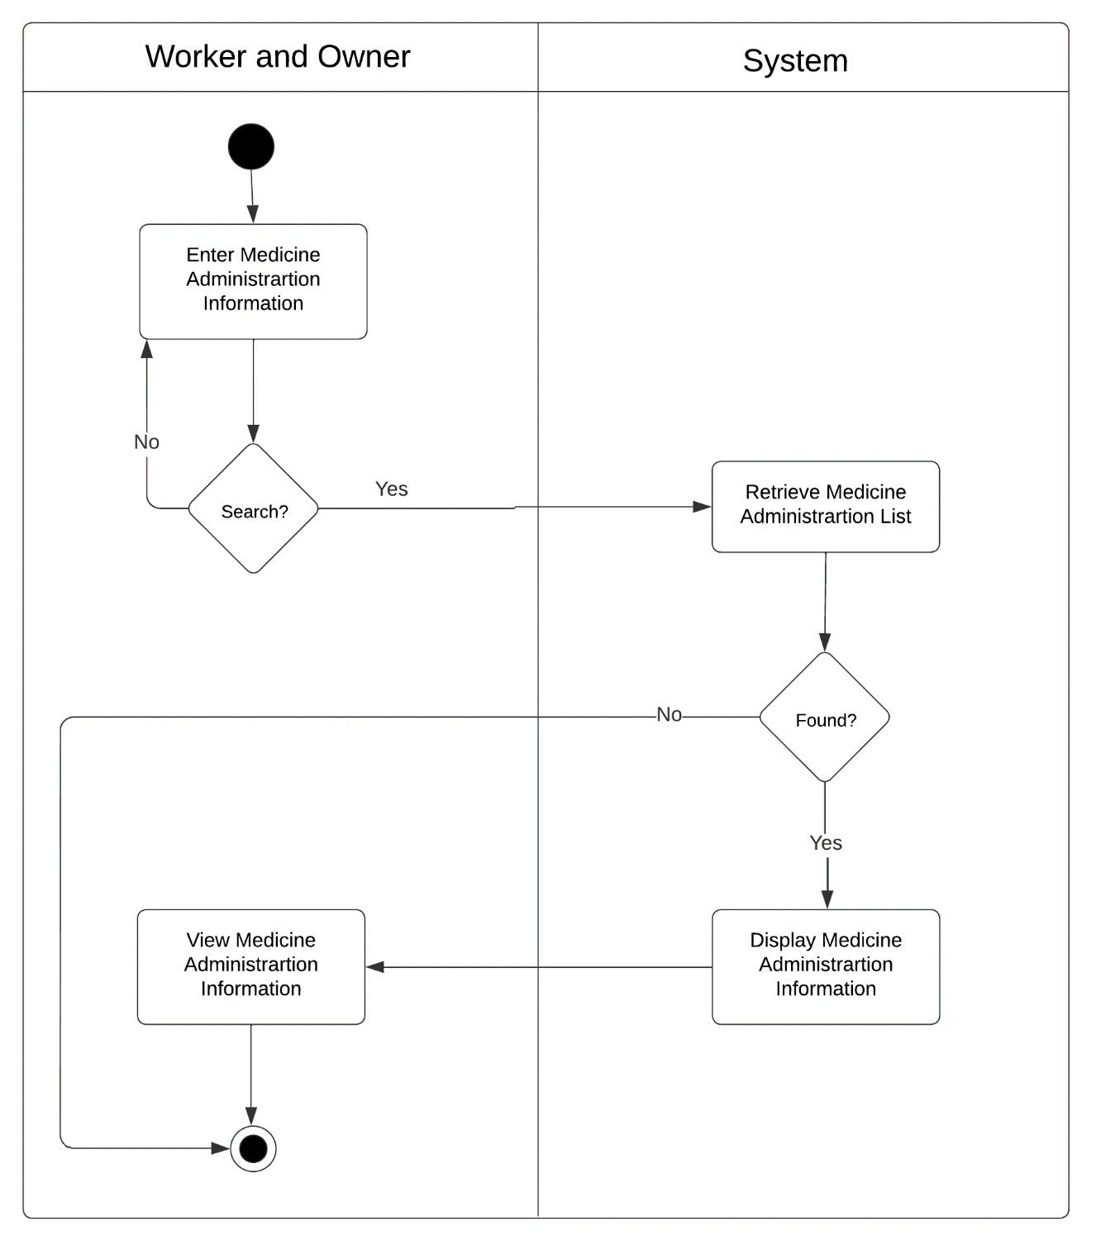

Figure 65: Activity Diagram of Web-based Piggery Management System Search Medicine Administration Information Module Use Case

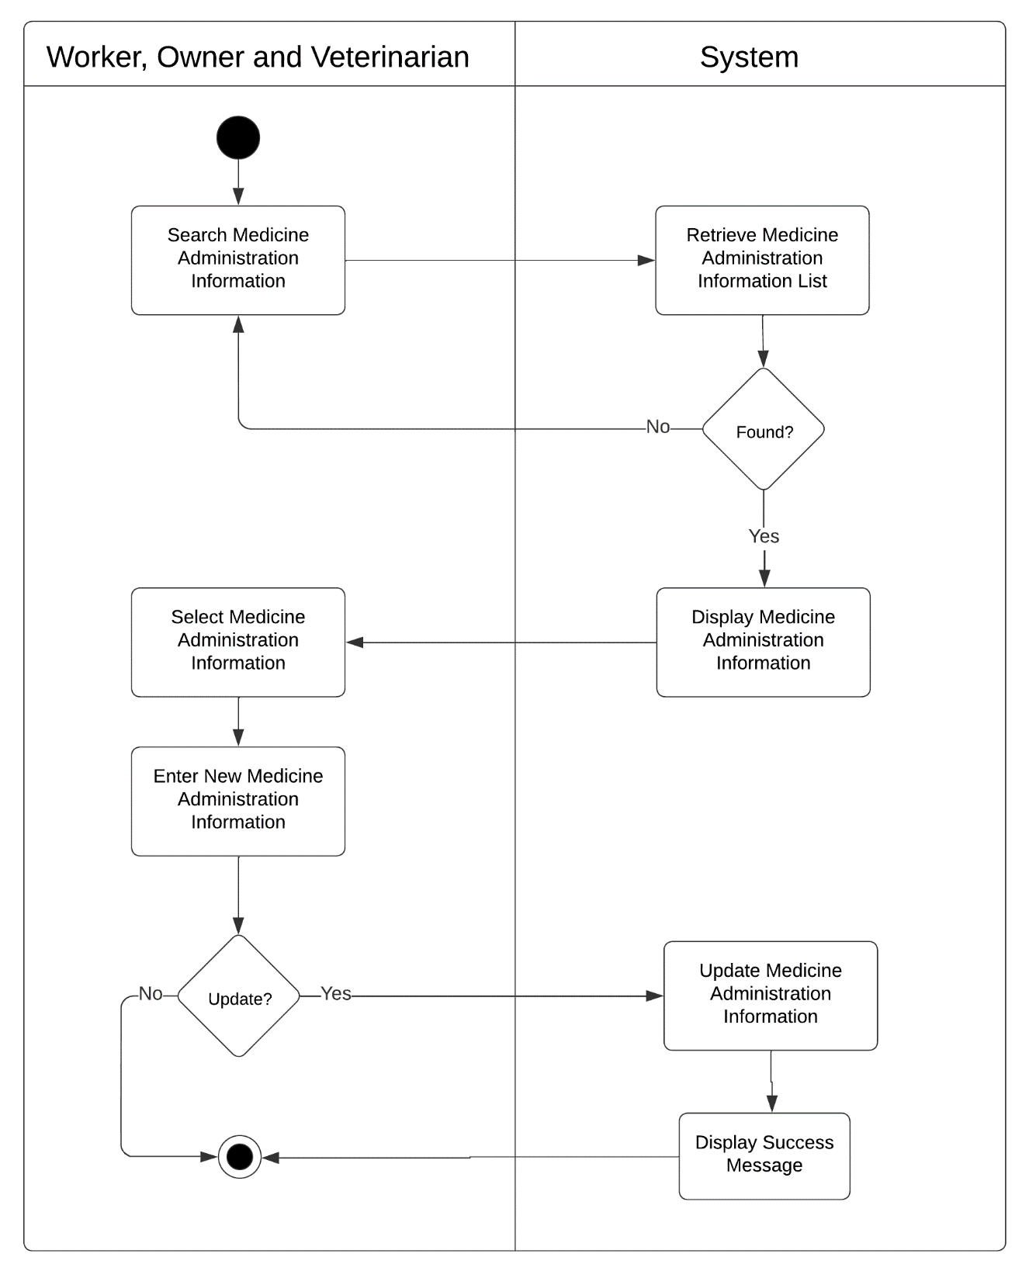

Figure 66: Activity Diagram of Web-based Piggery Management System Update Medicine Administration Information Module Use Case

Scheduling Management Module

|  |  |  |
| --- | --- | --- |
| Use Case | Description | User/Actor (Roles) |
| Add operation schedule | The user selects the new schedule button to add new schedule. | Owner and Worker |
| Search operation details | The user selects view button to view schedule details. | Owner and Worker |
| View operation schedule | The user selects each button to view the operation. | Owner and Worker |
| Update operation schedule | The user selects the update button to update the schedules that are already exist. | Owner and Worker |
| Delete operation schedule | The user selects remove button to remove the existing scheduled operation | Owner and Worker |

Table 11: Event Decomposition of the Piggery Management System Scheduling Management Module

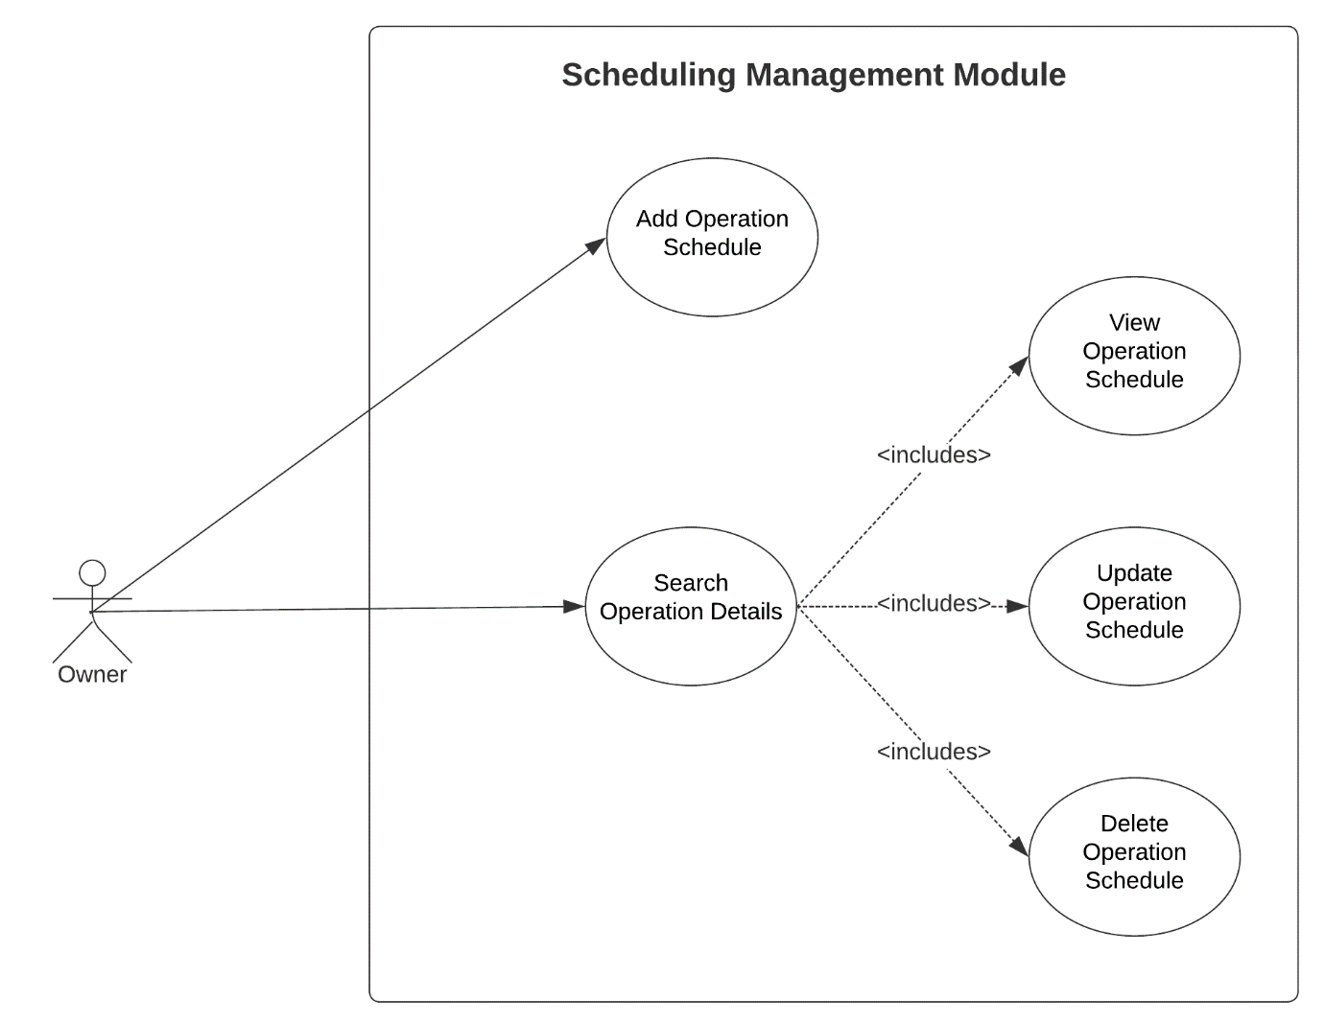

Figure 67: Use Case Diagram involving the Owner of Piggery Management System Scheduling Management Module

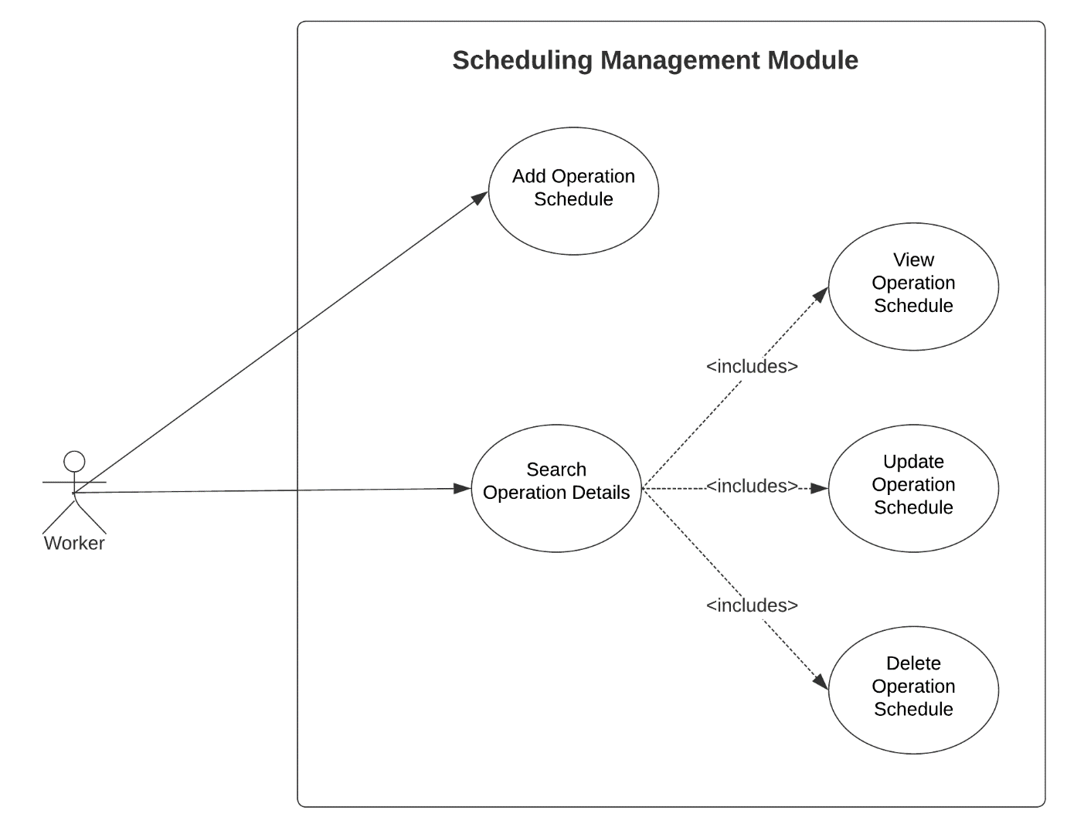

Figure 68: Use Case Diagram involving the Worker of Piggery Management System Scheduling Management Module

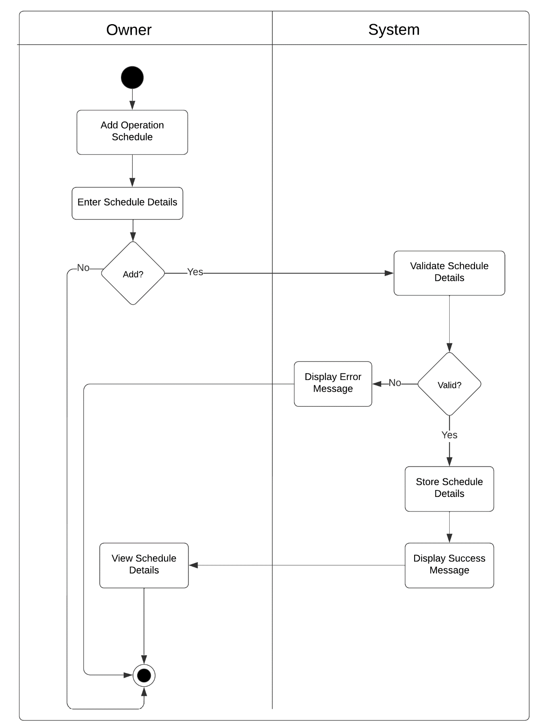

Figure 67: Activity Diagram of Web-based Piggery Management System Add Operation Schedule Module Use Case

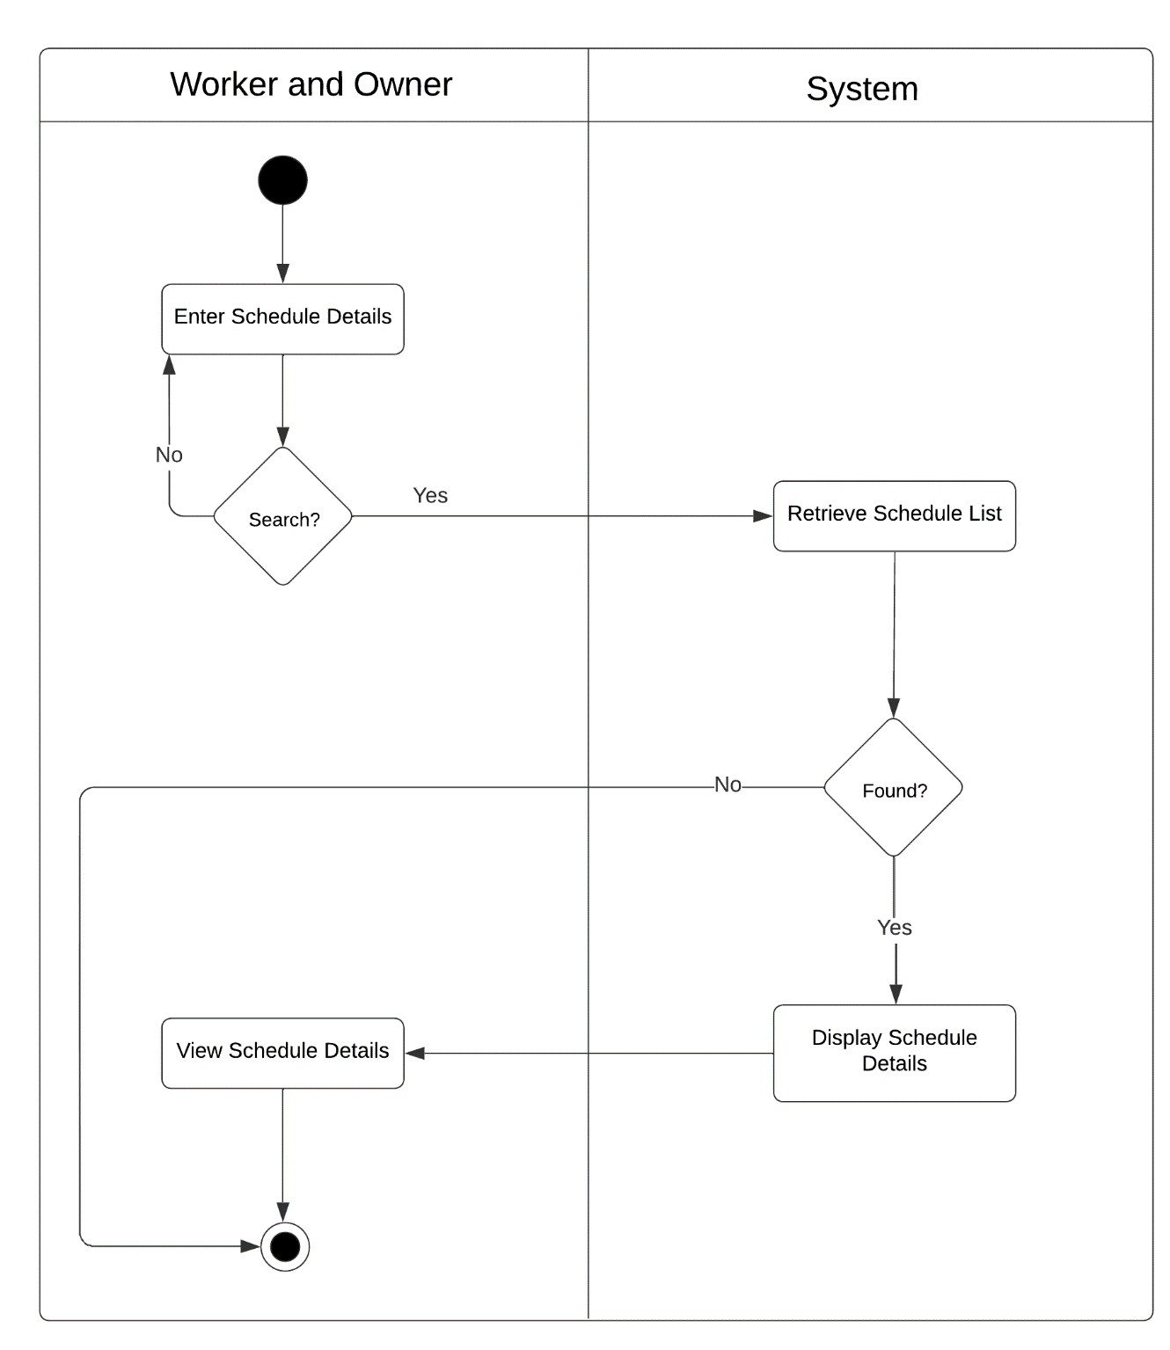

Figure 68: Activity Diagram of Web-based Piggery Management System Search Operation Schedule Module Use Case

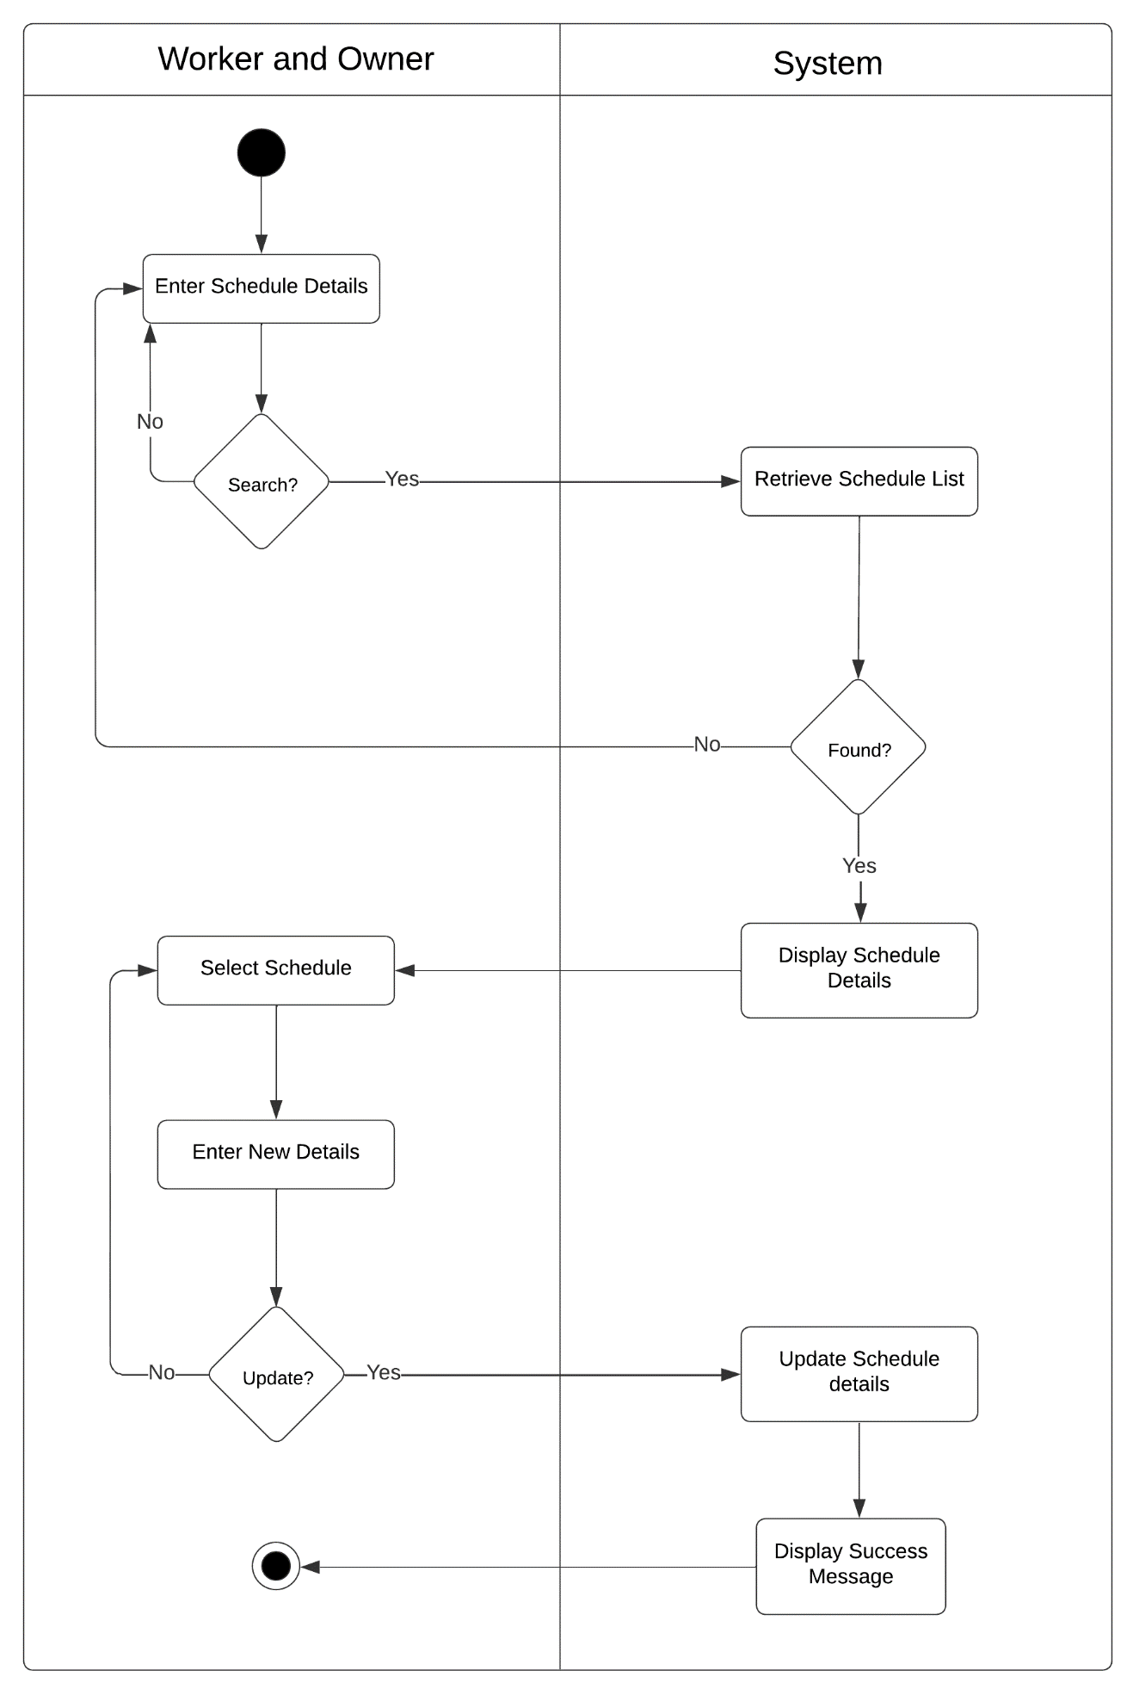

Figure 69: Activity Diagram of Web-based Piggery Management System Search and Update Operation Schedule Module Use Case

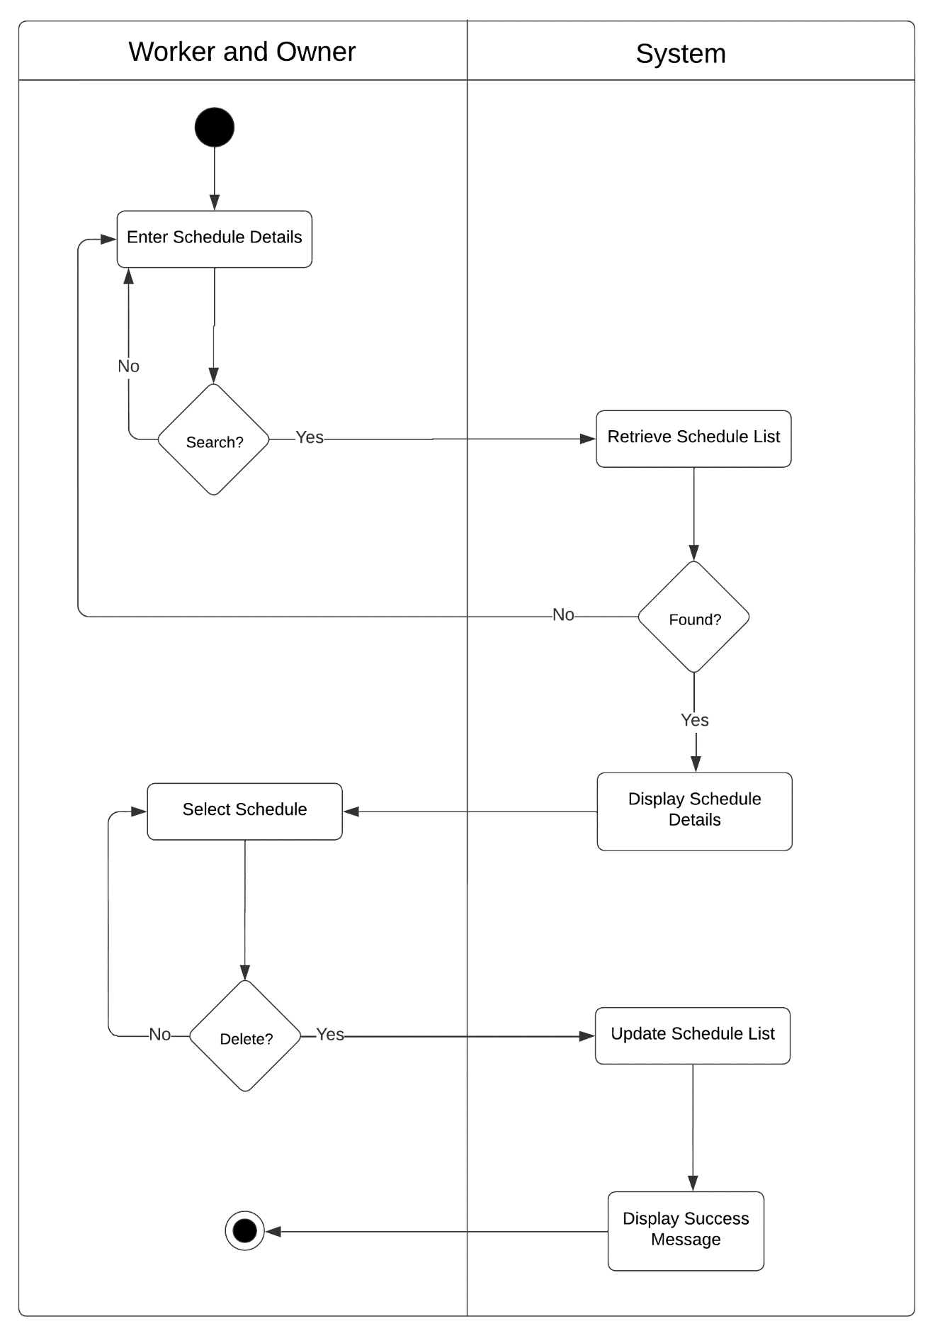

Figure 70: Activity Diagram of Web-based Piggery Management System Delete Operation Schedule Module Use Case

Pig Management Module

|  |  |  |
| --- | --- | --- |
| Use Case | Description | User/Actor (Roles) |
| Add cage | The user selects the add button to add pig in pig management. | Owner and Worker |
| View cage | The user selects the view button to view the cage details. | Owner and Worker |
| Update cage | The user selects the edit action to update cage details. | Owner and Worker |
| Delete cage | The user selects the delete action to delete the existing cage | Owner and Worker |
| Add pig batch | The user selects the new button to add new batch of pigs. | Owner and Worker |
| View pig batch | The user selects each button to view pig batch. | Owner and Worker |
| Update pig batch | The user selects edit action to update pig batch. | Owner and Worker |
| Add new pig | The user selects new button to add new pig in pig management. | Owner and Worker |
| Search new pig | The user selects search button to search new pig information. | Owner and Worker |

Table 12: Event Decomposition of the Piggery Management System Pig Management Module

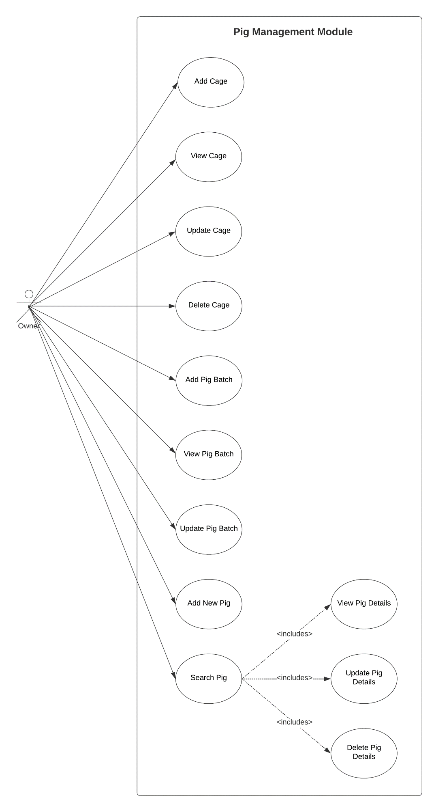

Figure 71: Use Case Diagram involving the Owner of Piggery Management System Pig Management Module

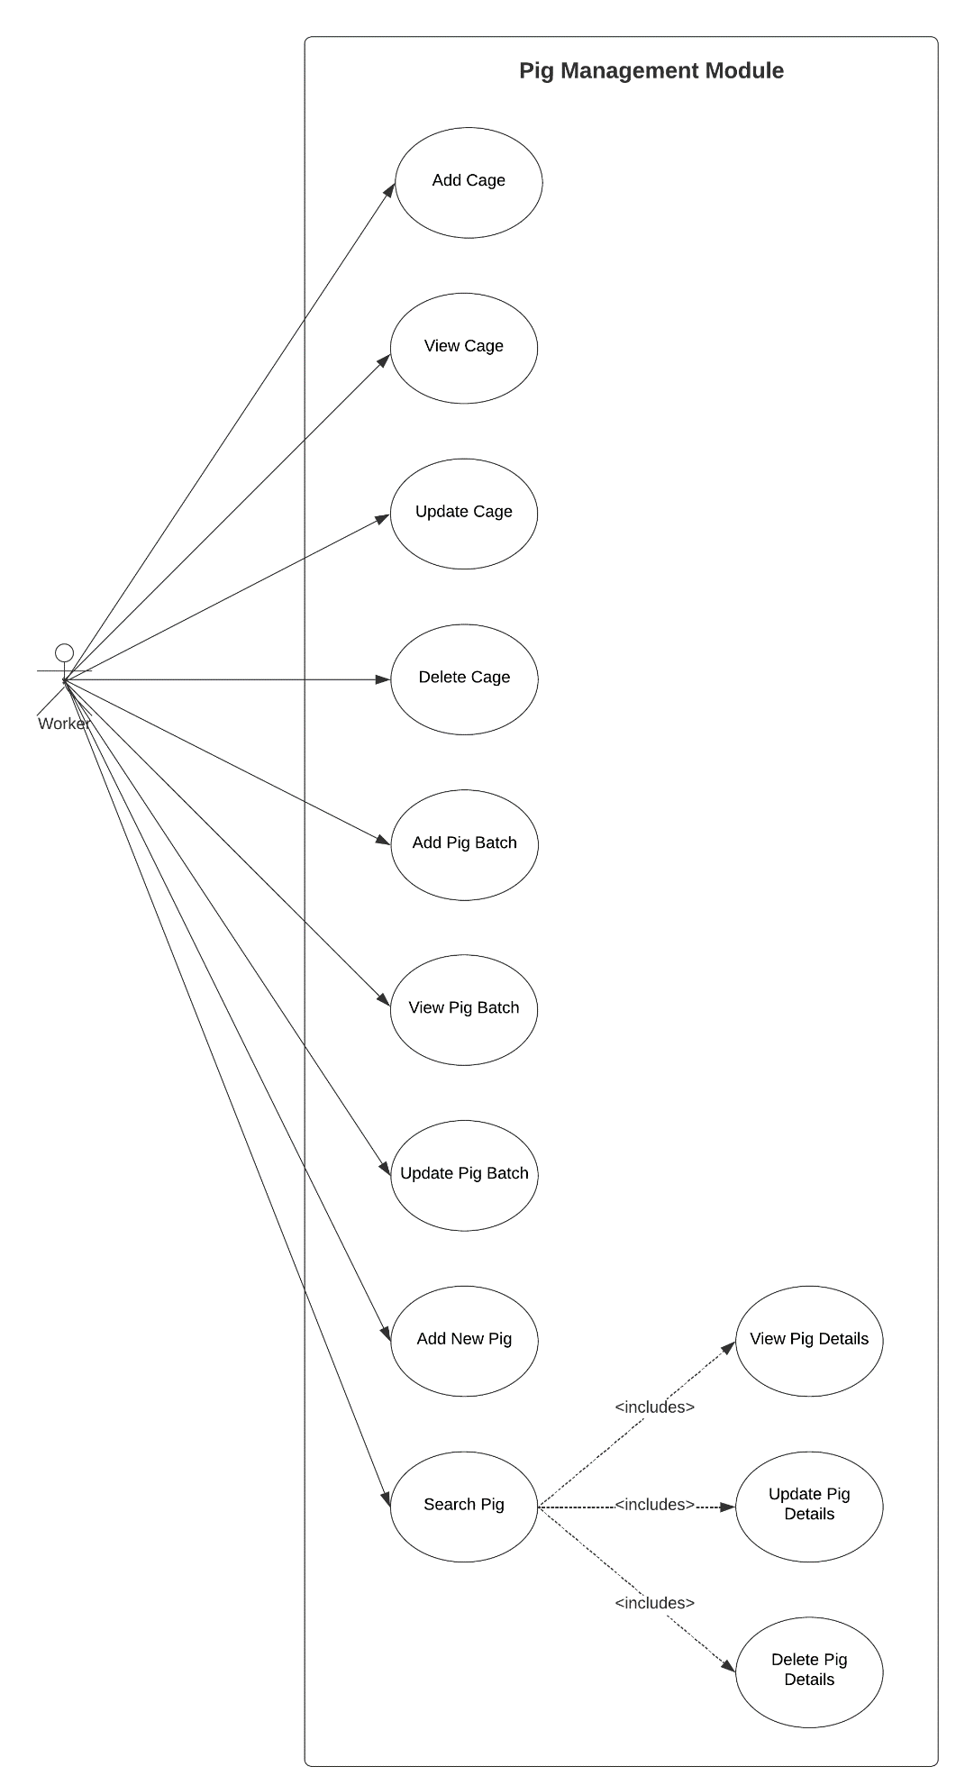

Figure 72: Use Case Diagram involving the Worker of Piggery Management System Pig Management Module

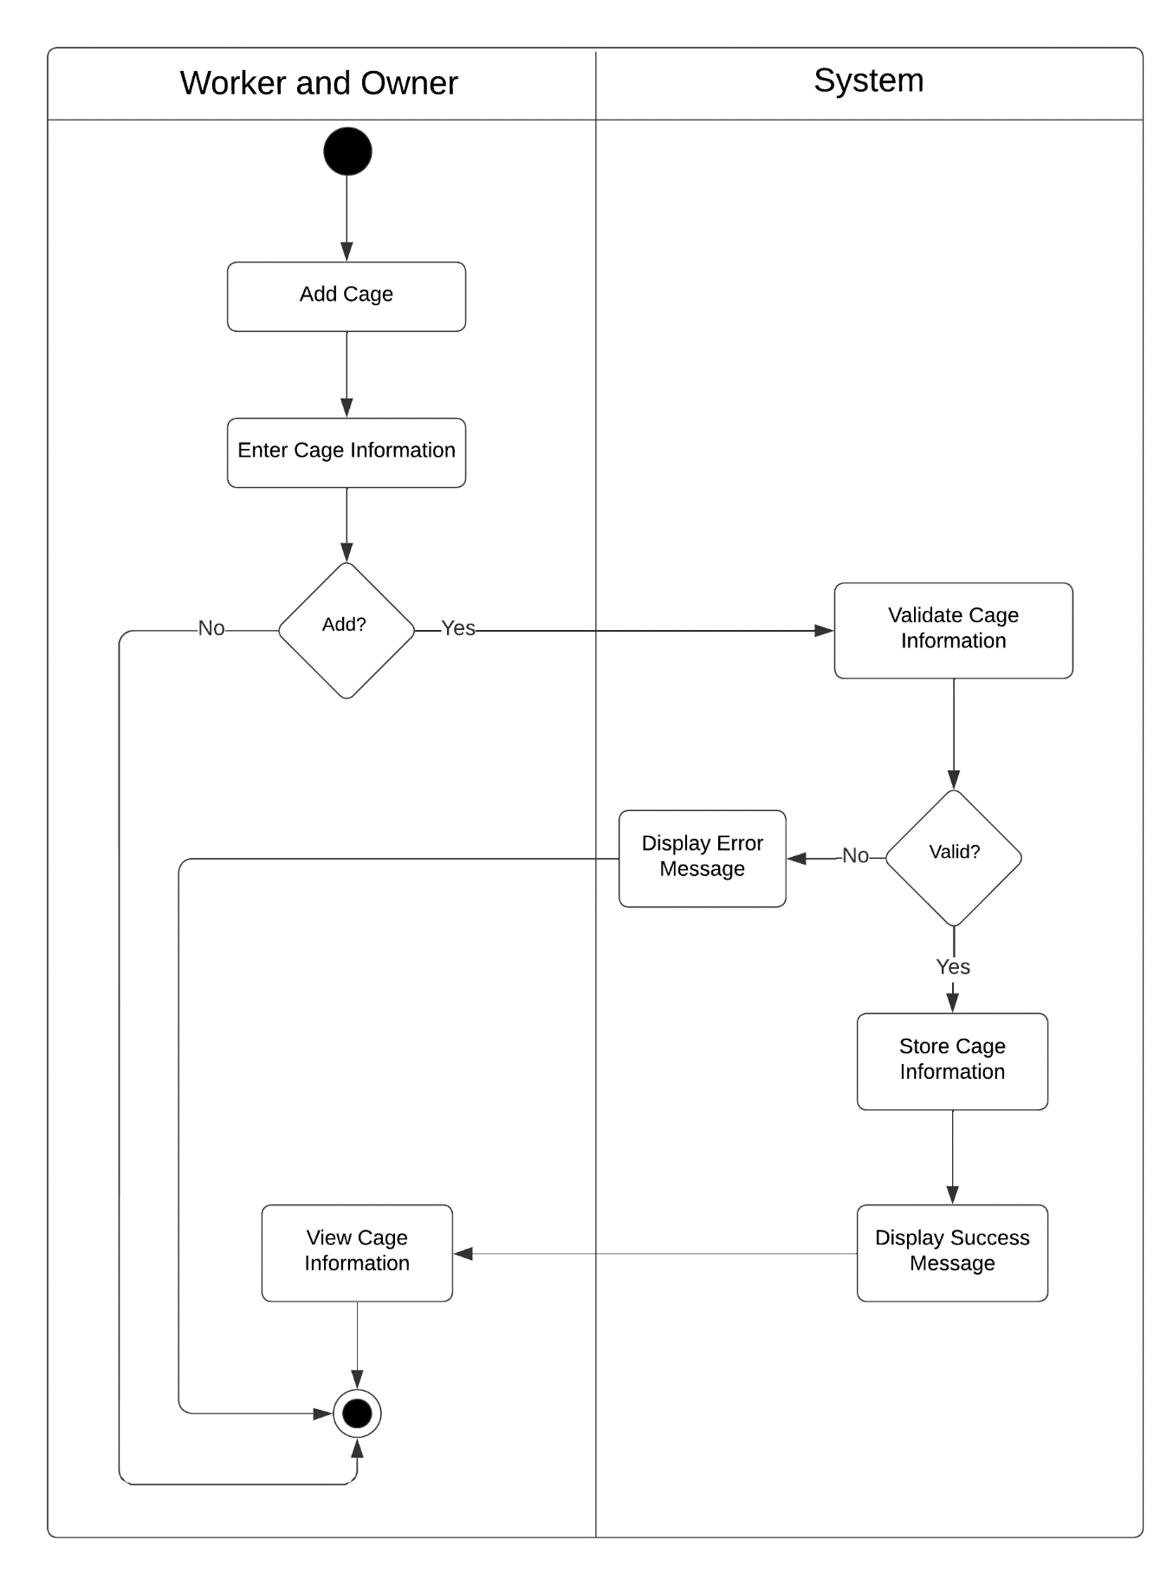

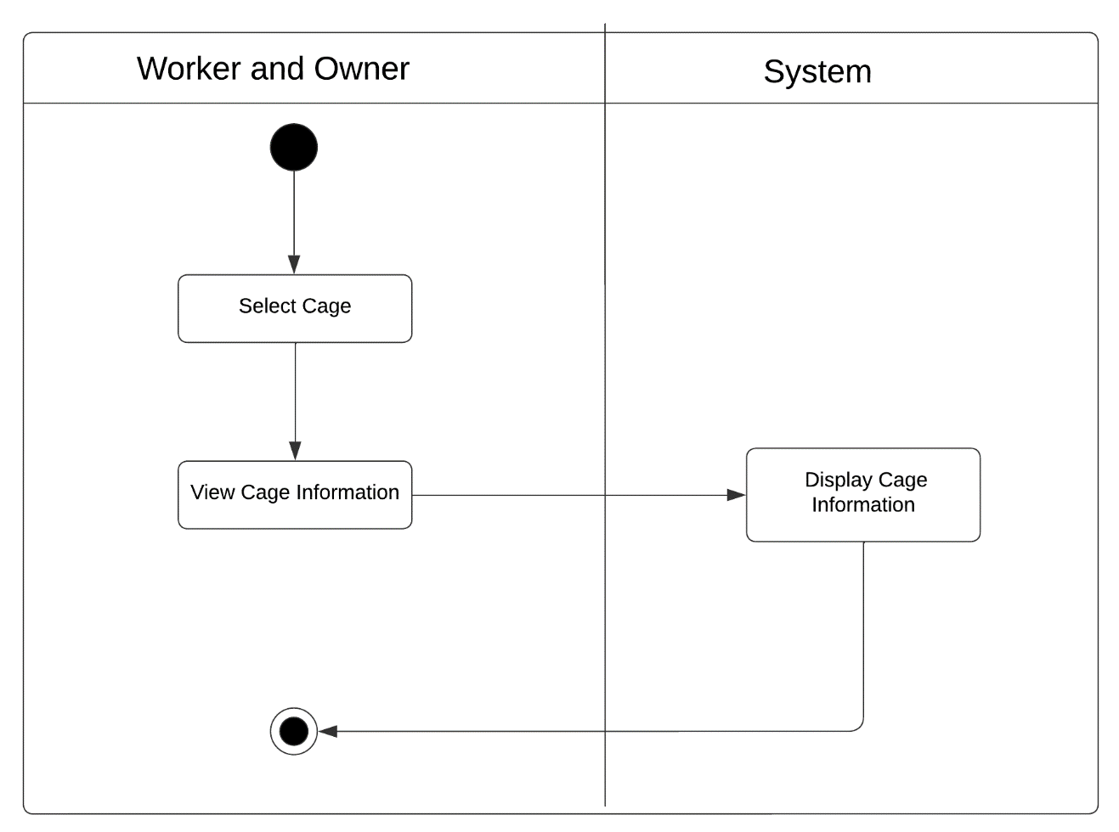Figure 73: Activity Diagram of Web-based Piggery Management System Add Cage Pig Management Module Use Case

Figure 74: Activity Diagram of Web-based Piggery Management System View Cage Pig Management Module Use Case

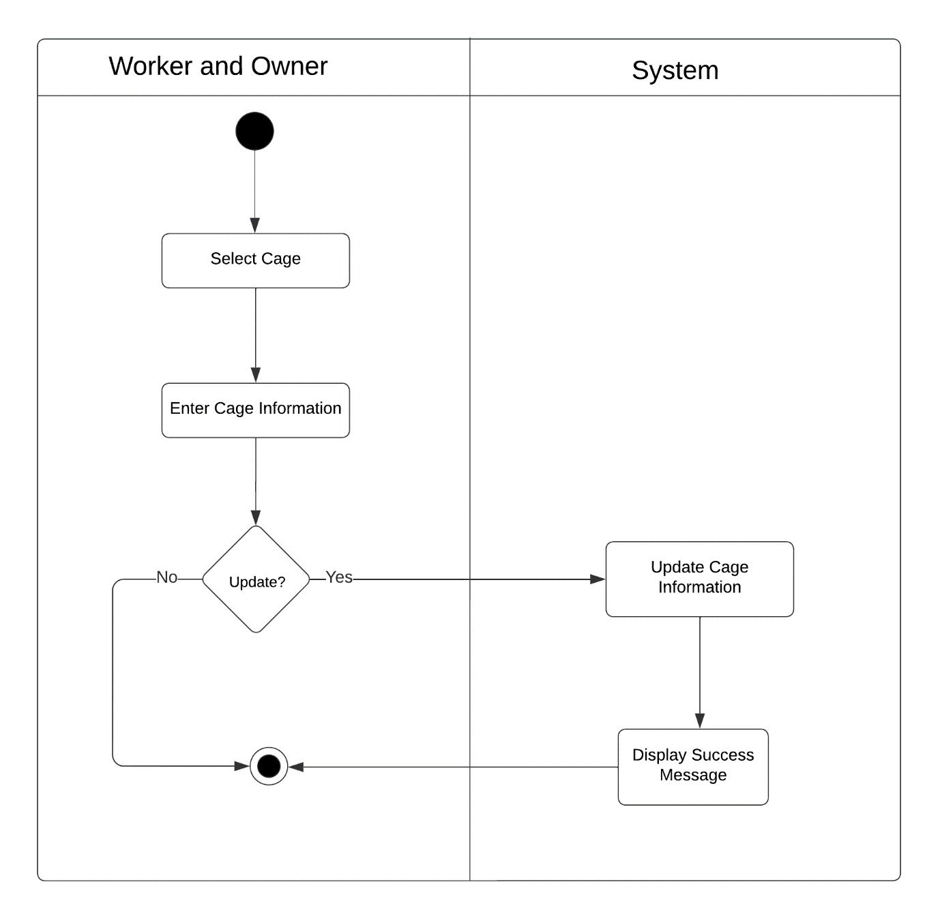

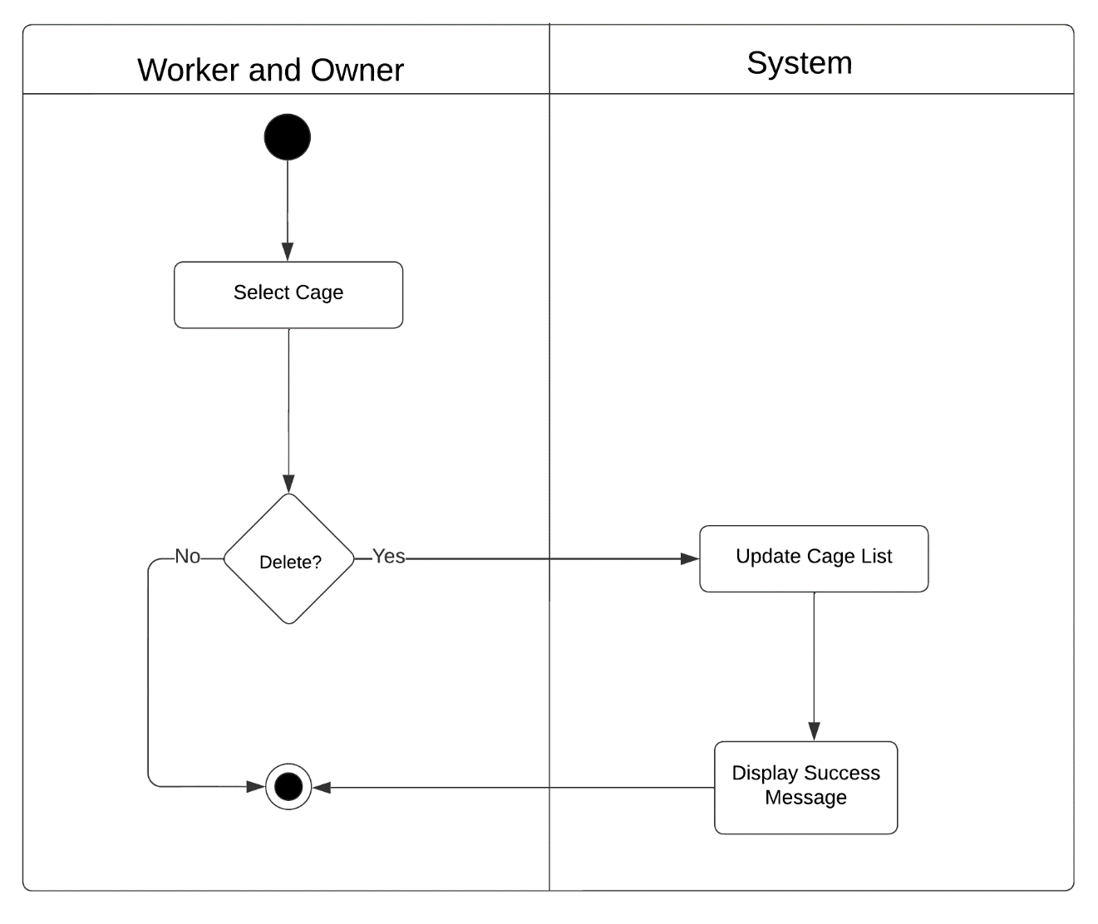Figure 75: Activity Diagram of Web-based Piggery Management System Update Cage Pig Management Module Use Case

Figure 76: Activity Diagram of Web-based Piggery Management System Delete Cage Pig Management Module Use Case

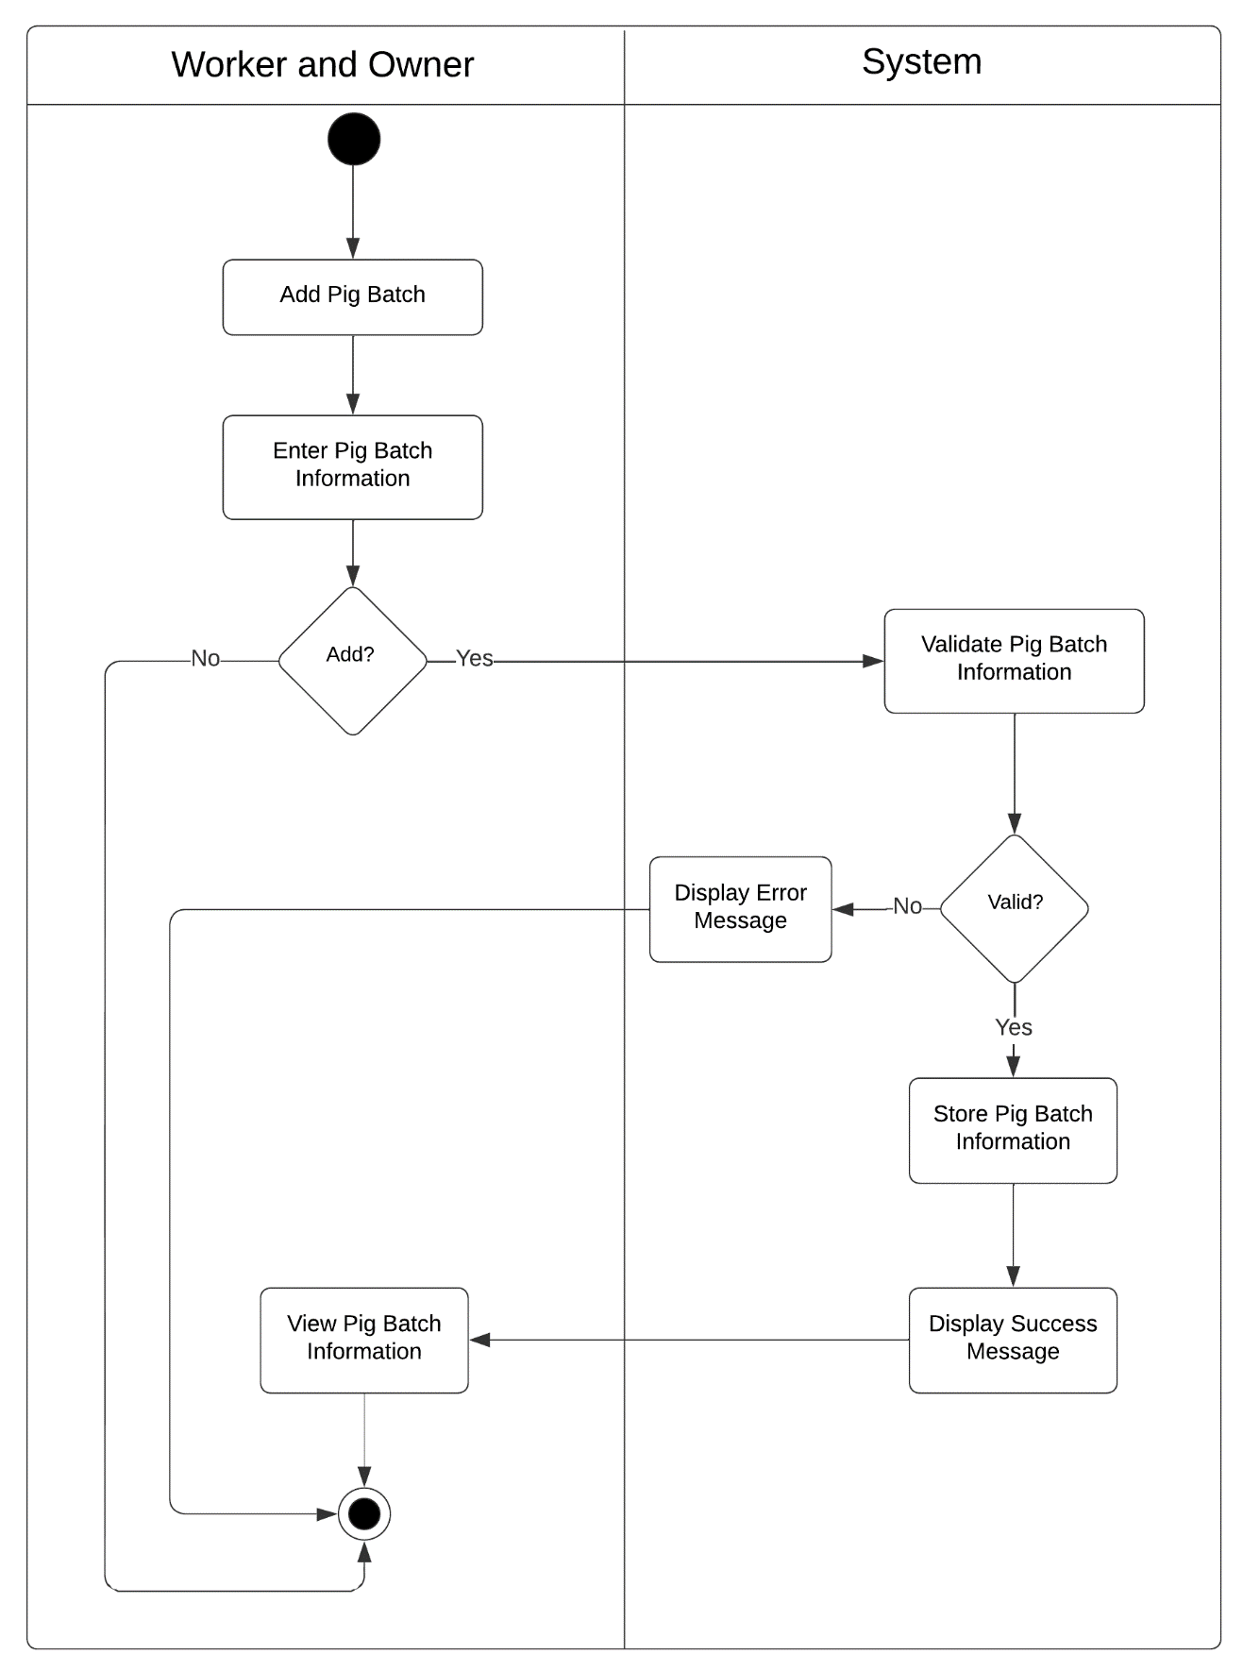

Figure 77: Activity Diagram of Web-based Piggery Management System Add Pig Batch Pig Management Module Use Case

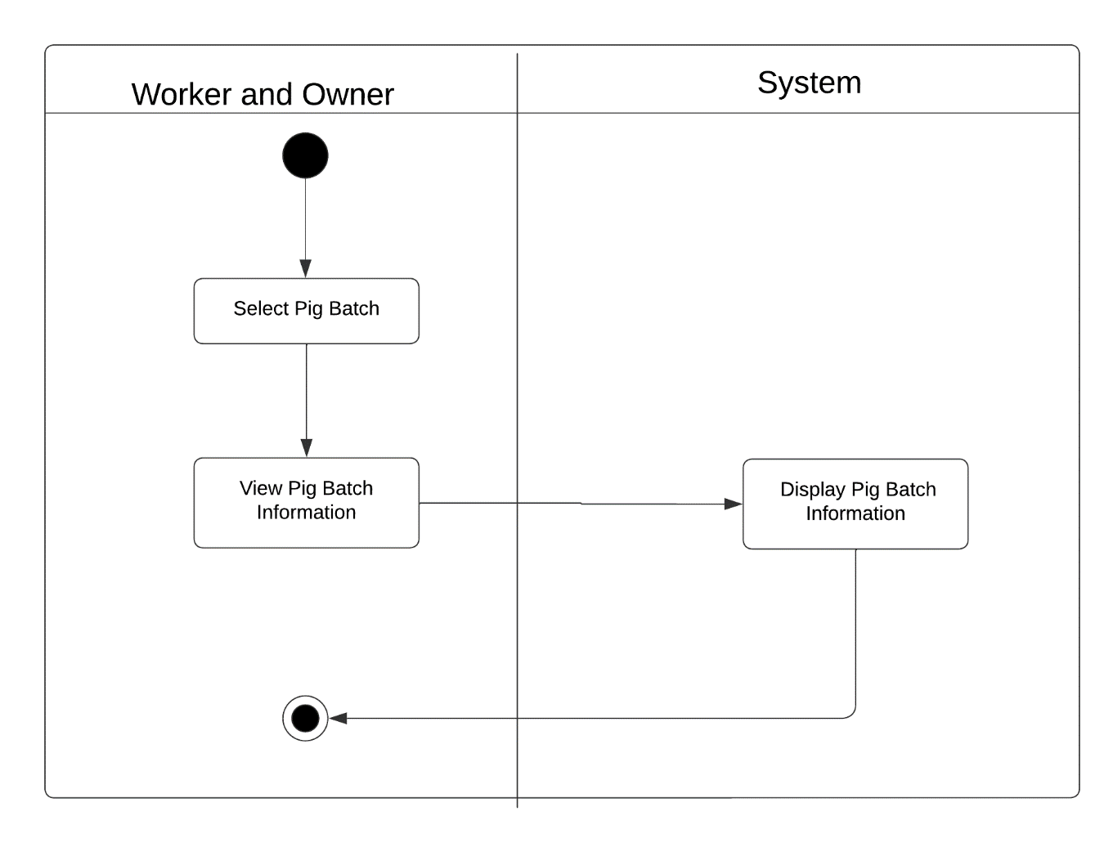

Figure 78: Activity Diagram of Web-based Piggery Management System View Pig Batch Pig Management Module Use Case

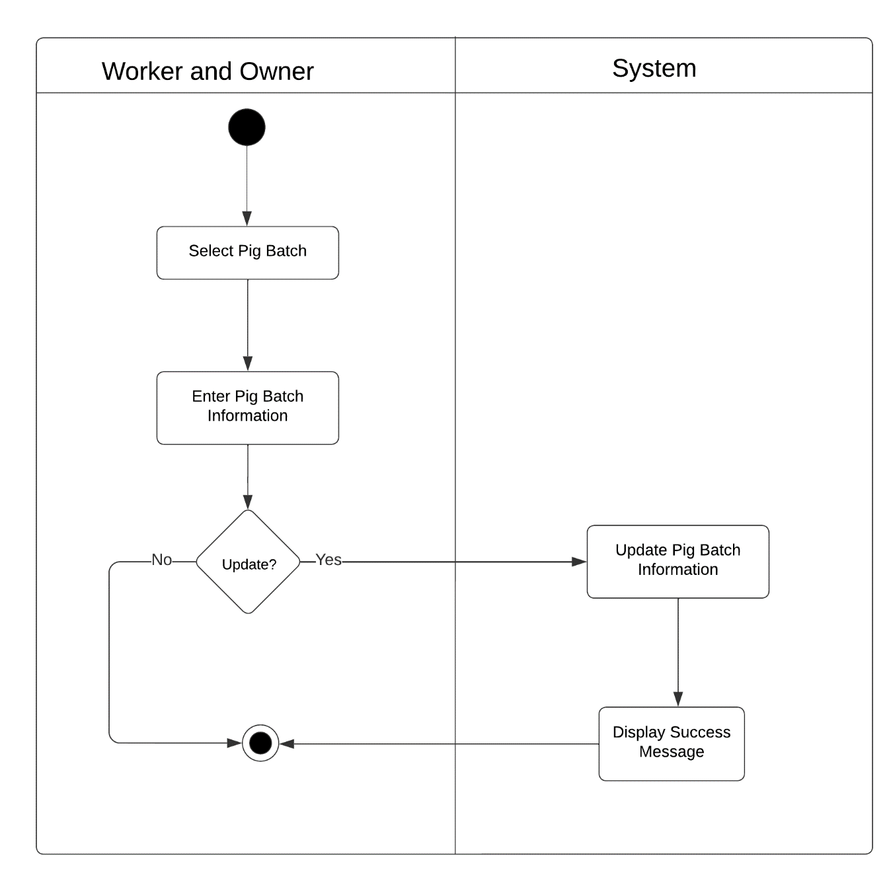

Figure 79: Activity Diagram of Web-based Piggery Management System Update Pig Batch Pig Management Module Use Case

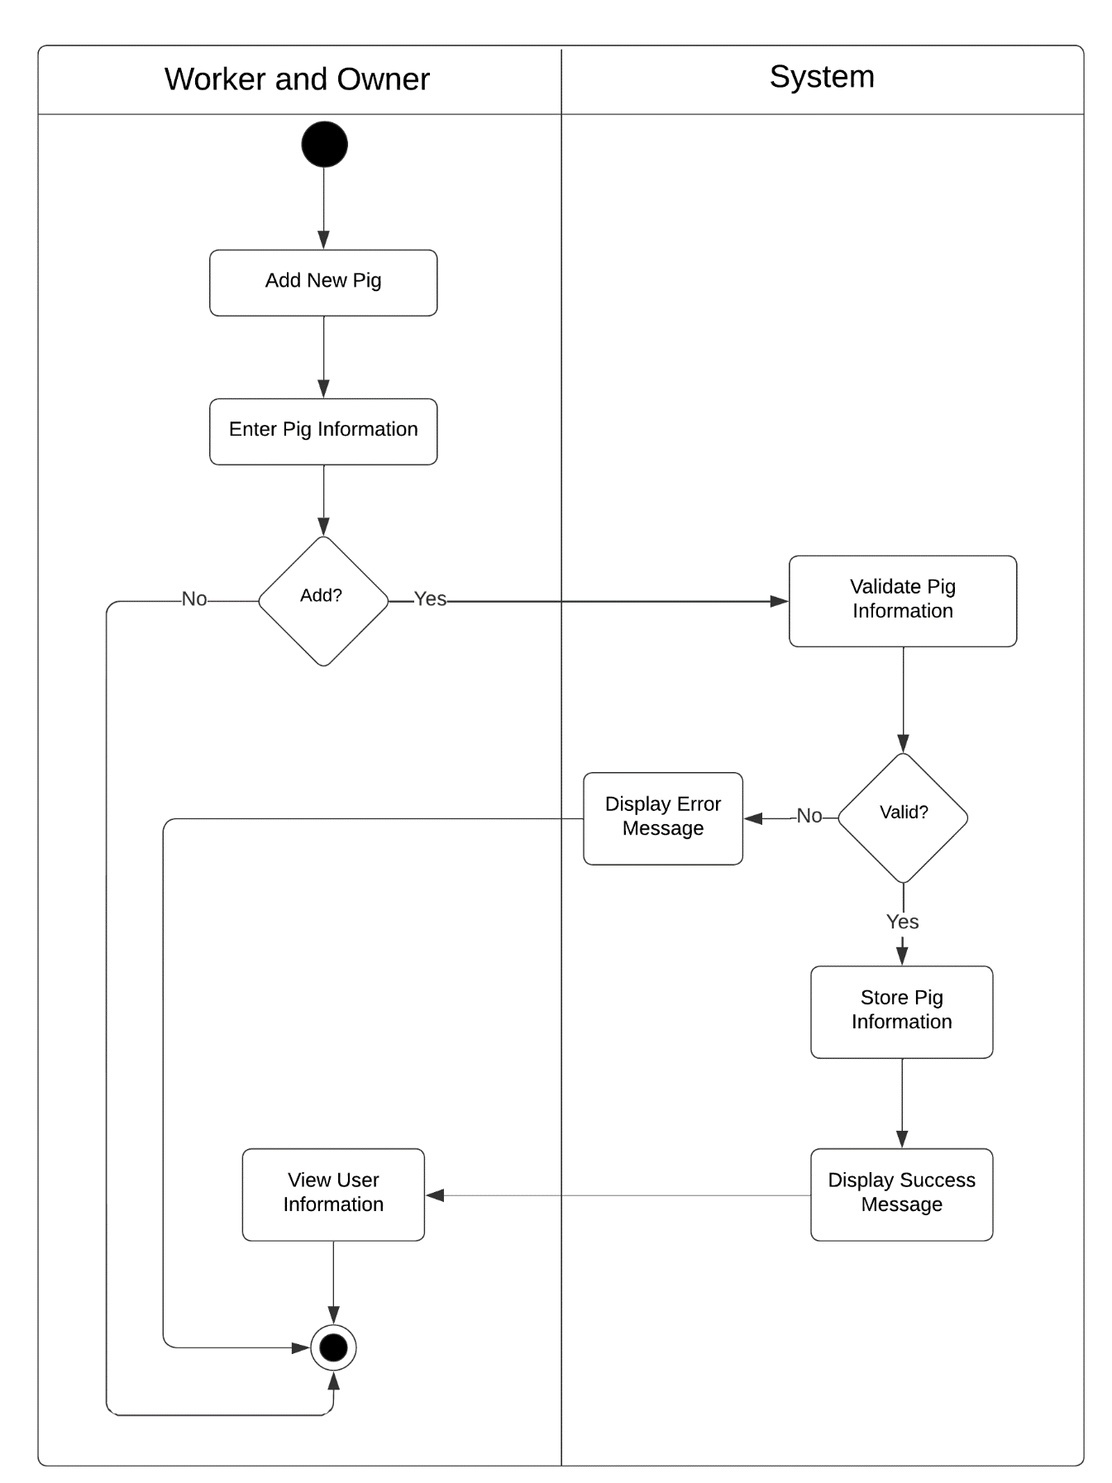

Figure 80: Activity Diagram of Web-based Piggery Management System Add New Pig Management Module Use Case

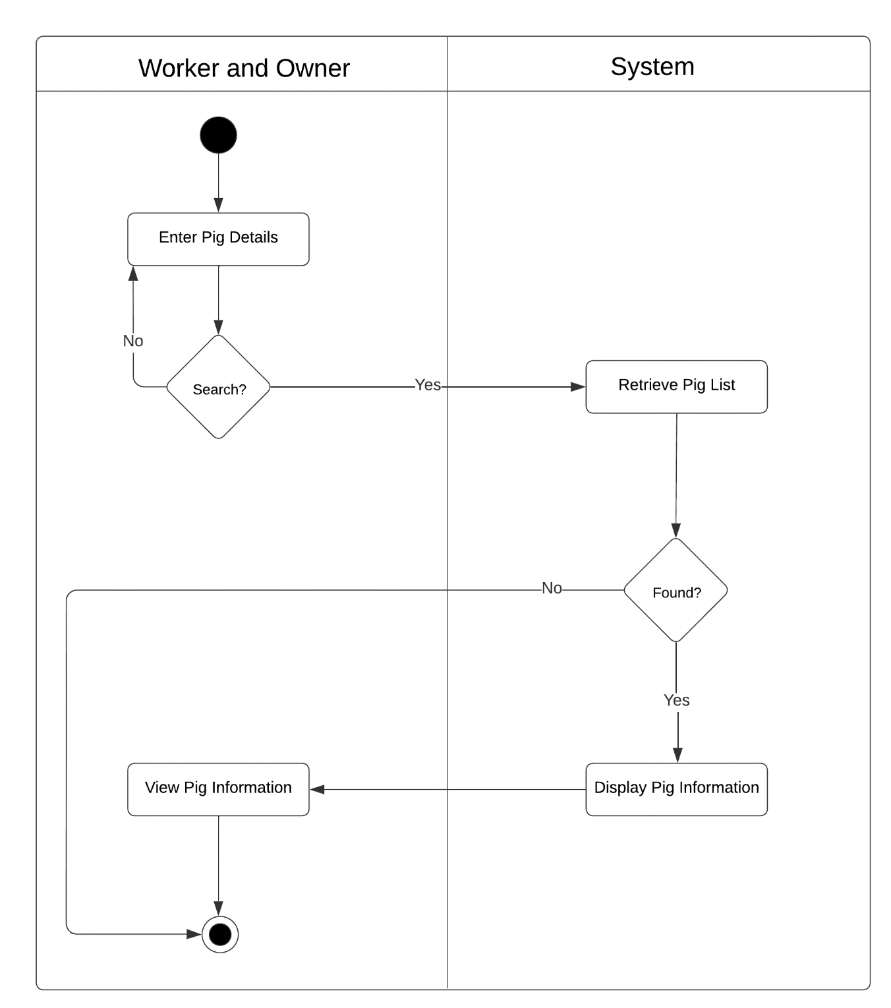

Figure 81: Activity Diagram of Web-based Piggery Management System Search Pig Information Pig Management Module Use Case

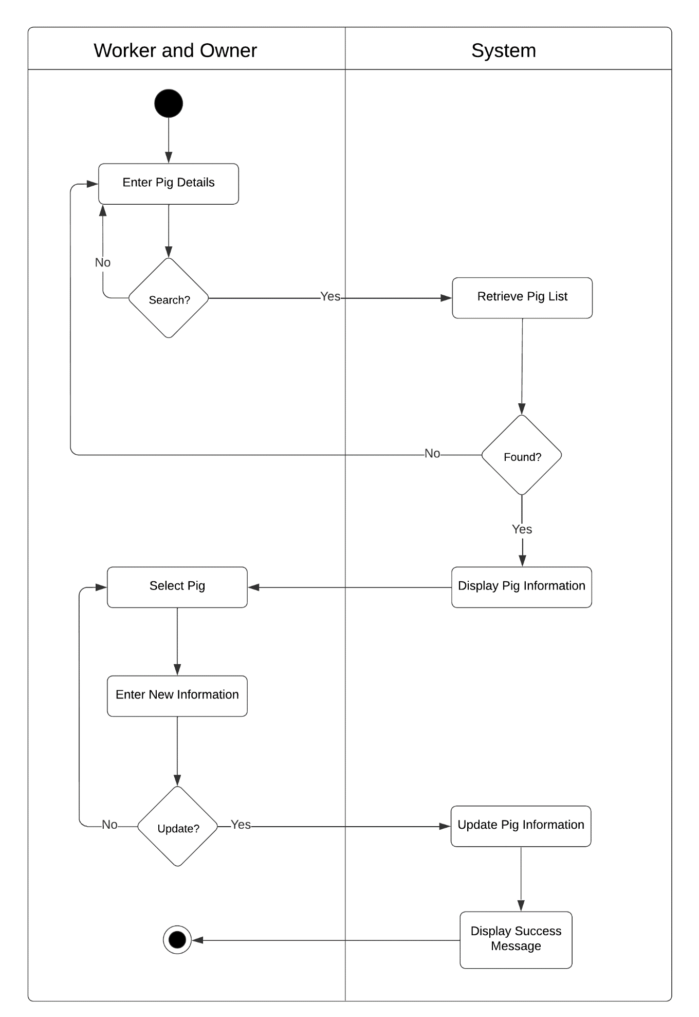

Figure 82: Activity Diagram of Web-based Piggery Management System Search Pig Details Pig Management Module Use Case

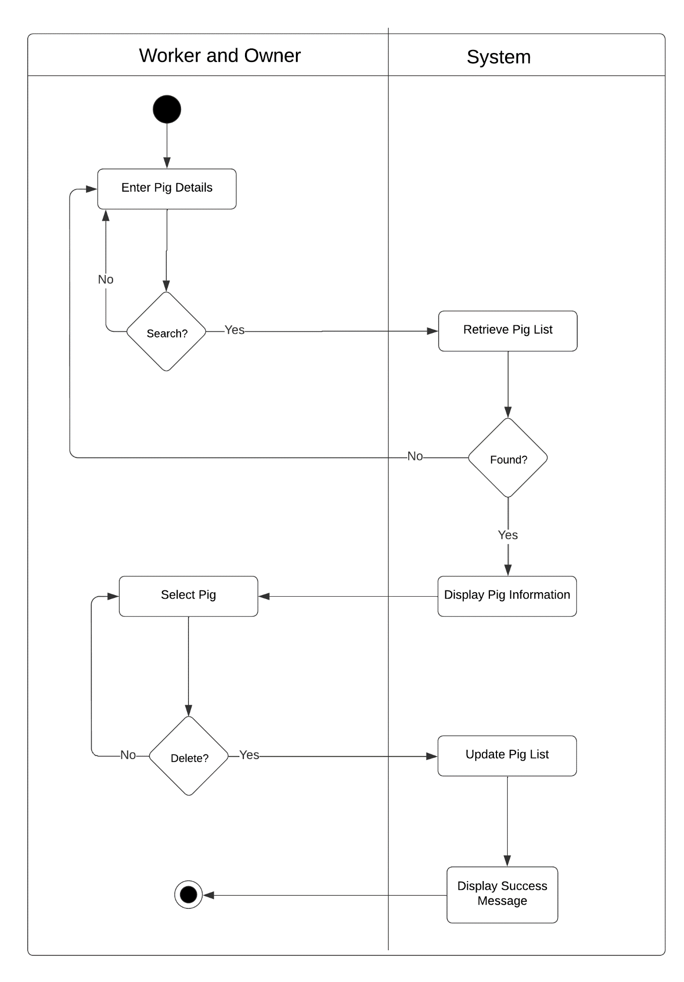

Figure 83: Activity Diagram of Web-based Piggery Management System Delete Pig Batch Pig Management Module Use Case

Inventory Management Module

|  |  |  |
| --- | --- | --- |
| Use Case | Description | User/Actor (Roles) |
| Add new item. | The user selects new item to add item in inventory. | Owner and Worker |
| Search item | The user selects search field to search the item in Inventory Module. | Owner and Worker |
| Add Purchase Request | The user selects add button to add item details | Owner and Worker |
| View Purchase Request | The user selects each button to view the purchase request details. | Owner and Worker |
| Update Purchase Request | The user selects the edit action to update purchase request. | Owner and Worker |
| Delete Purchase Request | The user selects edit action to delete purchase request. | Owner and Worker |

Table 13: Event Decomposition of the Piggery Management System Inventory Management Module

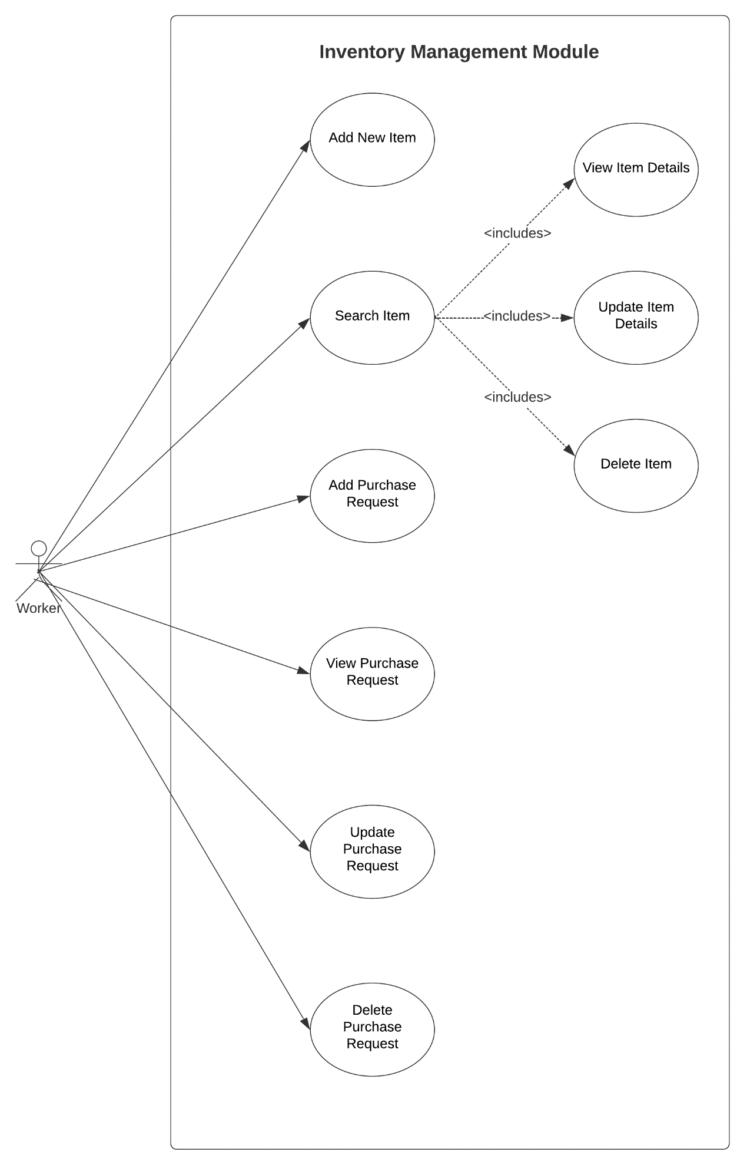

Figure 84: Use Case Diagram involving the Worker of Piggery Management System Inventory Management Module

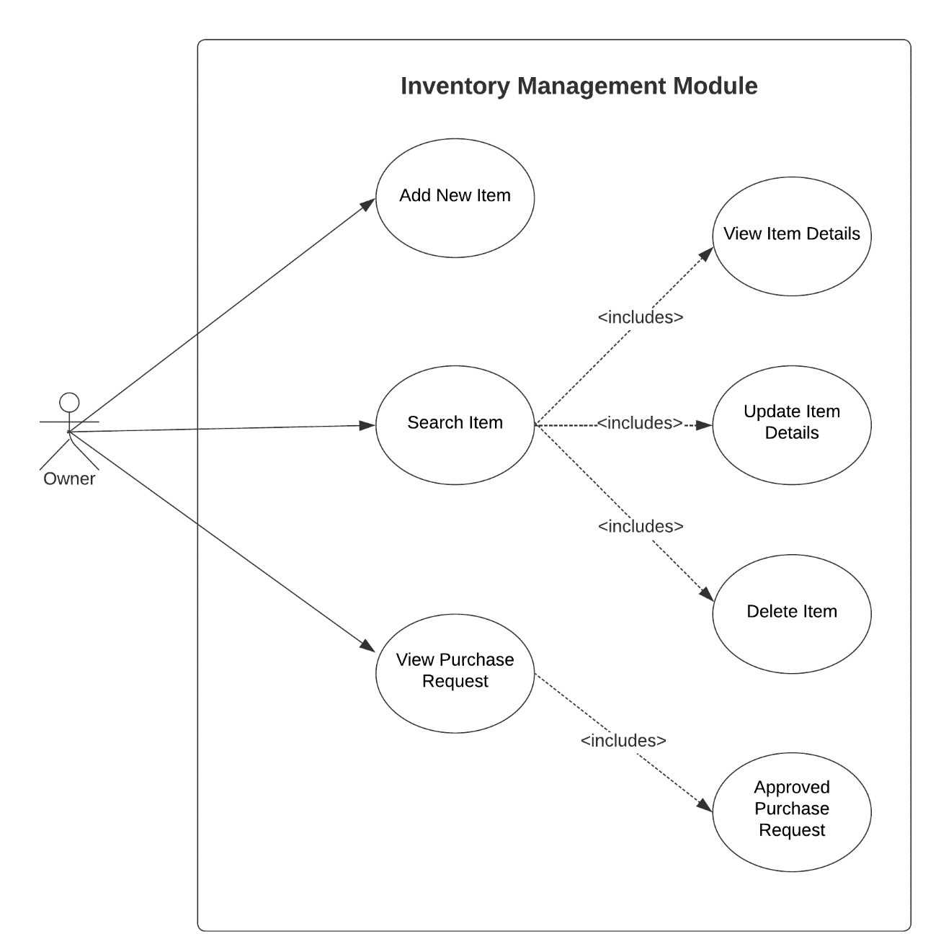

Figure 85: Use Case Diagram involving the Owner of Piggery Management System Inventory Management Module

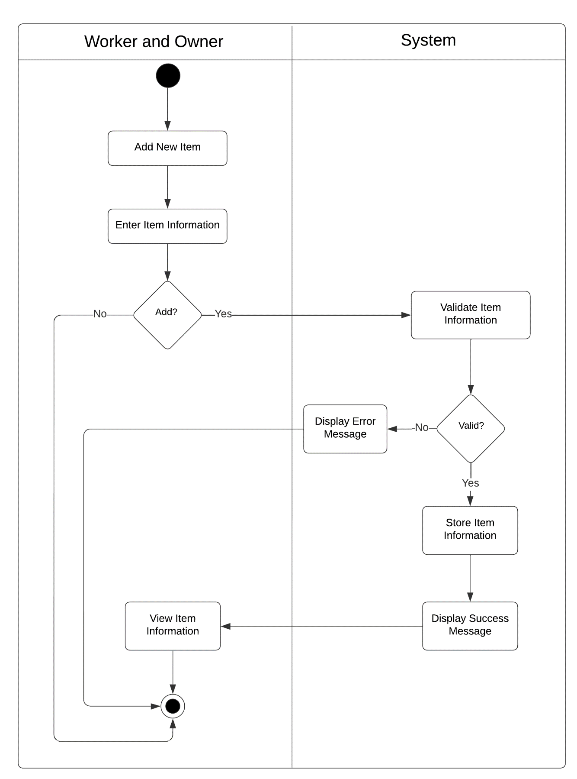

Figure 86: Activity Diagram of Web-based Piggery Management System Add New Item Inventory Management Module Use Case

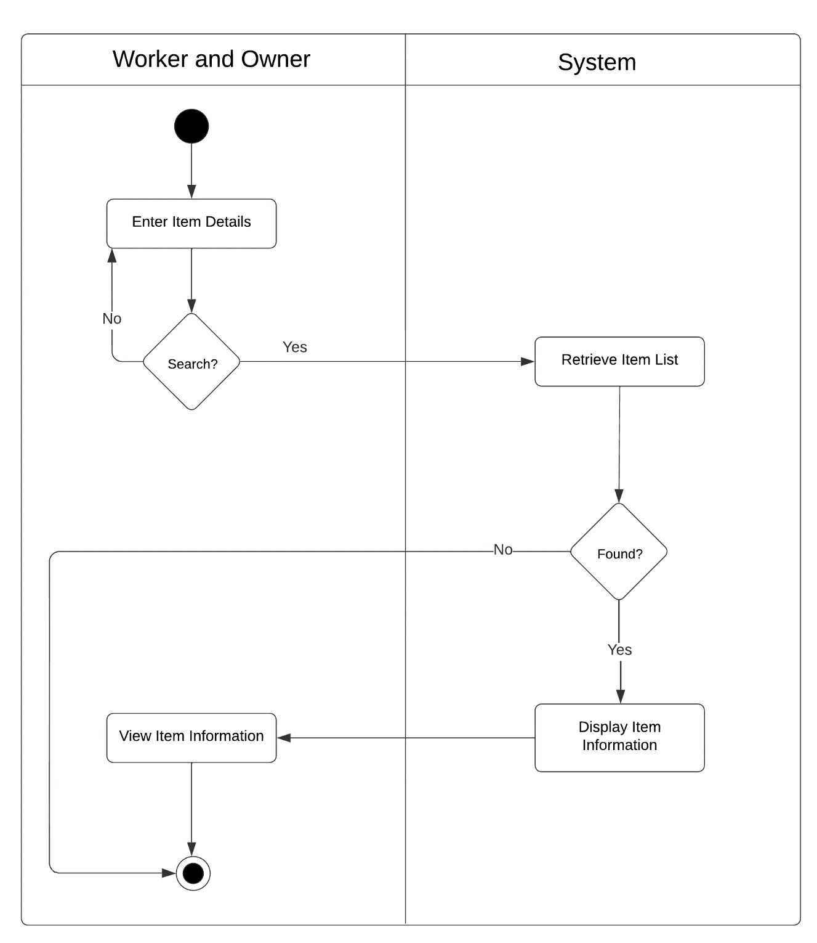

Figure 87: Activity Diagram of Web-based Piggery Management System Search Item Details Inventory Management Module Use Case

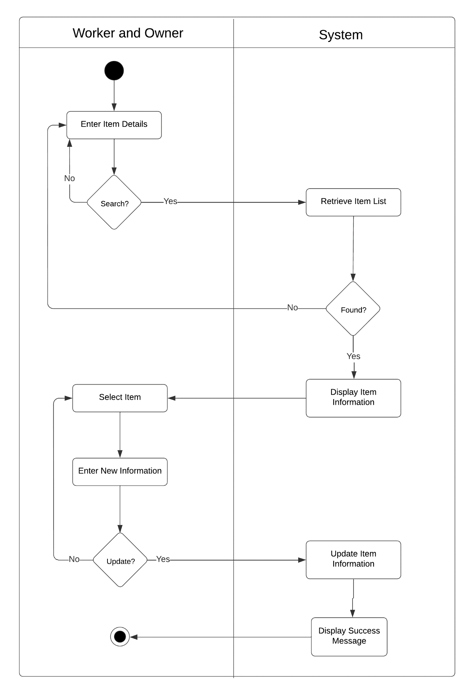

Figure 88: Activity Diagram of Web-based Piggery Management System Add Purchase Request Inventory Management Module Use Case

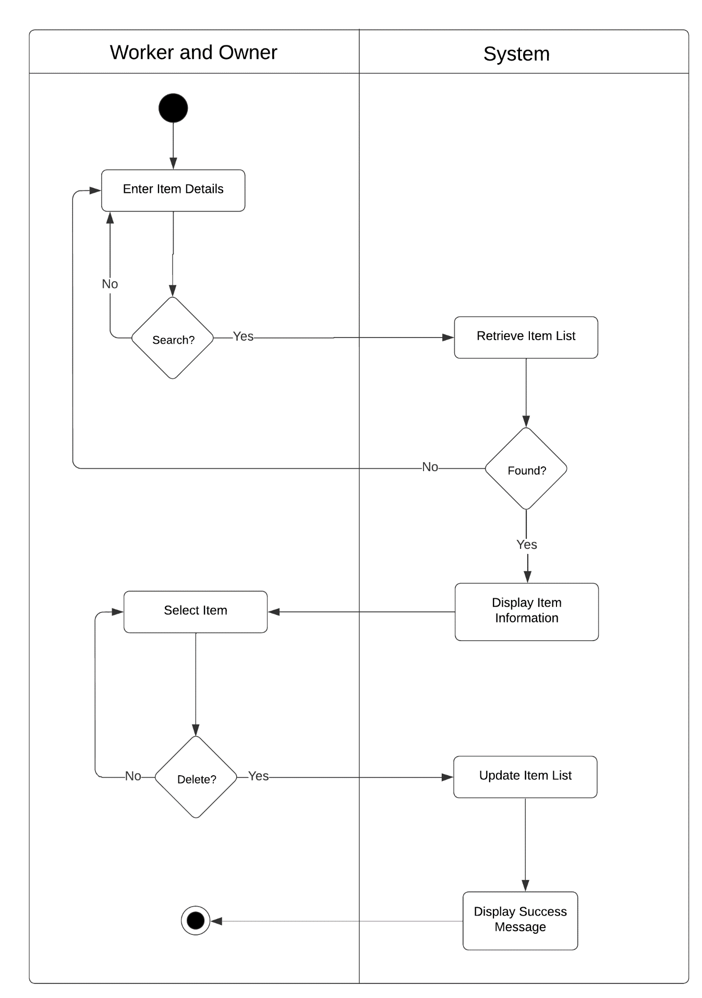

Figure 89: Activity Diagram of Web-based Piggery Management System Add Purchase Request Inventory Management Module Use Case

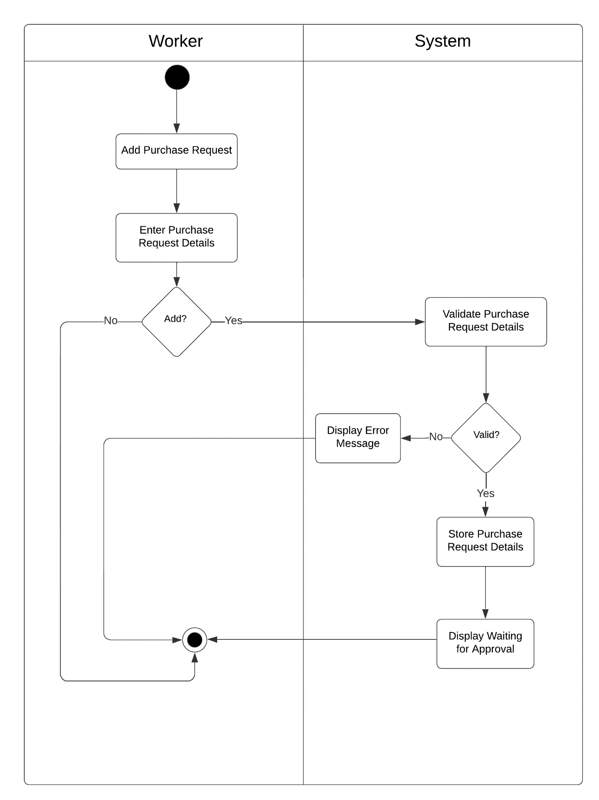

Figure 90: Activity Diagram of Web-based Piggery Management System Add Purchase Request Inventory Management Module Use Case

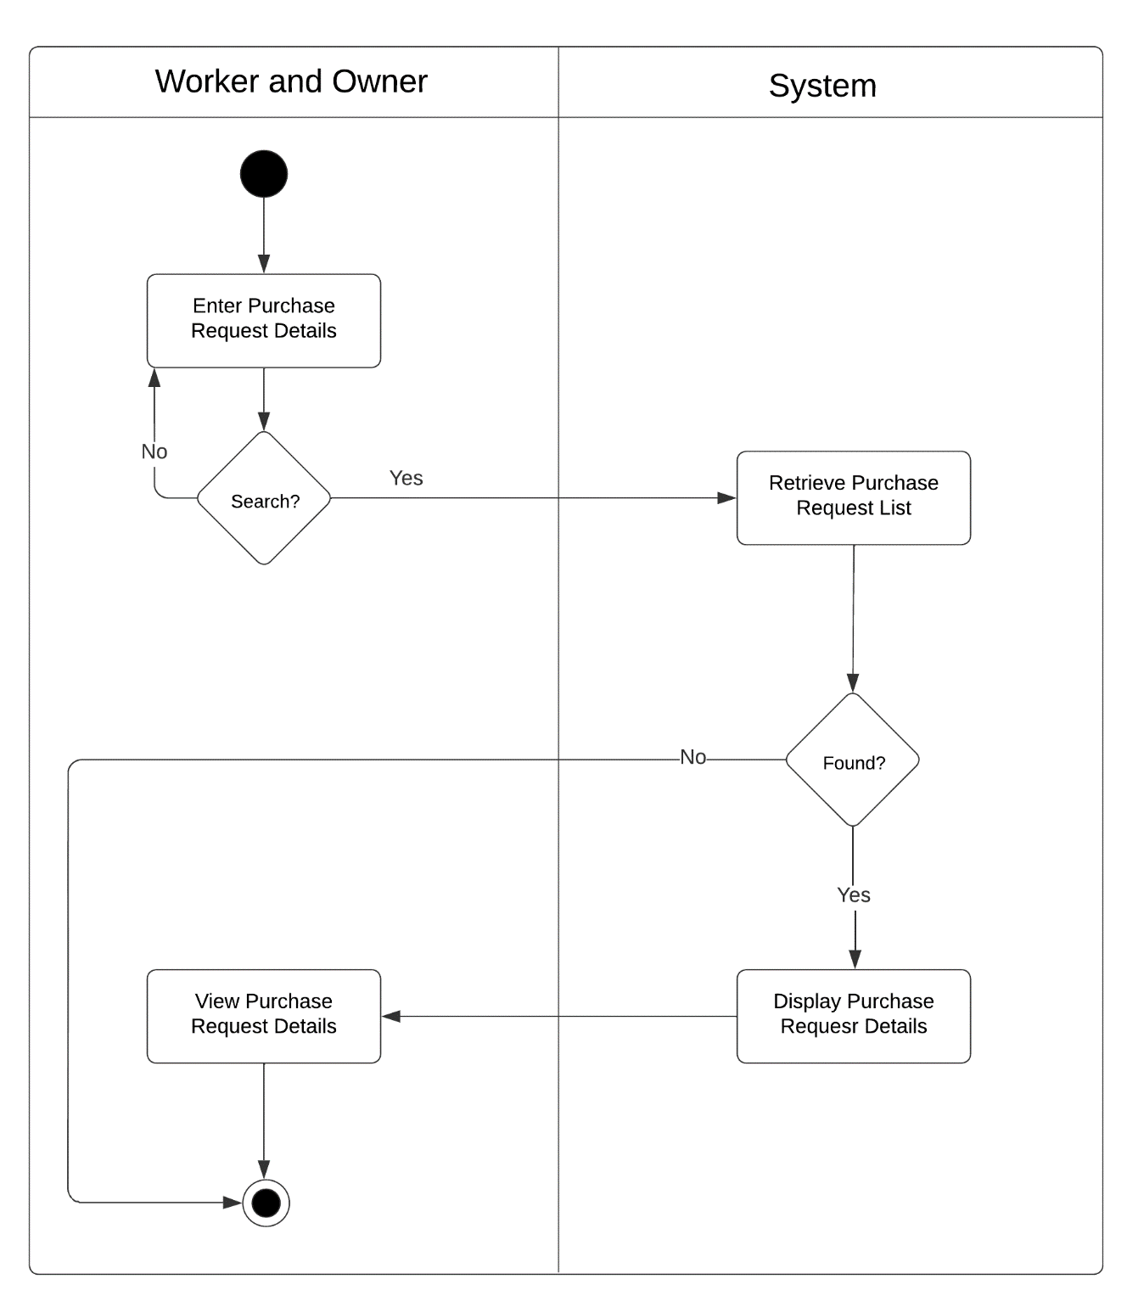

Figure 91: Activity Diagram of Web-based Piggery Management System Add Purchase Request Inventory Management Module Use Case

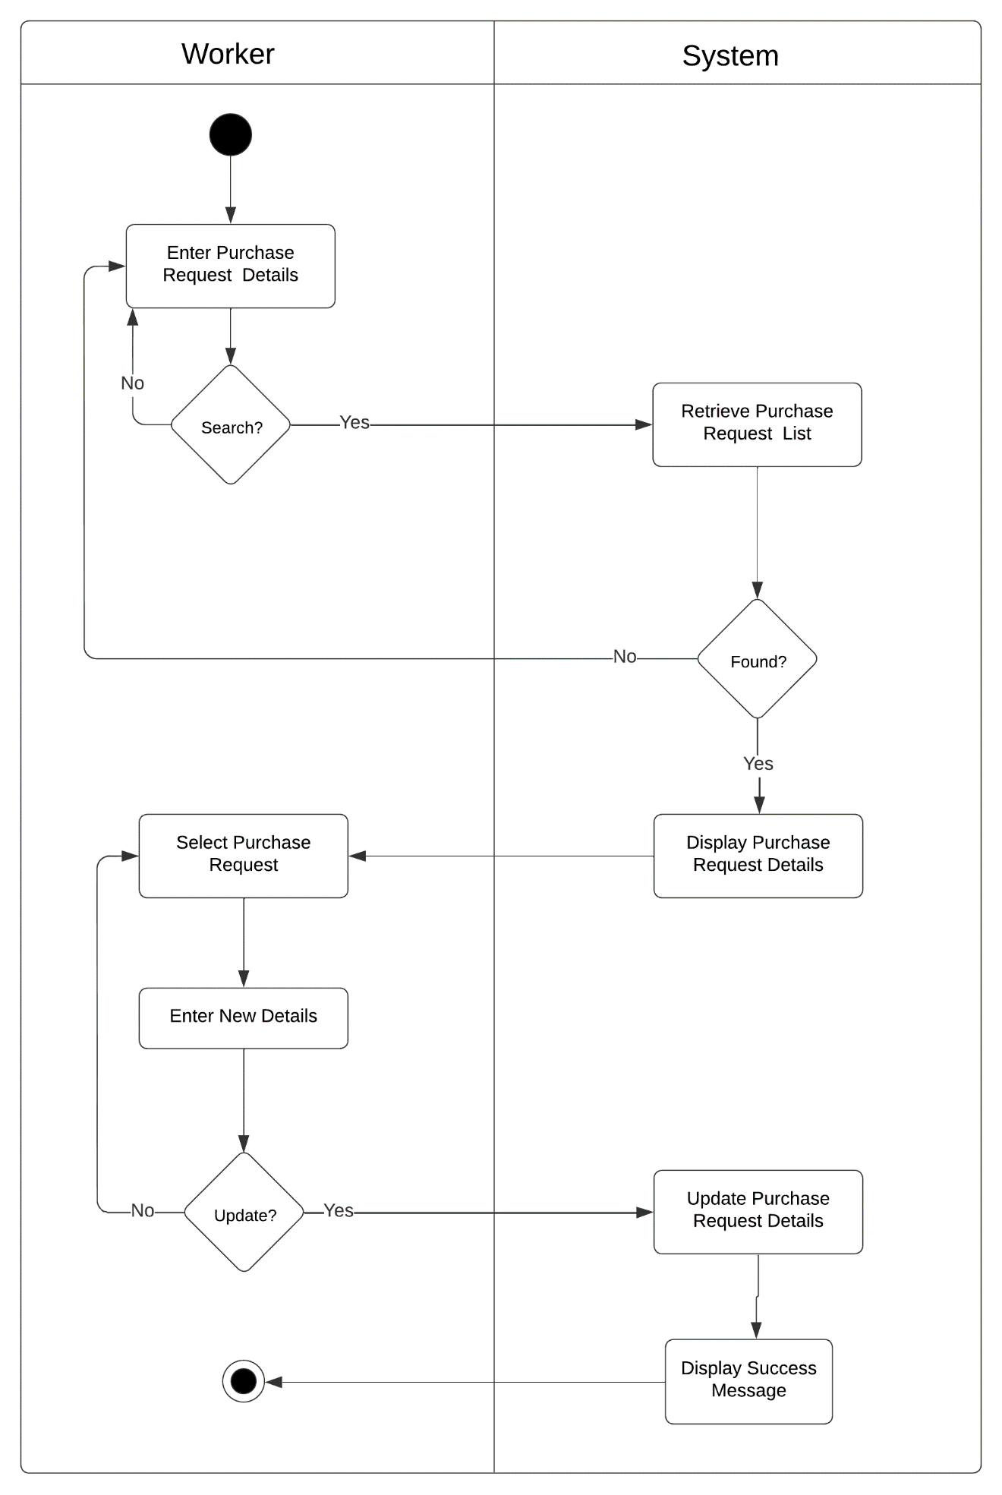

Figure 92: Activity Diagram of Web-based Piggery Management System Add Purchase Request Inventory Management Module Use Case

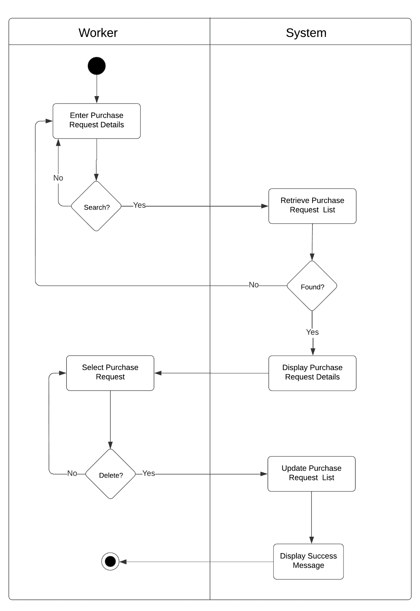

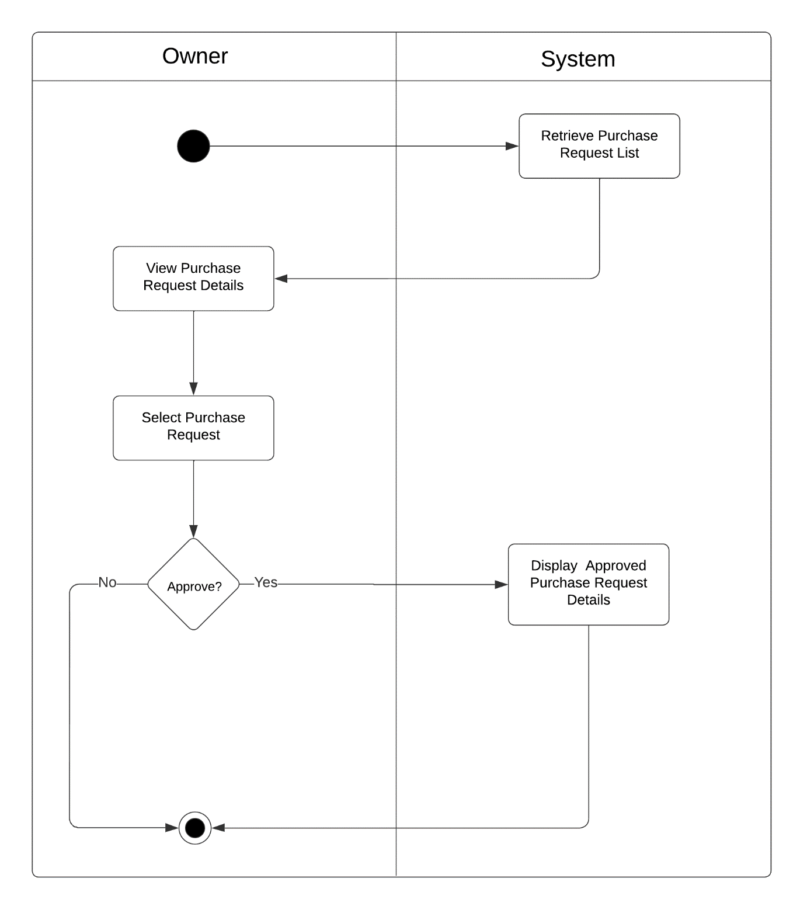Figure 93: Activity Diagram of Web-based Piggery Management System Add Purchase Request Inventory Management Module Use Case

Figure 94: Activity Diagram of Web-based Piggery Management System Add Purchase Request Inventory Management Module Use Case

User Management Module

|  |  |  |
| --- | --- | --- |
| Use Case | Description | User/Actor (Roles) |
| Login | The user selects login button to login to user interface user management module. | Owner, Worker, Veterinarian |
| Add new user | The user selects add new user to create new user. | Owner, Worker, Veterinarian |
| Search user | The user selects the search field to search the user. | Owner, Worker, Veterinarian |
| Log out | The user selects log out module to log out from the system. | Owner, Worker, Veterinarian |

Table 14: Event Decomposition of the Piggery Management System User Management Module

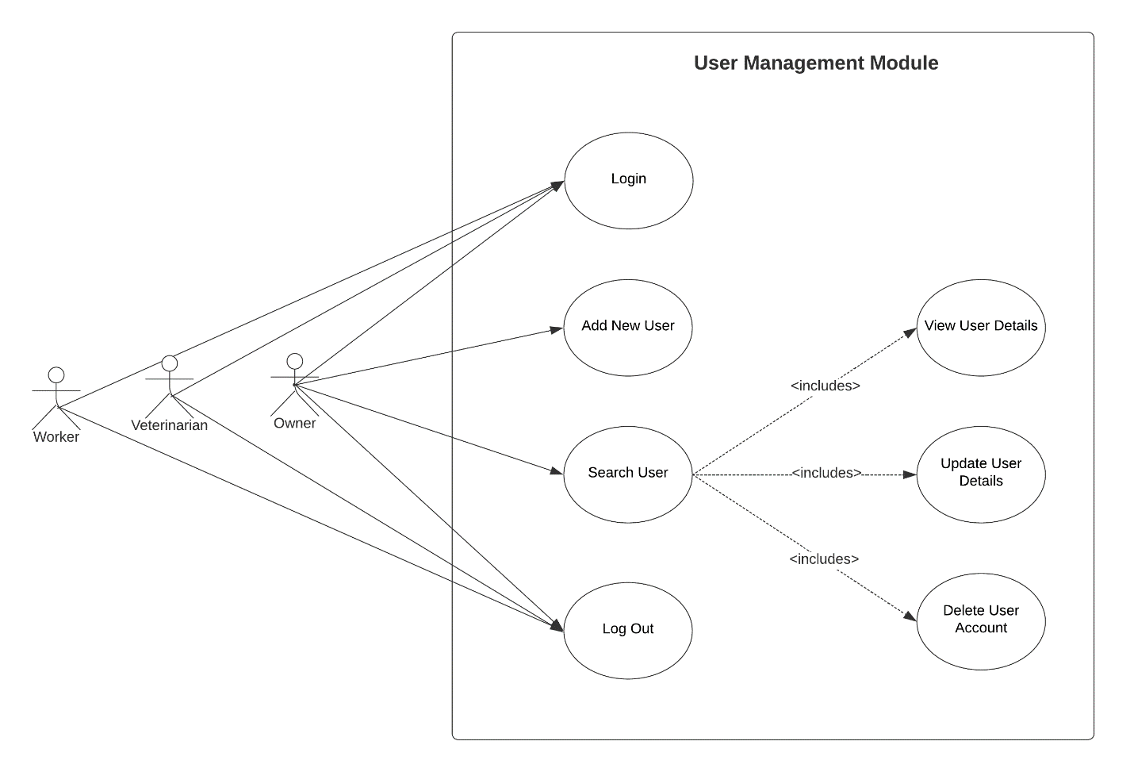

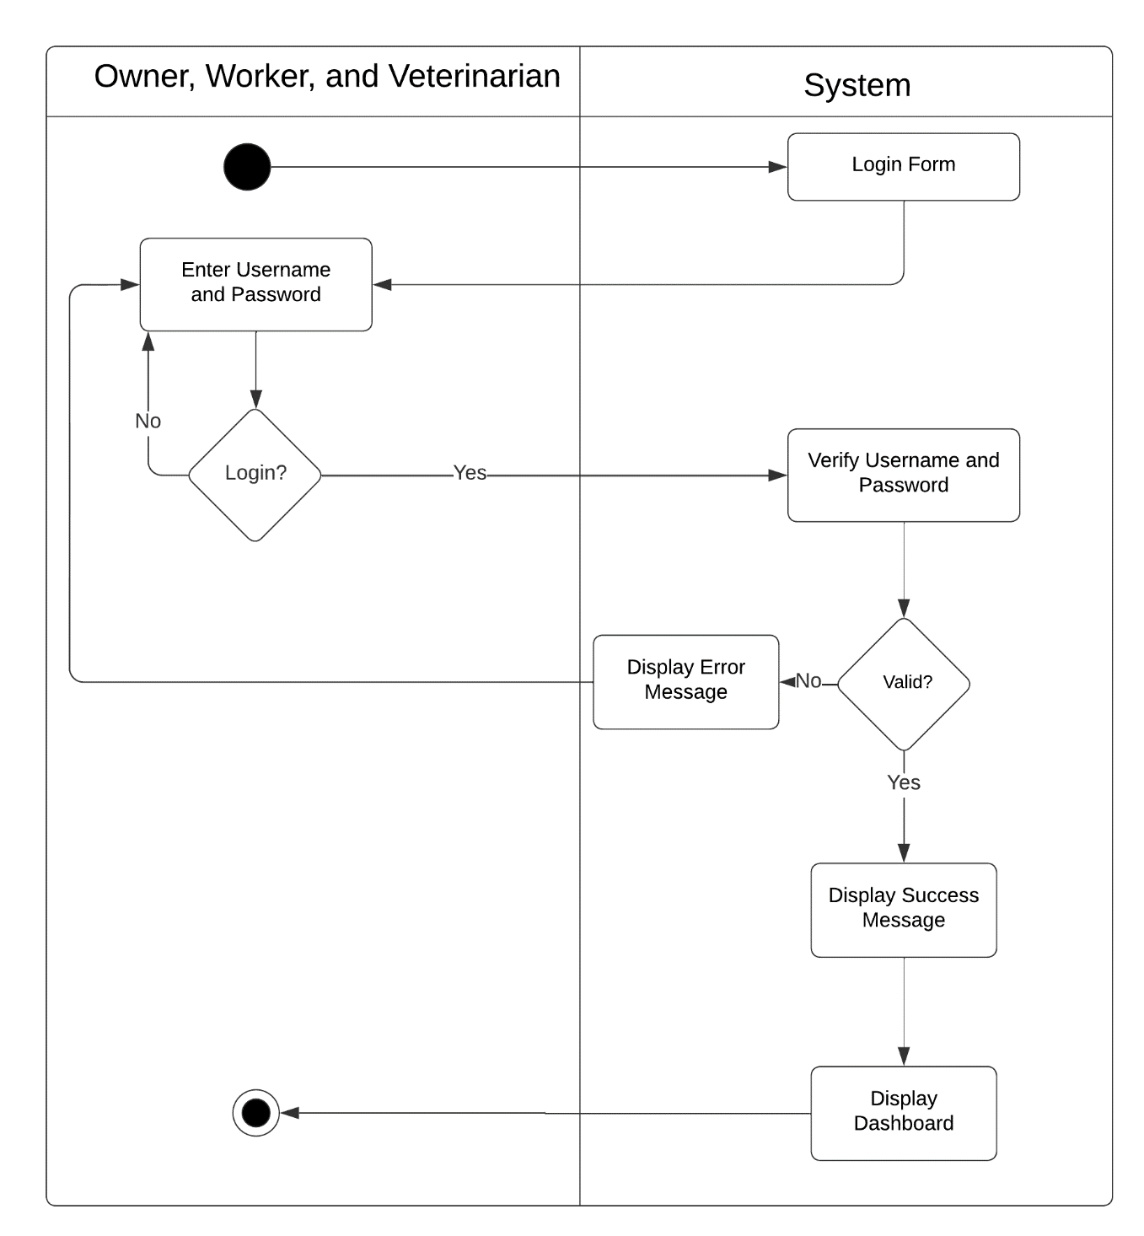

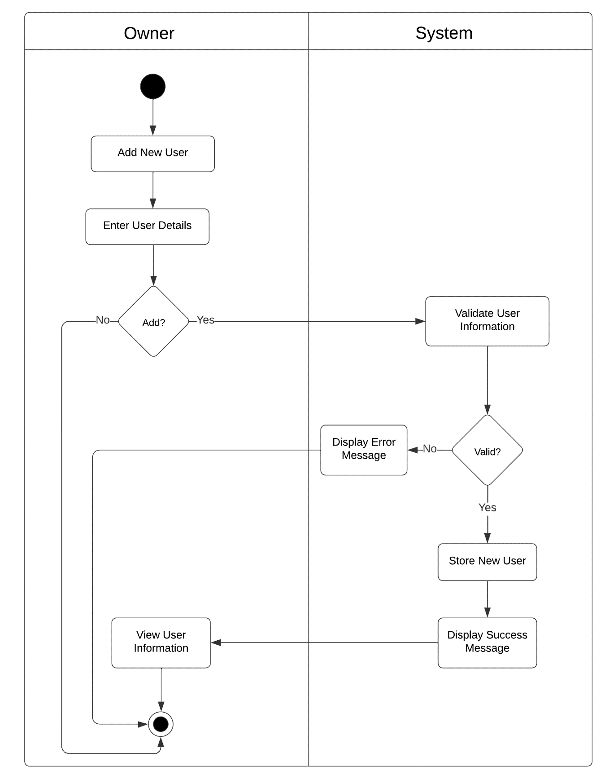

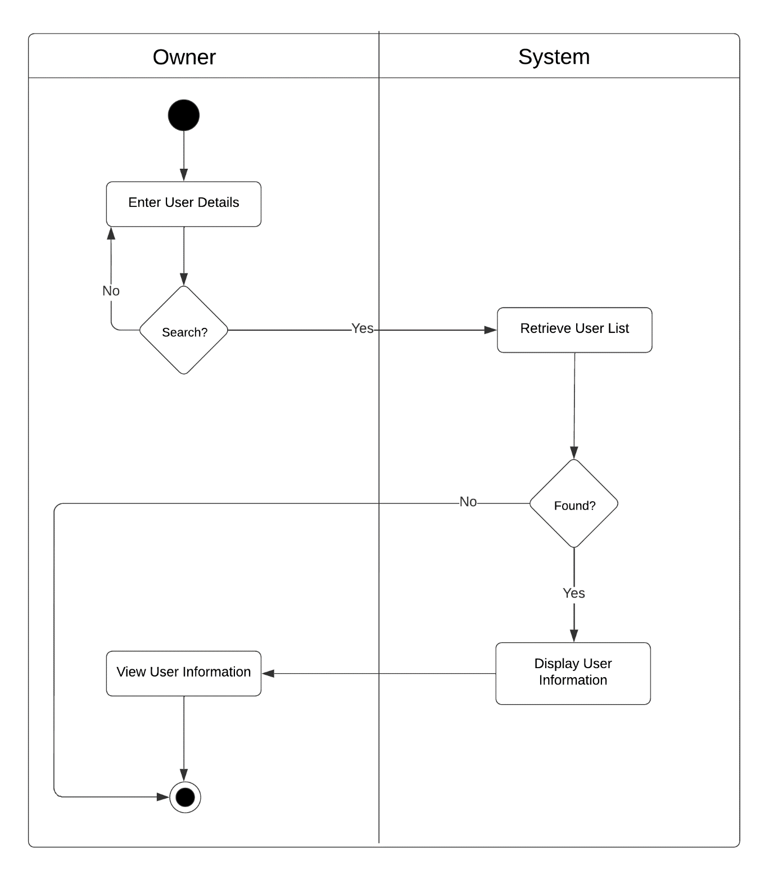

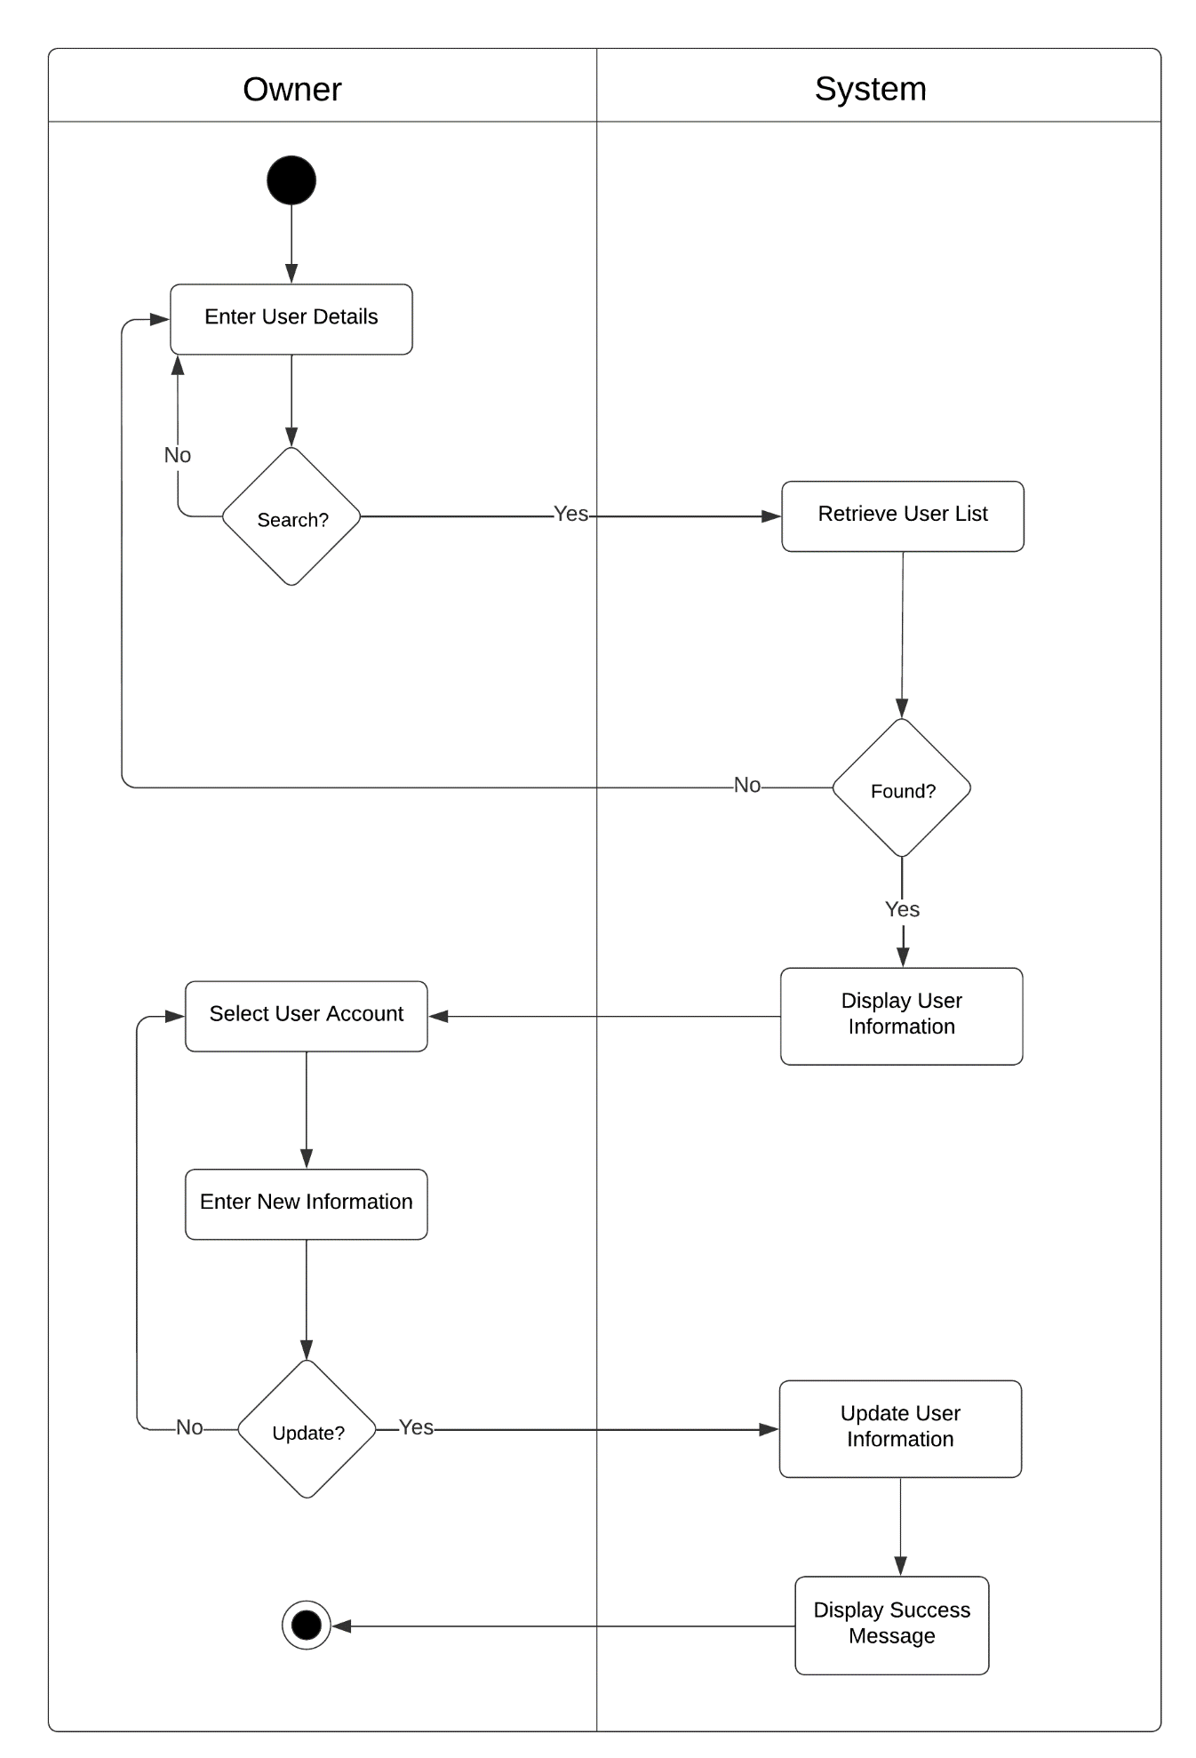

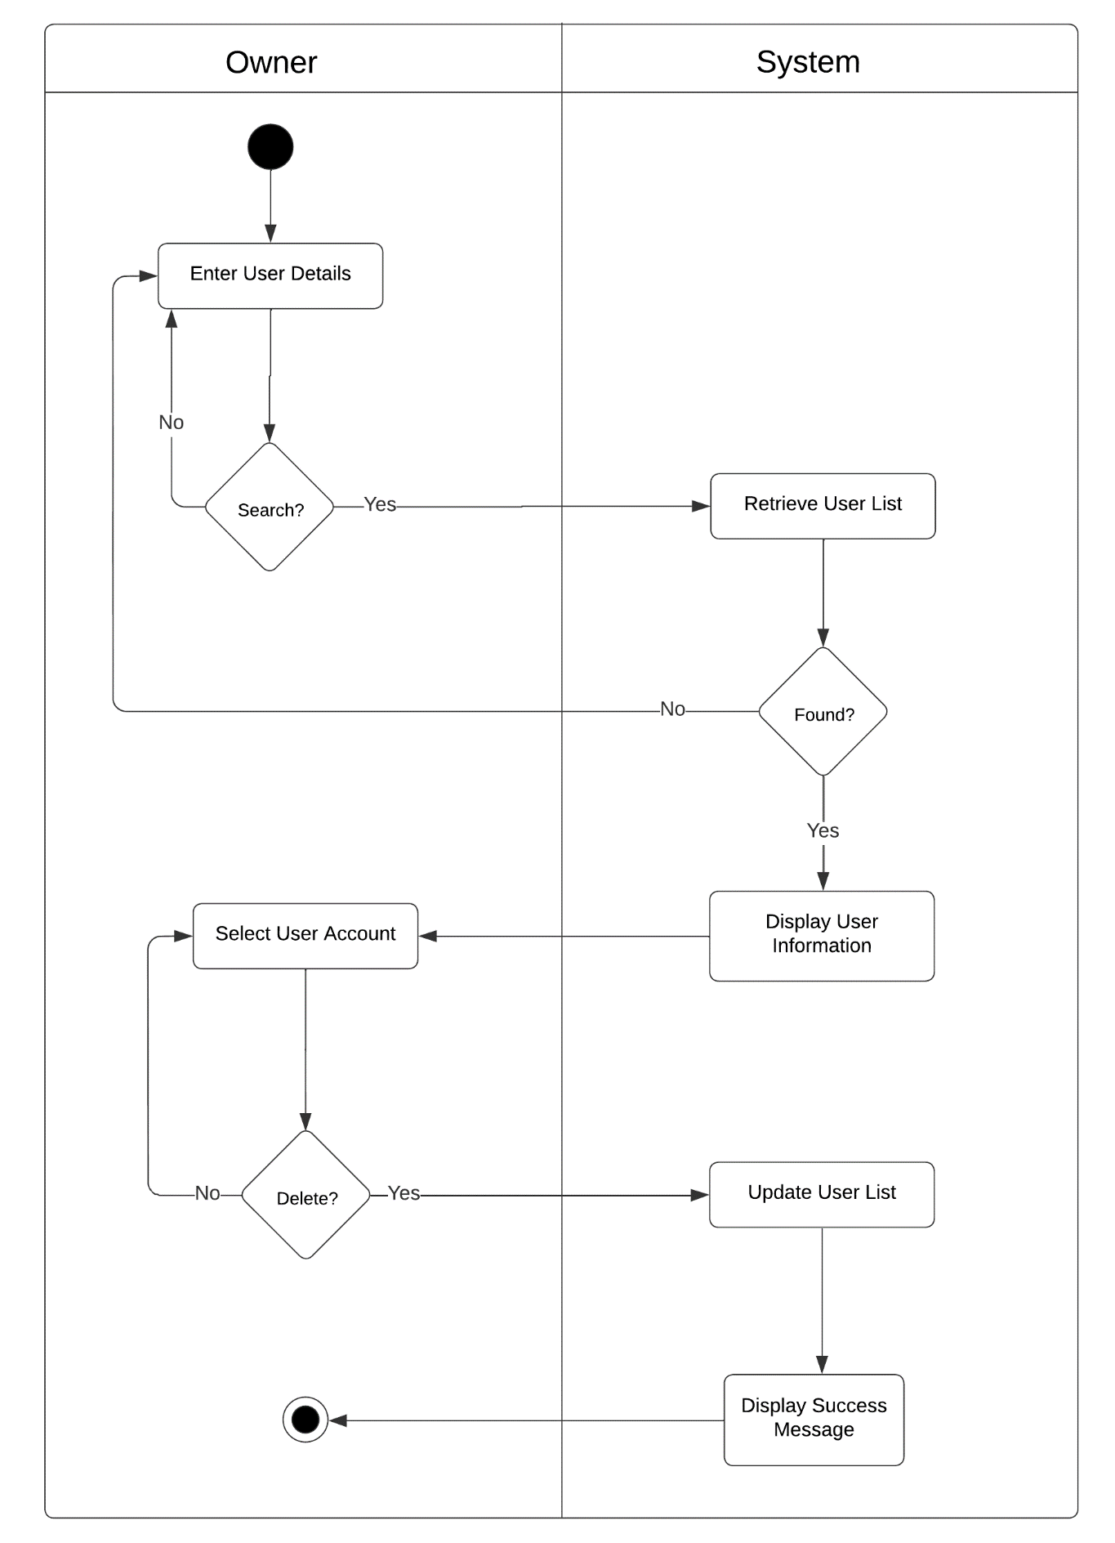

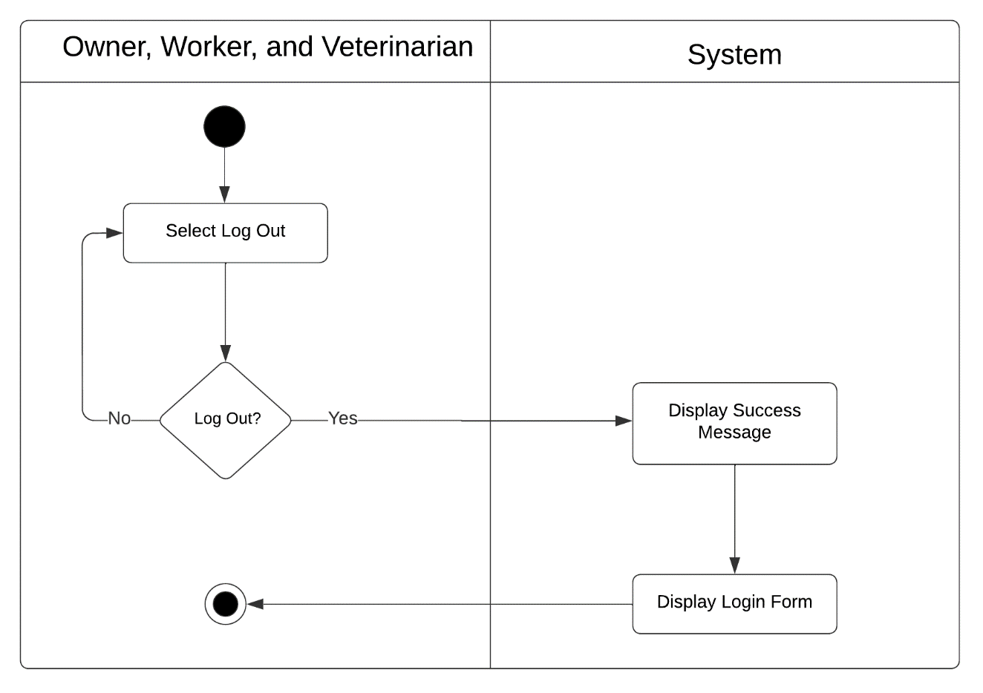

Back-up & Restore Module

|  |  |  |
| --- | --- | --- |
| Use Case | Description | User/Actor (Roles) |
| List of Data | The user selects the data to restore and delete data. | Owner |
| Restore list of data | The user selects the data to restore the list. | Owner |
| Delete data list | The user selects data to delete from the list. | Owner |

Table 12: Event Decomposition of the Piggery Management System Back-up & Restore Module

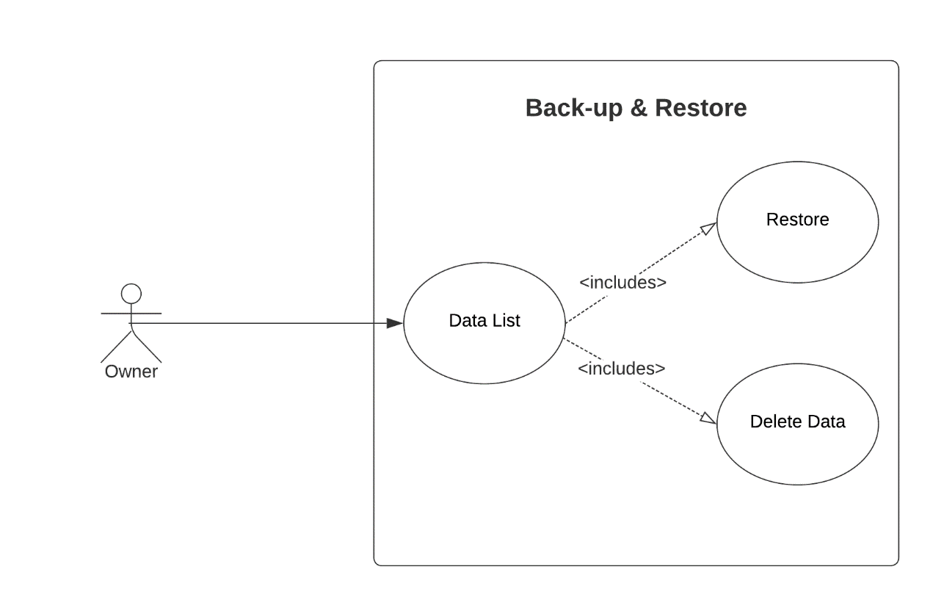

Figure 102: Use Case Diagram involving the Owner of Piggery Management System Back-up & Restore Module

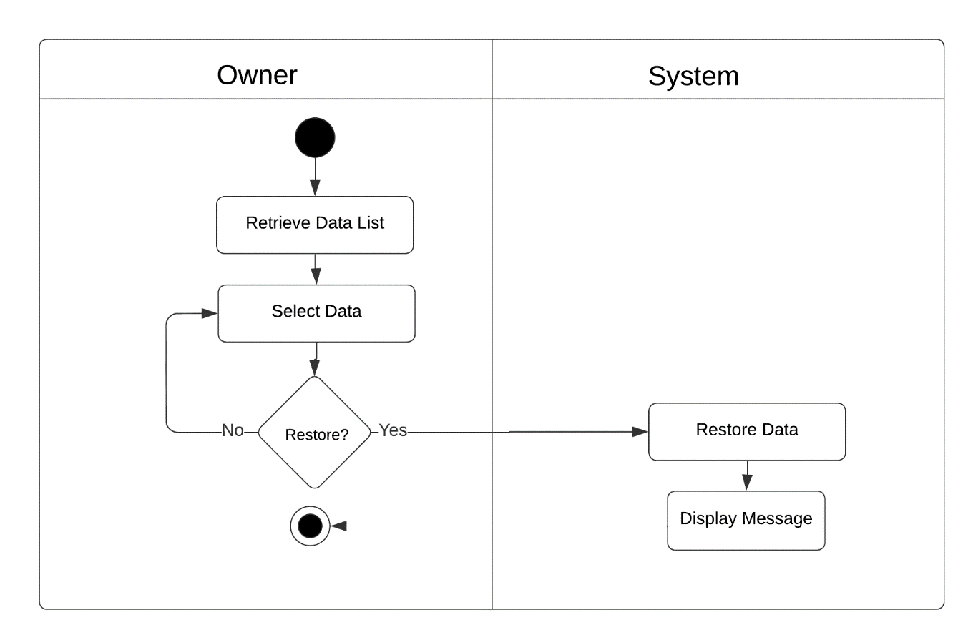

Figure 103: Activity Diagram of Restore Data Module Use Case

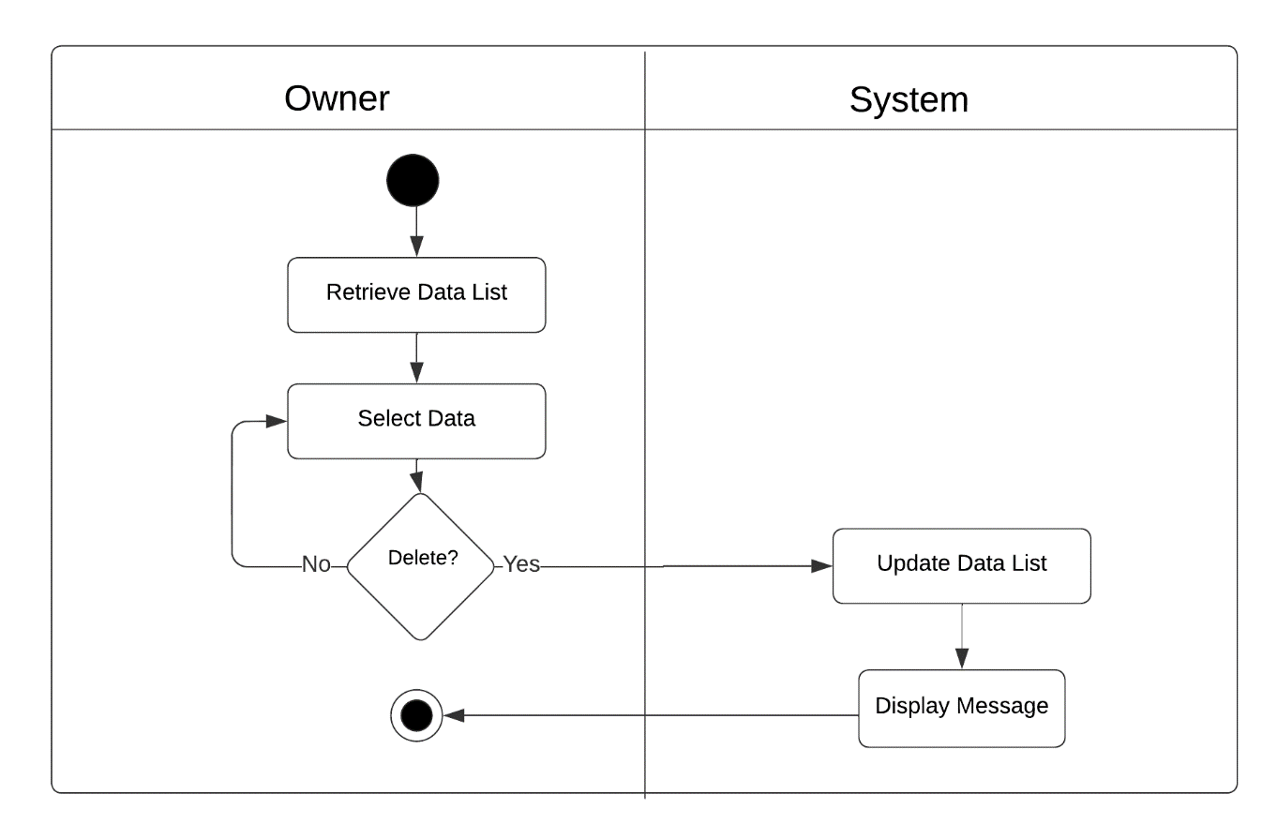

Figure 104: Activity Diagram of Delete Data Module Use Case

Conceptual Database Model

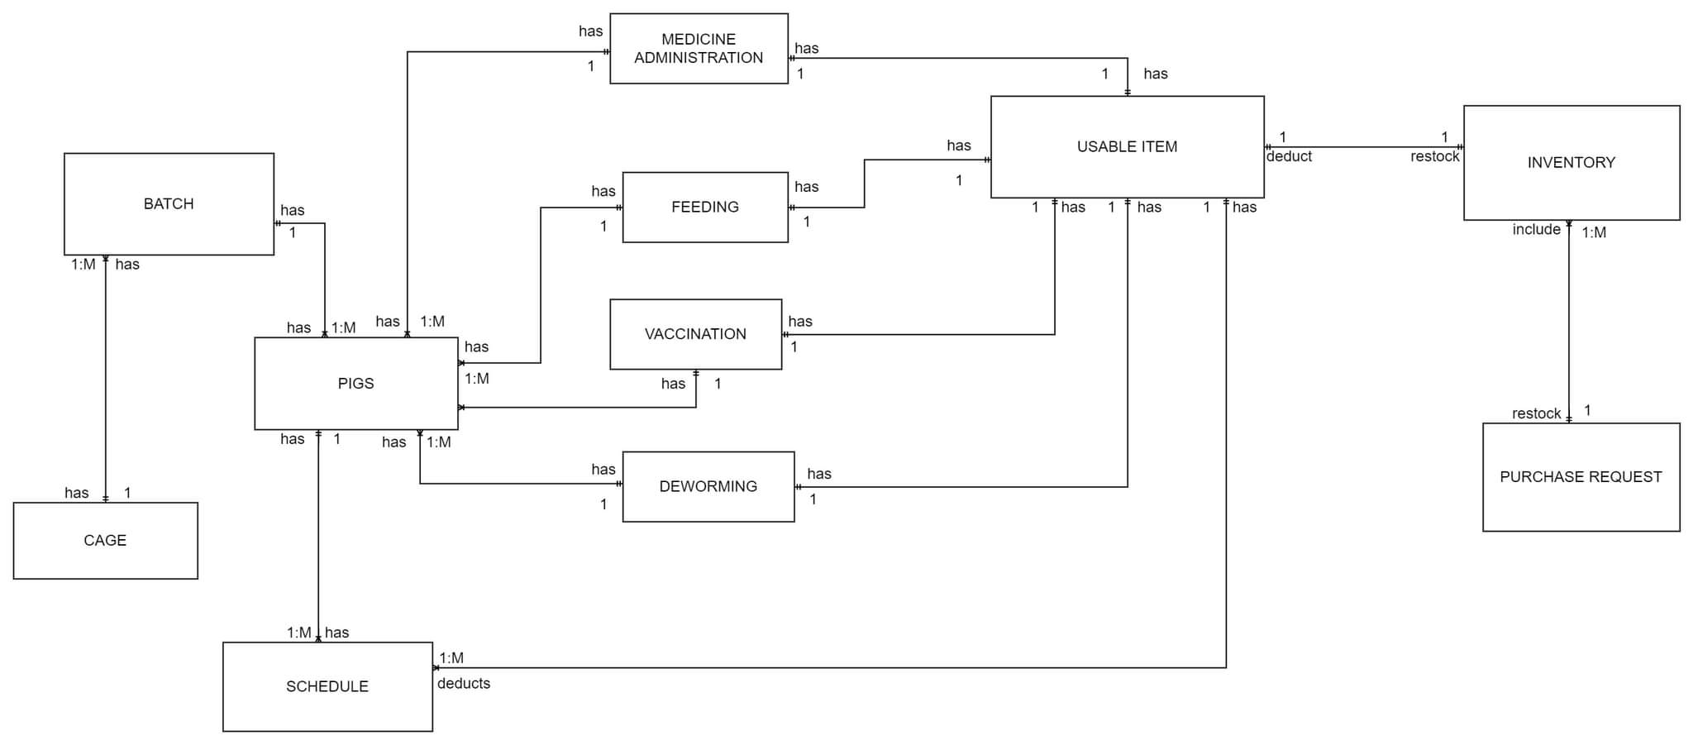

Figure 105: Conceptual Data Model of Web-Based Piggery Management System

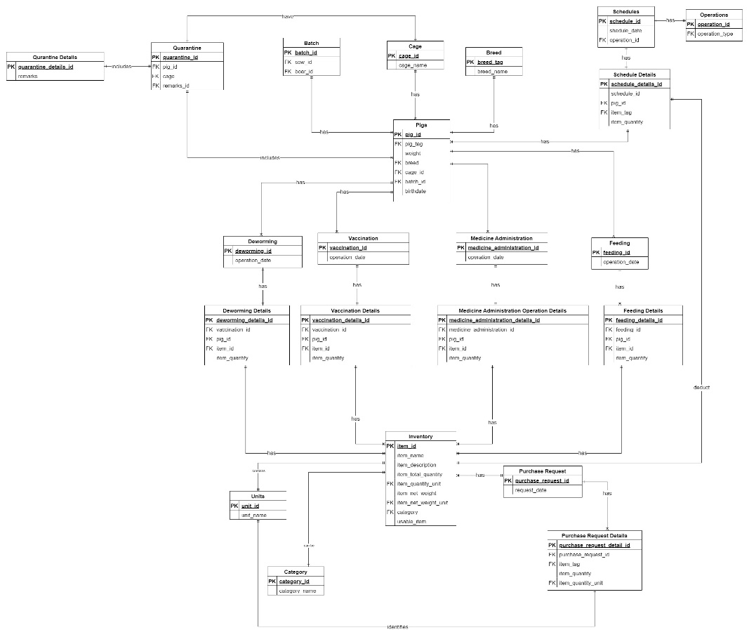

Figure 106: Logical Data Model of Web-Based Piggery Management System

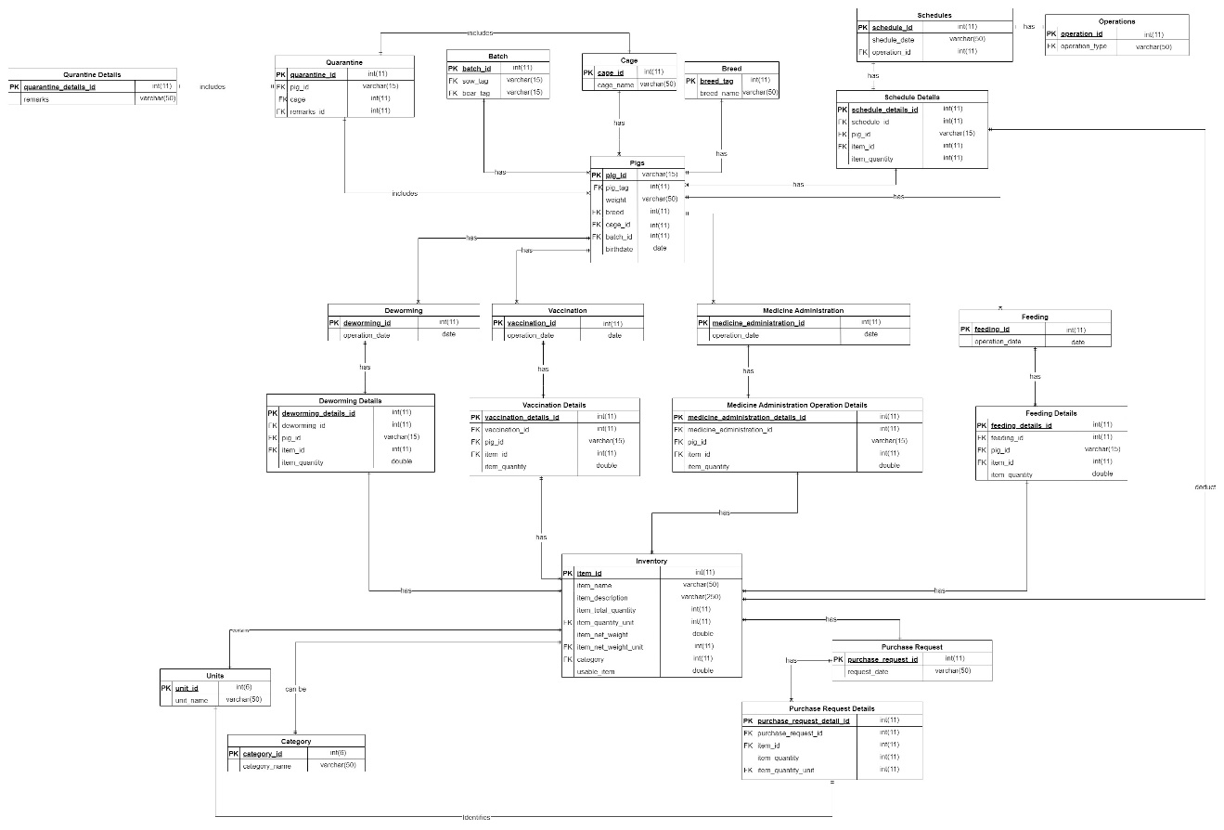

Figure 107: Physical Database Model of Web-Based Piggery Management System

Normalization

Pigs

|  |  |  |  |  |  |  |
| --- | --- | --- | --- | --- | --- | --- |
| pig_tag | weight | breed | birthdate | batch | cage | cage_max |
| 1 | 50kg | Large White | 08/05/2021 | 1 | r1c1 | 1 |
| 2 | 51kg | Duroc | 08/05/2021 | 1 | r1c2 | 1 |
| 2 | 49kg | Duroc | 08/05/2021 | 1 | r1c3 | 1 |
| 4,5 | 20kg | Duroc | 13/10/2022 | 2 | r1c4 | 12 |

Figure #2. Pigs-0NF

Figure 2 shows that pig table is in the unnormalized Form because attribute pig_tag is multi-valued and can’t be atomic.

Pigs

|  |  |  |  |  |  |  |  |
| --- | --- | --- | --- | --- | --- | --- | --- |
| pig_id | pig_tag | weight | breed | birthdate | batch | cage | cage_max |
| pig_hkl525 | 1 | 50kg | Large White | 08/05/2021 | 1 | r1c1 | 1 |
| pig_1dsw52 | 2 | 51kg | Duroc | 08/05/2021 | 1 | r1c2 | 1 |
| pig_658hkj | 2 | 49kg | Duroc | 08/05/2021 | 1 | r1c3 | 1 |
| pig_23daf | 4 | 20kg | Duroc | 13/10/2022 | 2 | r1c4 | 12 |
| pig_523ds | 5 | 20kg | Duroc | 13/10/2022 | 2 | r1c4 | 12 |

Figure #3. Pigs-1NF

Figure 3 shows that the attributes in Figure 2 which is the pig_tag is now atomic which makes Figure 3 in First Normal Form.

Pigs

|  |  |  |  |  |  |  |
| --- | --- | --- | --- | --- | --- | --- |
| pig_id | pig_tag | weight | breed | birthdate | batch | cage |
| pig_hkl525 | 1 | 50kg | Large White | 08/05/2021 | 1 | 1 |
| pig_1dsw52 | 2 | 51kg | Duroc | 08/05/2021 | 1 | 2 |
| pig_658hkj | 2 | 49kg | Duroc | 08/05/2021 | 1 | 3 |
| pig_23daf | 4 | 20kg | Duroc | 13/10/2022 | 2 | 4 |
| pig_523ds | 5 | 20kg | Duroc | 13/10/2022 | 2 | 4 |

Figure 4. Pigs-2NF

Breed

|  |  |
| --- | --- |
| breed_id | breed_name |
| 1 | Duroc |
| 2 | large_white |

Figure #5. Breed-2NF

Cage

|  |  |  |
| --- | --- | --- |
| cage_id | cage_name | cage_max |
| 1 | r1c1 | 1 |
| 2 | r1c2 | 1 |
| 3 | r1c3 | 1 |
| 4 | r1c4 | 12 |

Figure #6. Cage-2NF

Figure 4 is in Second Normal Form because there is no partial dependencies to achieve that figure 5 and figure 6 is created based on First Normal Form figure 2. Attribute pig_id is assigned as the primary key for figure 4 ,attribute breed_id is assigned as the primary key for figure 5 and lastly in figure 6 cage_id

Cage

|  |  |
| --- | --- |
| cage_name | cage_max |
| r1c1 | 1 |
| r1c2 | 1 |
| r1c3 | 1 |
| r1c4 | 12 |

Figure #7 Cage-0NF

Figure 7 show table cage which in Unnormalized form .It is unnormalized because cage_name and cage_max attribute cannot be identified as unique even they are in their atomic form.

Cage

|  |  |  |
| --- | --- | --- |
| cage_id | cage_name | cage_max |
| 1 | r1c1 | 1 |
| 2 | r1c2 | 1 |
| 3 | r1c3 | 1 |
| 4 | r1c4 | 12 |

Figure #8 Cage-1NF

Figure 8 shows the first normal form of cage which now has its own primary key to identify the attributes cage_name and cage_max.This normal form is also considered in second and third normal form as there is already no transitive and partial dependencies.

Purchase Request

|  |  |  |  |  |
| --- | --- | --- | --- | --- |
| request_date | Item_id | Item_name | Item_description | Item_quantity |
| 12/29/2022 | 1,2,3 | IverMictin, B-MEG Premium Grower,B-Complex | 12 gram Dewormer, 50kg 1 Sack Grower Feeds, 15mg 1 Bottle B-Complex Vitamins | 25 pcs,25pcs |

Figure #9 Purchase Request-0NF

Figure 9 shows the unnormalized form of purchase request this shows multi-value attributes in item_id,item_name,item_description and item_quantity.

|  |  |  |  |  |  |  |
| --- | --- | --- | --- | --- | --- | --- |
| purchase_request_id | request_date | item_id | item_name | item_description | item_quantity | item_quantity_unit |
| 1 | 12/29/2022 | 1 | IverMictin | 12 gram Dewormer | 25 | pcs |
| 2 | 12/29/2022 | 2 | B-MEG Premium Grower | 50kg 1 Sack Grower Feeds | 25 | pcs |
| 3 | 12/29/2022 | 3 | B-Complex | 15mg 1 Bottle B-Complex Vitamins | 25 | pcs |

Figure #10 Purchase Request-1NF

Figure 10 shows the First normal form of Purchase Request.Multi-valued attributes are now separated into separate rows and added primary key attribute purchase_request_id. All of attributes are now in its atomic form.

Purchase Request

|  |  |
| --- | --- |
| purchase_request_id | request_date |
| 1 | 12/29/2022 |
| 2 | 12/29/2022 |
| 3 | 12/29/2022 |

Figure #11 Purchase Request -2NF

Purchase Request Details

|  |  |  |  |  |
| --- | --- | --- | --- | --- |
| purchase_request_details_id | purchase_request_details_id | item_ID | item_quantity | item_quantity_unit |
| 1 | 1 | 1 | 25 | 1 |
| 2 | 2 | 2 | 25 | 1 |
| 3 | 3 | 3 | 25 | 1 |

Figure #12 Purchase Request Details-2NF

Units

|  |  |
| --- | --- |
| unit_id | unit_name |
| 1 | pcs |

Figure #13 Purchase Request Details-2NF

Figure 11 ,12, and 13 shows the result of splitting Figure 10 to remove partial dependencies. purchase_request_id was assigned to be the primary key of Figure 11 in Figure 12 purchase_request_details_id is assigned to its primary key while on figure #13 it is unit_id. Other than that figure 11,12, and 13 has no transitive dependencies so it is considered in its third normal form.

Inventory

|  |  |  |  |  |  |
| --- | --- | --- | --- | --- | --- |
| Item_name | Item_description | Item_quantity | item_net_weight | usable_item | category |
| IverMictin | 12 gram Dewormer | 12pcs | 100g | 100 | dewormer |
| B-MEG Premium Grower | 50kg 1 Sack Grower Feeds | 5sack | 50kg | 250 | feeds |
| B-Complex | 15mg 1 Bottle B-Complex Vitamins | 2pcs | 15mg | 45 | medicine |

Figure #14 Inventory-0NF

Figure 14 shows the unnormalized form of Inventory table. It contains non atomic attributes like item_quantity and item_net_weight.

Inventory

|  |  |  |  |  |  |  |  |  |
| --- | --- | --- | --- | --- | --- | --- | --- | --- |
| item_id | item_name | Item_description | Item_quantity | item_quantity_unit | item_net_weight | item_net_weight_unit | usable_item | category |
| 1 | IverMictin | 12 gram Dewormer | 12 | g | 100 | g | 100 | dewormer |
| 2 | B-MEG Premium Grower | 50kg 1 Sack Grower Feeds | 5 | kg | 50 | kg | 250 | feeds |
| 3 | B-Complex | 15mg 1 Bottle B-Complex Vitamins | 2 | mg | 15 | mg | 45 | medicine |

Figure #15 Inventory-1NF

Figure 15 shows the first normal form of Inventory table which non atomic attributes mentioned in figure 14 was removed by creating their own respective attributes. Other than that, item_id attributes was added to be assigned as primary key of figure 15.

Inventory

|  |  |  |  |  |  |  |  |  |
| --- | --- | --- | --- | --- | --- | --- | --- | --- |
| item_id | item_name | Item_description | item_quantity | item_quantity_unit | item_net_weight | item_net_weight_unit | usable_item | category |
| 1 | IverMictin | 12 gram Dewormer | 12 | 1 | 100 | 1 | 100 | 1 |
| 2 | B-MEG Premium Grower | 50kg 1 Sack Grower Feeds | 5 | 2 | 50 | 2 | 250 | 2 |
| 3 | B-Complex | 15mg 1 Bottle B-Complex Vitamins | 15 | 3 | 15 | 3 | 45 | 3 |

Figure #16 Inventory-2NF

Units

|  |  |
| --- | --- |
| unit_id | unit_name |
| 1 | g |
| 2 | kg |
| 3 | mg |

Figure #17 Units-2NF

Category

|  |  |
| --- | --- |
| category_id | category_name |
| 1 | dewormer |
| 2 | feeds |
| 3 | medicine |

Figure #18 Category-2NF

Figure 16,17,18 shows the second normal form of Inventory. Figure 16 shows no atomic attributes while unit is referenced into Figure 17 which is using unit_id as primary key and category referenced into figure 18 which uses attribute category_id as their primary key. figure 16,17,18 is considered as in third normal form as it do not have transitive dependencies can be identified.

Batch

|  |
| --- |
| origin_tags |
| 1,2 |
| 1,2 |

Figure #19 Batch-0NF

Figure 19 shows the unnormalized form of batch where orgin_tags is multi-valued.

Batch

|  |  |  |
| --- | --- | --- |
| batch_id | sow_id | boar_id |
| 1 | 1 | 2 |
| 2 | 1 | 2 |

Figure #20 Batch-1NF

Figure 20 shows the first normal form of Batch where origin_tags in figure 19 is separated to their atomic value and assigned to their own respective attributes. Furthermore batch_id is added to be the primary key of figure 20.Figure 20 is also considered in its third normal form as there is no more transitive dependency that can be identified .

Schedule

|  |  |  |  |  |  |  |
| --- | --- | --- | --- | --- | --- | --- |
| operation_type | Schedule_date | Pig_id | Item_tag | Item_name | Item_description | Item_quantity |
| Feeding | 12/22/2022 | pig_hkl525 | 1 | IverMictin | 12 gram Dewormer | 0.5g |
| Deworming | 12/12/2022 | pig_1dsw52 | 2 | B-MEG Premium Grower | 50kg 1 Sack Grower Feeds | 5 kg |
| Medicine Administration | 12/14/2022 | pig_658hkj | 3 | B-Complex | 15mg 1 Bottle B-Complex Vitamins | 0.5mg |

Figure #21 Schedule-0NF

Figure 21 shows the table Schedule which contains attributes with non-atomic value like item_quantity.

|  |  |  |  |  |  |  |  |  |
| --- | --- | --- | --- | --- | --- | --- | --- | --- |
| schedule_id | pig_id | operation_type | schedule_date | item_tag | item_name | item_description | item_quantity | units |
| 1 | pig_hkl525 | Feeding | 12/22/2022 | 1 | IverMictin | 12 gram Dewormer | 0.5 | g |
| 2 | pig_1dsw52 | Deworming | 12/12/2022 | 2 | B-MEG Premium Grower | 50kg 1 Sack Grower Feeds | 5 | kg |
| 3 | pig_658hkj | Medicine | 12/14/2022 | 3 | B-Complex | 15mg 1 Bottle B-Complex Vitamins | 0.5 | mg |

Figure #22 Schedule-1NF

Figure 22 shows the table Schedule with attributes that are atomic . It resulted in adding new attribute units.

Schedule

|  |  |  |
| --- | --- | --- |
| schedule_id | schedule_date | operation_id |
| 1 | 12/22/2022 | 1 |
| 2 | 12/12/2022 | 2 |
| 3 | 12/14/2022 | 3 |

Figure #23 Schedule-2NF

Operation

|  |  |
| --- | --- |
| operation_id | operation_type |
| 1 | Feeding |
| 2 | Deworming |
| 3 | Medicine Administration |

Figure #24 Operation-2NF

Units

|  |  |
| --- | --- |
| unit_id | unit_name |
| 1 | g |
| 2 | kg |
| 3 | mg |

Figure #25 Units-2NF

Schedule Details

|  |  |  |  |  |  |
| --- | --- | --- | --- | --- | --- |
| schedule_details_id | schedule_id | pig_id | Item_tag | Item_quantity | units |
| 1 | 1 | pig_hkl525 | 1 | 0.5 | 1 |
| 2 | 2 | pig_1dsw52 | 2 | 5 | 2 |
| 3 | 3 | pig_658hkj | 3 | 0.5 | 3 |

Figure #26 Schedule Details-2NF

Figures 23,24,25,26 show table Schedule,Operation,Units,and Schedule Details which are atomic and no partial dependence . Figures 23,24,25,and 26 also has no partial dependencies which considered it as in their third normal form.

Feeding

|  |  |  |  |  |  |
| --- | --- | --- | --- | --- | --- |
| operation_date | pig_id | item_id | item_name | item_description | item_quantity |
| 12/22/2022 | pig_hkl525 | 1 | IverMictin | 12 gram Dewormer | 0.5 g |
| 12/12/2022 | pig_1dsw52 | 2 | B-MEG Premium Grower | 50kg 1 Sack Grower Feeds | 5 kg |
| 12/14/2022 | pig_658hkj | 3 | B-Complex | 15mg 1 Bottle B-Complex Vitamins | 0.5mg |

Figure #27 Feeding-0NF

Figure 27 shows the unnormalized feeding table. Attribute item_quantity contains non-atomic value .

Feeding

|  |  |  |  |  |  |  |  |
| --- | --- | --- | --- | --- | --- | --- | --- |
| feeding_id | operation_date | pig_id | item_id | item_name | item_description | item_quantity | item_quantity_unit |
| 1 | 12/22/2022 | pig_hkl525 | 1 | IverMictin | 12 gram Dewormer | 0.5 | g |
| 2 | 12/12/2022 | pig_1dsw52 | 2 | B-MEG Premium Grower | 50kg 1 Sack Grower Feeds | 5 | kg |
| 3 | 12/14/2022 | pig_658hkj | 3 | B-Complex | 15mg 1 Bottle B-Complex Vitamins | 0.5 | mg |

Figure #28 Feeding-1NF

Figure 28 shows the feeding table on its first normal form which contain atomic values for each attributes.

Feeding

|  |  |
| --- | --- |
| feeding_id | operation_date |
| 1 | 12/22/2022 |
| 2 | 12/12/2022 |
| 3 | 12/14/2022 |

Figure #29 Feeding-2NF

Feeding Details

|  |  |  |  |  |  |
| --- | --- | --- | --- | --- | --- |
| feeding_details_id | feeding_id | pig_id | item_id | item_quantity | item_unit |
| 1 | 1 | pig_hkl525 | 1 | 0.5 | 1 |
| 2 | 2 | pig_1dsw52 | 2 | 5 | 2 |
| 3 | 3 | pig_658hkj | 3 | 0.5 | 3 |

Figure #30 Feeding Details-2NF

Units

|  |  |
| --- | --- |
| unit_id | unit_name |
| 1 | g |
| 2 | kg |
| 3 | mg |

Figure #31 Units-2NF

Figures 29,30,31 shows the second normal form of figure 28 which split into 3 tables with their respective table name and attributes. Figures 29,30,31 is already in their third normal form because they do not contain any transitive dependency.

Deworming

|  |  |  |  |  |  |
| --- | --- | --- | --- | --- | --- |
| operation_date | pig_id | item_id | item_name | item_description | item_quantity |
| 12/22/2022 | pig_hkl525 | 1 | IverMictin | 12 gram Dewormer | 0.5 g |
| 12/12/2022 | pig_1dsw52 | 2 | B-MEG Premium Grower | 50kg 1 Sack Grower Feeds | 5 kg |
| 12/14/2022 | pig_658hkj | 3 | B-Complex | 15mg 1 Bottle B-Complex Vitamins | 0.5mg |

Figure #32 Deworming-0NF

Figure #32 shows the unnormalized table of deworming table. Because it contains non-atomic value in attribute item_quantity.

Deworming

|  |  |  |  |  |  |  |  |
| --- | --- | --- | --- | --- | --- | --- | --- |
| deworming_id | operation_date | pig_id | item_id | item_name | item_description | item_quantity | item_quantity_unit |
| 1 | 12/22/2022 | pig_hkl525 | 1 | IverMictin | 12 gram Dewormer | 0.5 | g |
| 2 | 12/12/2022 | pig_1dsw52 | 2 | B-MEG Premium Grower | 50kg 1 Sack Grower Feeds | 5 | kg |
| 3 | 12/14/2022 | pig_658hkj | 3 | B-Complex | 15mg 1 Bottle B-Complex Vitamins | 0.5 | mg |

Figure #33 Deworming-1NF

Figure 33 shows the first normal form of deworming table .Non-atomic value is removed which resulted in adding new attribute called item_quantity_unit.

Deworming

|  |  |
| --- | --- |
| deworming_id | operation_date |
| 1 | 12/22/2022 |
| 2 | 12/12/2022 |
| 3 | 12/14/2022 |

Figure #34 Deworming-2NF

Deworming Details

|  |  |  |  |  |  |
| --- | --- | --- | --- | --- | --- |
| deworming_details_id | deworming_id | pig_id | item_id | item_quantity | item_unit |
| 1 | 1 | pig_hkl525 | 1 | 0.5 | 1 |
| 2 | 2 | pig_1dsw52 | 2 | 5 | 2 |
| 3 | 3 | pig_658hkj | 3 | 0.5 | 3 |

Figure #35 Deworming Details-2NF

Units

|  |  |
| --- | --- |
| unit_id | unit_name |
| 1 | g |
| 2 | kg |
| 3 | mg |

Figure #36 Units-2NF

Figures 34,35,36 shows the second normalized form of table Deworming. It removes partial dependencies by splitting the table into three. Also, This figures has no transitive dependencies which make this figures on their third normal form.

Medicine Administration

|  |  |  |  |  |  |
| --- | --- | --- | --- | --- | --- |
| operation_date | pig_id | item_id | item_name | item_description | item_quantity |
| 12/22/2022 | pig_hkl525 | 1 | IverMictin | 12 gram Dewormer | 0.5 g |
| 12/12/2022 | pig_1dsw52 | 2 | B-MEG Premium Grower | 50kg 1 Sack Grower Feeds | 5 kg |
| 12/14/2022 | pig_658hkj | 3 | B-Complex | 15mg 1 Bottle B-Complex Vitamins | 0.5mg |

Figure #37 Medicine Administration-0NF

Figure 37 shows the unnormalized form of Medicine Administration table. Which contains non-atomic values attribute like item_quantity.

Medicine Administration

|  |  |  |  |  |  |  |  |
| --- | --- | --- | --- | --- | --- | --- | --- |
| medicine_administration_id | operation_date | pig_id | item_id | item_name | item_description | item_quantity | item_quantity_unit |
| 1 | 12/22/2022 | pig_hkl525 | 1 | IverMictin | 12 gram Dewormer | 0.5 | g |
| 2 | 12/12/2022 | pig_1dsw52 | 2 | B-MEG Premium Grower | 50kg 1 Sack Grower Feeds | 5 | kg |
| 3 | 12/14/2022 | pig_658hkj | 3 | B-Complex | 15mg 1 Bottle B-Complex Vitamins | 0.5 | mg |

Figure #38 Medicine Administration-1NF

Figure 38 shows the first normal form of Medicine administration where it contains atomic values.

Medicine Administration

|  |  |
| --- | --- |
| medicine_administration_id | operation_date |
| 1 | 12/22/2022 |
| 2 | 12/12/2022 |
| 3 | 12/14/2022 |

Figure #39 Medicine Administration-2NF

Medicine Administration Details

|  |  |  |  |  |  |
| --- | --- | --- | --- | --- | --- |
| medicine_administration_details_id | medicine_administration_id | pig_id | item_id | item_quantity | item_unit |
| 1 | 1 | pig_hkl525 | 1 | 0.5 | 1 |
| 2 | 2 | pig_1dsw52 | 2 | 5 | 2 |
| 3 | 3 | pig_658hkj | 3 | 0.5 | 3 |

Figure #40 Medicine Administration Details-2NF

Units

|  |  |
| --- | --- |
| unit_id | unit_name |
| 1 | g |
| 2 | kg |
| 3 | mg |

Figure #41 Units-2NF

Figures 39,40,and 41 shows the second normal form of Medicine Administration. This tables contains no partial dependency and on first normal form. Also, this table is considered in third normal form which do not contain transitive dependency.

Vaccination

|  |  |  |  |  |  |
| --- | --- | --- | --- | --- | --- |
| operation_date | pig_id | item_id | item_name | item_description | item_quantity |
| 12/22/2022 | pig_hkl525 | 1 | IverMictin | 12 gram Dewormer | 0.5 g |
| 12/12/2022 | pig_1dsw52 | 2 | B-MEG Premium Grower | 50kg 1 Sack Grower Feeds | 5 kg |
| 12/14/2022 | pig_658hkj | 3 | B-Complex | 15mg 1 Bottle B-Complex Vitamins | 0.5mg |

Figure #42 Vaccination-0NF

Figure 42 shows the unnormalized form of vaccination table which contains non-atomic value in attribute item_quantity.

Vaccination

|  |  |  |  |  |  |  |  |
| --- | --- | --- | --- | --- | --- | --- | --- |
| vaccination_id | operation_date | pig_id | item_id | item_name | item_description | item_quantity | item_quantity_unit |
| 1 | 12/22/2022 | pig_hkl525 | 1 | IverMictin | 12 gram Dewormer | 0.5 | g |
| 2 | 12/12/2022 | pig_1dsw52 | 2 | B-MEG Premium Grower | 50kg 1 Sack Grower Feeds | 5 | kg |
| 3 | 12/14/2022 | pig_658hkj | 3 | B-Complex | 15mg 1 Bottle B-Complex Vitamins | 0.5 | mg |

Figure #43 Vaccination-1NF

Figure 43 shows the first normal form of vaccination table where every attributes are in their atomic value.

Vaccination

|  |  |
| --- | --- |
| vaccination_id | operation_date |
| 1 | 12/22/2022 |
| 2 | 12/12/2022 |
| 3 | 12/14/2022 |

Figure #44 Vaccination-2NF

Vaccination Details

|  |  |  |  |  |  |
| --- | --- | --- | --- | --- | --- |
| vaccination_details_id | vaccination_id | pig_id | item_id | item_quantity | item_unit |
| 1 | 1 | pig_hkl525 | 1 | 0.5 | 1 |
| 2 | 2 | pig_1dsw52 | 2 | 5 | 2 |
| 3 | 3 | pig_658hkj | 3 | 0.5 | 3 |

Figure #45 Vaccination-2NF

Units

|  |  |
| --- | --- |
| unit_id | unit_name |
| 1 | g |
| 2 | kg |
| 3 | mg |

Figure #46 Units-2NF

Figures 44,45,and 46 shows the second normal form of Vaccination table. Figures has no partial dependencies . Figures 43,44,and 45 also do not have transitive dependency which make this figures in third normal form.

Quarantine

|  |  |  |
| --- | --- | --- |
| pig_id | cage_name | remarks |
| pig_hkl525,pig_1dsw52,pig_658hkj | r1c1 | mild infection |

Figure #47 Quarantine-0NF

Figure #47 show the unnormalized form of Quarantine table which contains multi-valued value of attribute like pig_id.

Quarantine

|  |  |  |  |
| --- | --- | --- | --- |
| quarantine_id | pig_id | cage_name | remarks |
| 1 | pig_hkl525 | r1c1 | mild_infection |
| 2 | pig_1dsw52 | r1c1 | mild_infection |
| 3 | pig_658hkj | r1c1 | mild_infection |

Figure #48 Quarantine-1NF

Figure 48 shows the first normal form of Quarantine table which multi-valued attributes is separated into rows to create atomic value.

Quarantine

|  |  |  |  |
| --- | --- | --- | --- |
| quarantine_id | pig_id | cage_name | remarks_id |
| 1 | pig_hkl525 | 1 | 1 |
| 2 | pig_1dsw52 | 1 | 1 |
| 3 | pig_658hkj | 1 | 1 |

Figure #49 Quarantine-2NF

Quarantine Details

|  |  |
| --- | --- |
| quarantine_details_id | remarks |
| 1 | mild infection |

Figure #50 Quarantine Details-2NF

Figure 49 and 50 shows the second normal form of Quarantine which do not include partial dependency. Also figure 49 and 50 has no transitive dependency which make it in third normal form.

1NF-Usable Item

|  |  |  |  |
| --- | --- | --- | --- |
| (PK)usable_item_id | (FK)item_tag | total_quantity | quantity_unit |
| 1 | 1 | 40 | g |

2NF-Usable Item

|  |  |  |  |
| --- | --- | --- | --- |
| (PK)usable_item_id | (FK)item_tag | total_quantity | quantity_unit |
| 1 | 1 | 40 | g |

3NF-Usable Item

|  |  |  |  |
| --- | --- | --- | --- |
| (PK)usable_item_id | (FK)item_tag | total_quantity | quantity_unit |
| 1 | 1 | 40 | g |

Final Relations

This section contains list of tables with their attributes. The table below represent the final relations of Web-Based Piggery Management System with Mobile-Based QR Code Scanner.

|  |  |
| --- | --- |
| TABLE NAME | ATTRIBUTES |
| tbl_pigs | pig_id,pig_tag,weight,breed,birthdate,batch_id,cage_id |
| tbl_breed | breed_tag,breed_name |
| tbl_batch | batch_id,sow_tag,boar_tag |
| tbl_operation | operation_id,operation_type |
| tbl_cage | cage_id,cage_name,cage_max |
| tbl_purchase_request | purchase_request_id,request_date |
| tbl_purchase_request_details | purchase_request_details_id,purchase_request_id,item_id,item_quantity,item_quantity_unit |
| tbl_schedule | schedule_id,schedule_date,operation_id |
| tbl_schedule_details | schedule_details_id,schedule_id,pig_id,item_id,item_quantity,units |
| tbl_inventory | item_id,item_name,item_description,item_quantity,item_net_weight,item_net_weight_unit,item_quantity_unit,category,usable_item |
| tbl_feeding | feeding_id,operation_date |
| tbl_feeding_details | feeding_ details_id,feeding_id,pig_id,item_id,item_quantity,item_unit |
| tbl_deworming | deworming_id,operation_date |
| tbl_deworming_details | operation_details_id, deworming_id,pig_id,item_id,item_quantity,item_unit |
| tbl_medicine_administration | medicine_administration_id,operation_date |
| tbl_medicine_administration_operation_details | medicine_administration_details_id, medicine_administration_id,pig_id,item_tag,item_quantity,item_unit |
| tbl_vaccination | vaccination_id,operation_date, |
| tbl_vaccination_details | vaccination_details_id,vaccination_id,item_tag,item_quantity,item _unit |
| tbl_units | units_id,unit_name |
| tbl_quarantine | quarantine_id,pig_id,cage,remarks_id |
| tbl_quarantine_details_id | quarantine_details_id,remarks |
| tbl_category | category_id,category_name |

Data Dictionary

|  |  |  |  |  |  |  |  |  |
| --- | --- | --- | --- | --- | --- | --- | --- | --- |
| Table Name | tbl_pigs | | | | | | | |
| Description | This table records the pig information in the hog farm | | | | | | | |
| Alias | None | | | | | | | |
| Attribute Name | Description | Data Type | Default Value | Primary Key | Example | Not Allowed? (Y/N) | Length | Validation Rules |
| pig_id | Unique Identified for pig | var char | None | true | pig_hkl525 | N | 50 | [A-Z, a-z,0-9] |
| pig_tag | Physical tag attached to pig | int | None | false | 1 | N | 11 | [0-9] |
| weight | Weight of the pig | varchar | None | false | 12kg | Y | 50 | [A-Z,0-9/-] |
| breed | Breed if pig | int | None | false | 1 | N | 11 | [0-9] |
| birth_date | Date of birth of pig | date | None | false | 09/09/2021 | N |  | [0-9,/] |
| batch_id | Batch of pig | int | None | false | 1 | N | 11 | [0-9] |
| cage_id | Cage of pig | int | None | false | 1 | N | 11 | [0-9] |
| is_exist | Identify if the data should be shown to users | varchar | true | false | true | Y | 50 | [a-z] |

|  |  |  |  |  |  |  |  |  |
| --- | --- | --- | --- | --- | --- | --- | --- | --- |
| Table Name | tbl_cage | | | | | | | |
| Description | This table record which cage they are put | | | | | | | |
| Alias | None | | | | | | | |
| Attribute Name | Description | Data Type | Default Value | Primary Key | Example | Not Allowed? (Y/N) | Length | Validation Rules |
| cage_id | Unique Identified for cage | int | None | true | 1 | N | 11 | [0-9] |
| cage_name | name of assigned cage | varchar | None | false | r1c1 | Y | 50 | [A-Z,0-9] |
| is_exist | Identify if the data should be shown to users | varchar | true | false | true | Y | 50 | [a-z] |

|  |  |  |  |  |  |  |  |  |
| --- | --- | --- | --- | --- | --- | --- | --- | --- |
| Table Name | tbl_batch | | | | | | | |
| Description | This table records the batch information of the pig | | | | | | | |
| Alias | None | | | | | | | |
| Attribute Name | Description | Data Type | Default Value | Primary Key | Example | Not Allowed? (Y/N) | Length | Validation Rules |
| batch_id | Unique Identified for batch | int | None | true | 1 | N | 11 | [0-9] |
| sow_id | id of the sow pig | varchar | None | false | pig_hkl525 | Y | 50 | [0-9,A-Z,a-z] |
| boar_id | id of the boar pig | varchar | None | false | pig_hk325 | Y | 50 | [0-9,A-Z,a-z] |
| is_exist | identify if the data should be shown to users | varchar | true | false | true | Y | 50 | [a-z] |

|  |  |  |  |  |  |  |  |  |
| --- | --- | --- | --- | --- | --- | --- | --- | --- |
| Table Name | tbl_breed | | | | | | | |
| Description | This table records the breeds available in the hog farm | | | | | | | |
| Alias | None | | | | | | | |
| Attribute Name | Description | Data Type | Default Value | Primary Key | Example | Not Allowed? (Y/N) | Length | Validation Rules |
| breed_id | Unique Identified for pig breed | int | None | true | 1 | N | 11 | [0-9] |
| breed_name | Name of pig breed | varchar | None | false | Large White | Y | 50 | [A-Z,a-z] |
| is_exist | identify if the data should be shown to users | varchar | true | false | true | Y | 50 | [a-z] |

|  |  |  |  |  |  |  |  |  |
| --- | --- | --- | --- | --- | --- | --- | --- | --- |
| Table Name | tbl_inventory | | | | | | | |
| Description | This table records the inventory information in the hog farm | | | | | | | |
| Alias | None | | | | | | | |
| Attribute Name | Description | Data Type | Default Value | Primary Key | Example | Not Allowed? (Y/N) | Length | Validation Rules |
| item_tag | Unique Identified for item | varchar | None | true | 1 | N | 50 | [0-9] |
| item_name | Name of an item In inventory | varchar | None | false | Ivermectim | Y | 250 | [A-Z,a-z,0-9] |
| item_description | Description of item in inventory | varchar | None | false | 25g Ivermictin Dewormer | Y | 250 | [a-z,A-Z,0-9] |
| item_quantity | quantity of stored item. | double | None | false | 1 | Y |  | [0-9] |
| item_net_weight | net weigh of stored item | double | None | false | 25 | Y |  | [0-9] |
| item_unit | unit of stored item | varchar | None | false | g | Y | 50 | [a-z] |
| is_exist | identify if data should be shown to users | varchar | true | false | true | Y | 50 | [a-z] |

|  |  |  |  |  |  |  |  |  |
| --- | --- | --- | --- | --- | --- | --- | --- | --- |
| Table Name | tbl_schedules | | | | | | | |
| Description | This table records the scheduled operation in the hog farm | | | | | | | |
| Alias | None | | | | | | | |
| Attribute Name | Description | Data Type | Default Value | Primary Key | Example | Not Allowed? (Y/N) | Length | Validation Rules |
| schedule_id | Unique Identified for schedule | int | None | true | 1 | N | 11 | [0-9] |
| schedule_date | Date the operation conducted | date | None | false | 08/12/2022 | N |  | [/,0-9] |
| operation_id | ID of pig that will be operated | int | None | false | 1 | Y | 11 | [0-9] |
| is_exist | Identify if the data should be shown to users | varchar | true | false | true | Y | 50 | [a-z] |

|  |  |  |  |  |  |  |  |  |
| --- | --- | --- | --- | --- | --- | --- | --- | --- |
| Table Name | tbl_feeding | | | | | | | |
| Description | This table record the feeding operation of the piggery. | | | | | | | |
| Alias | None | | | | | | | |
| Attribute Name | Description | Data Type | Default Value | Primary Key | Example | Not Allowed? (Y/N) | Length | Validation Rules |
| operation_id | Unique Identified for operation | int | None | true | 1 | N | 11 | [0-9] |
| operation_date | Date of recorded operation | date | None | false | 09/09/2022 | Y |  | [/,0-9] |
| pig_id | ID of pig where the operation is done | varchar | None | false | pig_hkl525 | Y | 50 | [a-z,0-9] |
| operation_item_details | ID of item used in operation | int | None | false | 1 | Y | 11 | [0-9] |
| is_exist | identify if the data should be shown to the users | varchar | true | false | true | Y | 50 | [a-z] |

|  |  |  |  |  |  |  |  |  |
| --- | --- | --- | --- | --- | --- | --- | --- | --- |
| Table Name | tbl_feeding_details | | | | | | | |
| Description | This operation records the feeding operation details of the piggery. | | | | | | | |
| Alias | None | | | | | | | |
| Attribute Name | Description | Data Type | Default Value | Primary Key | Example | Not Allowed? (Y/N) | Length | Validation Rules |
| feeding_operation_item_details | Unique Identified for operation details | int | None | true | 1 | N | 11 | [0-9] |
| item_tag | item tag of used item | varchar | None | false | 2 | Y | 50 | [a-z,0-9] |
| item_quantity | quantity of item used | double | None | false | 0.5 | Y |  | [.,0-9] |
| item_quantity_unit | unit of item used in operation | varchar | None | false | mg | Y | 50 | [a-z] |
| is_exist | identify if data should be shown to the users | varchar | true | false | true | Y | 50 | [a-z] |

|  |  |  |  |  |  |  |  |  |
| --- | --- | --- | --- | --- | --- | --- | --- | --- |
| Table Name | tbl_deworming | | | | | | | |
| Description | This table record the deworming operation of the piggery. | | | | | | | |
| Alias | None | | | | | | | |
| Attribute Name | Description | Data Type | Default Value | Primary Key | Example | Not Allowed? (Y/N) | Length | Validation Rules |
| operation_id | Unique Identified for operation | int | None | true | 1 | N | 11 | [0-9] |
| operation_date | Date of recorded operation | date | None | false | 12/22/2022 | Y |  | [/-0-9] |
| pig_id | ID of pig where the operation is done | varchar | None | false | pig_hkl525 | Y | 50 | [0-9] |
| operation_item_details | ID of item used in operation | int | None | false | 1 | Y | 11 | [0-9] |
| is_exist | Identify if the data should be shown to users | varchar | true | false | true | Y | 50 | [a-z] |

|  |  |  |  |  |  |  |  |  |
| --- | --- | --- | --- | --- | --- | --- | --- | --- |
| Table Name | tbl_deworming_details | | | | | | | |
| Description | This table records the deworming details of piggery. | | | | | | | |
| Alias | None | | | | | | | |
| Attribute Name | Description | Data Type | Default Value | Primary Key | Example | Not Allowed? (Y/N) | Length | Validation Rules |
| operation_item_details_id | Unique Identified for operation details | int | None | true | 1 | N | 11 | [0-9] |
| item_tag | item tag of used item | varchar | None | false | 2 | Y | 50 | [a-z] |
| item_quantity | quantity of item used | double | None | false | 0.5 | Y |  | [.0-9] |
| item_quantity_unit | unit of item used in operation | varchar | None | false | g | Y | 50 | [0-9] |
| is_exist | identify if data should be shown to users | varchar | true | false | true | Y | 50 | [a-z] |

|  |  |  |  |  |  |  |  |  |
| --- | --- | --- | --- | --- | --- | --- | --- | --- |
| Table Name | tbl_medicine_administration | | | | | | | |
| Description | This table record the medicine administration operation of the piggery. | | | | | | | |
| Alias | None | | | | | | | |
| Attribute Name | Description | Data Type | Default Value | Primary Key | Example | Not Allowed? (Y/N) | Length | Validation Rules |
| operation_id | Unique Identified for operation | int | None | true | 1 | N | 11 | [0-9] |
| operation_date | Date of recorded operation | date | None | false | 12/22/2022 | Y |  | [/,0-9] |
| pig_id | ID of pig where the operation is done | varchar | None | false | pig_hkl525 | Y | 50 | [a-z,A-Z,0-9] |
| operation_item_details | ID of item used in operation | int | None | false | 1 | Y | 11 | [0-9] |
| is_exist | identify if data should be shown to the users | varchar | true | false | true | Y | 50 | [a-z] |

|  |  |  |  |  |  |  |  |  |
| --- | --- | --- | --- | --- | --- | --- | --- | --- |
| Table Name | tbl_medicine_administration_operation_details | | | | | | | |
| Description | This table records the medicine adminstration details of piggery. | | | | | | | |
| Alias | None | | | | | | | |
| Attribute Name | Description | Data Type | Default Value | Primary Key | Example | Not Allowed? (Y/N) | Length | Validation Rules |
| operation_item_details | Unique Identified for operation details | int | None | true | 1 | N | 11 | [0-9] |
| item_tag | item tag of used item | varchar | None | false | 2 | Y | 50 | [0-9] |
| item quantity | quantity of item used | double | None | false | 0.5 | Y |  | A-Z/-0-9] |
| item _unit | unit of item used in operation | varchar | None | false | g | Y | 50 | [a-z] |
| is_exist | identify if data should be shown to users | varchar | true | false | true | Y | 50 | [a-z] |

|  |  |  |  |  |  |  |  |  |
| --- | --- | --- | --- | --- | --- | --- | --- | --- |
| Table Name | tbl_vaccination | | | | | | | |
| Description | This table record the vaccination operation of the piggery. | | | | | | | |
| Alias | None | | | | | | | |
| Attribute Name | Description | Data Type | Default Value | Primary Key | Example | Not Allowed? (Y/N) | Length | Validation Rules |
| operation_id | Unique Identified for operation | int | None | true | 1 | N | 6 | [0-9] |
| operation_date | Date of recorded operation | date | None | false | 12/22/2022 | N | 250 | [/0-9] |
| pig_id | ID of pig where the operation is done | varchar | None | false | pig_hkl525 | N | 12 | [0-9] |
| operation_item_details | ID of item used in operation | int | None | false | 1 | N | 5 | [0-9] |

|  |  |  |  |  |  |  |  |  |
| --- | --- | --- | --- | --- | --- | --- | --- | --- |
| Table Name | tbl_vaccination_details | | | | | | | |
| Description | This table records the vaccination details of piggery. | | | | | | | |
| Alias | None | | | | | | | |
| Attribute Name | Description | Data Type | Default Value | Primary Key | Example | Not Allowed? (Y/N) | Length | Validation Rules |
| operation_item_details_id | Unique Identified for operation details | int | None | true | 1 | N | 6 | [0-9] |
| vaccination_operation_details | Identifier for operation | int | None | false | 1 | N | 6 | [0-9] |
| item_tag | item tag of used item | int | None | false | 2 | N | 6 | [0-9] |
| item_quantity | quantity of item used | double | None | false | 0.5 | N | 250 | A-Z/-0-9] |
| item_quantity_unit | unit of item used in operation | varchar | None | false | g | N | 12 | [0-9] |

|  |  |  |  |  |  |  |  |  |
| --- | --- | --- | --- | --- | --- | --- | --- | --- |
| Table Name | tbl_operation | | | | | | | |
| Description | This table records the inventory information in the hog farm | | | | | | | |
| Alias | None | | | | | | | |
| Attribute Name | Description | Data Type | Default Value | Primary Key | Example | Not Allowed? (Y/N) | Length | Validation Rules |
| operation_id | ID of the operation type | int | None | true | 1 | N | 11 | [0-9] |
| operation_type | Type of operation done to pigs | varchar | None | false | Feeding | Y | 50 | [A-Z,a-z] |
| is_exist | Identify if data should be shown to users | varchar | true | false | true | Y | 50 | [a-z] |

|  |  |  |  |  |  |  |  |  |
| --- | --- | --- | --- | --- | --- | --- | --- | --- |
| Table Name | tbl_purchase_request_details | | | | | | | |
| Description | This table records the details of Purchase Request | | | | | | | |
| Alias | None | | | | | | | |
| Attribute Name | Description | Data Type | Default Value | Primary Key | Example | Not Allowed? (Y/N) | Length | Validation Rules |
| purchase_request_details_id | Unique Identified for purchase request details | int | None | true | 1 | N | 11 | [0-9] |
| purchase_request_id | Purchase Request Identifier | int | None | false | 1 | N | 11 | [0-9] |
| item_tag | Item tag that will be used in Purchase Request | varchar | None | false | 1 | N | 50 | [0-9] |
| item_quantity | Number of item requested | double | None | false | 25 | Y |  | [0-9] |
| is_exist | Identify if the data should be shown to users | varchar | true | false | true | Y | 50 | [a-z] |

|  |  |  |  |  |  |  |  |  |
| --- | --- | --- | --- | --- | --- | --- | --- | --- |
| Table Name | tbl_purchase_request | | | | | | | |
| Description | This table records the purchase request of users | | | | | | | |
| Alias | None | | | | | | | |
| Attribute Name | Description | Data Type | Default Value | Primary Key | Example | Not Allowed? (Y/N) | Length | Validation Rules |
| purchase_request_id | Unique Identified for purchase request | int | None | true | 1 | N | 11 | [0-9] |
| request_date | The date the request is added | Date | None | false | 08/12/2022 | N |  | [/,0-9] |
| is_exist | Identify if the data should be shown to users | varchar | true | false | true | Y | 50 | [a-z] |

|  |  |  |  |  |  |  |  |  |
| --- | --- | --- | --- | --- | --- | --- | --- | --- |
| Table Name | tbl_schedule_details | | | | | | | |
| Description | This table records the purchase request of users | | | | | | | |
| Alias | None | | | | | | | |
| Attribute Name | Description | Data Type | Default Value | Primary Key | Example | Not Allowed? (Y/N) | Length | Validation Rules |
| schedule_details_id | Identifier for schedule details | int | None | true | 1 | N | 11 | [0-9] |
| schedule_id | ID of schedule | int | None | false | 1 | N | 11 | [0-9] |
| pig_id | Pig id that made the schedule is set to operate | varchar | None | false | pig_hkl525 | N | 50 | [A-Z/0-9] |
| item_tag | Tag of item used in the operation | varchar | None | false | 1 | N | 50 | [0-9] |
| item_quantity | Total Item used in scheduled operation | double | None | false | 0.5 | N |  | [0-9,.] |
| is_exist | Identify if the data should be shown to users | varchar | true | false | true | Y | 50 | [a-z] |

|  |  |  |  |  |  |  |  |  |
| --- | --- | --- | --- | --- | --- | --- | --- | --- |
| Table Name | tbl_usable_item | | | | | | | |
| Description | This table records the purchase request of users | | | | | | | |
| Alias | None | | | | | | | |
| Attribute Name | Description | Data Type | Default Value | Primary Key | Example | Not Allowed? (Y/N) | Length | Validation Rules |
| usable_item_id | identifier for the usable item | int | None | true | 1 | N | 11 | [0-9] |
| item_tag | item tag of the item from the inventory | varchar | None | false | 1 | N | 50 | [0-9] |
| total_quantity | total quantity of item that can be used in farm | double | None | false | 5 | N |  | [0-9,.] |
| quantity_unit | unit of usable item | varchar | None | false | g | N | 50 | [a-z] |
| is_exist | Identify if the data should be shown to users | varchar | true | false | true | Y | 50 | [a-z] |

## Appendix

Resource Persons

Reyan Fernandez Antiquin

Owner of RVM Hog Farm

Lamba, Banga, South Cotabato

Rodrilito Gluma

Worker of RVM Hog Farm

Lamba, Banga, South Cotabato

Christian Fernandez

Worker of RVM Hog Farm

Lamba, Banga, South Cotabato

# References

Related Literature

Reginio, R., & Robles, J. (2021). Development and Implementation of

Marinduke Native Pig Breed Information System. Southeast Asian Journal of Science and Technology, 6 (2(SI). 23-26. Retrieved April 10, 2022, from <http://sajst.org/online/index.php/sajst/article/view/154>

Jung, S., Lee, T., Gasic, K., Campbell, T., Yu, J., Humann, J., Ru, S., Garza,

D., Hough, H., & Main, D. (2021). The Breeding Information

Management System (BIMS): an online resource for crop breeding. *Database*, Volume 2021, 2021, baab054. Retrieved June 15, 2022, from <https://doi.org/10.1093/database/baab054>

Hady, A. A., & Lammers, P. (2015). Pig Breeding Systems for Small and

Beginning Pig Farmers.Pork Information Gateway. Retrieved May 17, 2022, from <https://porkgateway.org/resource/pig-breeding-systems-for-small-and-beginning-pig-farmers/>

Knox, R. V. (2021). Breeding Management of Pigs*.* MSD Manual Veterinary

Manual. Retrieved May 19, 2022, from <https://www.msdvetmanual.com/management-and-nutrition/management-of-reproduction-pigs/breeding-management-of-pigs>

Hillyer, M. (2015). An introduction to database normalization - uchile.cl. An

Introduction to Database Normalization. Retrieved June 15, 2022, from <https://users.dcc.uchile.cl/~mnmonsal/cc42a/guias/intronorm.pdf>

Dar, A. R., & Ravindran, D. (2018). A Comprehensive Study On Cloud

Computing. ResearchGate. Retrieved June 14, 2022, from <https://www.researchgate.net/publication/324587212_A_COMPREHENSIVE_STUDY_ON_CLOUD_COMPUTING>

Hossain, M. S., Zhou, X., & Rahman, M. F. (2018). Examining the impact of

QR codes on purchase intention and customer satisfaction on the basis of perceived flow. *Sage Journals*. Retrieved June 15, 2022, from <https://doi.org/10.1177/1847979018812323>

Odeh, A. H. (2019). Analytical and Comparison Study of Main Web

Programming Languages ‒ ASP and PHP. *TEM Journal*. Volume 8, Issue 4, Pages 1517-1522, ISSN 2217-8309. Retrieved June 15, 2022, from <https://www.temjournal.com/content/84/TEMJournalNovember2019_1517_1522.pdf>

Siame, A. & Kunda, D. (2017). Evolution of PHP Applications: A Systematic

Literature Review. ResearchGate. Retrieved June 14, 2022, from <https://www.researchgate.net/publication/315988466_Evolution_of_PHP_Applications_A_Systematic_Literature_Review>

Wheeler, R. (2021). 2021 Roadmap To Web Development. IEEE Computer

Society. Retrieved June 15, 2022, from <https://www.computer.org/publications/tech-news/build-your-career/2021-web-development-roadmap>

Evin, A., Dopney, K., & Cucchi, T. (2017). A history of pig domestication: New

ways of exploring a complex process. University of Aberdeen. Retrieved June 15, 2022, from <https://abdn.pure.elsevier.com/en/publications/a-history-of-pig-domestication-new-ways-of-exploring-a-complex-pr>

Maliappis, M. T., Yialouris, C. P., Deligeorgis, S. G., & Sideridis, A. B. (2014).

EMISP: An Expert Management Information System for Pigs. ResearchGate. Retrieved May 17, 2022, from <https://www.researchgate.net/publication/253700943_EMISP_AN_EXPERT_MANAGEMENT_INFORMATION_SYSTEM_FOR_PIGS>

Janani, A. K., (2021). Agile Methodology. Atatus. Retrieved June 9, 2022, from

<https://www.atatus.com/glossary/agile-methodology/>

**Sharma, L. (2021).** What is waterfall model in software development life cycle –

toolsqa. Retrieved May 20, 2022, from <https://www.toolsqa.com/software-testing/waterfall-model/>

Martin, M. (2022). Spiral model: When to use? advantages and

disadvantages.Guru99. Retrieved May 21, 2022, from <https://www.guru99.com/what-is-spiral-model-when-to-use-advantages-disadvantages.html?fbclid=IwAR1HONlunbCJsSed1n3aBM86yG3uPUQG0DYXtn___BzvrE2N6PRTadIuKcg>

Related Studies

Labuanan, F., Tapaoan, S. J., & Camungao, R. (2021). Class Scheduling

System. *ResearchGate.* Retrieved June 9, 2022, from <https://doi.org/10.35940/ijrte.B1026.078219>

Arpankumar, P., Ansel, J., Shubham, S., & Rohini, N. (2019). Smart Student

Attendance System Using QR Code. *SSRN.* Retrieved June 9, 2022, from <https://dx.doi.org/10.2139/ssrn.3370769>

Maharjan, A. (2016). Final Year Project On Inventory Management System

Submitted By. Academia. Retrieved May 21, 2022, from <https://www.academia.edu/26003928/Final_Year_Project_On_Inventory_Management_System_Submitted_By>

Curriculum Vitae of

ROYD P. CATALUNES

Lamba Banga, South Cotabato

catalunes.181138@koronadal.sti.edu.ph

09082294656

EDUCATIONAL BACKGROUND

|  |  |  |
| --- | --- | --- |
| Level | Inclusive Dates | Name of school/ Institution |
| Tertiary | 2019 - Present | STI College Koronadal |
| Vocational/Technical | 2017 - 2019 | Notre Dame of Lamba |
| High School | 2013 - 2017 | Notre Dame of Lamba |
| Elementary | 2007 - 2013 | Lamba Central Elementary School |

PROFESSIONAL OR VOLUNTEER EXPERIENCE

|  |  |  |
| --- | --- | --- |
| Inclusive Dates | Nature of Experience/  Job Title | Name and Address of Company or Organization |
| N/A | N/A | N/A |
|  |  |  |

AFFILIATIONS

|  |  |  |
| --- | --- | --- |
| Inclusive Dates | Name of Organization | Position |
| N/A |  |  |
|  |  |  |

SKILLS

|  |  |  |
| --- | --- | --- |
| SKILLS | Level of Competency | Date Acquired |
| N/A | N/A | N/A |
|  |  |  |

TRAININGS, SEMINARS, OR WORKSHOPS ATTENDED

|  |  |
| --- | --- |
| Inclusive Dates | Title of Training, Seminar, or Workshop |
| N/A | N/A |
|  |  |

Curriculum Vitae of

APRIL JUDE D. PROVIDO

Barangay Avanceña, Koronadal City, South Cotabato

provido.08635@koronadal.sti.edu.ph

09082294975

EDUCATIONAL BACKGROUND

|  |  |  |
| --- | --- | --- |
| Level | Inclusive Dates | Name of school/ Institution |
| Tertiary | 2019 - Present | STI College Koronadal |
| Senior High | 2017 - 2019 | STI College Koronadal |
| High School | 2013 - 2017 | Koronadal National Comprehensive Highschool |
| Elementary | 2007 - 2013 | Marbel 3 elementary School |

PROFESSIONAL OR VOLUNTEER EXPERIENCE

|  |  |  |
| --- | --- | --- |
| Inclusive Dates | Nature of Experience/  Job Title | Name and Address of Company or Organization |
| 2021-Current | Web Developer | Edge Digital Marketing Services |

AFFILIATIONS

|  |  |  |
| --- | --- | --- |
| Inclusive Dates | Name of Organization | Position |
| N/A | N/A | N/A |

SKILLS

|  |  |  |
| --- | --- | --- |
| SKILLS | Level of Competency | Date Acquired |
| N/A | N/A | N/A |

TRAININGS, SEMINARS, OR WORKSHOPS ATTENDED

|  |  |
| --- | --- |
| Inclusive Dates | Title of Training, Seminar, or Workshop |
|  |  |
| 2020 | Tagisan Nang Talino: Codefest Entry Level at STI College Tagum |
| 2020 | Tagisan Nang Talino: Codefest Entry Level at STI College Koronadal |
| 2020 | PSITS XII: Embracing Diversity & Transformation Breakthrough Innovation & Creativeness |

Curriculum Vitae of

PEA MARIE D. TUMILAP

Lower, Liwanay, Bo.1 Banga, South Cotabato

tumilap.183045@koronadal.sti.edu.ph

09551397508

EDUCATIONAL BACKGROUND

|  |  |  |
| --- | --- | --- |
| Level | Inclusive Dates | Name of school/ Institution |
| Tertiary | 2019 - Present | STI College Koronadal |
| Senior High | 2017 - 2019 | Notre Dame of Marbel University |
| High School | 2013 - 2017 | Libertad National Highschool |
| Elementary | 2007 - 2013 | Purok Sison Elementary School |

PROFESSIONAL OR VOLUNTEER EXPERIENCE

|  |  |  |
| --- | --- | --- |
| Inclusive Dates | Nature of Experience/  Job Title | Name and Address of Company or Organization |
| N/A | N/A | N/A |

AFFILIATIONS

|  |  |  |
| --- | --- | --- |
| Inclusive Dates | Name of Organization | Position |
| N/A | N/A | N/A |
|  |  |  |

SKILLS

|  |  |  |
| --- | --- | --- |
| SKILLS | Level of Competency | Date Acquired |
| N/A | N/A | N/A |
|  |  |  |
|  |  |  |

TRAININGS, SEMINARS, OR WORKSHOPS ATTENDED

|  |  |
| --- | --- |
| Inclusive Dates | Title of Training, Seminar, or Workshop |
|  |  |
| 2020 | PSITS XII: Embracing Diversity & Transformation Breakthrough Innovation & Creativeness |

TRANSCRIPT OF INTERVIEW

Respondent: REYAN FERNANDEZ ANTIQUIN - RVM Hog Farm owner

Q1: What are the feeds you use in your farm?

Answer: These are the list of feeds we use in our farm: gestating, lactating, booster, Starter, pre-starter, grower, and finisher.

Q2: How many times do you inject vitamins in your pigs?

Answer: We inject vitamins according to the growth of the pig.

Q3: How do you record your expenses in your farm? Is it daily, weekly, or monthly?

Answer: We record the income and expenses using logbook, and it is daily, weekly, monthly, and yearly.

Q4: For kinds of pigs (mother pig, piglet, boar, adult pig) do they have different deworming procedures? What are those?

Answer: They have the same deworming medicine.

Mother Pig (Gilts /Sow): Ivermectin

Piglet: Ivermectin

Boar: Ivermectin

Adult Pig: Ivermectin

Q5: What is the monthly budget for the feeds, vitamins, and deworming?

Answer: The budget for the feeds and other are different each time cause the product price are not stable it changes every time. But our budget is 400kl of feeds per 2 weeks. As for the vitamins and deworm they are pack.

Q6: How frequent do you sell the pigs?

Answer: It depends on the quantity and weight of the pig and at the same time it depends on the buyer.

Q7: What are the specific details that are being recorded in the sow or mother pig?

Answer: The specific information that are being recorded in sow is the heat period, pregnancy date, boar race, vitamins, deworm and feeding time.

Q8: What are the specific details that are being recorded in the piglet?

Answer: The information about the piglet that are being recorded is date of birth, breed of both sow and boar, the generation of the pig, vitamins and deworm.

Q9: What are the specific details that are being recorded in adult pig?

Answer: Like in the piglet, adult pig also has the same information that are being recorded.

Q10: What are the specific details that are being recorded in boar?

Answer: The race of the boar is important, the vitamins, deworm and the times it uses to breed.

Q11: How many times do you feed your pig in a day?

Answer: For sow, we feed it two times a day, for the adult pig we feed it until it is full.

Q12: How much time do you spend in monitoring the pigs?

Answer: In monitoring the pig we spent almost 8 hours just to ensure that the sow in not stress.

Q13: How many times do the veterinarian visit the farm in a month?

Answer: It depends on the situation of the hog farm; they visit at least twice or thrice a month.

Q14: How much your pig cost if you sell them in the marketplace?

Answer: It depends on the market price and the weight of the pig.

Q15: How much does a pig weigh when it goes to market?

Answer: The average kilo of the pig that should be sold is eighty kilos and above.

Q16: What do piglet weight when they are born?

Answer: There is no specific weight, but they have different weight when they are born.

Q17: What kind of treatment do you use in your pigs?

Answer: The treatment depends on the veterinarian on what he will suggest.

Q18: How much did the treatment cost?

Answer: It depends on the situation of the farm, but the personal items of the veterinarian that are use is being paid.

Q19: Where do you buy treatment for your pigs?

Answer: The veterinarian brings the treatment.

Q20: Does the veterinarian inspect your pigs in a month?

Answer: The veterinarian inspects the pig whenever he came to the farm.

Q21: How many times do you check your pigs?

Answer: We check them on daily basis.

Q22: Have you used a monitoring system for your pig farm?

Answer: We do not have that kind of system.

Q23: What is the problem that occur in your business or farm?

Answer: One of the common problems is the recording of information as far as the hog farm get older, the more the information we record. We use the information record to track the origin of the pig. I also want to monitor the pig even when I am far or away from my farm.

Q24: Can you give a scenario of this problems?

Answer: Tracking the origin of the pig is hard especially if you are only using a record book at the same time, we sometimes lost our record books. And for the monitoring I cannot monitor the information of the farm if I am away.

Q25: In what percentage thus this problem affects your business /farm?

Answer: Well, it is a small factor but once the problems is solved it is still beneficial to the farm.

Q26: How many are your worker in the farm?

Answer: Currently, we have five workers at the farm they take turn to maintain the farm.

Q27: Why do you need to track each piglet that are born of each mother pig?

Answer: We, use this method so that we can get another batch of sow in our own breeding in the farm, at the same time we can ensure that the next sow is well because it come from our farm. Also, using it we can avoid in breeding so that is why we use tracking.

